User Manual IP - System User – v2.13
0 Version control
Date | Author | Version | Change
2020.02.18. | Lajtos András | 1.1 | Master copy created
2020.06.10. | Szernai Judit | 2.0 | 2020 developments shipment 1
2020.08.10. | Magdus Adrienn | 2.1 | NOMINT document
2020.11.27. | Szernai Judit | 2.2 | Display balance items, marginal prices list
2021.08.11. | Bandi Zsuzsa | 2.3 | Filter bars
2021.11.25. | Szernai Judit Magdus Adrienn | 2.4 | Crisis settlement  Login informations
2022.01.05. | Tokai Alexandra | 2.5 | Capacity transfer changes
2022.02.14. | Szernai Judit | 2.6 | WDO, My Tickets
2022.05.17. | Bandi Zsuzsa | 2.7 | DZK capacities
2022.11.28 | Szernai Judit, Tóth I. Krisztofer | 2.8 | LPFS, Extension of excel used in crisis accounting,
2023.04.20. | Buriusz Beáta | 2.9 | Addition of collateral calculation with partner qualification
2023.09.05. | Buriusz Beáta | 2.10 | Modification of WDO calculation due to change in ÜKSZ
2023.10.25 | Bandi Zsuzsa | 2.11 | Data modification request
2023.11.24 | Bandi Zsuzsa | 2.12 | MFA
2023.12.15. | Szernai Judit | 2.13 | Restriction data service

Tartalomjegyzék
1. General framework functions 5
1.1 Settings 5
1.2 Filter bars 5
1.3 Hide or show columns 9
1.4 Quick filters 9
1.5 Exporting 11
1.6 History 11
1.7 Shortcut keys 12
1.8 Refresh 12
1.9 Forward 12
1.10 Field check 13
1.11 Layout 14
2. Login informations 15
2.1 Certificate expiration 15
2.2 Setting the language of the system 16
2.3 View Own privileges 16
2.4 View current workspace 16
3. Menu structure 17
4. Nomination 17
4.1 Portfoliomanagement – Balancing portfolios 18
4.1.1 Listing balancing portfolios 18
4.1.2 Viewing balancing portfolios 19
4.1.3 Listing balancing portfolio versions 26
4.1.4 View balancing portfolio versions 26
4.1.5 Export balancing portfolio versions 27
4.1.6 View nomination document 28
4.2 Edit nomination 30
4.2.1 Registering a new nomination row 31
4.2.2 Edit nomination row 33
4.2.3 Fill nomination row with zeros 36
4.2.4 Edit hourly distribution 38
4.2.5 Fill down 39
4.2.6 Transfer yesterday 40
4.3 Export nomination rows 42
4.4 Import nomination rows 43
4.4.1 Fault possibilities 43
4.4.2 Structure of the to be imported Excel 45
4.5 Single side nomination 47
4.6 Submitting overnomination 48
4.7 Manage trade notifications 50
4.7.1 Recording manual trade rows 50
4.7.2 Erase trade row 52
4.7.3 Mark cancel trade notification 53
4.7.4 Trade notification Excel export 54
4.7.5 Trade notification Excel import 55
4.7.6 View Market transaction 56
4.8 RENOM cycle documents 57
4.9 View cycle documents 57
4.10 Nomination rows 58
4.11 Trade notifications 58
4.12 Market transaction rows 58
4.13 Within day obligation notifications 59
4.13.1 E-mail értesítés küldése portfólió WDO határértéksértésről (NZ0019) 59
5. Capacity 60
5.1 Capacity transactions 60
5.1.1 List capacity transactions 60
5.1.2 View capacity transaction 60
5.2 Capacity diagram 61
5.2.1 View Capacity diagram 61
5.3 Capacity demand forecast 68
5.3.1 Data provisions 68
6. Contract 69
6.1 Capacity contracts 69
6.1.1 List Capacity contracts 69
6.1.2 View capacity contract 70
6.1.3 Download contractual documents 70
6.1.4 Capacity contract Excel export 71
6.2 Customer migration 72
6.2.1 List Customer Migration 73
6.2.2 View Customer Migration 73
6.2.3 Recording new Customer Migration 74
6.2.4 Edit Customer Migration 75
6.2.5 Send Customer Migration for approval 75
6.2.6 Recipient partner accepts Customer Migration 76
6.2.7 Recipient partner rejects Customer Migration 76
6.2.8 Delete Customer Migration 76
6.2.9 Export Customer Migration 77
6.2.10 Import Customer Migration 77
6.2.11 Customer migration hand over - take over export 78
6.3 Capacity Transfers 81
6.3.1 List capacity transfers 81
6.3.2 View capacity transfers 82
6.3.3 Record new capacity transfer manually (BCP procedure) 82
6.3.4 Edit a manually recorded Capacity transfer 83
6.3.5 Send a manually recorded Capacity transfer for approval 84
6.3.6 Recipient partner accepts a manually recorded Capacity transfer 84
6.3.7 Recipient Partner rejects a manually recorded Capacity transfer 85
6.3.8 Export Capacity transfer 85
6.3.9 Import Capacity transfer 85
6.4 Bilat and Anonym market deals 86
6.5 CMP locking 87
6.5.1 List CMP locking 87
6.5.2 View CMP locking 87
6.6 CMP contracts 88
6.6.1 List of CMP contracts 88
6.6.2 View CMP contracts 88
6.6.3 Download CMP contracts 89
6.7 Capacity Conversions 89
6.7.1 List capacity conversions 89
6.7.2 View capacity conversions 90
7. Allocation 90
7.1 List allocation items (also with OBA accounting) 90
8. Accounting / Invoicing 91
8.1 Document library 91
8.1.1 List document library 91
8.1.2 Downloading documents 92
8.2 List Daily Close Shipper Balance 92
8.3 Collateral 93
8.3.1 Collateral accounts 93
8.3.2 Collateral account rows 96
8.4 List Marginal prices 97
8.5 List crisis prices 98
8.6 Download import template for crisis prices 98
8.7 Crisis prices batch import 99
8.8 Approve crisis prices 100
9. Functions only for Shipper Admin 100
9.1 Partners 100
9.1.1 Listing partners 100
9.2 Users 102
9.2.1 Add New User (for Organization) 102
9.3 Data transfers 103
9.4 Shipper pair registration 104
9.4.1 Listing shipper pair registrations 104
9.4.2 Add new shipper pair registration. 104
9.4.3 Edit shipper pair registration 105
9.4.4 NU counterparty list 105
10. My Tickets 106
11. Restriction Data Service 106
11.1.1 POD master data list 106
11.1.2 Import POD master data 106

General framework functions

Settings
Click Settings in the top right corner of the list view to access the following functions:
- Display/hide filter field bar
- Delete filters
- Save new filter
- Load saved filter
- Restore original column order
- Export
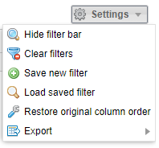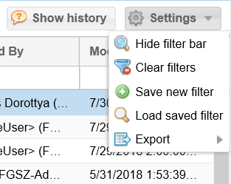

Filter bars
Each view has relevant filters. To view filters they need to be activated on the screen. If filters are not activated, select the Show filter bar button from the top right corner menu.
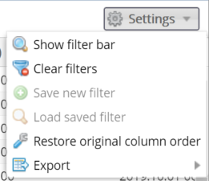
Or alternatively click the arrow on the top of the column headers and select “Show filter bar”.
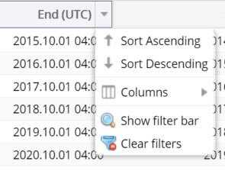
Filter bars will appear on the top of the column headers under the title; and their type depends on whether they contain numerical or alphabetic values. For textual values the following filter criteria can be selected:
- Contains – the text contains the filter expression, in any location
- Starts with – the filter expression is at the beginning of the text
- Ends with – the filter expression is at the end of the text
- Like – filter values matching the given search pattern (the * wildcard character matches any number of any characters)
- Not like – filter values not matching the given search pattern (the * wildcard character matches any number of any characters)
- In – values matching any of the specified elements (separated by semicolons)
- Not in – values not matching the specified elements (separated by semicolons)
- Similar to – text is similar to the filter expression entered
- Empty – search for empty values
- Not empty – search for non-empty fields with any value
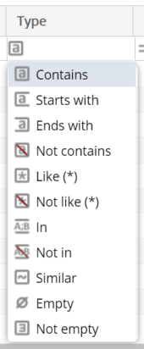
For numerical values and date columns the following filter criteria can be entered:
- Is equal to – the value equals the given number/date
- Greater than or equal – the value equals or is greater than the given number/date
- Less than or equal – the value equals or is less than the given number/date
- Is not equal to – the value does not equal to the given number/date
- Between – the number/date is within the given range (the two values must be separated by a semicolon)
- Not between – the number/date is outside of the given range (the two values must be separated by a semicolon)
- Empty – search for empty fields
- Not empty – search for non-empty fields with any value
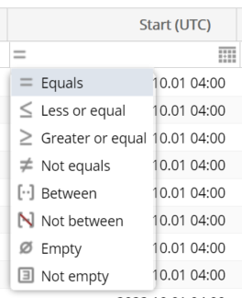
When typing in the filter bar filtering automatically starts shortly after and the searched rows will come up. When a row is filtered the header row turns red and italics. Filter criteria in the field can be deleted by clicking “X”. All filters can be deleted in Settings/Clear filters function.
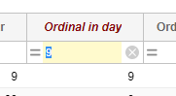
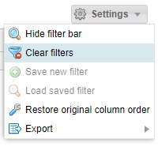
The column order of the views can be changed as desired by dragging the columns. Use the Restore original column order button under the Settings menu to restore the original column order of the view.
You may set up custom filters to make your work easier, so that you do not have to set up the same complex filters each time.
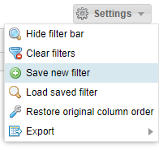
This is sufficient to perform it once, then click “Save new filter” from the “Settings” menu on the right above the list.
Give a name (one that is easy to identify) to the filter parameters composed previously in the pop up window “Saved filters” and give them a name (one that is easy to identify). Click “OK” to save them.
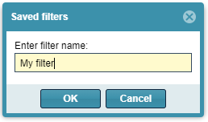
Select “Load saved filter” from “Settings” menu to see the “saved filters” pop up window.
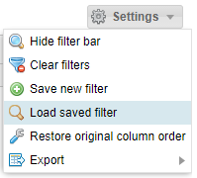
Select the filter you wish to run from the saved filters, then click “Apply filter”.
It is possible to delete the selected filter parameter select “Delete filter”.
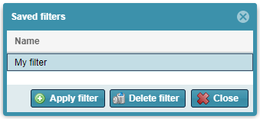

Hide or show columns
In the drop down menu on the top right corner of a column, click “Columns” and tick or uncheck the headers upon your preferences.
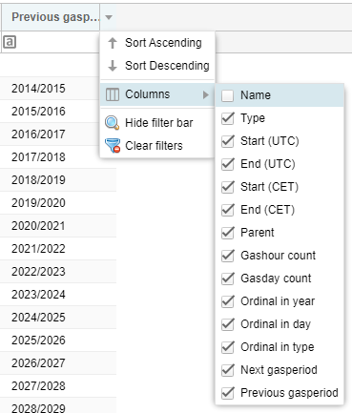

Quick filters
This function is available on the left side of the screen for certain views.
Shortly after typing in the filter bar filtering automatically starts and the searched rows will appear.
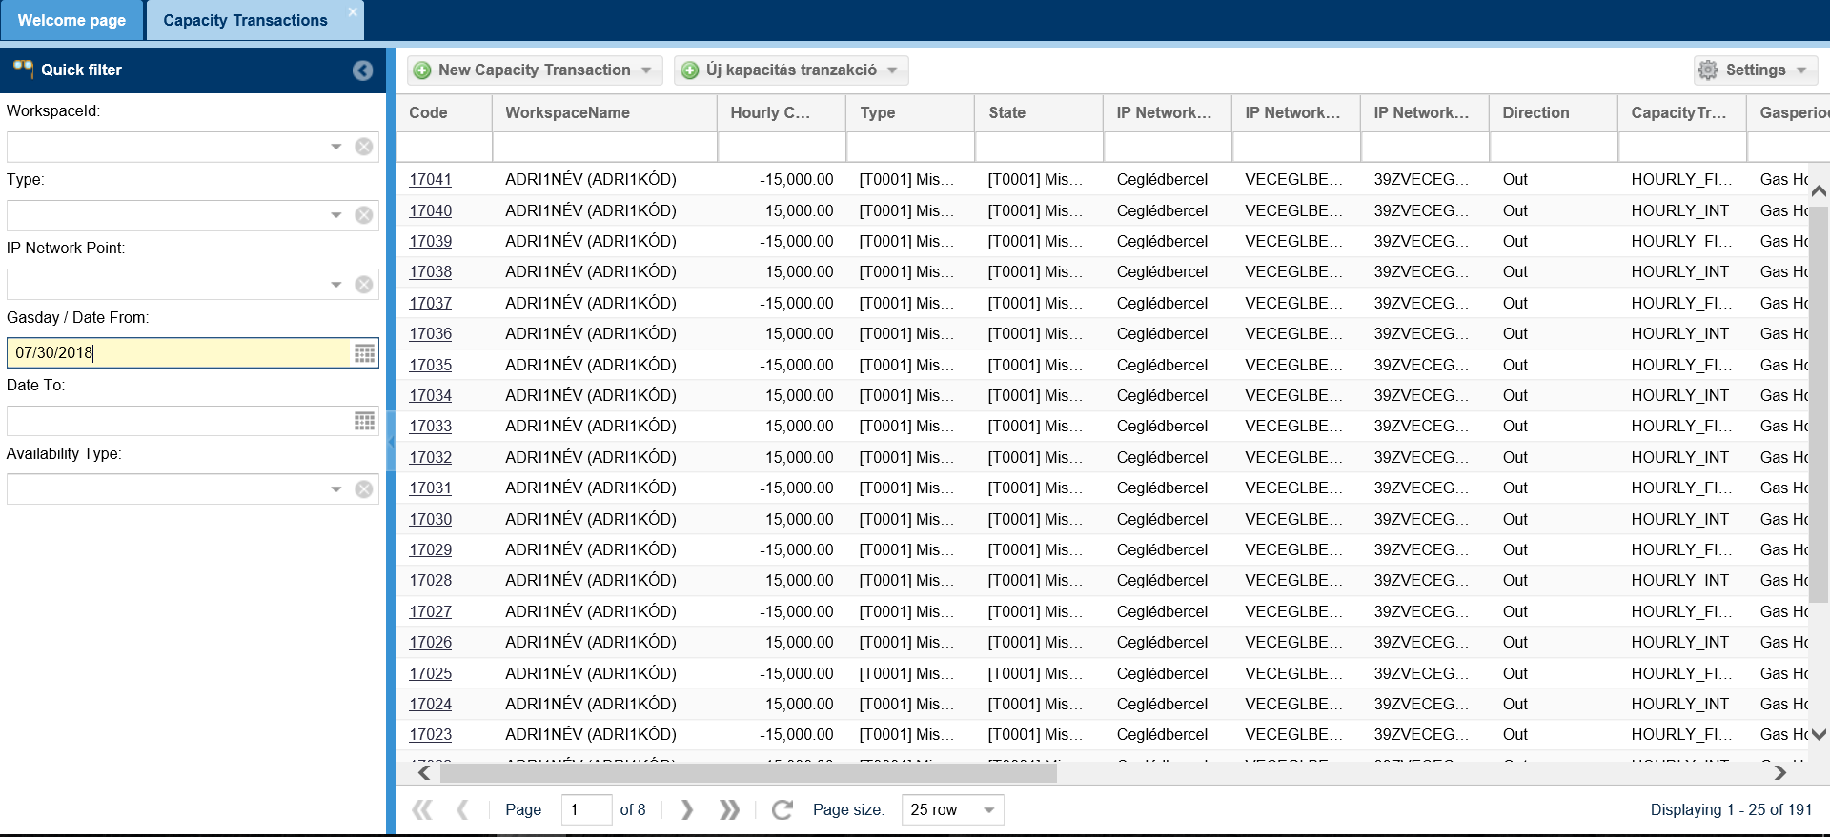
Filter criteria in the field can be deleted by clicking “X”. The screen resets to the original version without filters.
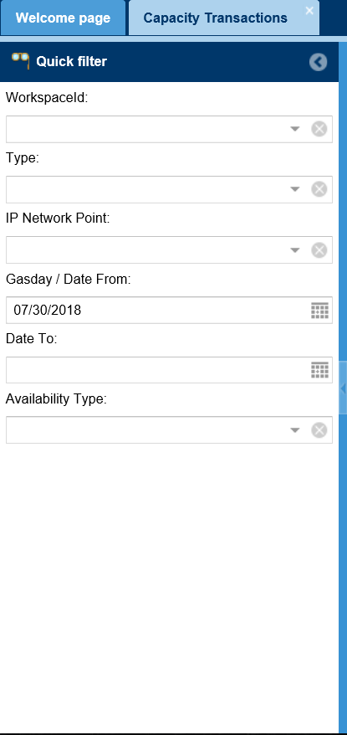
If you do not wish to use Quick filters, click the arrow in the title row to “close” it.
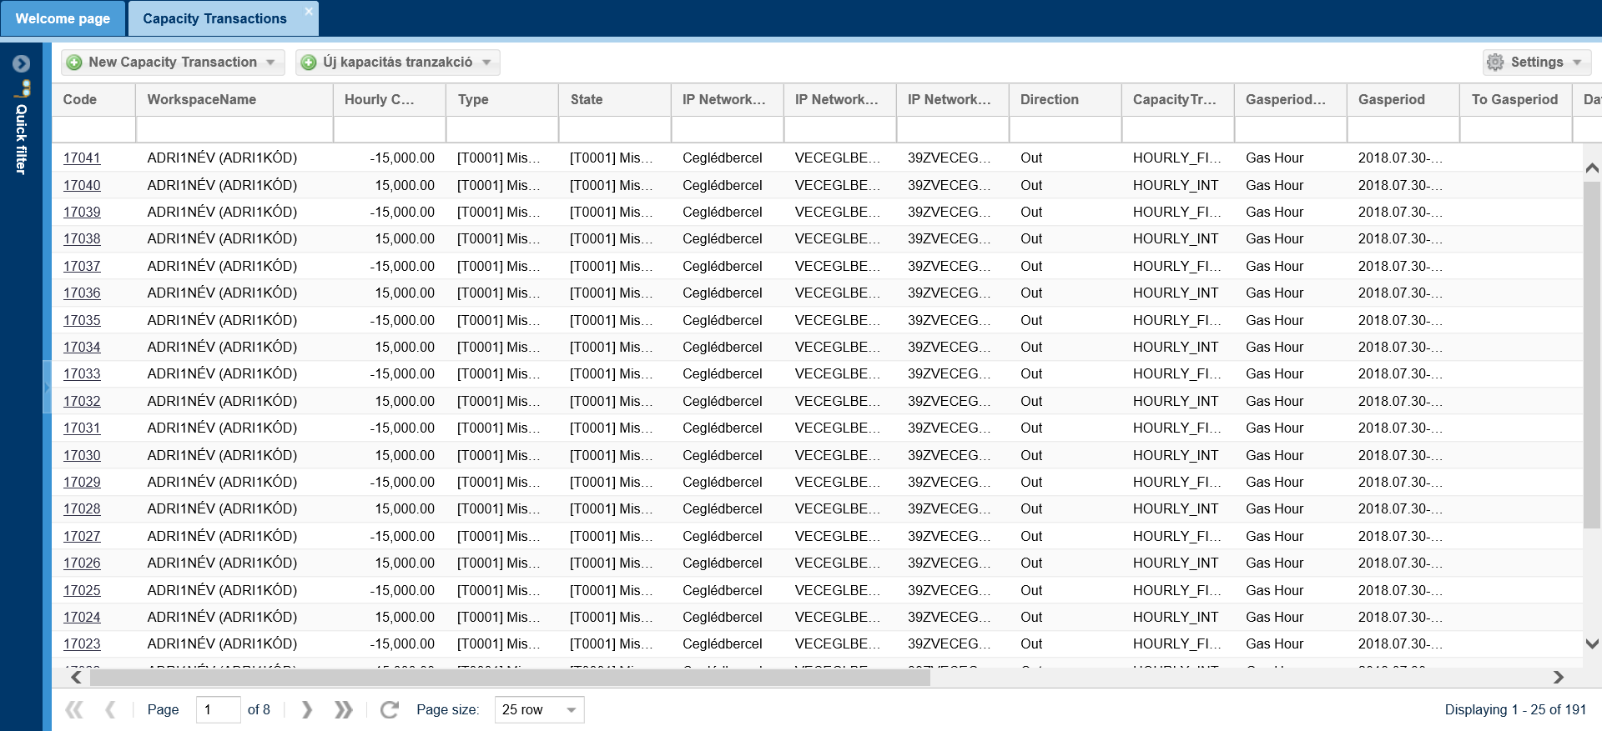

Exporting
Under different menus in this system listed data can be exported in XLSX (Excel 2007/2010), CSV (Comma Separated), XML, HTML and JSON format. Please use Settings/Export function in the top right corner.
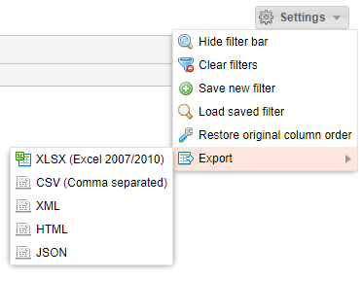
Export is valid for the total (filtered or not filtered list (regardless of the number of pages). The maximum number of rows to be exported can be activated at system parameters with an admin role.
Files can be saved or opened with an .xlsx extension file by MS Excel application and .csv files also by MS Excel. After opening you may use the options for a linked application (e.g. formatting, editing, printing, etc).

History
The history of the core function history can be viewed. Functions are visible in the top right corner of a chart overview if a record is selected.
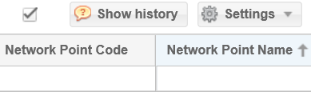
In the pop up window you may see what tasks were performed by certain users and when on the same record.
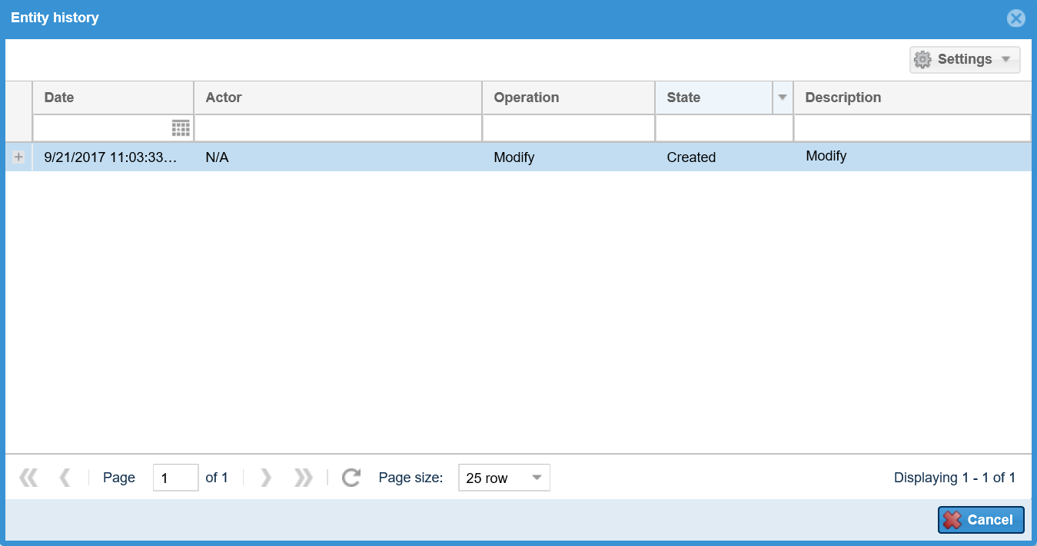

Shortcut keys
Use “Tab” to navigate, “Enter” to save and “Esc” to exit the edit window. This system does not support any other shortcut keys.

Refresh
Click “Refresh” to make the system download the given page again with the current data contents.
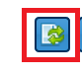
or
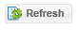

Forward
If you have several pages of information in the given list view you can see the forward button at the bottom of the page.
Use left arrows to go back. The single arrow jumps pages and the double arrows navigates you to the first page of the list view.
Use the right arrows to move forward. The single arrow jumps pages and the double arrows navigates you to the last page of the list view.
If you know the page number you may directly jump to the information page you are looking for.
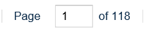
You can use the scroll down bar to select the number of hits on a page.
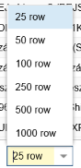
Click this button to refresh the contents of a page.

Field check
The system checks immediately if a field is filled in as soon as we leave the field. Any incorrect fields with no data will be highlighted with red borders and if you keep the mouse over the text box the reason for the fault will appear in a text bubble.
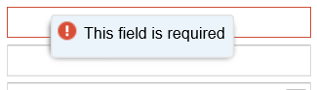
Generally a red asterisk is put in front of each required field.
Edit windows cannot be saved until the user corrects the value.
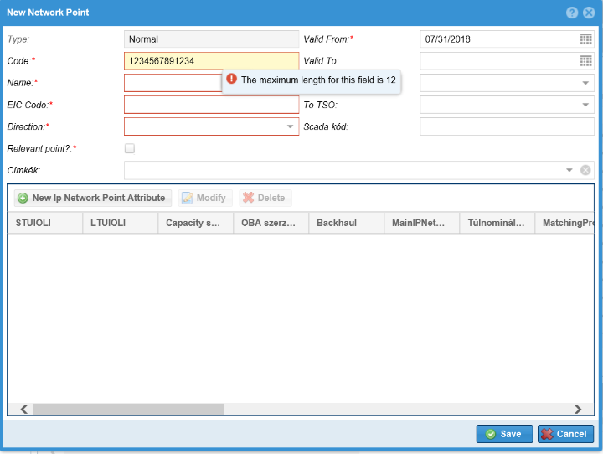

Layout
In any view you may arrange columns according to different criteria. Click on the highlighted column, and hold down the left mouse button to move columns. Move the mouse to the required location; the green arrow indicates where the column will move. Use left mouse button to adjust column width and size to make their contents well visible.
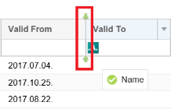
Click the arrow on the right of the header to open the drop down menu. The contents of the columns can be activated as per sorting order either “ascending” or “descending”. Use checkers before the headers in the Columns menu to present them in a view or not. You may modify the settings any time. All fields will be displayed on the lists by default.
You may change the order of columns with moving their header rows and click their sides to change width.

Login informations

Certificate expiration

The logged in user can look at the right corner and see the green shield icon before her/his name, which indicates the current certificate of the user is valid. Move the cursor over the icon. A tooltip informs the user about the expiration date of its password.
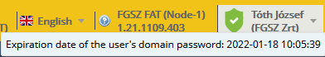

If the expiration date of the certificate or password is soon, a yellow shield icon with an exclamation point appears before the name of the logged in user:

If the expiration date of the certificate or password is going to be very soon, a red shield icon with an exclamation point appears, warning the user, that the password needs to be changed very soon:

In case of invalid certificate or password a red shield icon with an „X” appears before the name of the logged in user:
When logging into the application, the system shows a warning message, that the password is invalid:
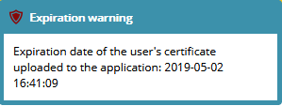

Setting the language of the system
Clik on the flag icon in the right corner of the window and set your language from the drop down list. The system will reload to the choosen language.
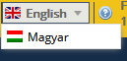

View Own privileges
Click on the logged in user’s name in the right corner of the window. Choose My privileges from the drop down list.
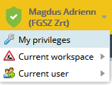
The data sheet of the current user opens, where basic data, notification settings, roles and privileges can be seen.
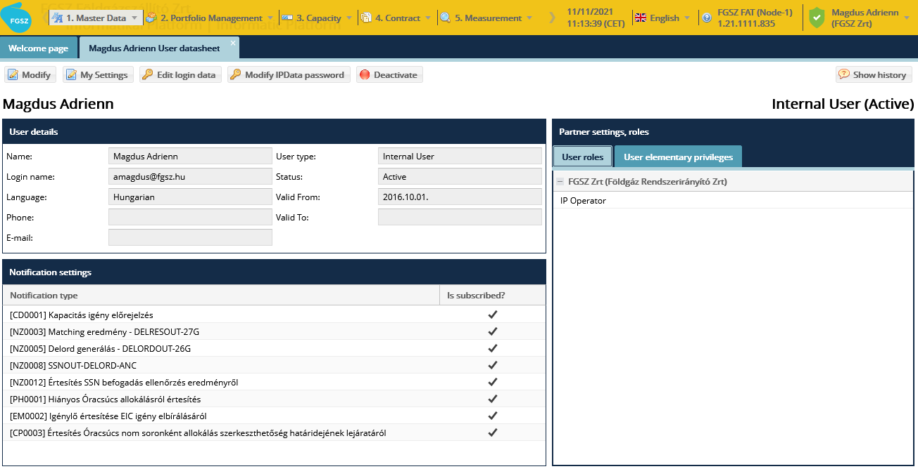

View current workspace
Click on the logged in user’s name in the right corner of the window. Choose Current workspace from the drop down list. There appears a list of the partners of which the current user is assigned. A user usually has one workspace to work.
In case of impersonating the current workspace is the impersonated user’s workspace.
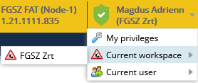
If there are more than one partners assigned to the current user, then those partners will be listed here. A user can be assigned only to different types of partners, for example one network user and one
The user can change workspaces using this function

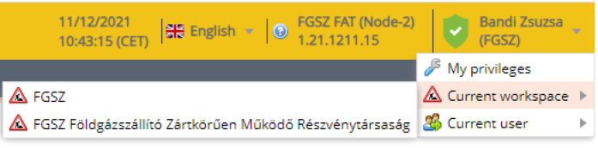

Changing workspace also means that changing roles and privileges the user has at that particular network user.

Menu structure
View application menu.
The following menu sections are available from here:
- 2. Portfolio management Balancing portfolios, RENOM cycle documents, RENOM cycle result
- 3. Capacity Capacity transactions, Capacity diagram
- 4. Contract Capacity contracts, Secondary deals, CMP deals, Capacity conversions
- 6. Allocation Allocation detail
- 7. Settlement Browse Reports, Collateral

Nomination
Network users can give delivery order of their purchased capacities to the TSO via the nomination module. Delivery orders, i.e. nomination rows are received, stored, managed and checked by the nomination module, it also carries out interruptions. FDAUIOLI and OSBB procedures, a matching with neighboring network operators as well as finalizes them and sends a feedback on the parties concerned. The schedule of nomination processes and tasks as well as the availability of nomination related functions have strictly defined time-limits.
For the given D gas-day, nomination is possible 60 days prior, on until D-1 gas day by 14.00 (for the 9th gas-hour), then the renomination period starts officially on D-1 day at 16.00. In order to maintain the continuity of the network usage, nomination is possible also on D-1 day between 14:00 and 16:00 for a D gas-day. The nominationcan be used continuously until H-2 gas-hour.
For D gas-day, the renomination period last from the 9th gas-hour (CET 14:00) on D-1 gas-day to the 22th gas-hour (CET 03:00) on D gas-day.
The first matching process for D gasday starts at the 9th gashour of D-1 gasday. The last matching process for D gasday starts at the 22th gashour of D gasday.
Based on the past experienes and the EDIG@AS practies, the system manages the nomination rows on a daily basis. The Network User can manage its nominations for a gas-day collectively and the latest version of the portfolio is considered valid. In order to ensure this, the daily balancing portfolio is introduced, and further functions are added, that is, not only the daily nomination rows are collected, but also the transaction notices for the shipper for the given gas day (gas transaction deals within and outside the system) are also included, to ensure that te broadest possible picture of the Balancing portfolio can be seen.

Portfoliomanagement – Balancing portfolios
Network users can perform all changes in the created portfolios via the Nomination rows and the Trade notifications functions. The latest time for submitting a nomination is 2 hours before the given gas hour in a portfolio with an Open status, therefore the operation of editing nomination is influenced not only by closing of nomination but passing time as well.
In any portfolio with a Nomination closed status nomination rows cannot be changed. This status change is carried out every day at 4 a.m.
The Network users can perform further changes only via the Trade notifications function until the end of the gas day in the Closed nomination portfolio until the status of the given daily portfolio changes to Fully closed.

Listing balancing portfolios
Open the Portfolio management menu Balancing portfolios view.
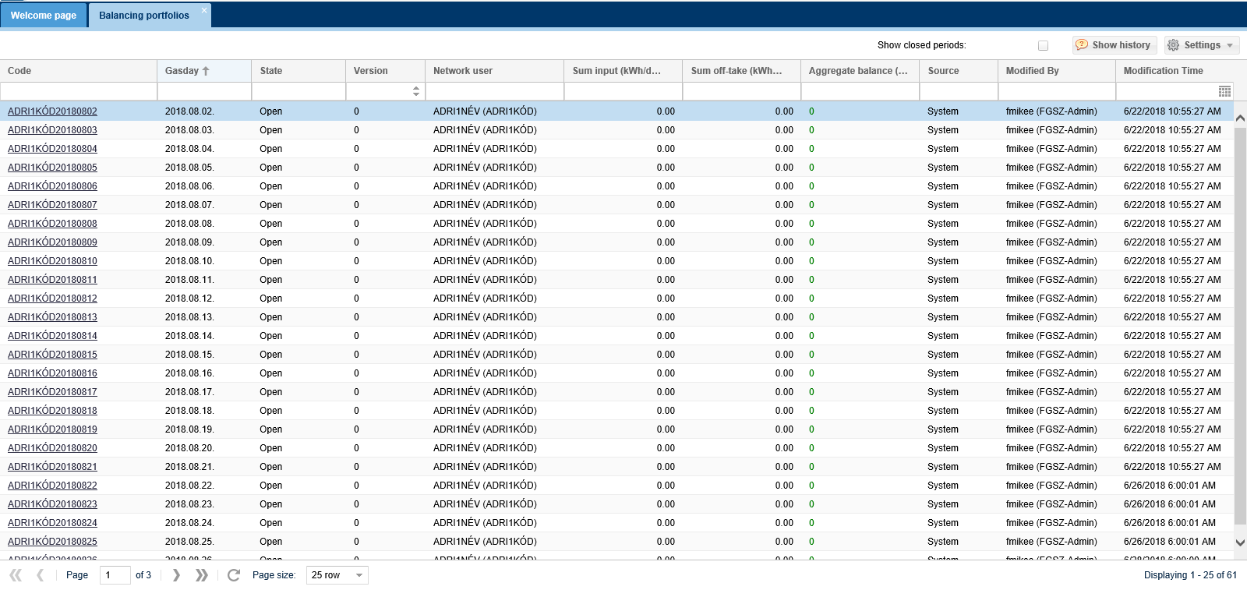
The Balancing portfolio list screen is displayed with each portfolio that has an “Open” status.
Network users can only see their own portfolios.
Sum input column includes the total of Network users nomination inputs and acquiring trade notifications. Sum off-take column includes the total of outgoing nominations and disposing trade notifications. The aggregate balance shows their difference. If unbalanced the total balance is showing in red.

Listing closed portfolios
Open the Portfolio management menu Balancing portfolios view.
In addition to Settings function button you may find a check box for “Show closed periods”.
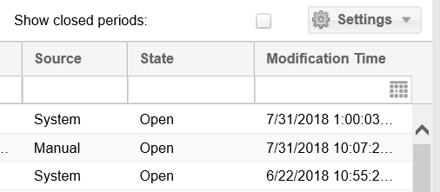
If this box is checked all closed status portfolios are displayed too.
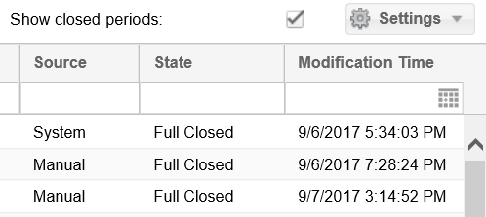

Viewing balancing portfolios
Open Portfolio management menu, Balancing portfolios view, then select the requested portfolio. Click the link in the code column.
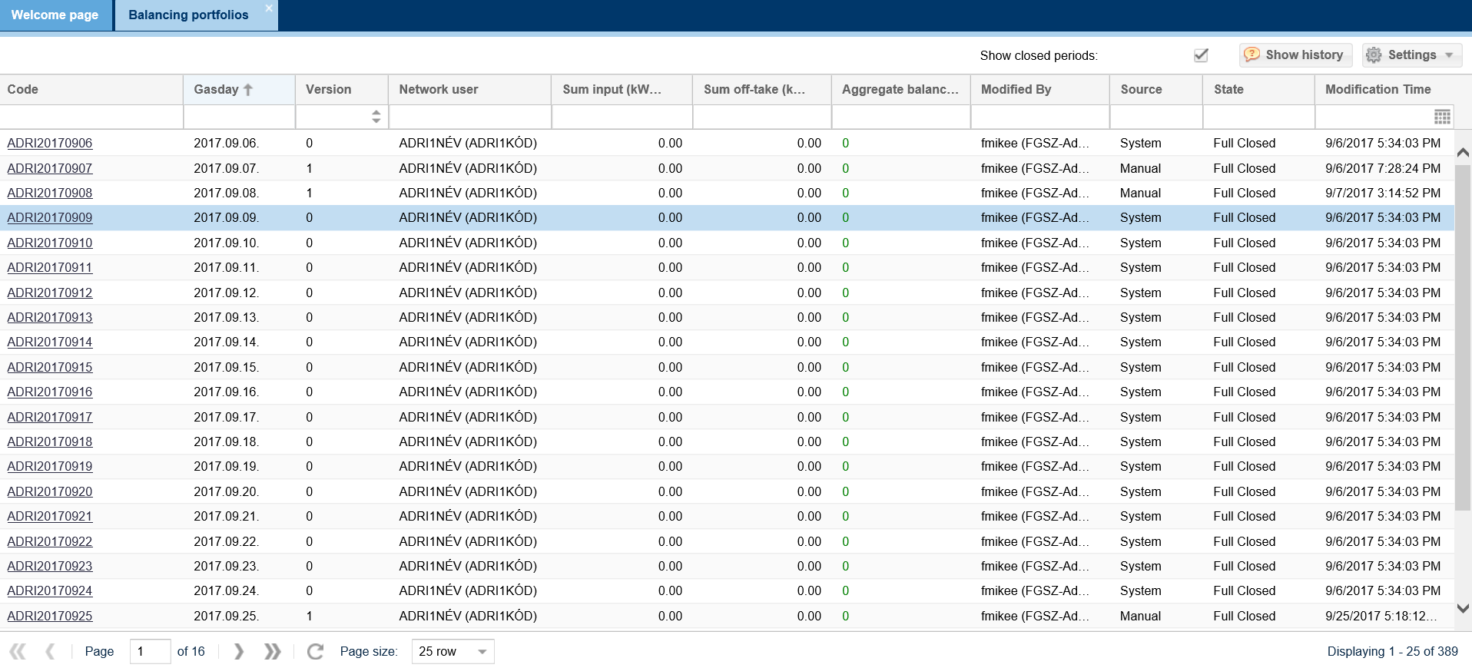
Then the portfolio data sheet opens on a new tab.

Portfolio details can be viewed in an information dashboard with different tiles.
The tiles can be resized for better overview and management.
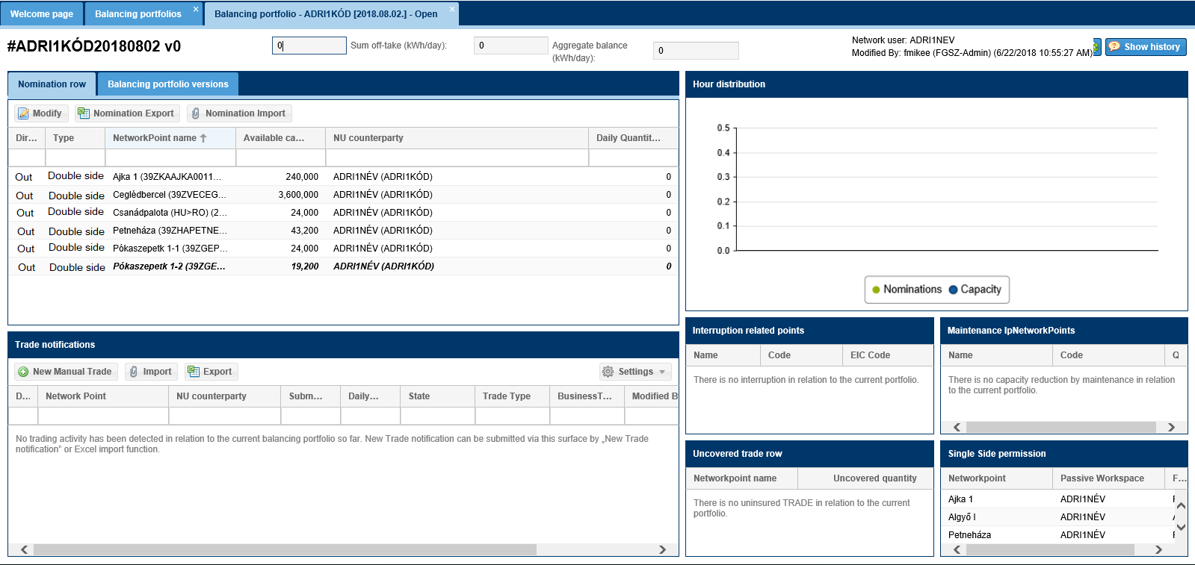
In the portfolio header you may see:
- a portfolio ID, that is composed of the following: the Network user IP system code and the relevant portfolio date
- portfolio version number
- Sum input column: the total of Network user nomination inputs and acquisition trade notifications.
- Sum off-take column includes the total of outgoing nominations and disposing trade notifications at a given transaction point.
- Balance: shows portfolio balance
- „WDO violation”: if the Network user is in WDO violation based on his/her portfolio (based on submitted nominations and confirmed deliveries for the past hours), this label will appear
- Network user: portfolio owner name and code
- Modified By: This may be the registered user of the system or the Network user partner, who last modified the nomination rows with the Modify nomination function or trade notifications with any of its functions.
- Time of the modification: the time of last change. The nominations for the given day and trade notifications management functions are available depending on the portfolio status.
Open status portfolio a Functions are available on the nomination rows tab:
Modify nomination, export nomination, import nomination. On the trade notifications tiles New manual trade, Import and Export are available.
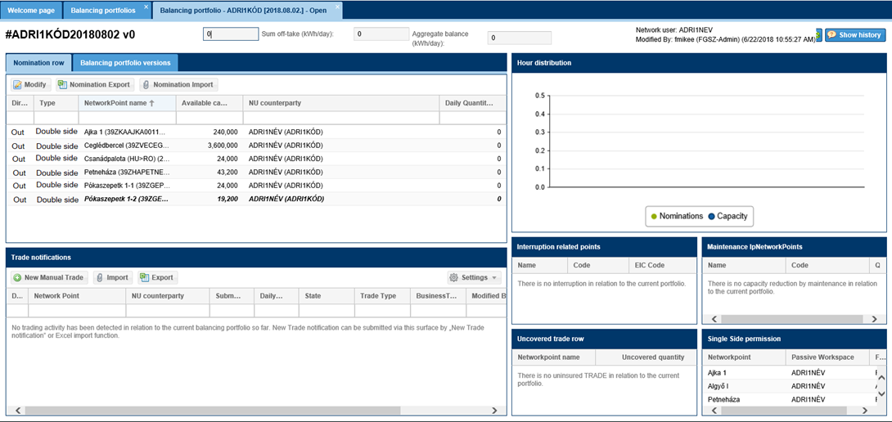
Closed nomination portfolio a Functions are available on the nomination rows tab: Nomination export. On the Trade notifications tile functions similar to that of Open status are available.
Fully closed status portfolio Nomination rows functions are available on the tab: Nomination export. On trade notifications tile only Export is available.
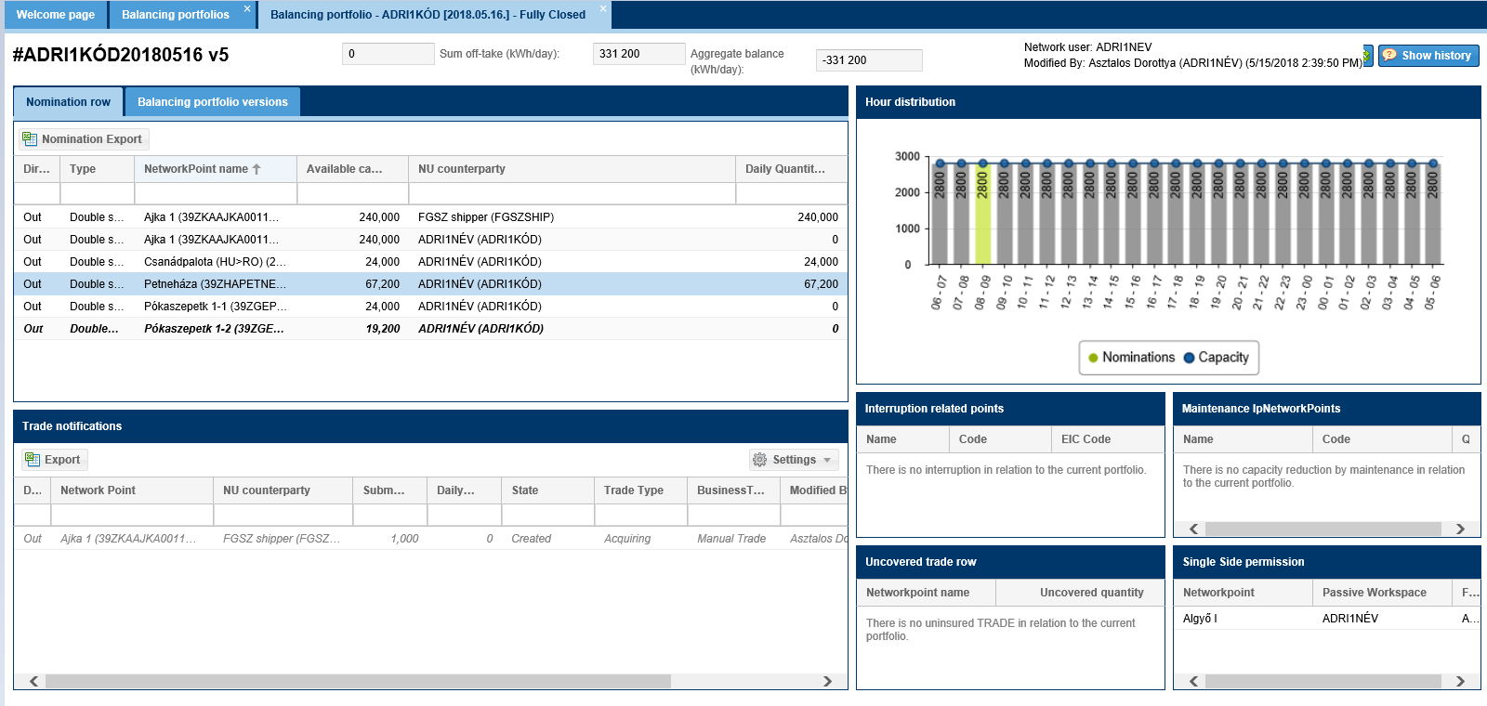

View nomination rows
Two tiles in the top corner of the screen with two tabs.
The nominations of the Network users for the given day are to be managed under the Nomination rows tab. For each row with a contracted capacity the Network user as NU counterparty appears with a row of zeros for the daily quota.
If a given shipper did not buy any capacity for the given day the following text appears on the screen in the nomination rows window: “No nomination activity has been detected in relation to the current balancing portfolio so far. Nomination via this surface can be submitted by „Modify” function or Excel import function.”
Daily balancing portfolio versions tabs show former versions of the given portfolio.
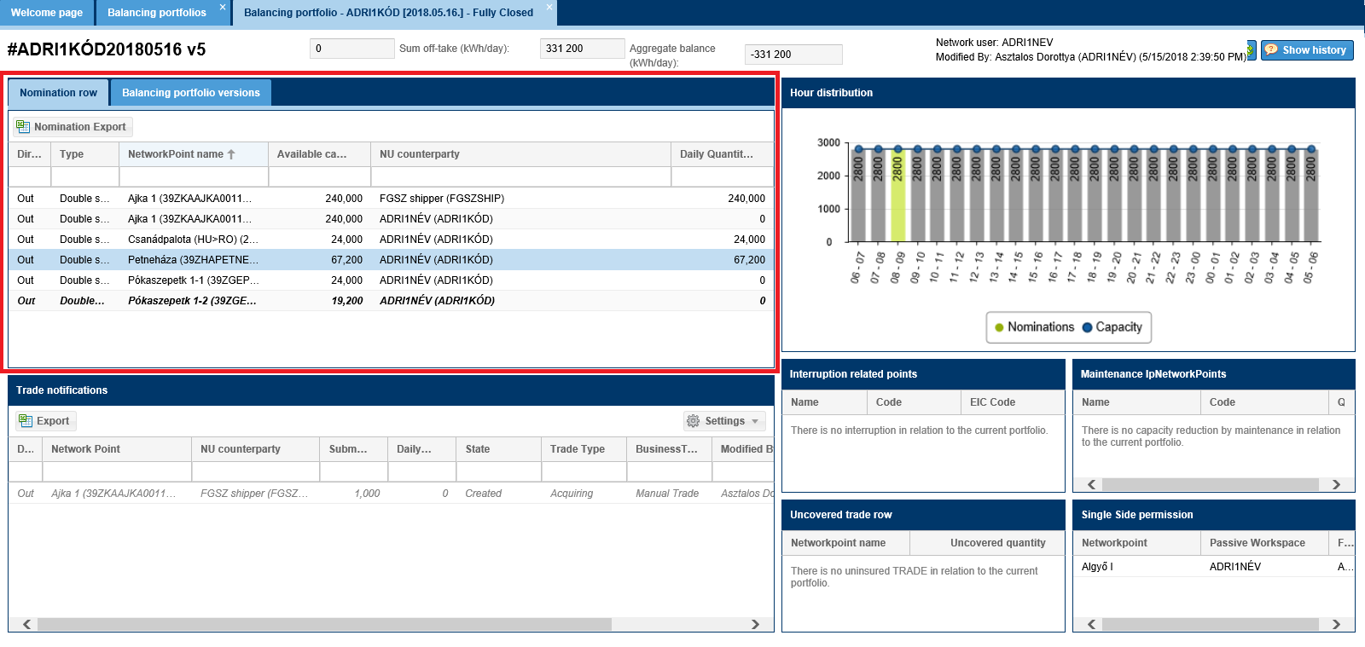

View Trade notifications
This tile is in the lower left section of the screen.
Available functions: New Manual Trade, Import and Export.
In the trade notifications window, if the Network user has not yet submitted any notification the following message displays: “No trading activity has been detected in relation to the current balancing portfolio so far. New Trade notification can be submitted via this surface by „New Trade notification” or Excel import function.” You may start new notifications via the “New Manual Trade” function.
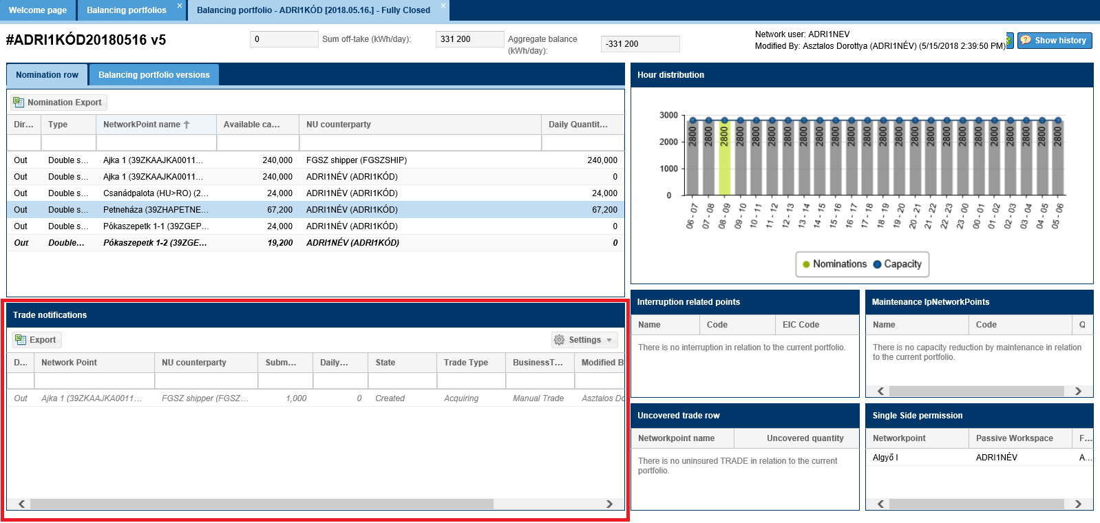
LPFS transactions for the given gasday are also displayed in the Trade Notifications list of the balancing portfolio. The system automatically creates the LPFS trades for D and D+1 gasdays for all RH partners using LPFS services at the MGP point. LPFS trades can only be created by the system, and after creation they must be automatically matched.
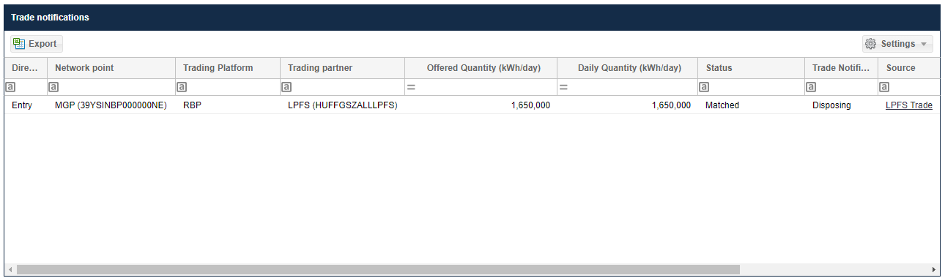
LPFS transactions are included in the balance of the portfolio.

View hourly distribution diagram
See this tile on the top right of the screen. Highlight the row on the nomination rows chart to view nomination and capacity data for in a gas hour distribution.
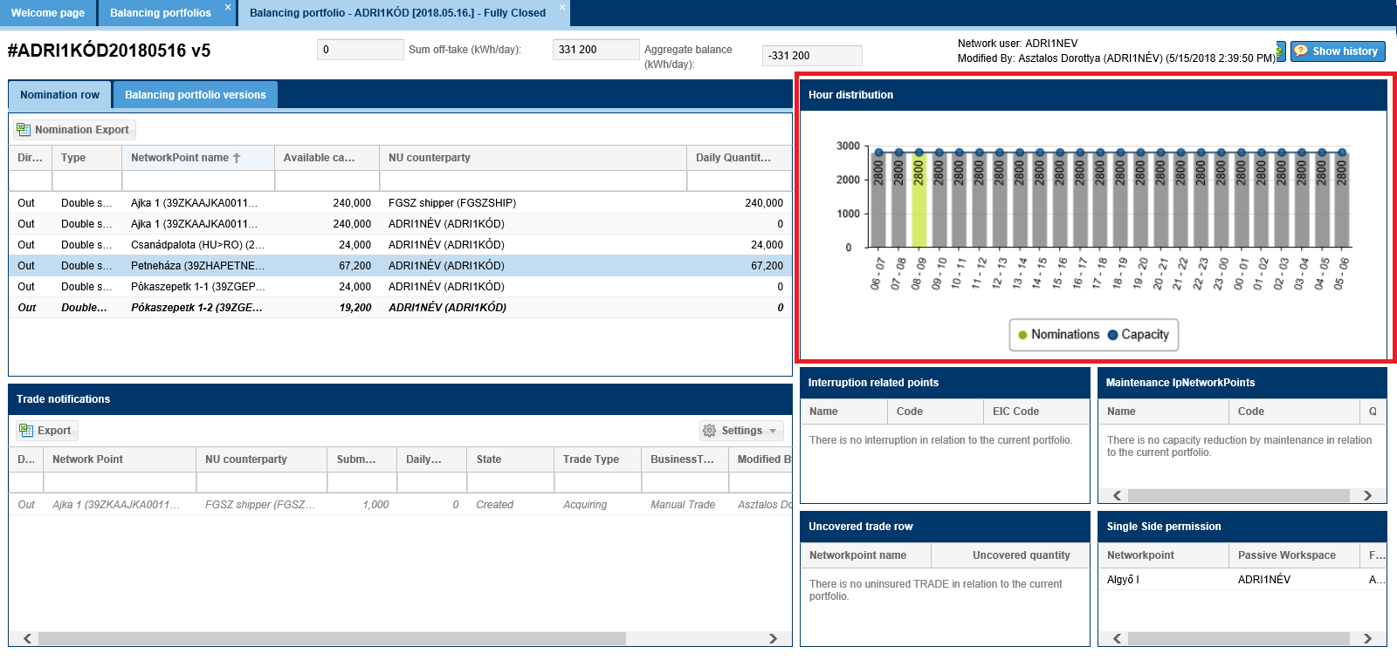
The columns will show nominated volume. Color coding:
- gray: until there is a matching
- green: if during the last hourly closing during the matching procedure the given row became “matched”
- red: if during the last hourly closing during the matching procedure the given row became “Volume mismatch”
- turquoise: if disconnection happened during the last hourly closing
Move the mouse over a given column and a bubble will appear to show for the given hour:
- match /mismatch/no data
- if there was a disconnection its extent
The graph shows Network user nominable capacity at the point that is part of the allocated nomination row.
Move the mouse over a given graph and a bubble will appear to show for the given hour:
- The volume of the Network user nominable capacity that can be nominated for the selected row and the ratio of interruptible and uninterruptible capacities
- And what is the remaining capacity to be over nominated, if possible to overnominate the point that is in the highlighted row

View interruption related points
See this information tile on the bottom right of the screen.
List the points of the Network user portfolio where the system performed interruption or it is to be expected, if the nomination is not changed.
If there was no interruption during the given day the window will display the following message: “There is no interruption in relation to the current portfolio.”
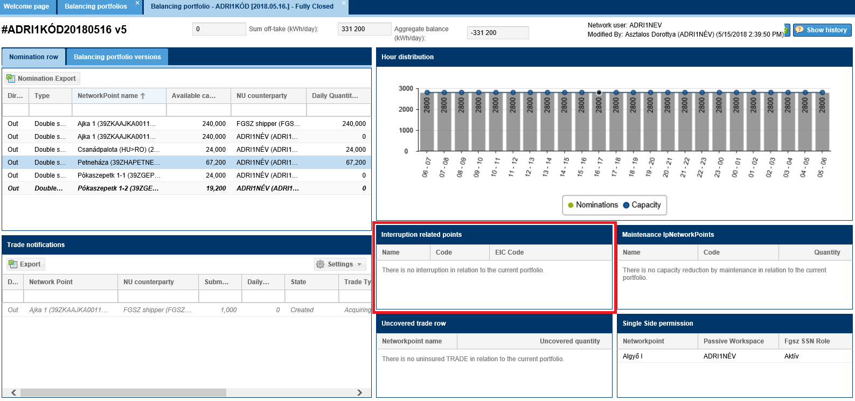

View Maintenance Network points
See this information tile on the bottom right of the screen.
List the points of the Network user portfolio where maintenance works impacting the nominable capacity is registered. Next to the point the capacity decrease will also display.
If there is no published maintenance work for the given day the window will display the following text: “There is no capacity reduction by maintenance in relation to the current portfolio.”

View uncovered trade row
See this information tile on the bottom right of the screen.
In case of trade notifications(s) created on the given gas day the seller (transferring) and the buyer (recipient) is obliged to enter the volume of the transactions at the network point of the transaction (nomination and/or transaction deal) or dispatch according to the direction of the transaction.
The physical delivery of the non-MGP (Hungarian gas balancing point) transactions is the responsibility of the shipper. If this is not performed the Transactions without coverage tile will show this.
- Users selling gas via a transaction deal through an input point are obliged to import it by nomination.
- Users selling gas via a transaction deal through an output point are obliged to export it by nomination.
If there was no transaction without coverage the window will display the following message: “There is no uninsured TRADE in relation to the current portfolio.”
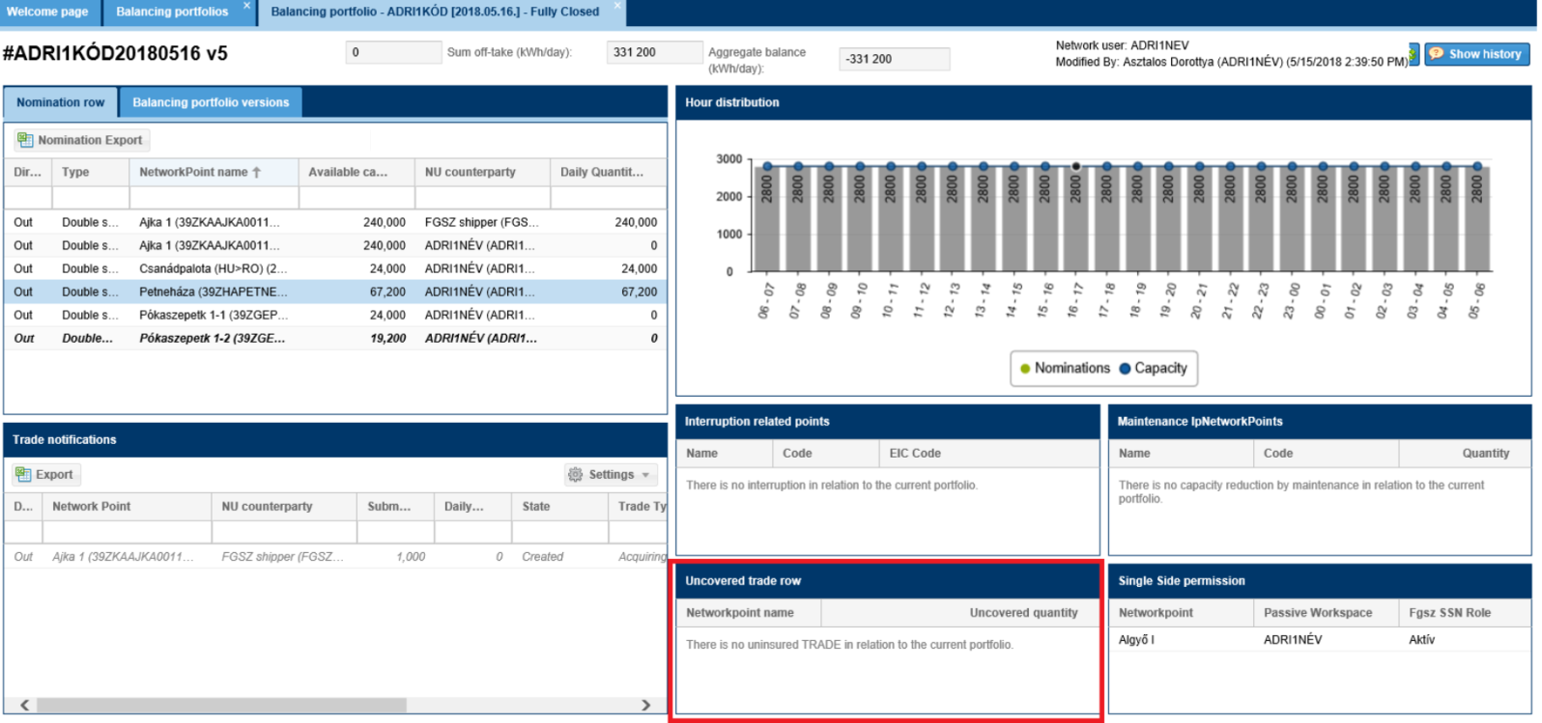

View single side permission
See this information tile on the bottom right of the screen.
List the points of the Network user portfolio where they have an authorization to submit a single side nomination and with exactly which NU counterparty. Fields of the chart:
- Network point name
- Passive shipper: the NU counterparty, who agreed not to nominate and instead of this party this Network user can submit a nomination
- FGSZ SSN role.
If there was no authorization for the given day the window will display the following message: “There is no received SSN permission in relation to the current portfolio.”
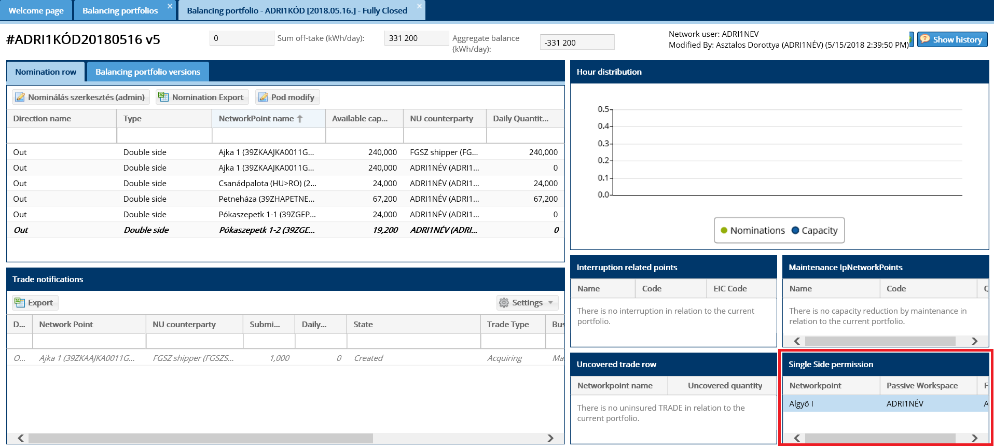

Listing balancing portfolio versions
Click Balancing portfolios menu view Balancing portfolio versions tab. The versions linked to the portfolio are listed here.
The number of versions will increase if a change is entered into the nomination rows by the Network user or the system during the hourly closing; or if there is any status change in the trade notifications.
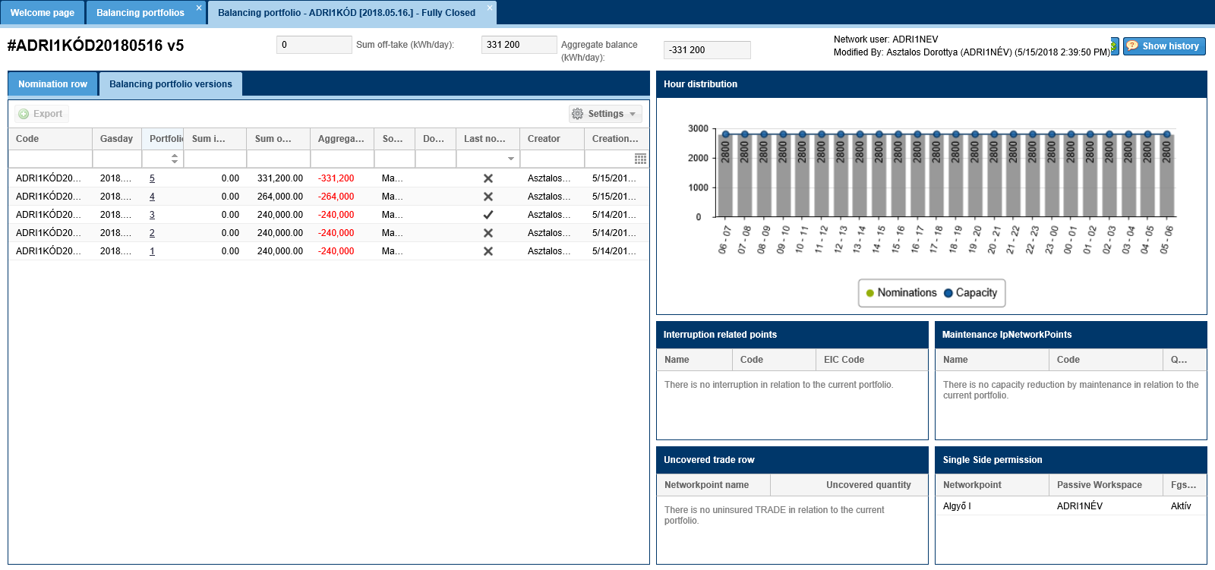

View balancing portfolio versions
Open Balancing portfolios menu view Balancing portfolio versions tab. Click the number of the required version in the Portfolio column. This is a link.
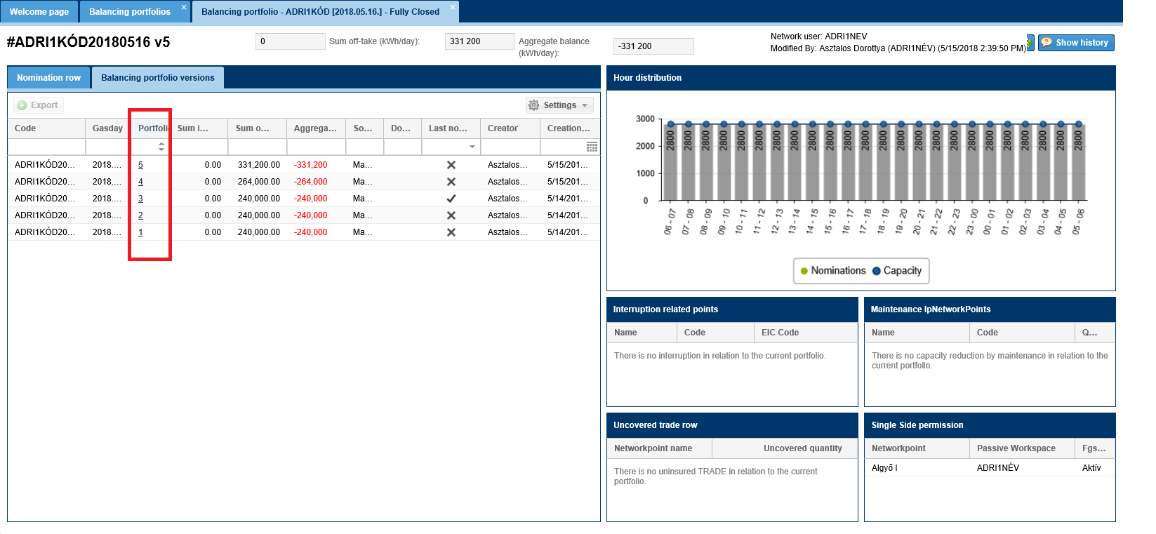
The full data contents of the given version displays.
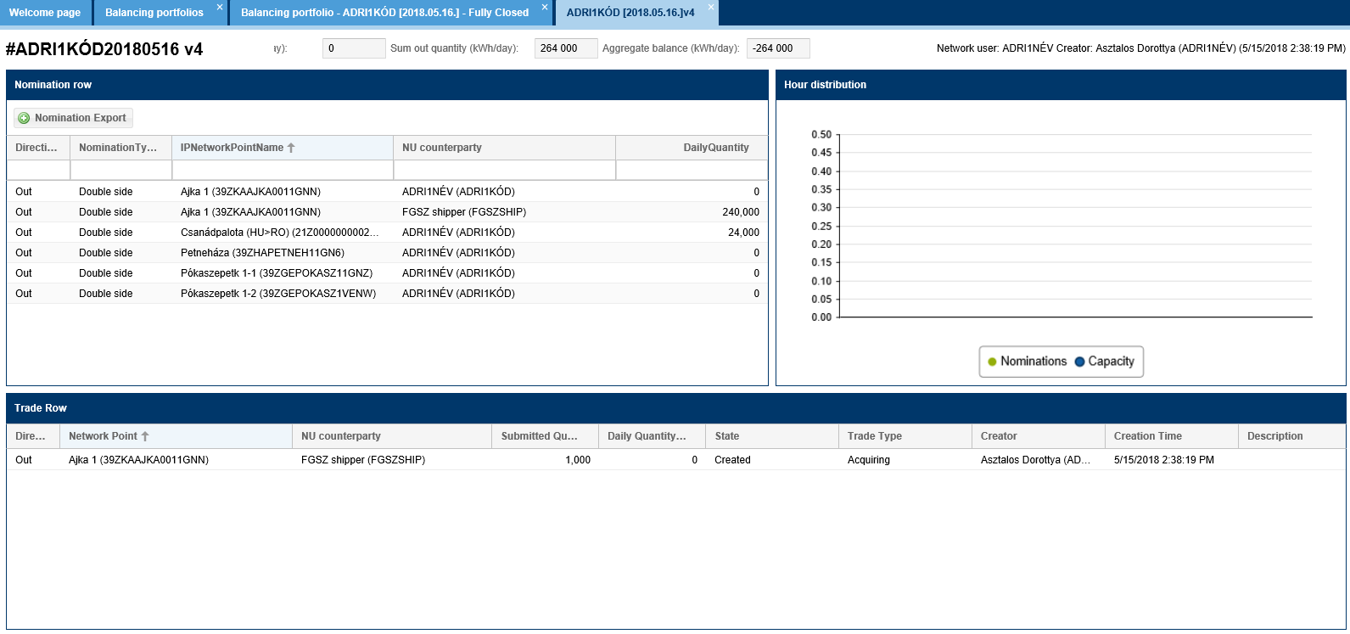
In this view the nomination export function is available.

Export balancing portfolio versions
Open Balancing portfolios menu view Balancing portfolio versions tab. Click a row of versions, or on the View data sheet of the version, use Export function to generate an Excel, and that will be a NOMINT type file.
This function will only export the nomination rows!
The system will ask you a confirmation question before execution. Please confirm this.
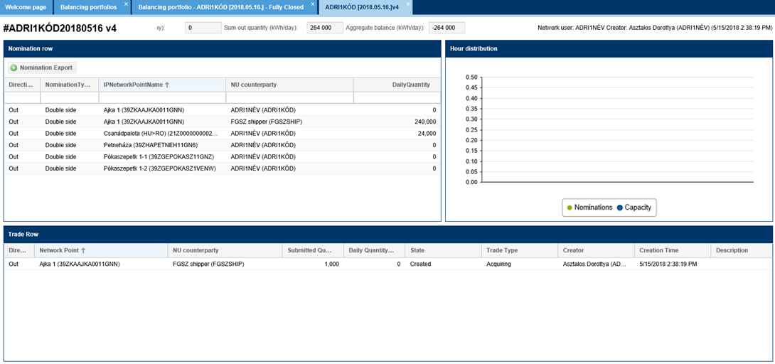
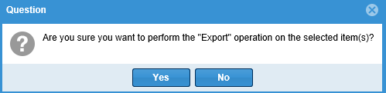
The nomination rows related to the selected portfolio version will be exported into an Excel file.
This function is identical with the export nomination function, however it is possible to export nomination rows of previous versions.

View nomination document
Open Balancing portfolios menu view Balancing portfolio versions tab. Click document ID in the given column. This ID is shown only, if there is a version in the portfolio that is from an external source. External sources are manual imports or imports via an interface.
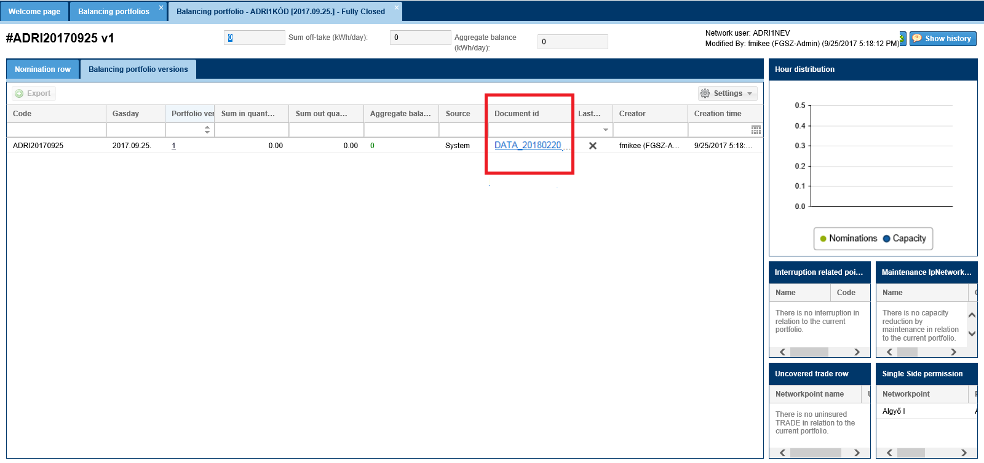
The selected nomination document data contents are displayed on a separate data sheet.
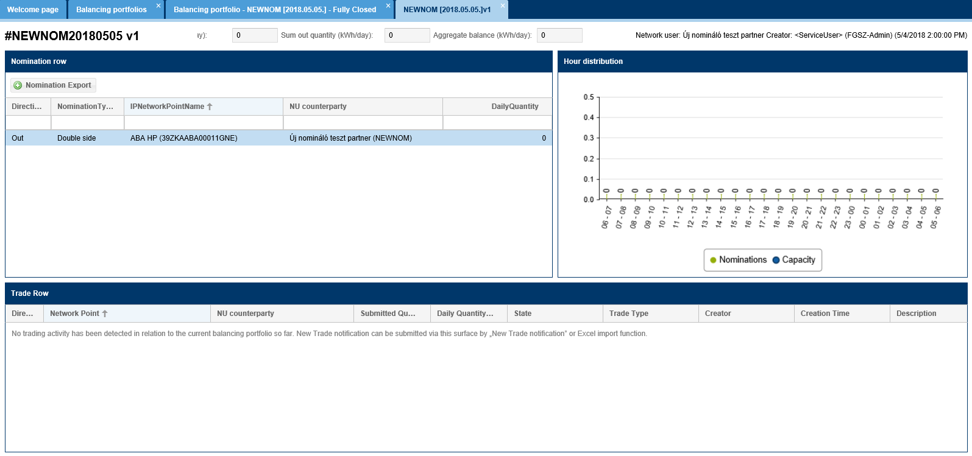
The new type of the nomination document is NOMINT, which can be seen at the RENOM cycle documents screen:
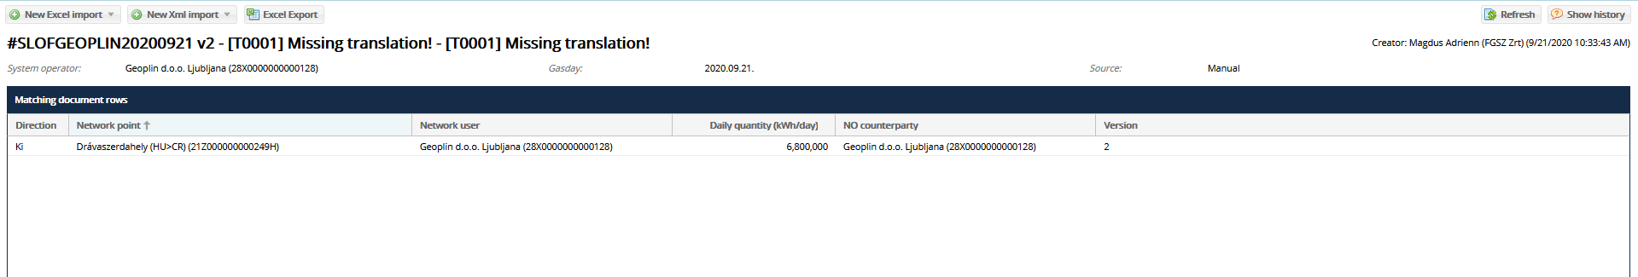

Edit nomination
Open Balancing portfolios view and click an “Open” portfolio. Select “Modify” on the given portfolio view screen.
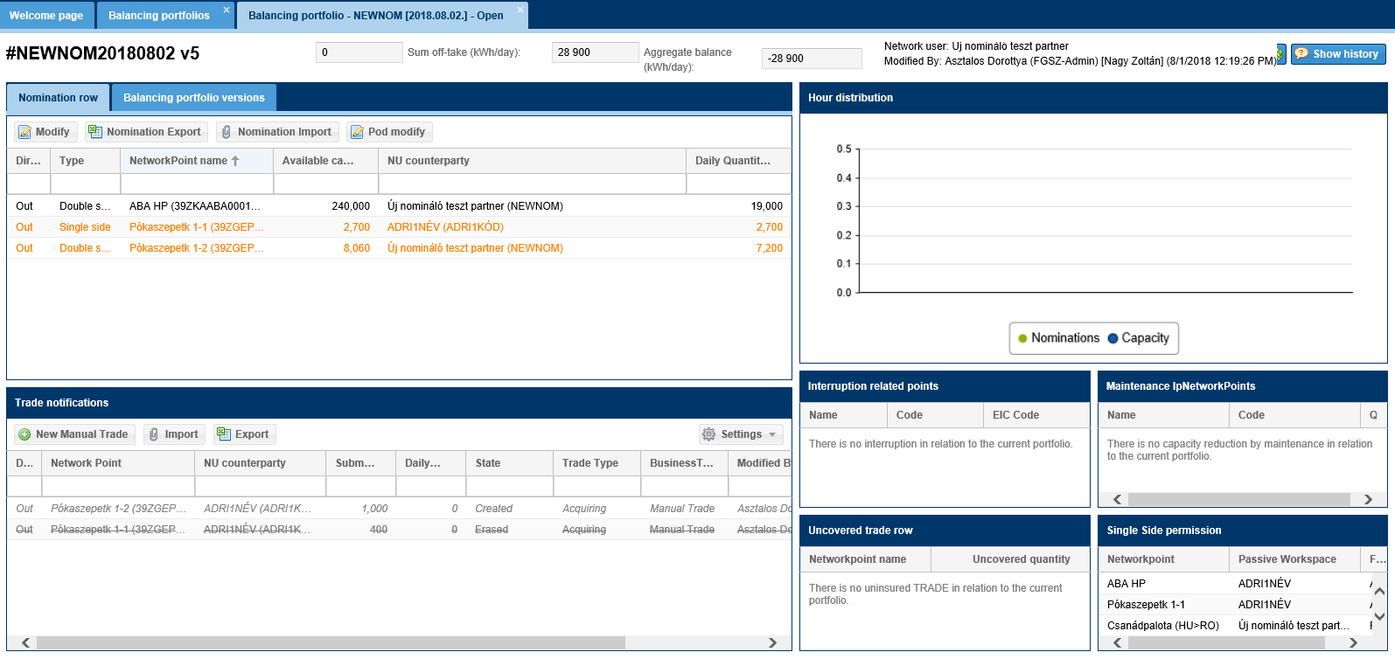
Edit nomination for version zero portfolios automatically includes rows the Network user has nominable capacities. In a default case it has daily volume zero. The default partner is basically itself. Users can change these with further functions of edit nomination.
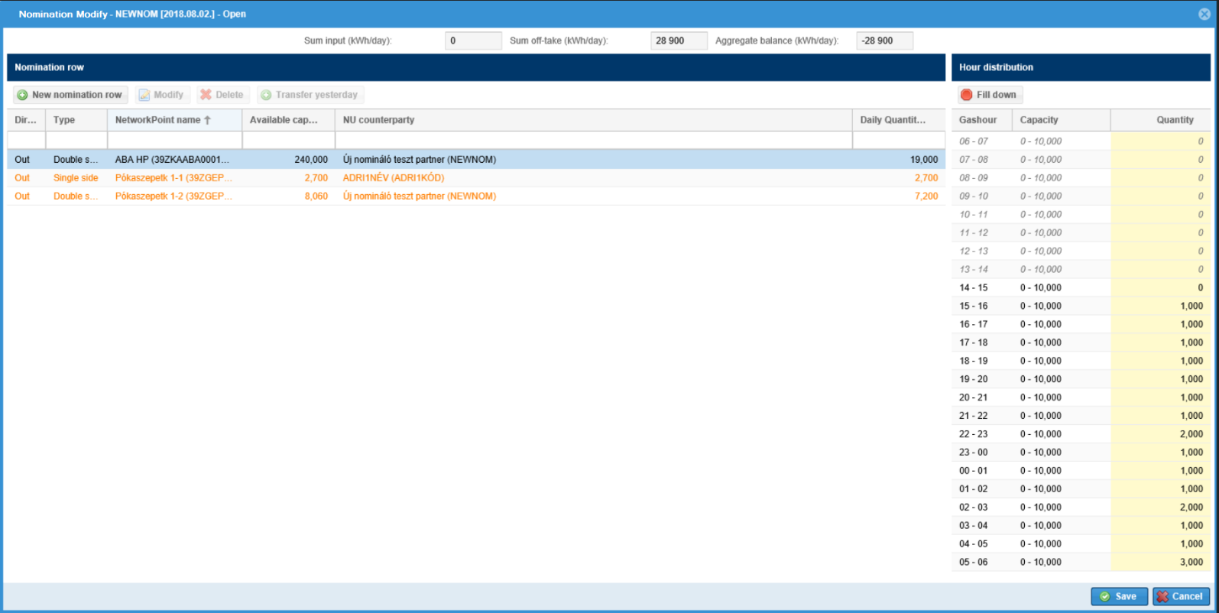
The following functions are available by clicking a row in the window: New nomination row, Modify, Delete, Transfer yesterday. And at this time on the right of the screen the hourly distribution is editable, and fill down function becomes active.
New nomination rows and changes are saved when clicking button “Save” in the bottom right corner of the Nomination modify window, in case the system cannot find a mistake when running necessary checks.
Nomination row fields:
- Direction
- Type: nomination type can be single side or double side. In a default case it is double side.
- Network point name
- Available Capacity
- NU counterparty: Shipper Pair
- Daily quantity: the delivery demand
- NU counterparty code: Shipper Pair code, hidden column in a default case
- Network point code: hidden in a default case
- Version: nomination row version number, in a default case hidden column

Registering a new nomination row
Open Balancing portfolios view and click a portfolio. Select “Modify” function on the given portfolio view screen. Then click “New nomination row” button.
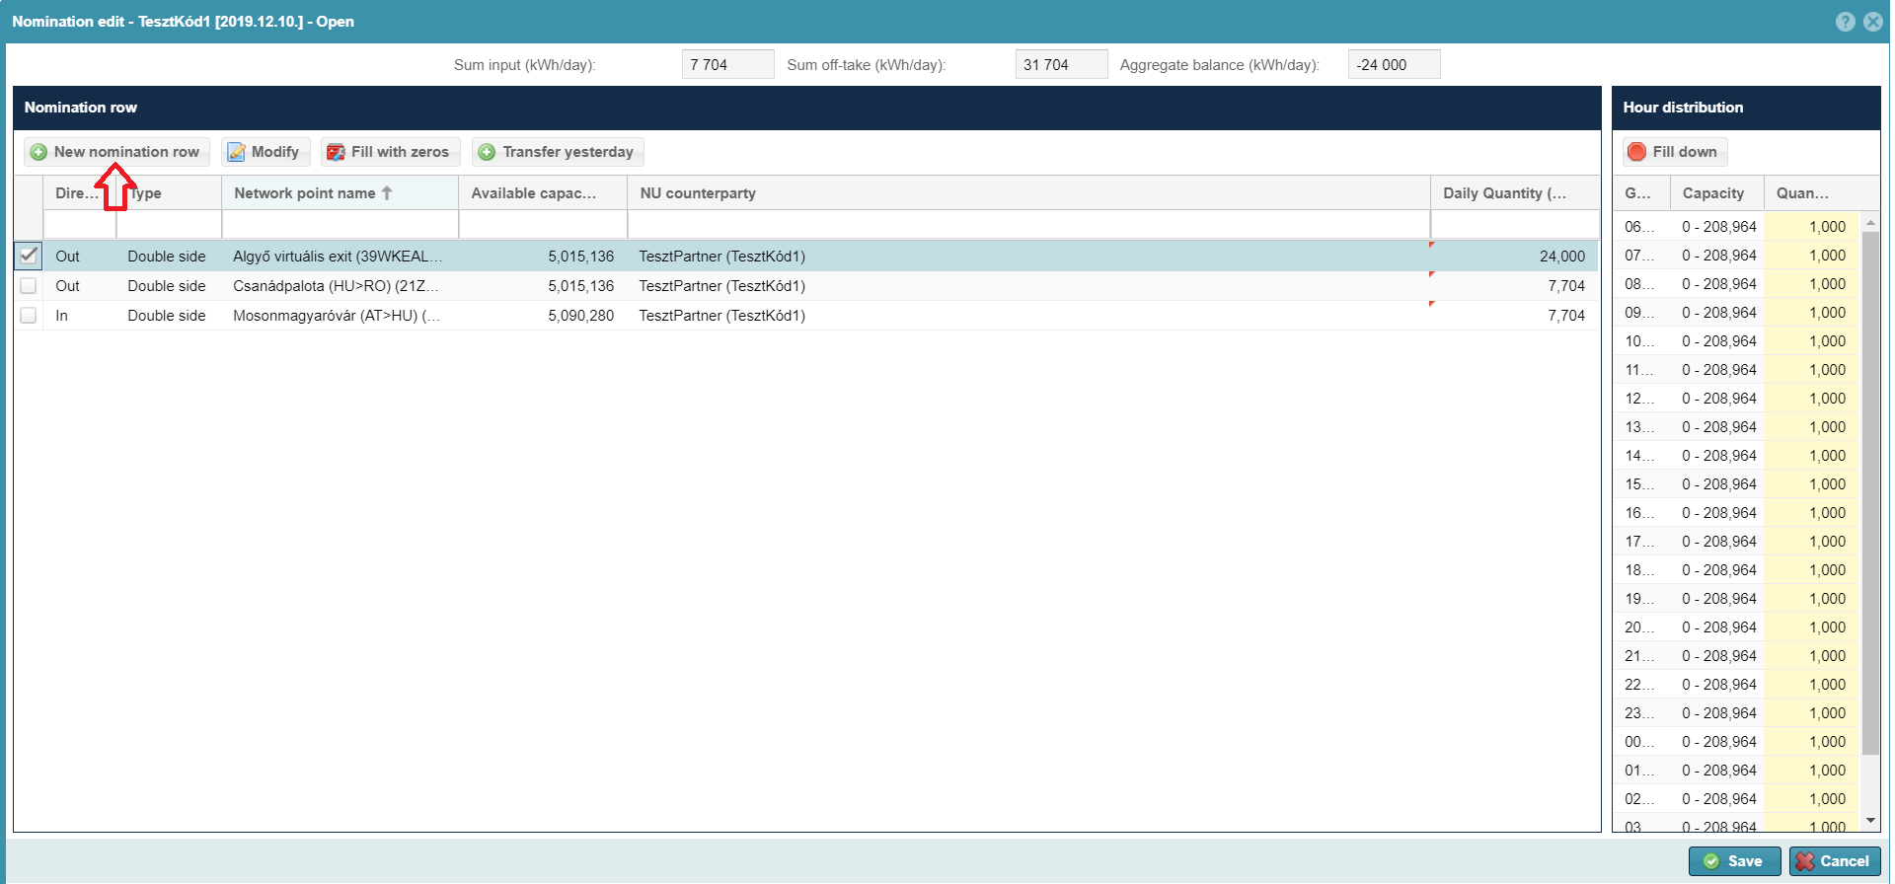
The system will show mandatory fields in a text bubble and with an asterisk.
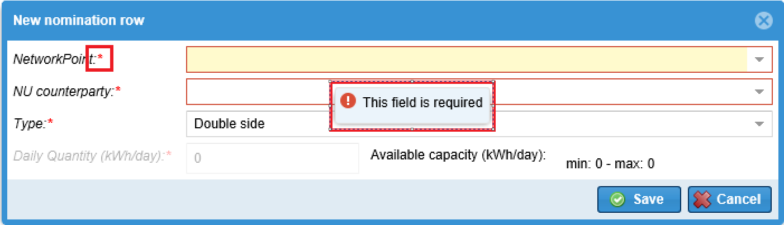
Enter mandatory fields in the pop up window:
- Network point: select network points from the drop down list the Network user has nominable capacity, or can be overnominated
- NU counterparty: shipper pair
- Type: in a default case the system offers double nomination submission, but you can also select single side nomination.
- Daily quantity (kWh/day): the total delivery demand for the given gas day
Information field:
- Nominable Capacity
  - minimum value different from zero: if due to a FDAUIOLI procedure the system set up a nomination minimum. This may happen in two cases:
    - in case the procedure is permitted at the point where the Network user has a capacity and the Network user nominated minimum 20% of the daily nominable capacity, then for the renomination period the minimum capacity to nominate will be 10%, and nomination cannot be lower than this limit.
    - In case the procedure is permitted at the point where the Network user has capacity to nominate and the Network user nominated less than 20% of the daily nominable capacity, in the renomination period the minimum capacity to nominate is half of the daily nominated capacity (nomination – (nomination/2)).
  - maximum value: the nominable capacity that is related to the Network user at the selected network point. If no point is selected, it is zero.
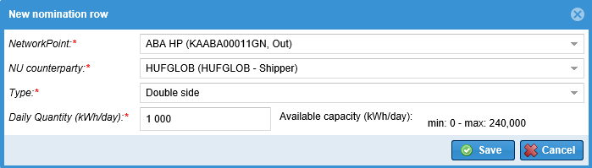
The new nomination row is created and can be seen in nomination modify window. The hourly nomination quantities are evenly distributed: according to the rules of rounding, and the rest is collected for the last hour. The rest distribution is calculated for the last hour, and with this the hourly quantity to be nominated can exceed the maximum that can be nominated for the hour, and in this case it cannot be saved.
If there is a nomination row for a given network point, type and shipper, the system does not let the user save data.
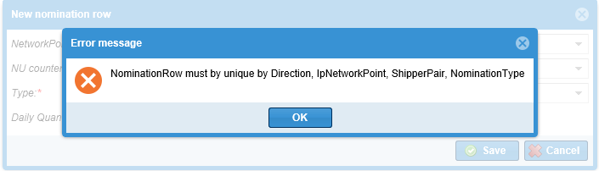
Restrictions for function availability:
This function is available within a running gas day too, however the daily quantity can no longer be edited, only after saving the row when the hourly distribution is edited.
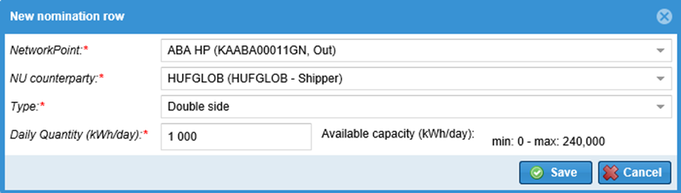

Edit nomination row
Open Balancing portfolios view and click a portfolio. Select “Modify” function on the given portfolio view screen. Click “Modify”.
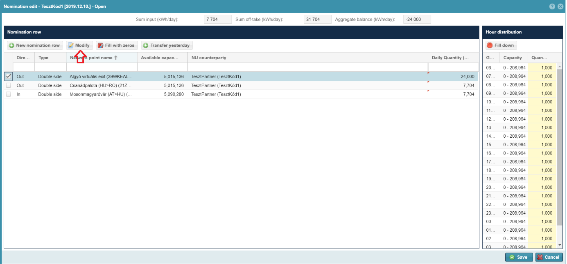
Change the required data in the Nomination modify pop up window then click “Save”.
Enter mandatory fields in the pop up window:
- Network point: cannot be changed only in case of portfolio version zero. Should you want to change a network point, use New row function
- NU counterparty: shipper pair
- Type: in a default case the system offers double side nomination submission
- Daily quantity: the total delivery demand for the given gas day
Information field:
- Nominable Capacity
  - minimum value different from zero: if due to a FDAUIOLI procedure the system set up a nomination minimum. This may happen in two cases:
    - In case the procedure is permitted on that day and the Network user nominated at least 20% of the nominable capacity. Then the minimum capacity will be 10%, and nomination cannot be decreased under this.
    - if the procedure is permitted at the point and the Network user nominated 20% of the nominable capacity. Then the minimum nomination will be – (nomination/2).
The rest distribution is calculated for the last hour, and with this the hourly volume to be nominated will exceed the maximum volume that can be nominated for the hour, and it cannot be saved.
  - maximum value: the nominable capacity that is related to the Network user at the selected network point. If no point is selected, it is zero.
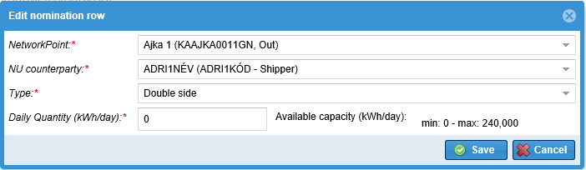
Changes can be seen in nomination modify window. The hourly nomination quantities are evenly distributed: according to the rules of rounding, and the rest is collected for the last hour.
Restrictions for function availability:
Within a running gas day this function is only available in version zero. In such cases the daily quantity can no longer be edited, only after saving the row when the hourly distribution is edited.
Within a running gas day and not in portfolio version zero this function is not available.
In the renomination period this function is not available only if there has been no change in the nominations. In this case with editing hourly distribution
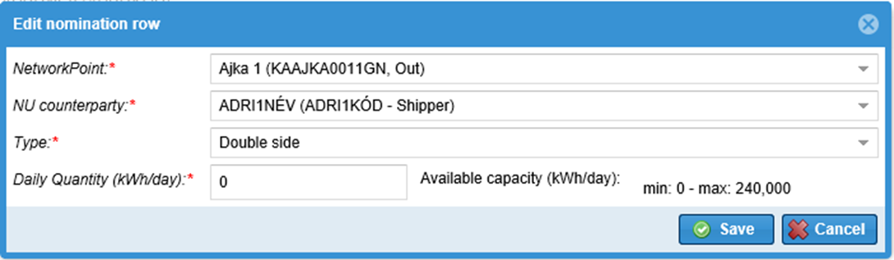
In such cases the daily quantity can no longer be edited, only after saving the row when the hourly distribution is edited.
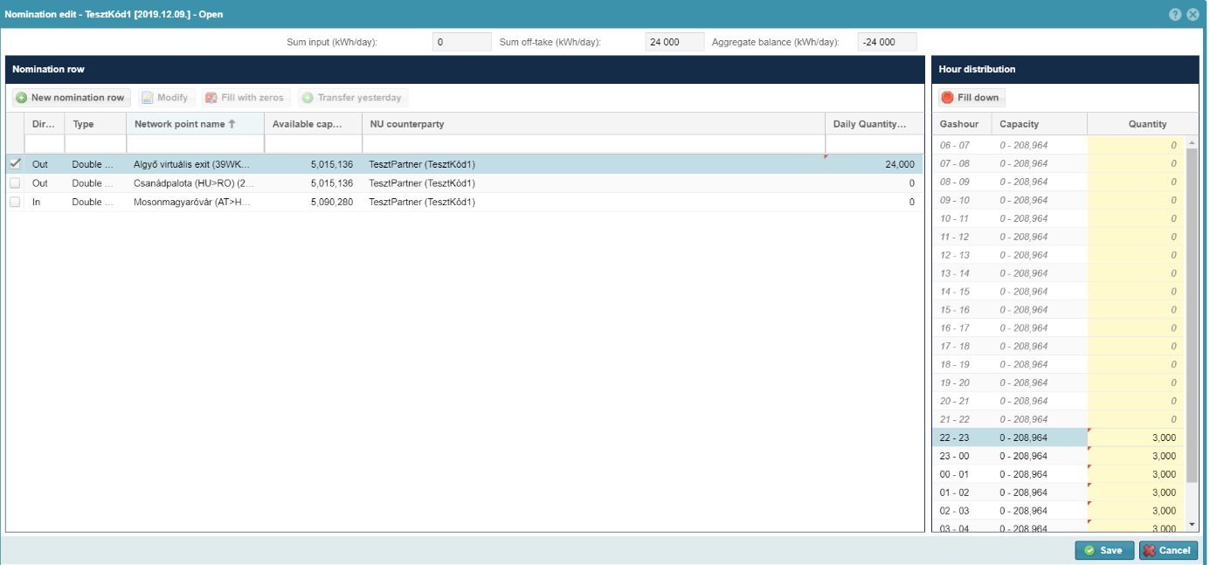
Any changes in the system will have a red triangle in the top left corner of the field.
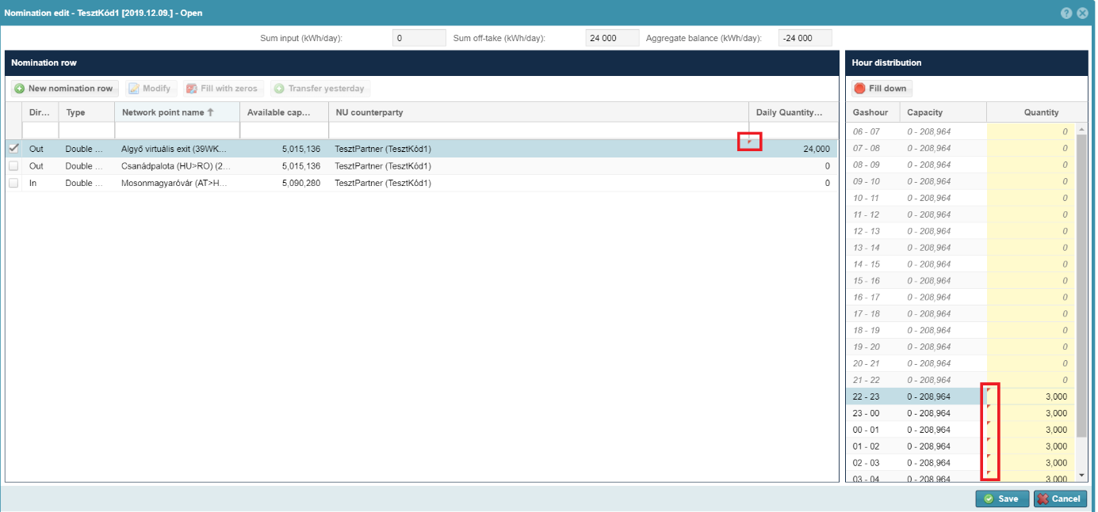
In case of a quantity mismatch (e.g.: higher than the nominable capacity) the field value resets to zero and the cursor moves out of the edit function.
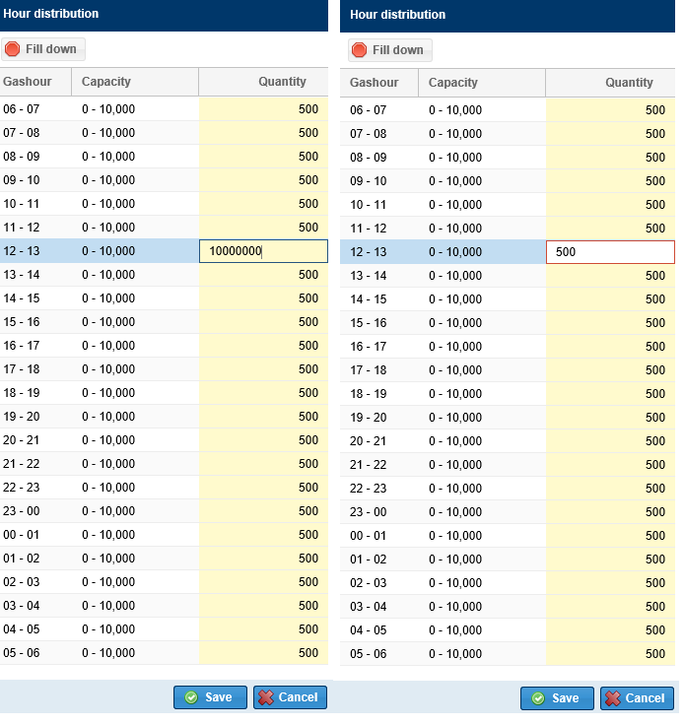

Fill nomination row with zeros
Open Balancing portfolios view and click a portfolio. Select “Modify” function on the given portfolio view screen. Click “Fill with zeros”.
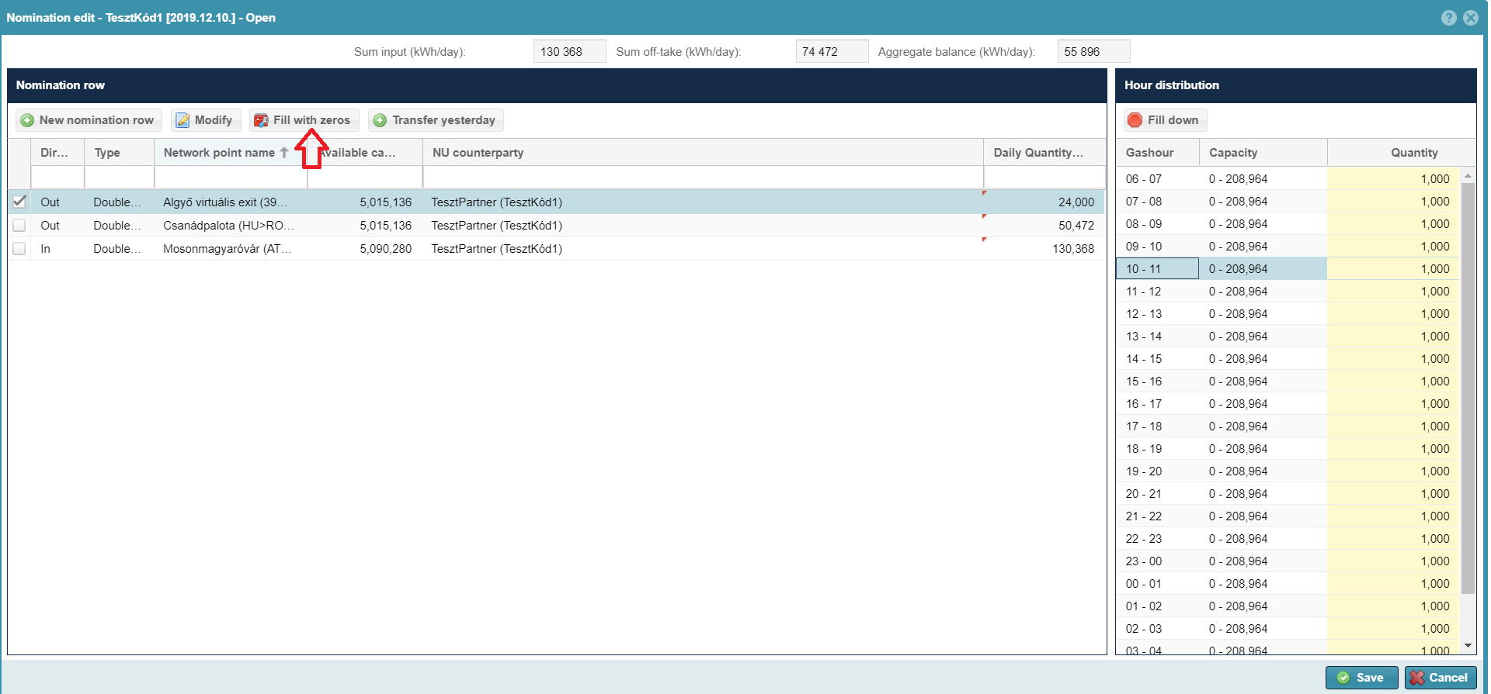
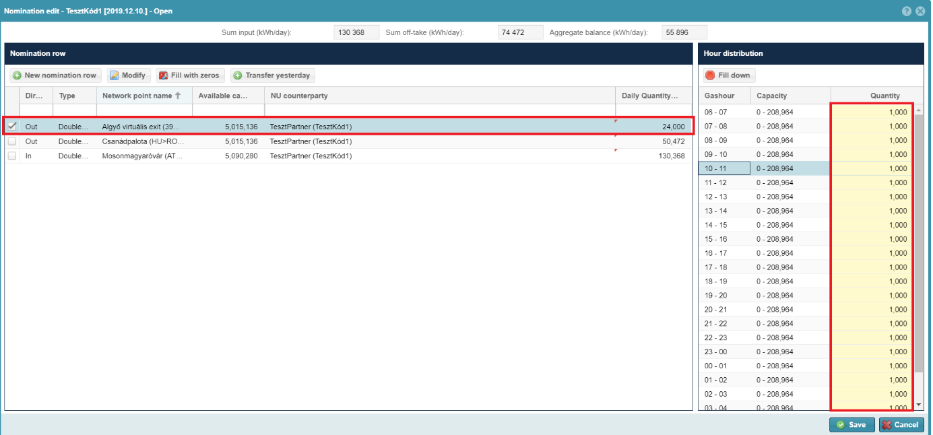
The nomination row value data will be zero. But this row will not be deleted.
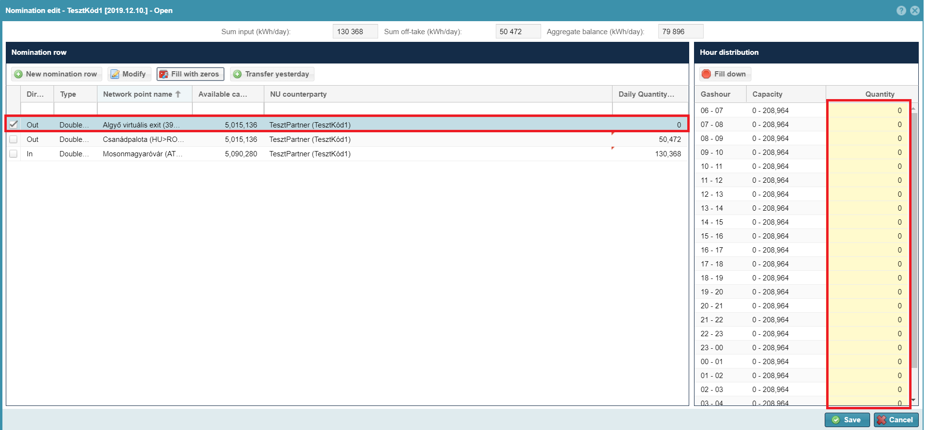
If at least one closing procedure was run for the given day, this function is no longer available. That means the renomination period.
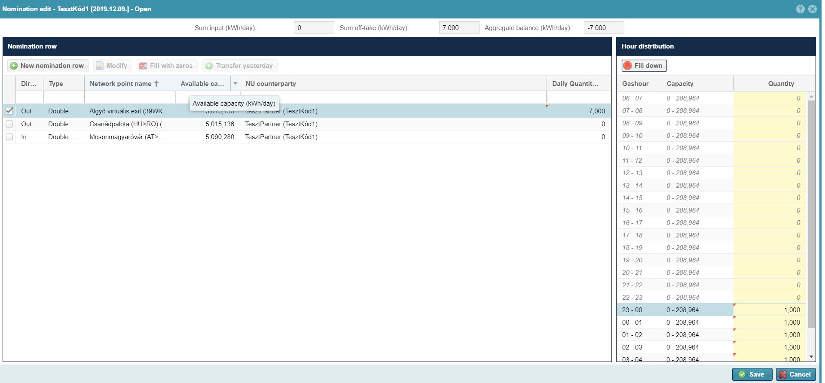

Edit hourly distribution
Open Balancing portfolios view and click a portfolio. Select “Modify” function on the given portfolio view screen.
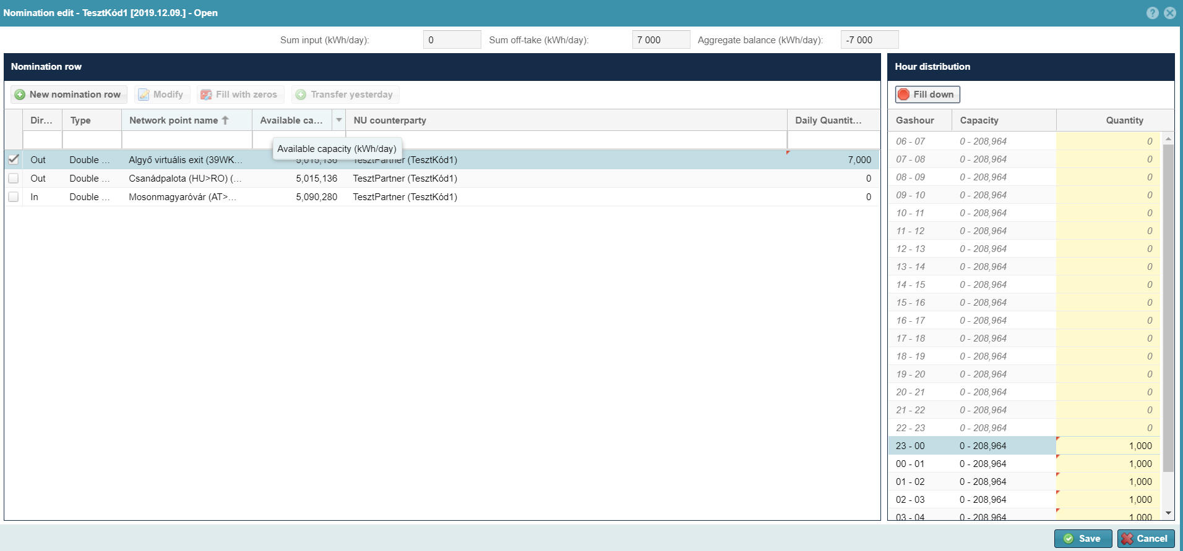
Select a nomination row from the view, then in the hourly distribution select time and write the Nomination quantity in the column. Click save to import nomination row hourly quantities to the database.
If the quantity has a mismatch with the nominable capacity, then hit ENTER or upon clicking another hourly value in a cell the field value resets to zero.
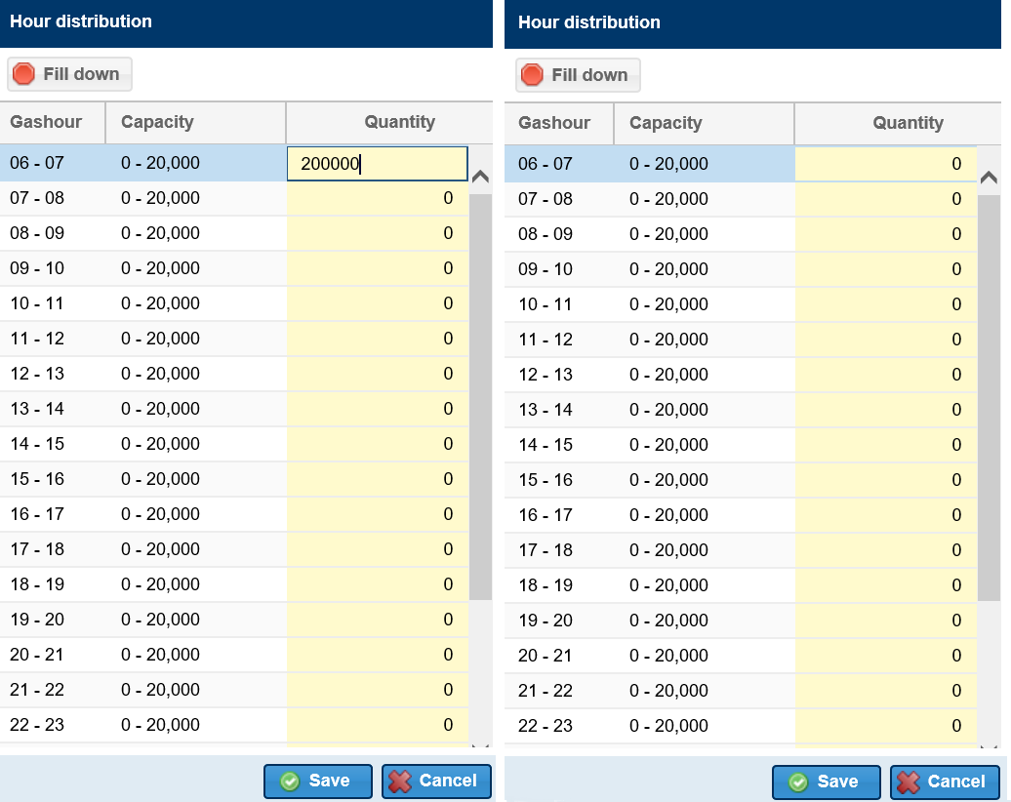
From the start of the hourly closing the hourly volumes can no longer be changed, therefore in the hourly distribution the daily quantity can be changed in maximum 2 hours prior to starting the given hour. Rows that cannot be changed are gray and italics and the cell cannot be edited.

Fill down
Open Balancing portfolios view and click a portfolio. Select “Modify” function on the given portfolio view screen.
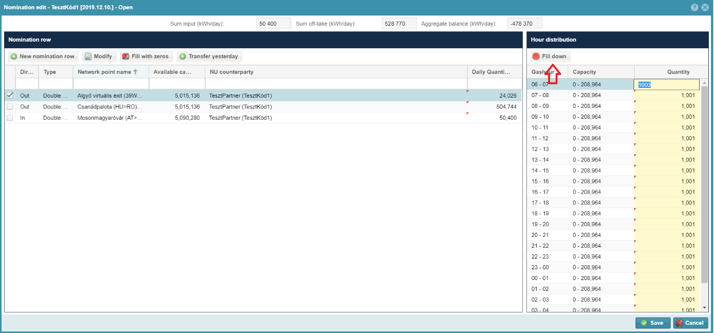
Select a nomination row in the view, then in the right of the screen in the hourly distribution enter the requested amount to the Nomination quantity column. Click “Fill down”. Then as an impact of this function the system will fill out the nominated hourly quantity from the given hour to the end of the day. Quantities can also be edited row by row, so you may change volumes at a given time easily.
Click Save to save volumes and the Daily quantity will become the total of hourly quantities.
If the Network user is in WDO violation based on the imbalance of his/her portfolio, the system displays the [IN0089] error message, but the process can continue. “The portfolio to be saved has been identified as having a resource shortfall above the imbalance limit based on the submitted nominations. The resulting potential nomination cutback can be achieved by reducing the portfolio's resource shortfall!” (In addition, an email message will be sent to the network user with the template NZ0019.)

In case of a quantity mismatch (higher than the nominable capacity) the field value resets to zero and the cursor moves out of the edit function.
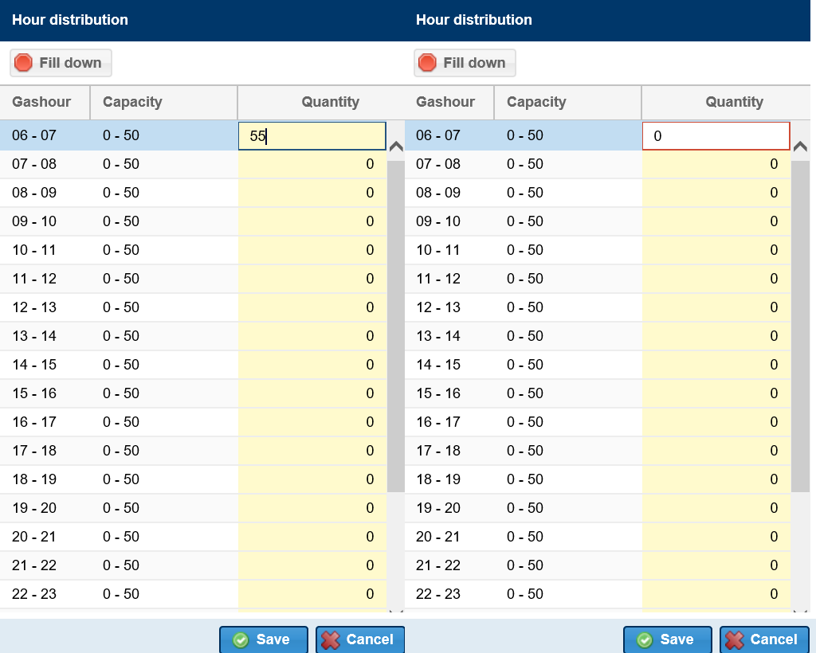
The system handles the value as per the rounding rules if it is not a round figure.
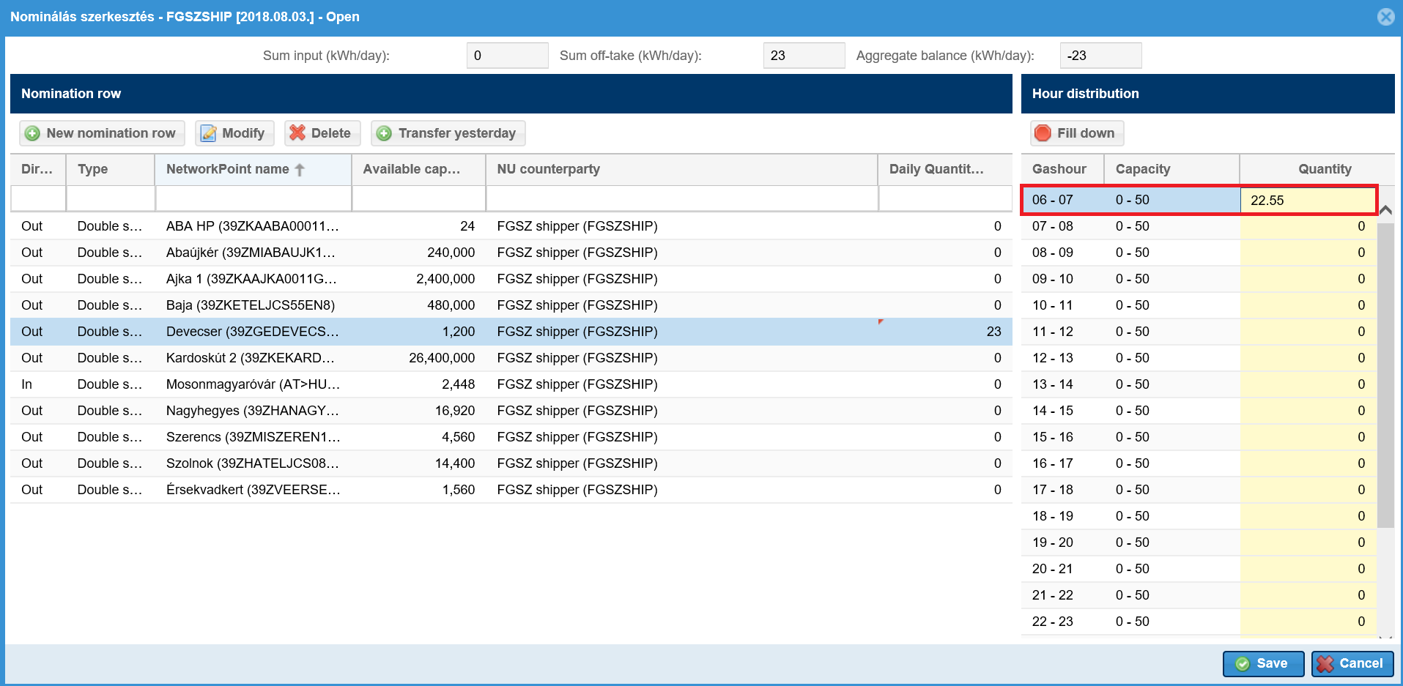
If you use the button Fill down and it does not meet the nominable capacity, the field value resets to zero.
Restrictions for function availability:
In the hourly distribution the daily amount can be changed maximum 2 hours before the start of the given hour. Rows that cannot be changed are gray and italics and the cell cannot be edited, Fill down is not active.

Transfer yesterday
Open Balancing portfolios view and click a portfolio. Select “Modify” function on the given portfolio view screen. In the view field click “Transfer yesterday” function.
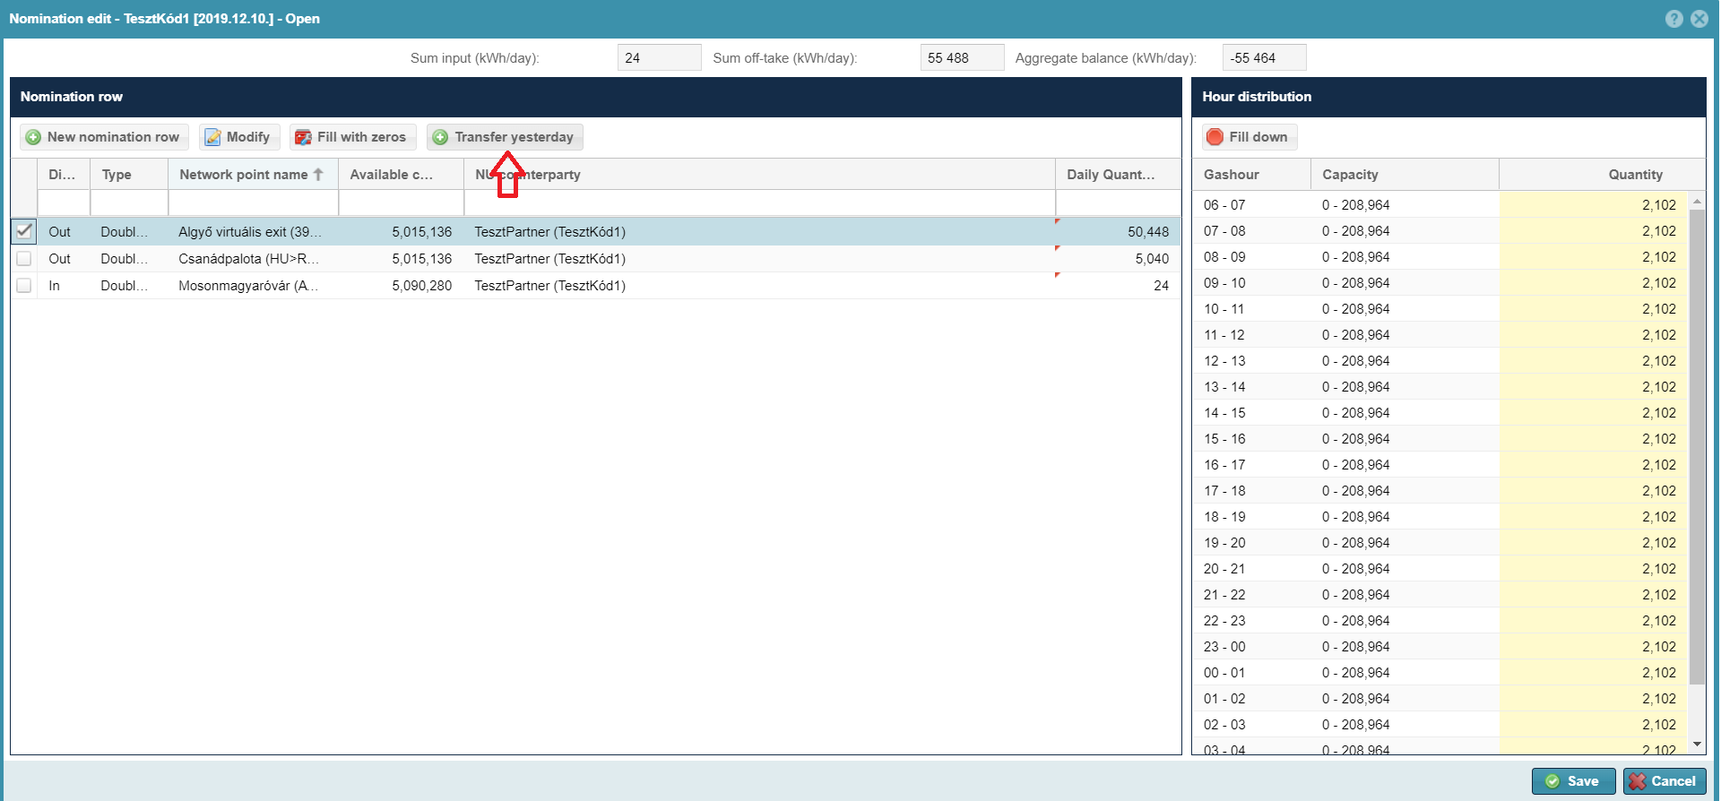
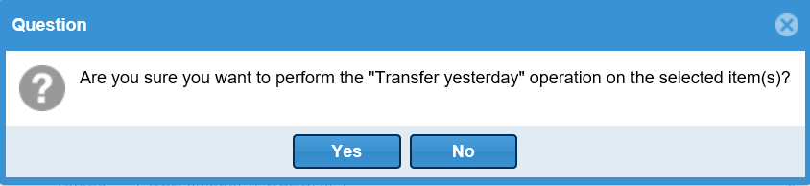
After approving the confirmation question the nomination row values will be changed. Previous day delivery demand is uploaded to the same network points with RH partners. Click save at the bottom of the nomination modify window to import volumes to the database.
If at least one closing procedure was run for the given day, this function is no longer available.
In case the portfolio of the previous day includes multiple nomination points they will also be loaded over, but saving the portfolio is not possible, as no volume can be entered that exceeds the available nominable capacity. The system sends an error message and does not let the user save this amount, only if the overnomination is possible at the given point with the given user.
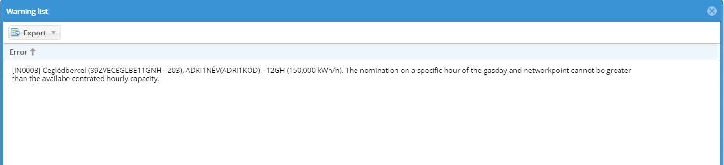
Restrictions for function availability:
This function is not available during a running gas day.

Export nomination rows
Open Balancing portfolios view and click a portfolio. Select “Nomination export” function on the given portfolio view screen. The system opens or saves the Excel file after the confirmation of the question (depending on your choice), and the file includes the nomination data that belongs to the latest portfolio version. The file name is the following: NOMINT-[Shipper code+portfoliodate:yyymmdd]-[portfolioversion]
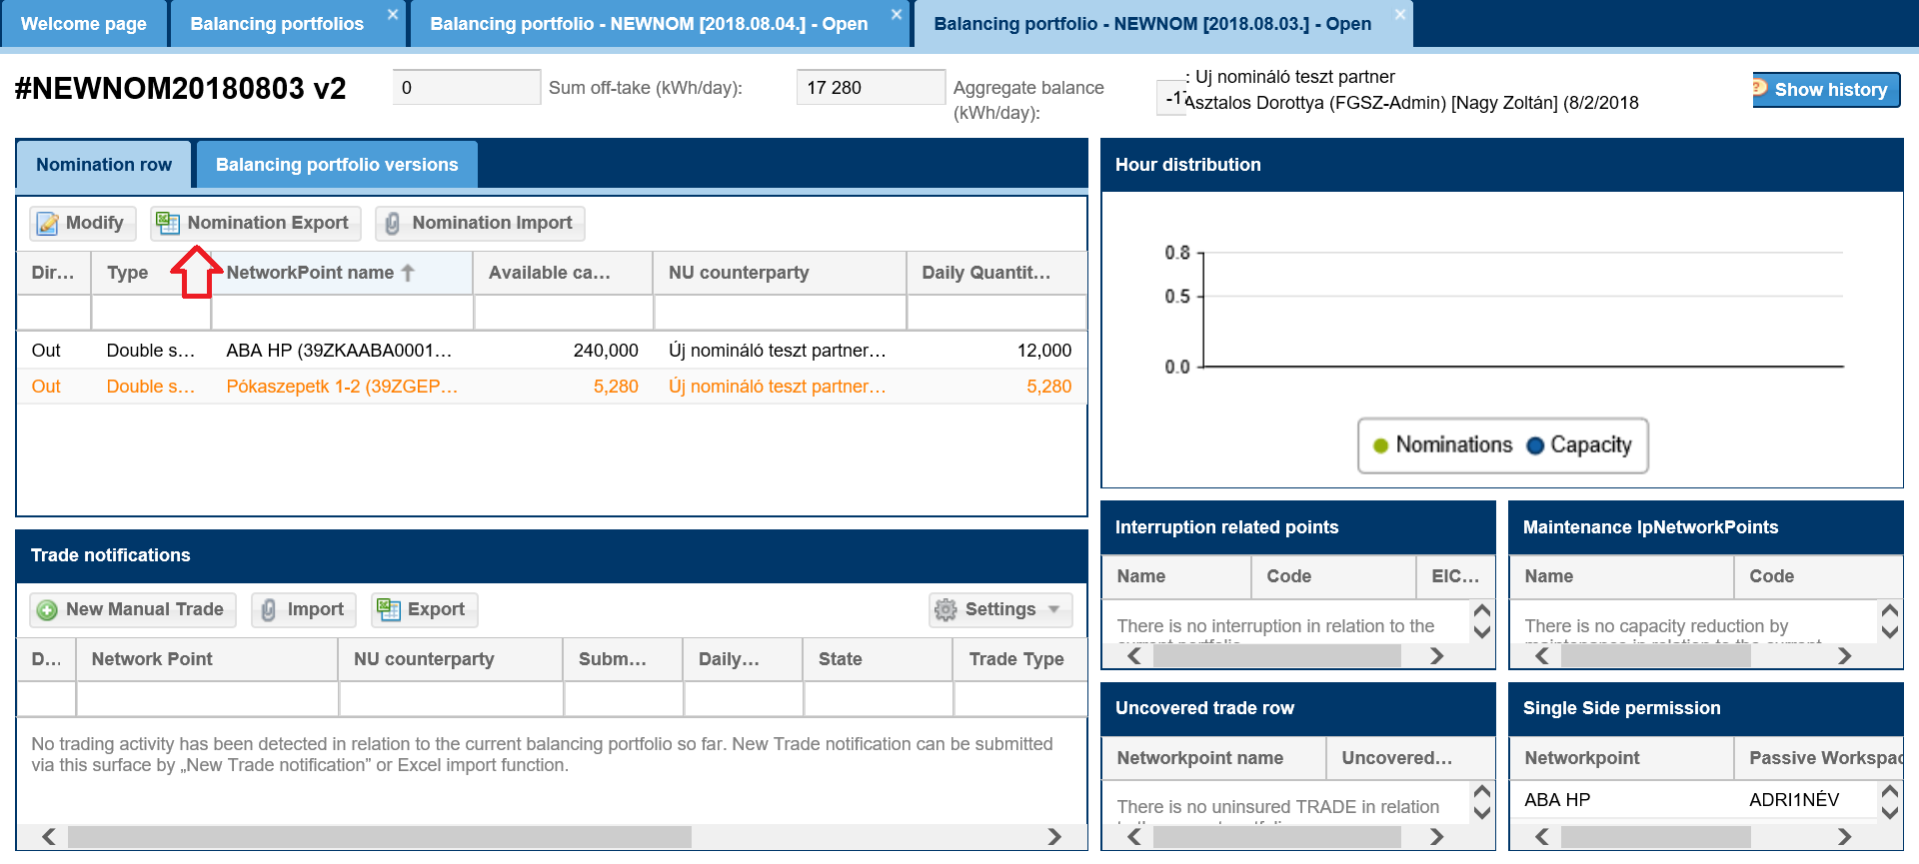
In the generated excel there are two worksheets Info and NOMINT. Info worksheet includes general information, and actual data contents is saved in the NOMINT worksheet in an hourly distribution.
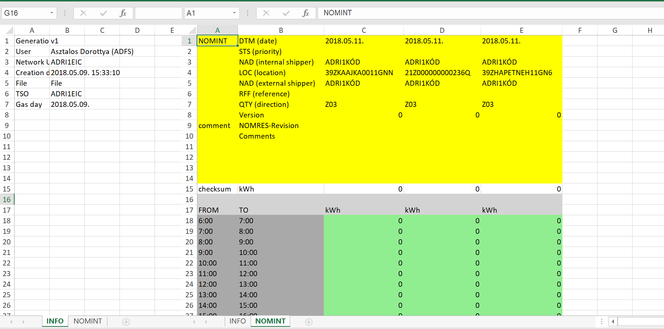
If there is no nomination the number of records in the Excel will be the valid capacity contracts for network points on the given day, but the hourly data will be zero.
Restrictions for function availability:
This function is always available. This function is not the same as the Export function in the Settings function!

Import nomination rows
Open Balancing portfolios view and click a portfolio. Select “Nomination import” function on the given portfolio view screen. The Import function of the nomination rows will receive the Exported Excel with the appropriate version number. The system cannot receive the same NOMINT document twice. Filling out the Info worksheet in the NOMINT file is not mandatory. File names are optional, but authenticity check is according to names.
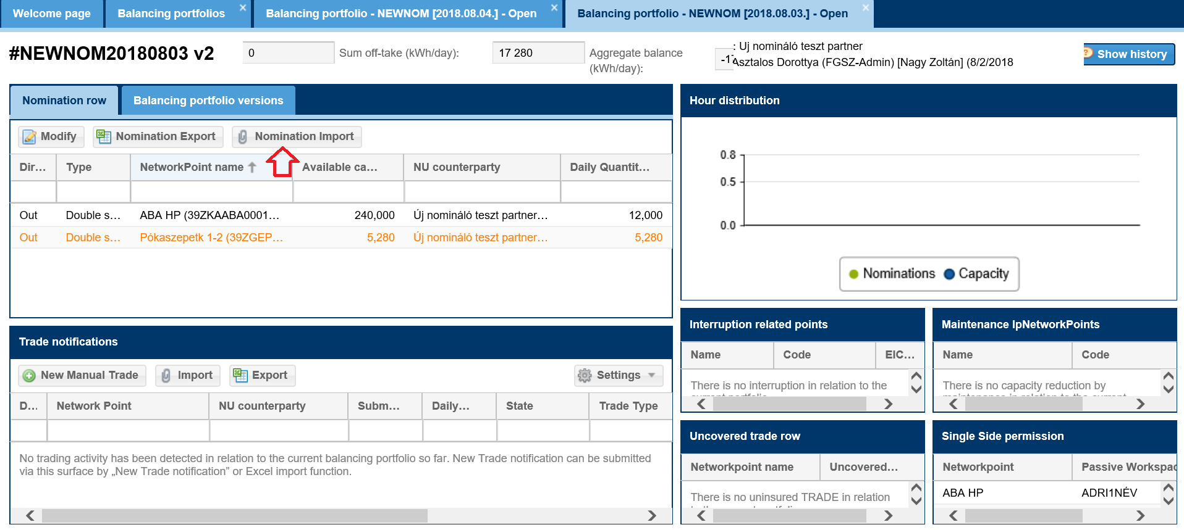
After this you will see an "Import nomination " window that allows you to select the file you want to load.
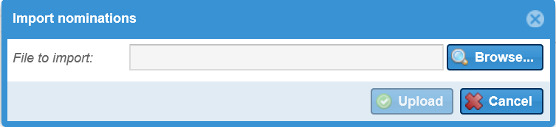
The new portfolio version only includes nominations that were part of the Excel. If a row is not present in the new file, but it was part of the portfolio, the nominated value will be zero.
When clicking “Upload” function button, the system will run form and contents check for excel. Contents checks are the same as logical check with Modify a nomination function.
Data are saved in a new version of shipper daily portfolio.

Fault possibilities
- Should the check find any form and/or contents faults, the system will inform the user via the “Nomination import results” screen in an error message. In such cases data are not saved.
Form check fault:
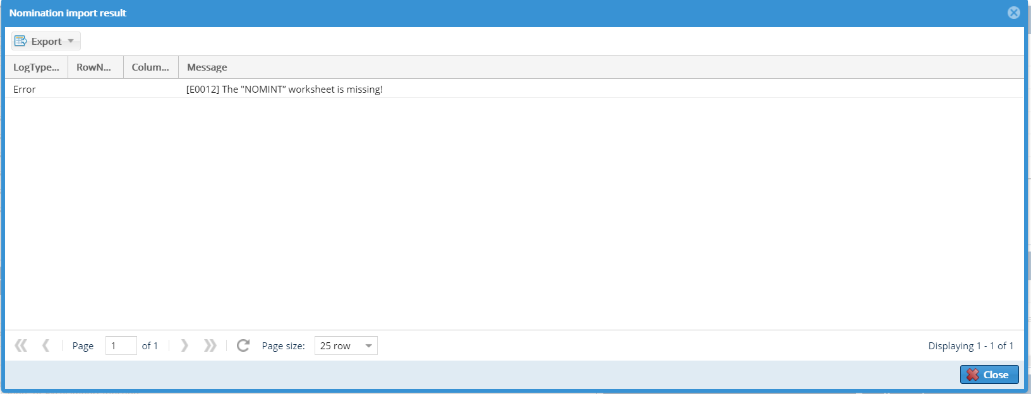
Contents check fault:
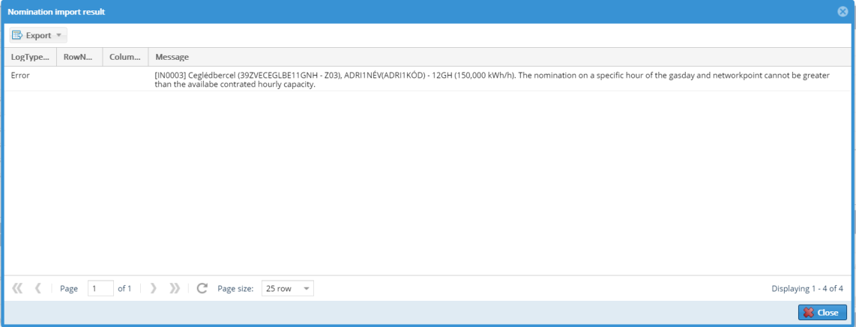

- Notification message not preventing saving.
If you wish to import data click “Confirm and continue”.
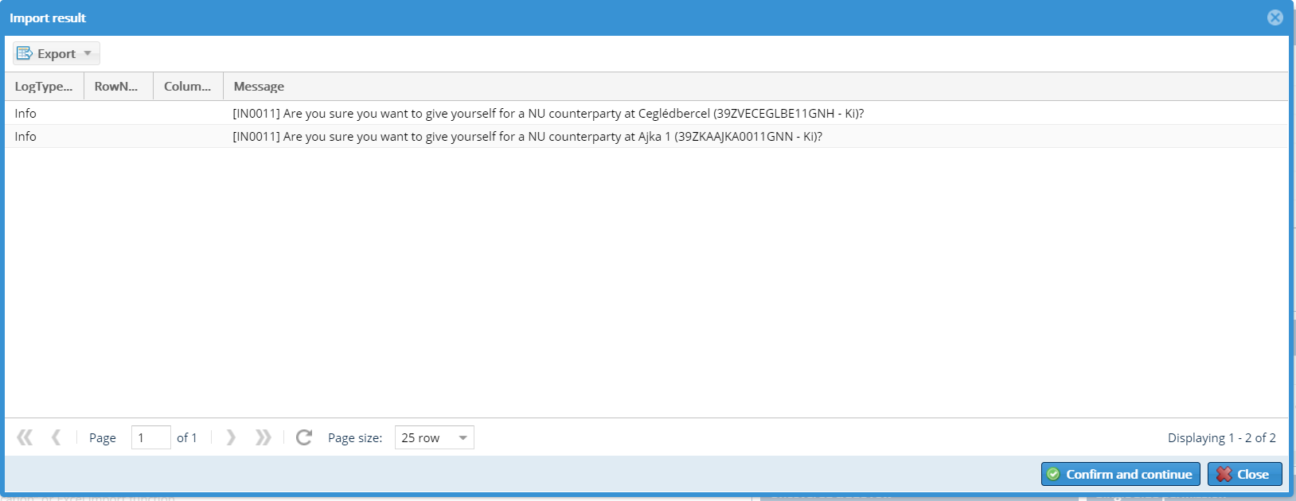
For instance if you wish to enter yourselves as Network user partner. Click “Cancel” and data will not be saved in the database and we can load the file again or “Accept and continue” import to save data.
You may export nomination import results in xlsx, csv, xml, html, json formats. This describes in what row of which column and the possible problem.
In xsls format this looks as follows:
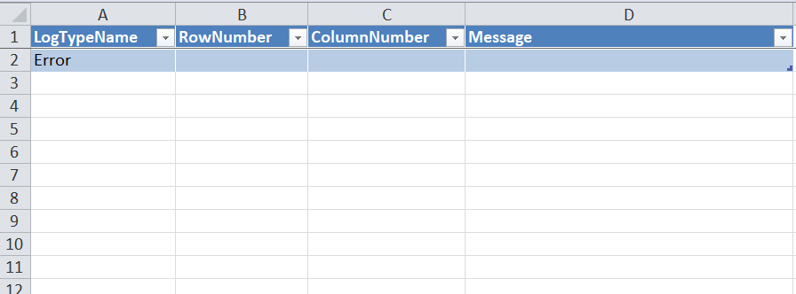

Structure of the to be imported Excel
In the Excel on Info worksheet this field is not mandatory, the system does not run controls for these fields.
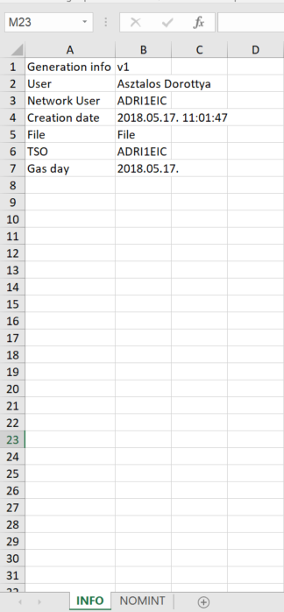
On NOMINT worksheet nomination rows have columns. The following data are to be filled out:
- DTM (date) - the time of the given gas day and it has to be the same as the relevant portfolio day
- NAD (internal shipper) – a the Network user owner code
- LOC: network point EIC code
- NAD (external shipper) - Network user partner code
- QTY (direction) – network point direction with edigas codes: Z02-in, Z03-out
- Hourly quantities in kWh/h
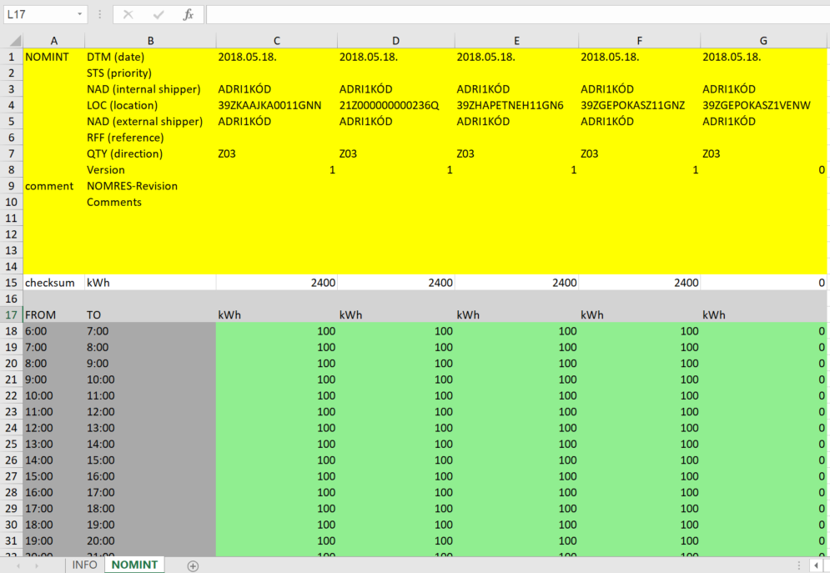

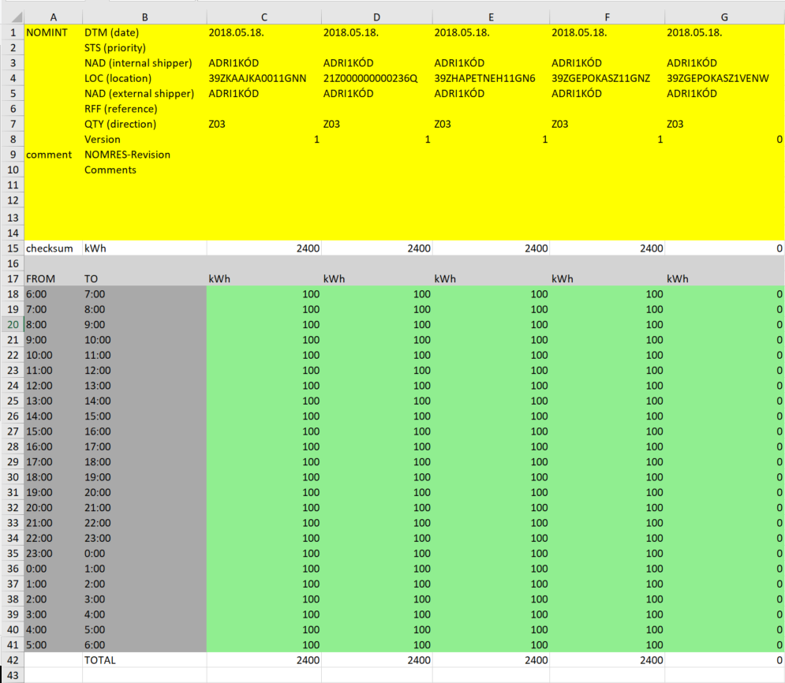

Single side nomination
Open Balancing portfolios view and click a portfolio. Select “Modify” function on the given portfolio view screen.
Then on the nomination modify screen click “New nomination row” or click a row and edit it.
Enter the mandatory fields in the pop-up window and select Type Single side and click Save.
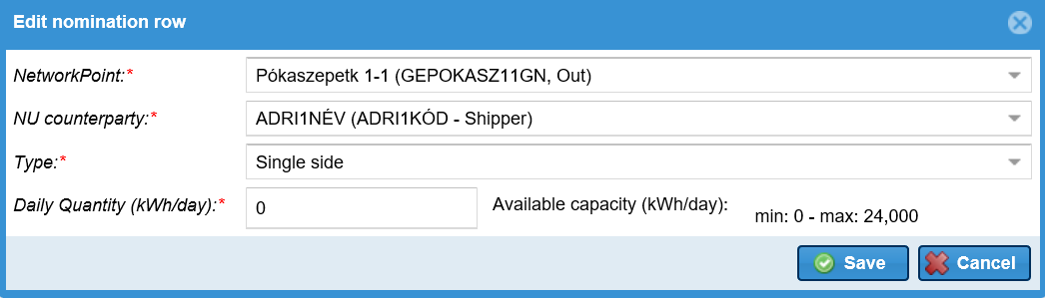
The system saves changes with clicking Save.
Via single sided nomination it is not possible to overnominate.
Restrictions regardig function availability:
The Network user has a single side nomination permit. Use single side authorization tile to view authorizations.

Submitting overnomination
A special double side nomination is via immediate capacity purchase.
The shipper can nominate in the system in addition to the nominable capacity, if it has permission and overnomination is permitted at the network point (overnomination point). And it is also possible to nominate for an overnomination point for which it has no nominable capacity.
Open Portfolio management menu Balancing portfolios view, click a portfolio, or use a given balance portfolios view to use “Modify” function.
In this portfolio only the rows with capacity will display, but rows with overnomination option are in italics and bold:
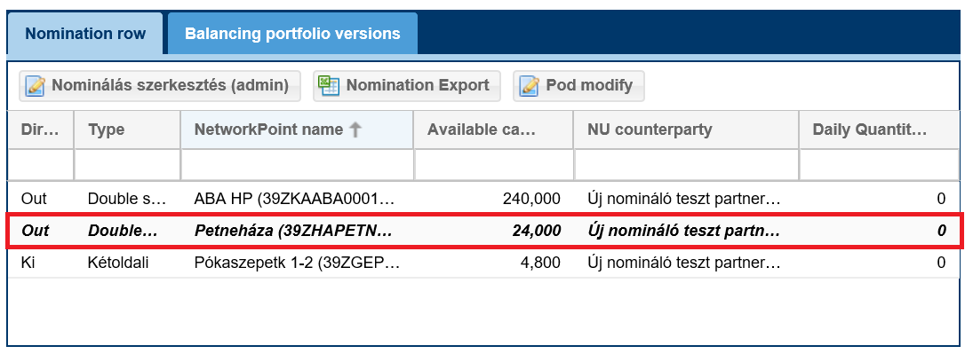
Edit nomination function and all its subfunctions work the same way at the double side nomination rows with the following extra option:
When a new row is added all overnomination points will appear to all overnomination permission partners at the Select network point field. If you selected a point with overnomination for which you have capacity the max capacity will be the point’s uninterruptible technical capacity.
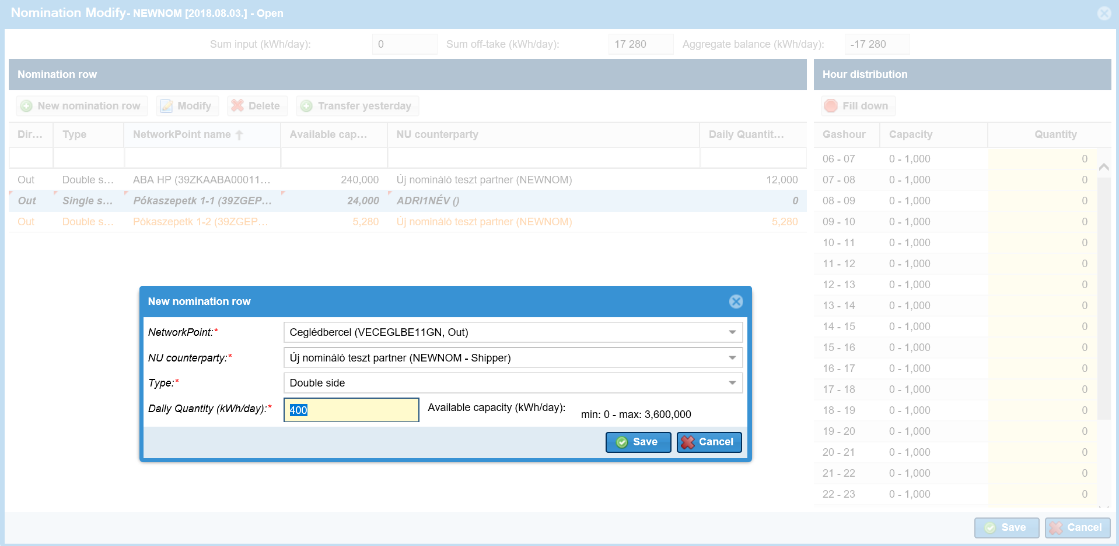
Usual checks will be carried out when edit nomination is saved.
Capacity purchase is confirmed by a special notification message. Save these rows by clicking “confirm and continue”.
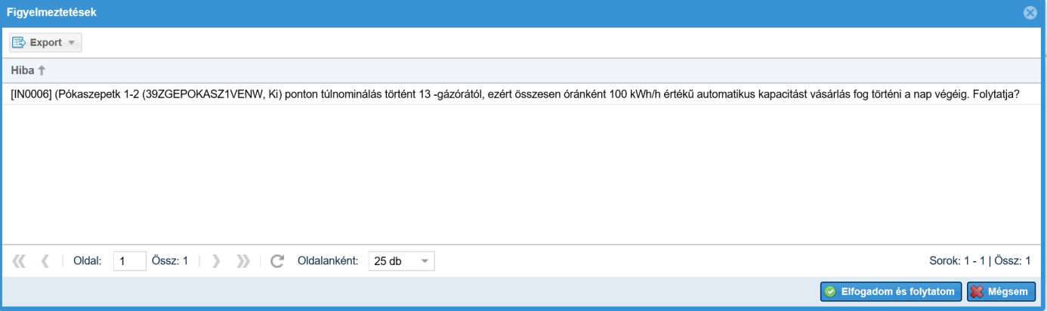
Overnominated rows in the portfolio will be orange:
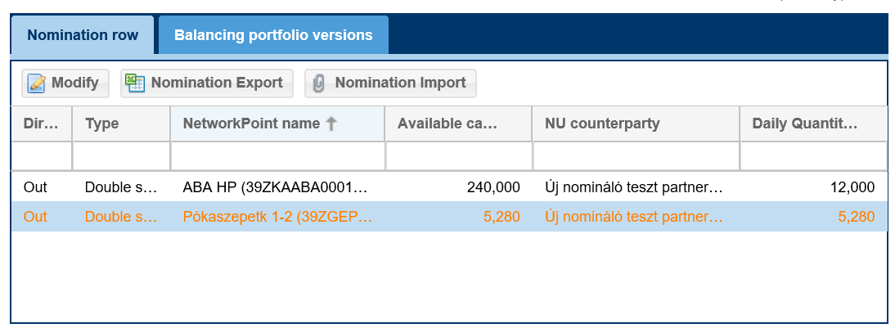
Restrictions regardig function availability:
Overnomination is possible for the next or the running gas day. Via single sided nomination it is not possible to overnominate.

Manage trade notifications
Shippers can transfer natural gas ownership rights to each other without transferring them through the network points. This is possible via recording a trade notification to the system. Trade rows are only considered in the portfolio balance, if the transferring party (seller) and recipient party (buyer) also recorded the transaction. Transaction notices from an external gas trading platform (for instance CEEGEX or KP) are part of the portfolio balance immediately.
It is possible to enter, delete or mark to withdraw notices 60 days before the actual gas day from 06:00 until the end of the gas day.
Transaction notices can be in the following statuses:
- Creation: A trade row created by a Network user, for which the NU counterparty has not yet created a transaction pair. This does not modify the portfolio balance. Can be canceled.
- Erase: This is a manual notification the Network user deleted before the Commercial Partner could also record the transaction. This does not modify the portfolio balance. No further operations are possible.
- Matched: A notification recorded by both partners and matched, where the Network user and NU counterparty volumes have parity. Allocated volume is part of the portfolio balance and can be marked for cancellation.
- Mismatch: A notification recorded by both partners and matched, where the Network user and NU counterparty volumes have no parity, so the smaller volume was allocated out of the two. Allocated volume is part of the portfolio balance and can be marked for cancellation.
- Marked cancel: A trade row recorded by both partners and matched, where the Network user marked for cancellation, and the NU counterparty has not. Allocated volume is part of the portfolio balance. No further operations are possible.
- Marked Cancel: A notification recorded by both partners and matched for cancellation by both. This does not modify the portfolio balance. No further operations are possible.
The system sends an email notification on all status changes to the NU counterparty, and increases the version number of the portfolio.

Recording manual trade rows
Open the selected Balancing portfolio View and click New Manual Trade on the Trade notifications tiles.
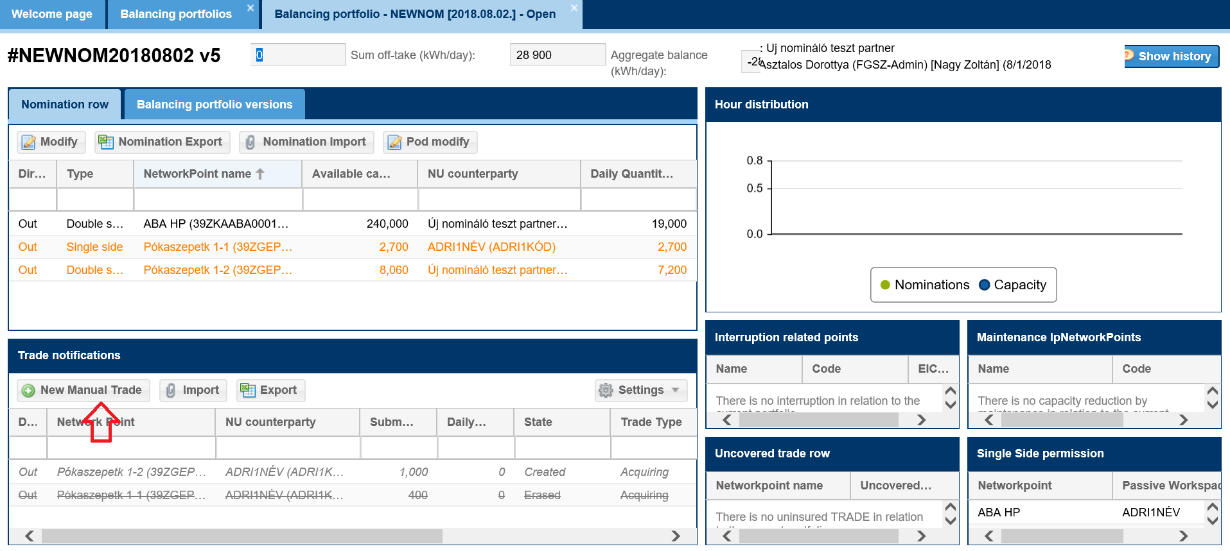
Fill out the mandatory fields in the window and save.
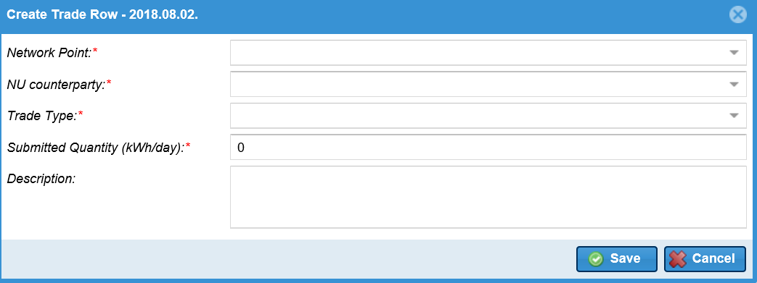
- Network point: network point to which the trading refers
- NU counterparty: the other Network user the transaction is made with
- Trade type: take over in case of a purchase, and hand over for sales
- Submitted quantity
- Description
When you save a trade row is generated with status “Created” and that will not change the portfolio balance. The NU counterparty receives an automatic notification of the total transaction.
If the Network user is in WDO violation based on the imbalance of his/her portfolio, the system displays the [IN0089] error message, but the process can continue. “The portfolio to be saved has been identified as having a resource shortfall above the imbalance limit based on the submitted nominations. The resulting potential nomination cutback can be achieved by reducing the portfolio's resource shortfall!” (In addition, an email message will be sent to the network user with the template NZ0019.)
If the maching takes place and the network user is still in WDO violation based on his/her portfolio, he will also receive an email message.

Core rule:
On a given gas day at a given network point to a given direction between the same Network user and NU counterparty only 1 trade row can be recorded in the system.
If the NU counterparty also records the relevant pair, the notification status automatically changes: Matched or mismatch and it will be part of the portfolio balance. If the NU counterparty found recorded a different volume, the allocated volume is in line with the smaller principle.
The system will not consider the direction at the MGP point.
The system checks the right to create trade notification. If the network user right to trade is suspended because of WDO limit violation the system will show the error message: [IN0087] The Creation rights of new Manual Trade notifications for {0}, of type {1} were restricted, due to lack of resources above balancing limit, and the trade can not be submitted.

Erase trade row
Open the selected Balancing portfolio. View and highlight a row and click “Erase” on the transaction notices tiles.
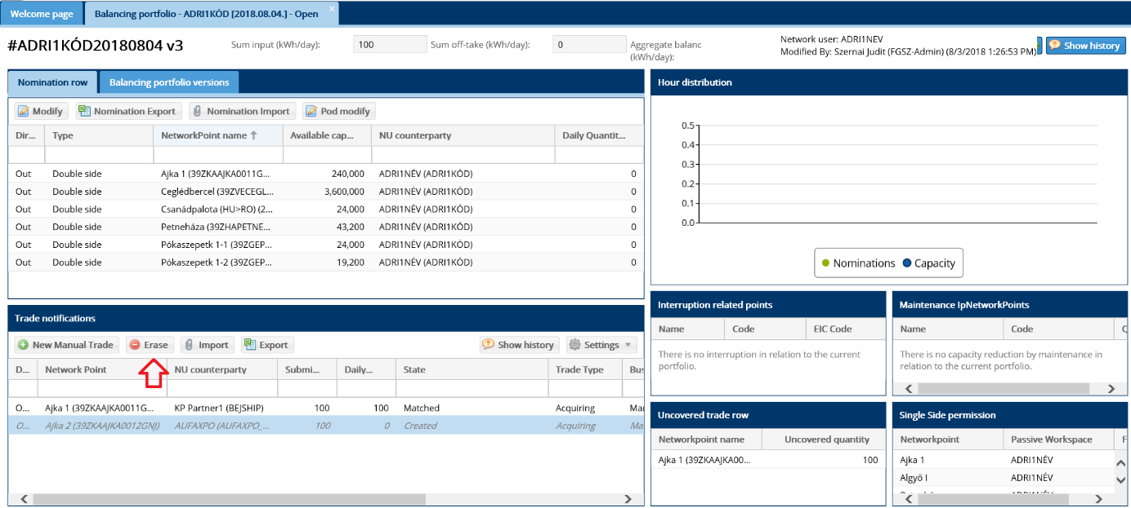
After the confirmation question the notification status changes to “Erased”.
The Commercial Partner receives an automatic notification of the total transaction.
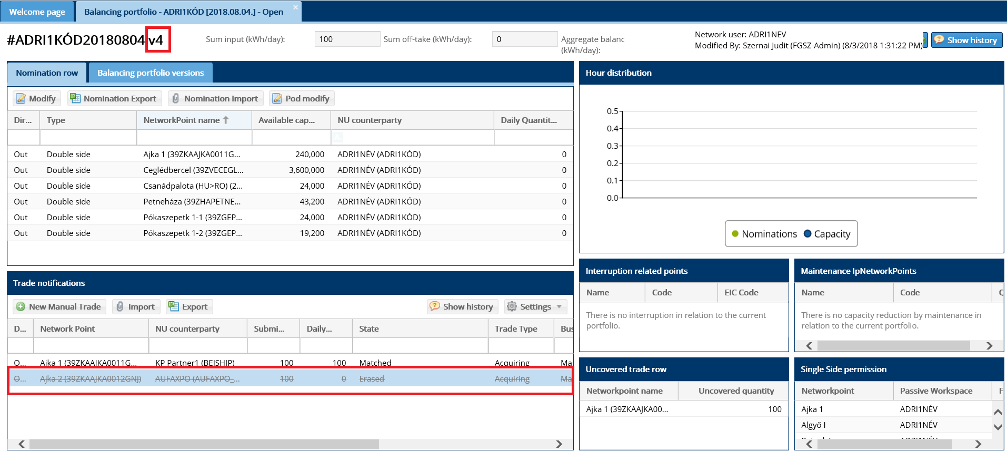
After you erased the transaction notification, this row is not deleted from the list, but text in that row is crossed out, and the font changes to gray color and the status changes to “Erased”. The portfolio version number increases.

Mark cancel trade notification
Open the selected Balancing portfolio View and highlight a row and click “Mark Cancel” on the trade notificationtiles from the Matched or Mismatched rows.
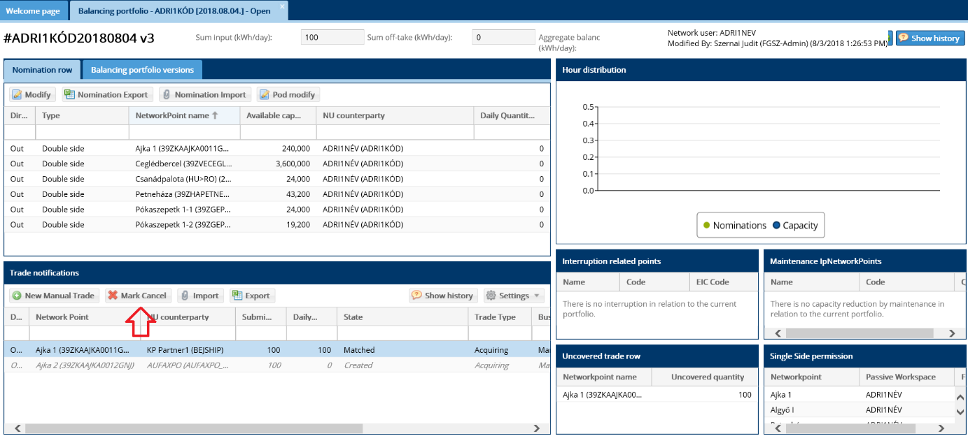
After selecting function and approving the confirmation question the system will examine if the trade notification pair is in “Marked Cancel” status. If yes, both transactions will change to “Erased” status. If not, the trade notification state changes to “Marked Cancel”.
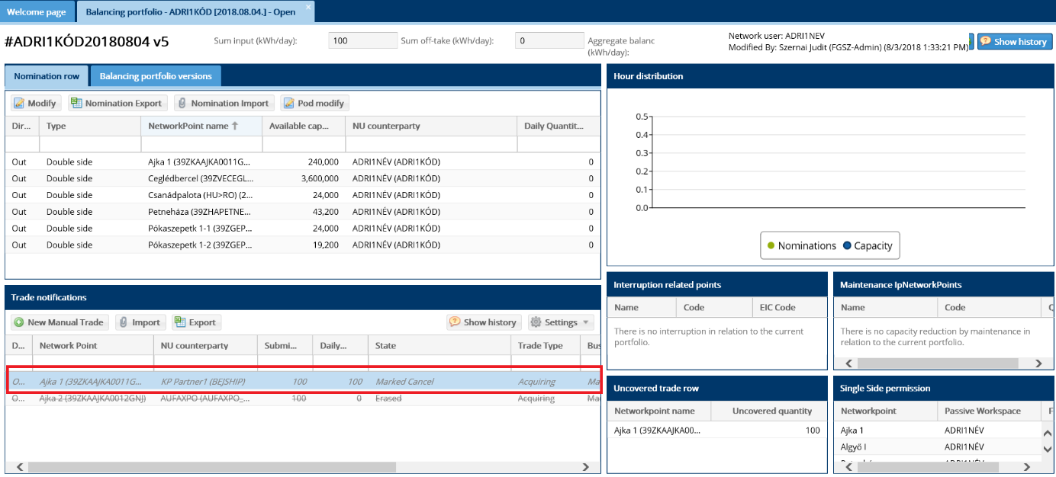
The trade notificationwhere the Marked cancel was approved will be gray and use italics.
It will be part of the portfolio balance until the NU counterparty marks its own trade notification for cancellation too.
The NU counterparty receives an automatic notification of the total transaction.

The system checks the right to cancel trade notification. If the network user right to cancel trade is suspended because of WDO limit violation the system will show the error message: “[IN0088] The Mark Cancel rights of new Manual Trade notifications for {0}, of type {1} were restricted, due to lack of resources above balancing limit.”

Trade notification Excel export
Open the selected Balancing portfolio View and click “Export” button on the trade notification tiles.
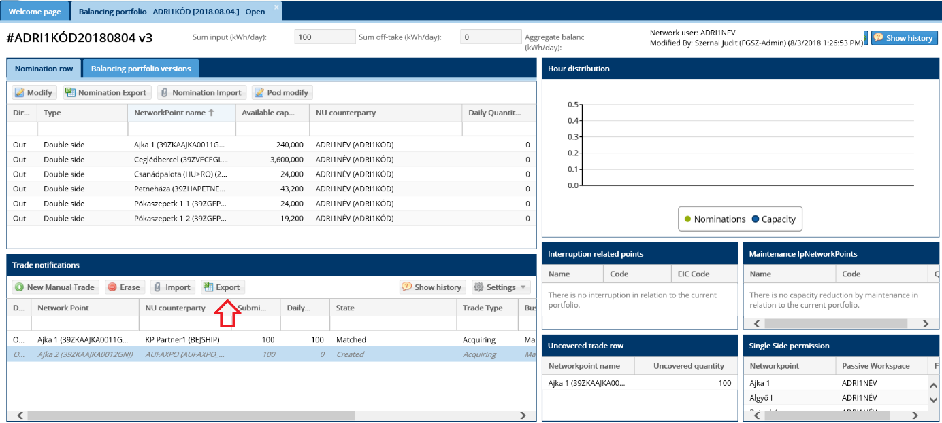
Upon the approval of the confirmation question the system will open or save the Excel file with the latest portfolio version trade notificationdetails.
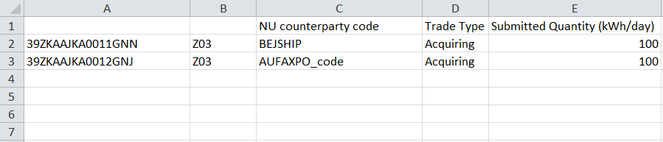

Trade notification Excel import
Open the selected Balancing portfolio View and click “Import” button on the trade notificationtiles.
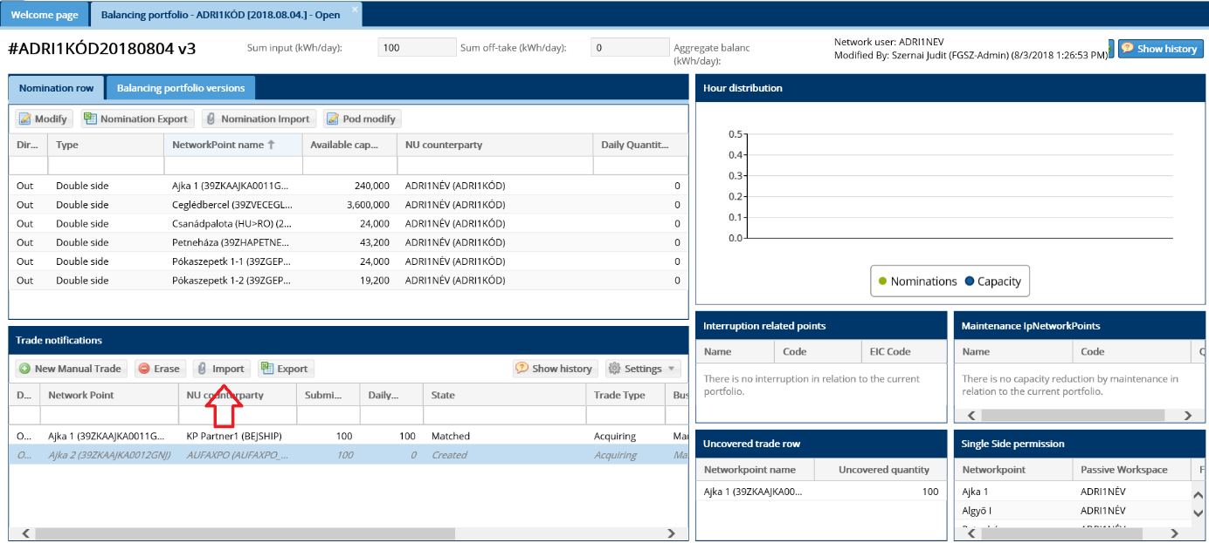
The “Import data” window will display and you can upload the file to be imported.
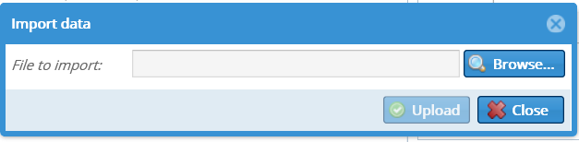
Then upon clicking the Upload button the system will make the necessary checks.
Excel fields:
Network point EIC code | Flow direction | Commercial Partner code | Transaction notice type | Submitted volume (kWh/day) | Comment
39ZKAABA00011GNE | Z03 | ADRI1KÓD | Transfer | 6000
The system will not consider the direction at the MGP point.
If no fault was found during the check, the trade notificationare saved and can be viewed in this chart. The checks will be the same as for the manual checks. The already Erased/Marked Cancel/Matched or Mismatch status notifications cannot be changed in excel.
If any mistake is found in the file to be uploaded, in a next window details will be displayed to the Network user on the “Import results” screen. In such a case no record will be imported to the database.
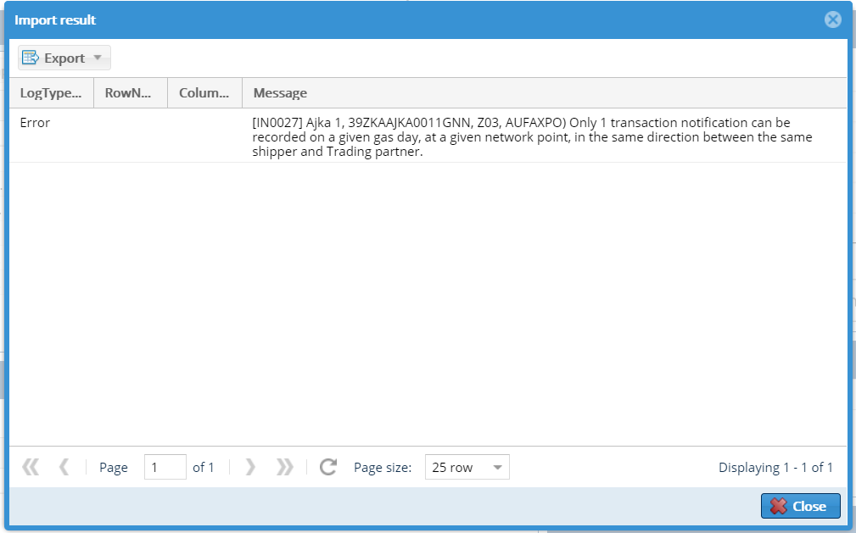
The list of faults displayed in the “Import results” can be exported upon clicking “Export”.

View Market transaction
It is available in three different way:
- In the daily balancing portfolio click on the link in the Source column of the traderow section. This detailed view is only for external trades.
- Open the Trade rows menu in the Portfolio Management menu, and click on the link in the Id column.
- Open the Market Transactions row menu in the Porftolio Management menu, and click on the link in the Id column.
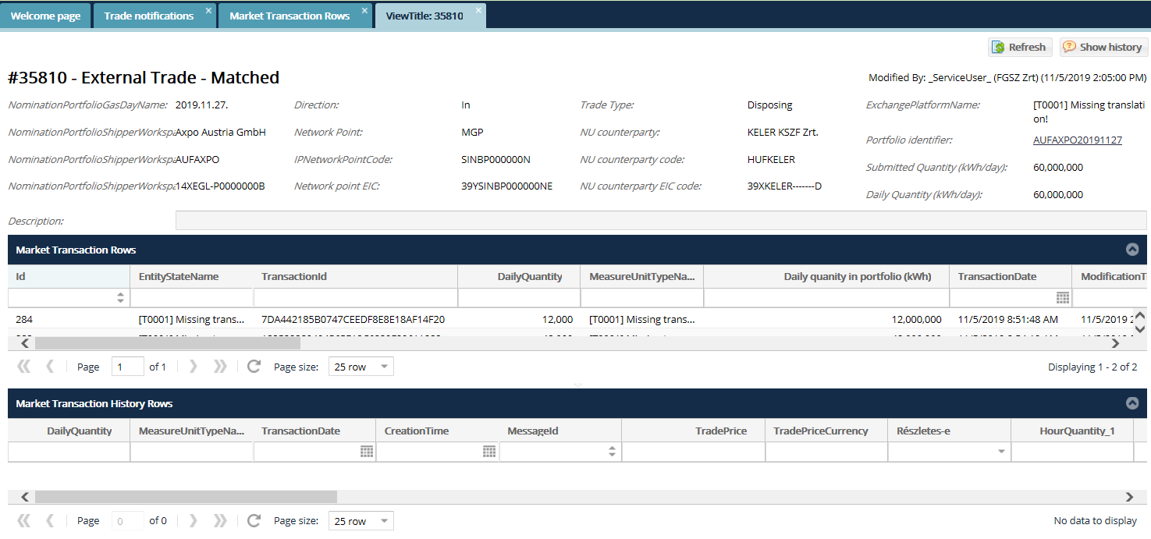

On the view of that external trade you can examine how many trades were sent from the source system, how many times has the data arrived and the hourly data can be seen as well.

RENOM cycle documents
Open the Portfolio Management menu RENOM cycle documents view. Network users can only see their relevant NOMRES documents.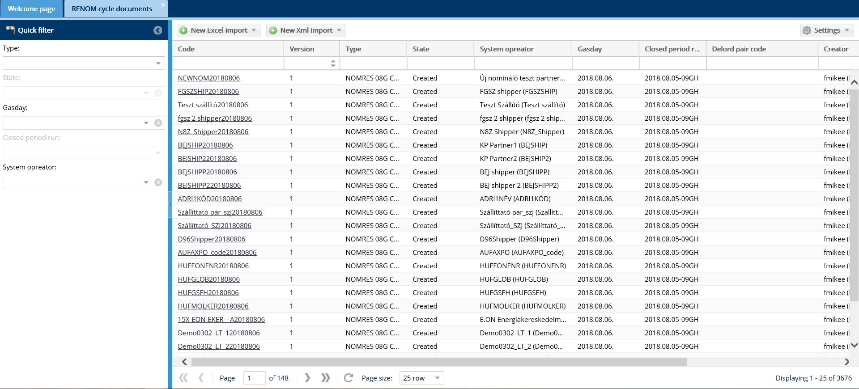
The NOMRES document list screen comes up.

View cycle documents
- In the system 3 types of NOMRES documents can be created as System User. NOMRES 07G processed: this includes the nomination row the Network usersubmitted in AS4
- NOMRES AND : a document including the actual and expected disconnections of the System User
- NOMRES 08G confirmed: the system creates this if due to a matching procedure the Network usernomination rows have changed
Open the Portfolio Management menu RENOM Cycle documents view. Click the required ID for the NOMRES document and the document data sheet opens a separate tab.
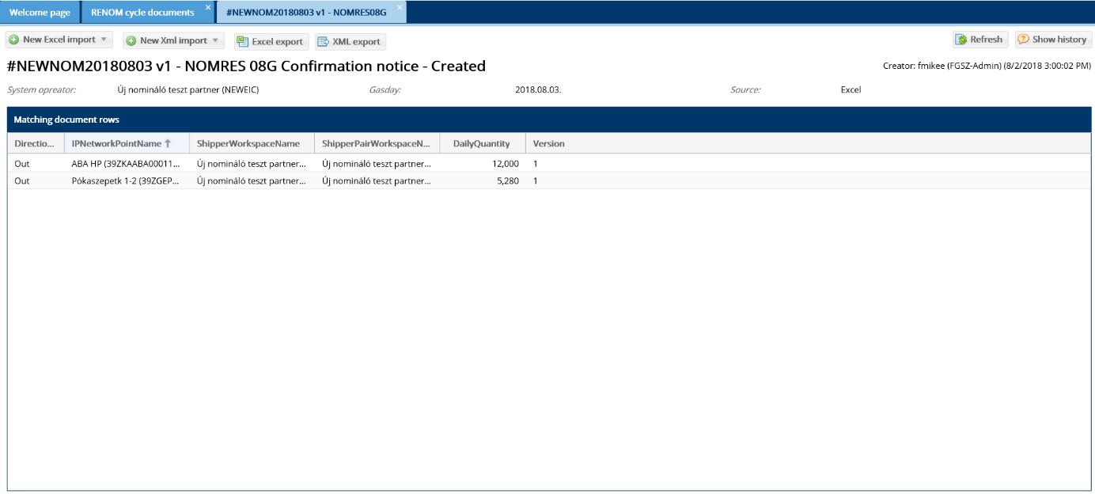
Document data can be viewed.
Click a NOMRES document to access two functions Excel Export and XML Export with the relevant buttons.

Nomination rows
Open the Portfolio Management menu Nomination rows view. Network users can see all their nomination rows. You can select the gasday or the closed periods.

Trade notifications
Open the Portfolio Management menu Trade notifications view. You can see all your manual and external trades. You can select the gasday or the closed periods.
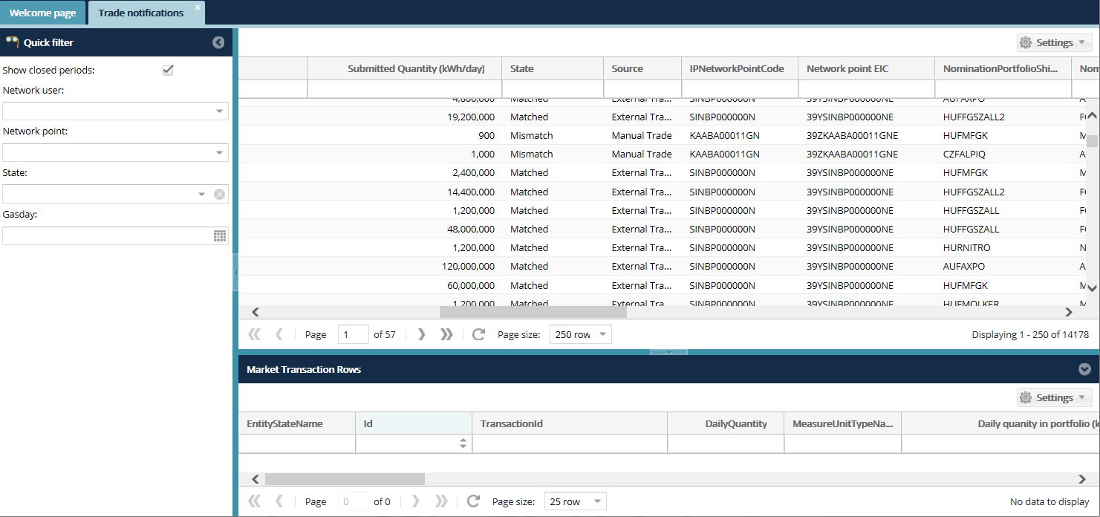

Market transaction rows
Open the Portfolio Management menu Market Transaction Rows view. You can see all your external trades, and examine how many trades were sent from the source system. Click on a Market transaction row and see in the lower table how many times has the data arrived and the hourly data can be seen as well.
You can select the gasday or networkpoint.

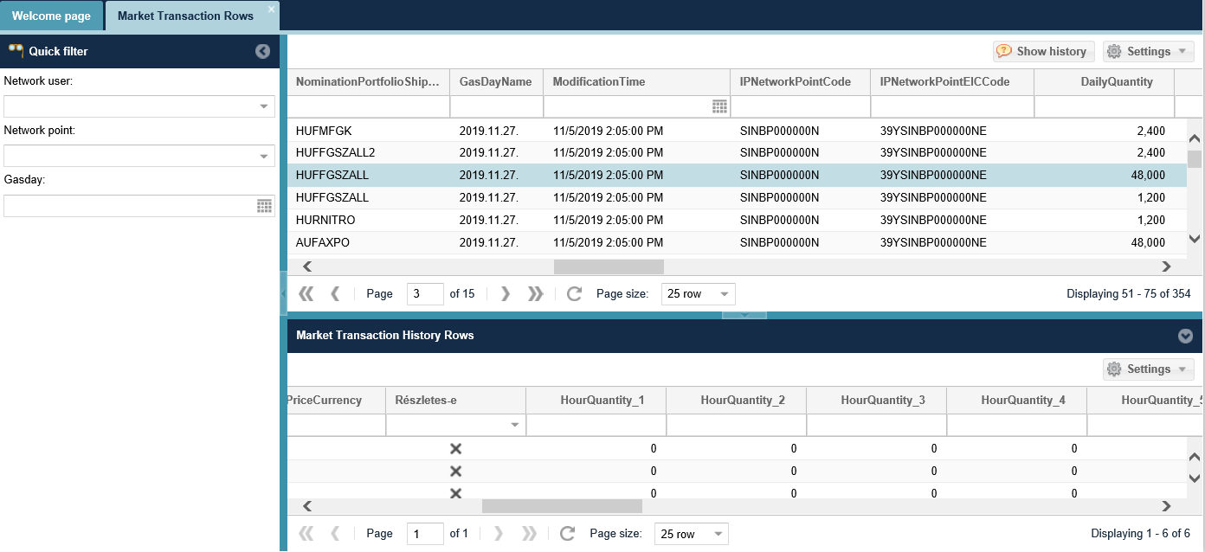

Within day obligation notifications
Once a WDO has been identified, affected system users will be notified by e-mail (NZ0016) WDO notice.

The message will be sent as follows:

1. It will be sent every hour between the re-nomination period and the start of the gas day (D-1 between 14:00 and D 06:00)
2. In any gashour on the gasday, after the WDO investigation.
3. The WDO was resolved within a gas day.

The system then also sends a message to the affected system users about the WDO limit violation measures. ((NZ0017) Notification of WDO actions)
Note: From the beginning of the 1st gas hour of a gas day (from 06:00 CET), the measure due to WDO violation comes into effect if the fact of WDO violation exists in two consecutive gas hours.

E-mail értesítés küldése portfólió WDO határértéksértésről (NZ0019)
If the Network user is in WDO violation based on the imbalance of his/her portfolio, the system will send an email message, when he/she save the portfolio or create a new manual trade.
If the maching takes place and the network user is still in WDO violation based on his/her portfolio, he will also receive an email message.
The system also sends this email when a network user whose portfolio is unbalanced and in WDO violation creates a trade on one of the trading platforms, and after the transaction he/she is still in WDO violation.
Note: The system also sends this email in case of nominations and transaction notifications sent via SOAP or AS4.

Capacity

Capacity transactions

List capacity transactions
Open the Capacity menu capacity transaction view. Quick filter is available on the left side of the screen.

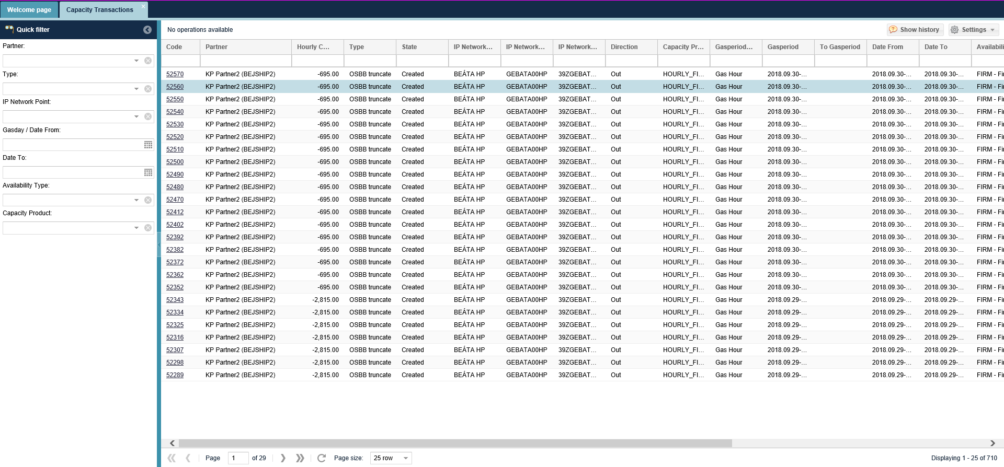
Data as per the possible filter conditions

View capacity transaction
Open the Capacity menu capacity transaction view. Click the link of the selected transaction code column.
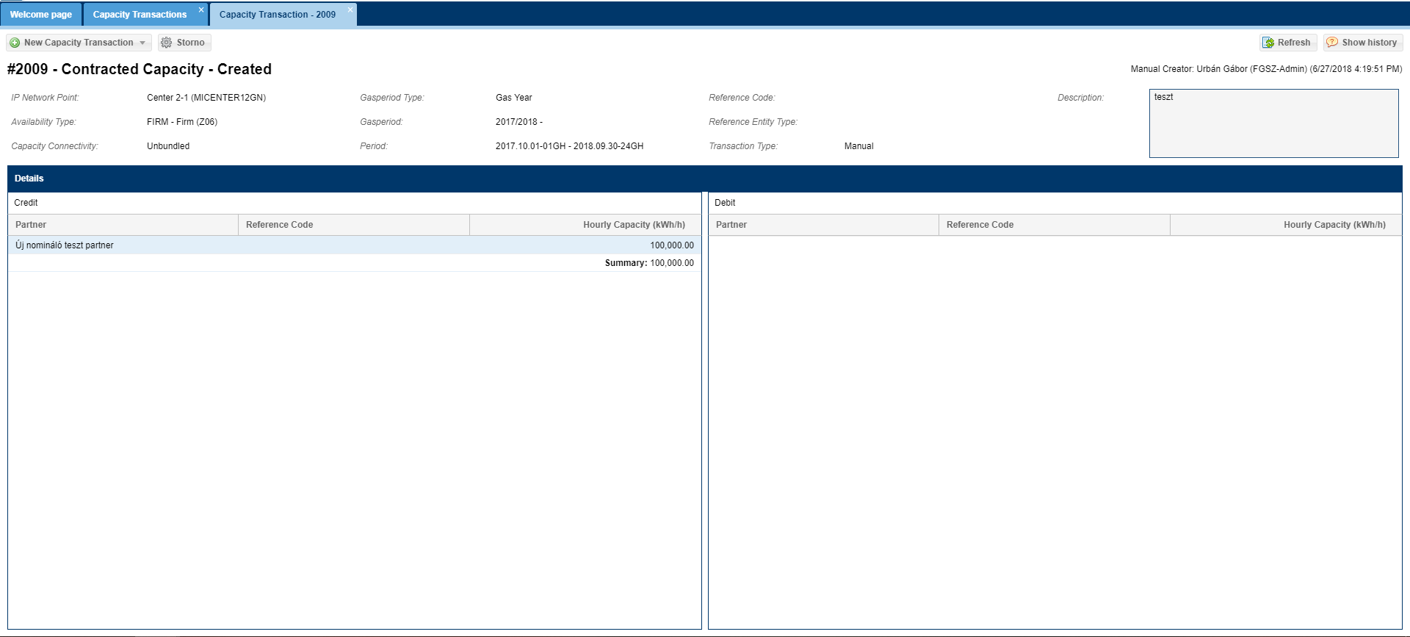
The data sheet of the given transaction will display. In the Transaction details window in the Crediting chart for the Capacity transaction positive and in the Charge chart negative capacity transaction rows are displayed.

Capacity diagram

View Capacity diagram
Open the Capacity menu capacity diagram view. Select diagram type, and enter Network point, Gas period type, and gas period.
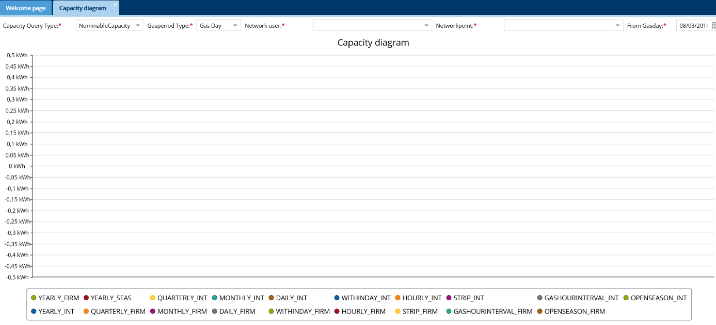
The capacity diagram will display in line with the given filter criteria. If the query period exceeds 31 days the selected breakdown will automatically change to Daily period. The diagram shows for a selected Network point and period the given capacity of the network user per capacity product.

Nominable capacity diagram
Open the Capacity menu Capacity diagram view. Select Nominable capacity from the diagram type from the scroll down list. Enter a Network point, Gas period type, period and the requested breakdown. Use the color selection under the diagram for gas period type and click the color before the period to select.

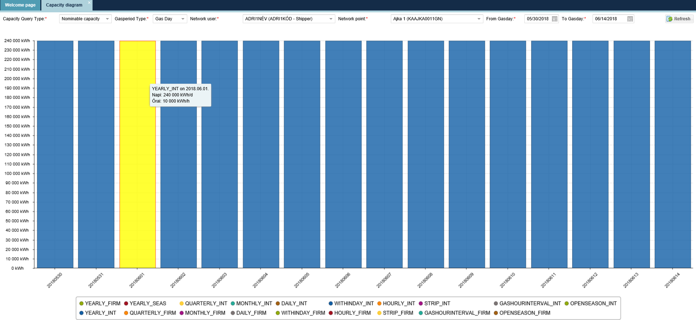
The Nominable capacity diagram shows the given capacity per capacity product for a selected Network point and period. When you move your mouse over the given column, exact information is visible and you do not need to read them from the diagram.

Technical capacity diagram
Open the Capacity menu Capacity diagram view. Select Technical Capacity from the diagram type from the scroll down list. Enter a Network point, Gas period type, Gas period and the requested breakdown.

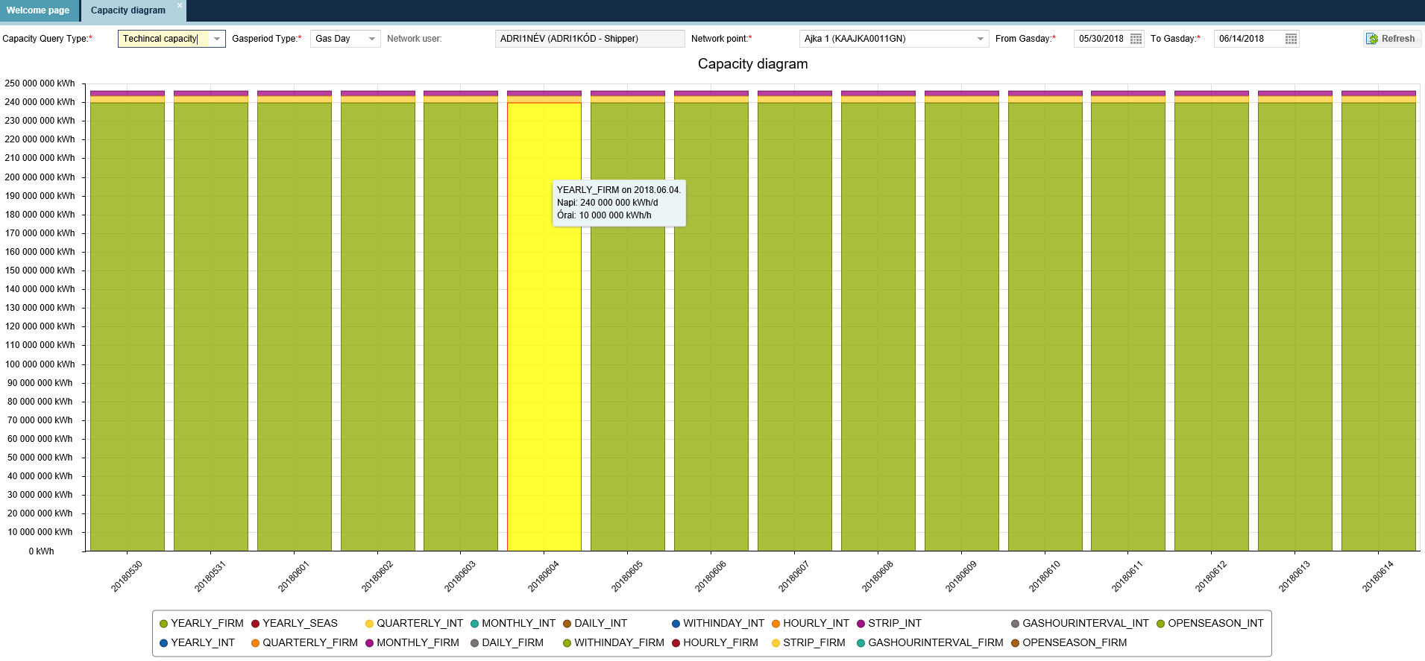
The Technical Capacity diagram shows the technical capacity of the selected Network point and Gas period. When you move your mouse over the given column, exact information is visible and you do not need to read them from the diagram.

Primary capacity diagram
Open the Capacity menu Capacity diagram view. Select Primary Capacity from the diagram type from the scroll down list. Enter a Network point, Gas period type, Gas period and the requested breakdown.

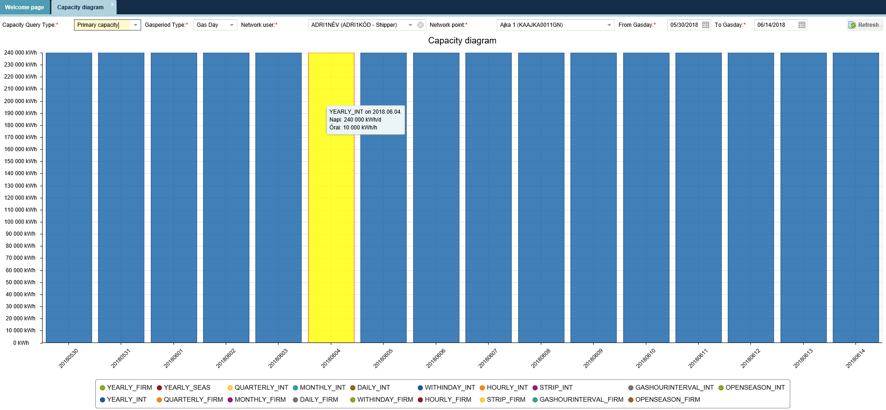
The Primary Capacity diagram shows the given capacity per capacity product for a selected Network point and period. When you move your mouse over the given column, exact information is visible and you do not need to read them from the diagram.

Offerable capacity diagram
Open the Capacity menu capacity diagram view. Select Offerable capacity from the diagram type from the scroll down list. Enter a Network point, Gas period type, Gas period and the requested breakdown.

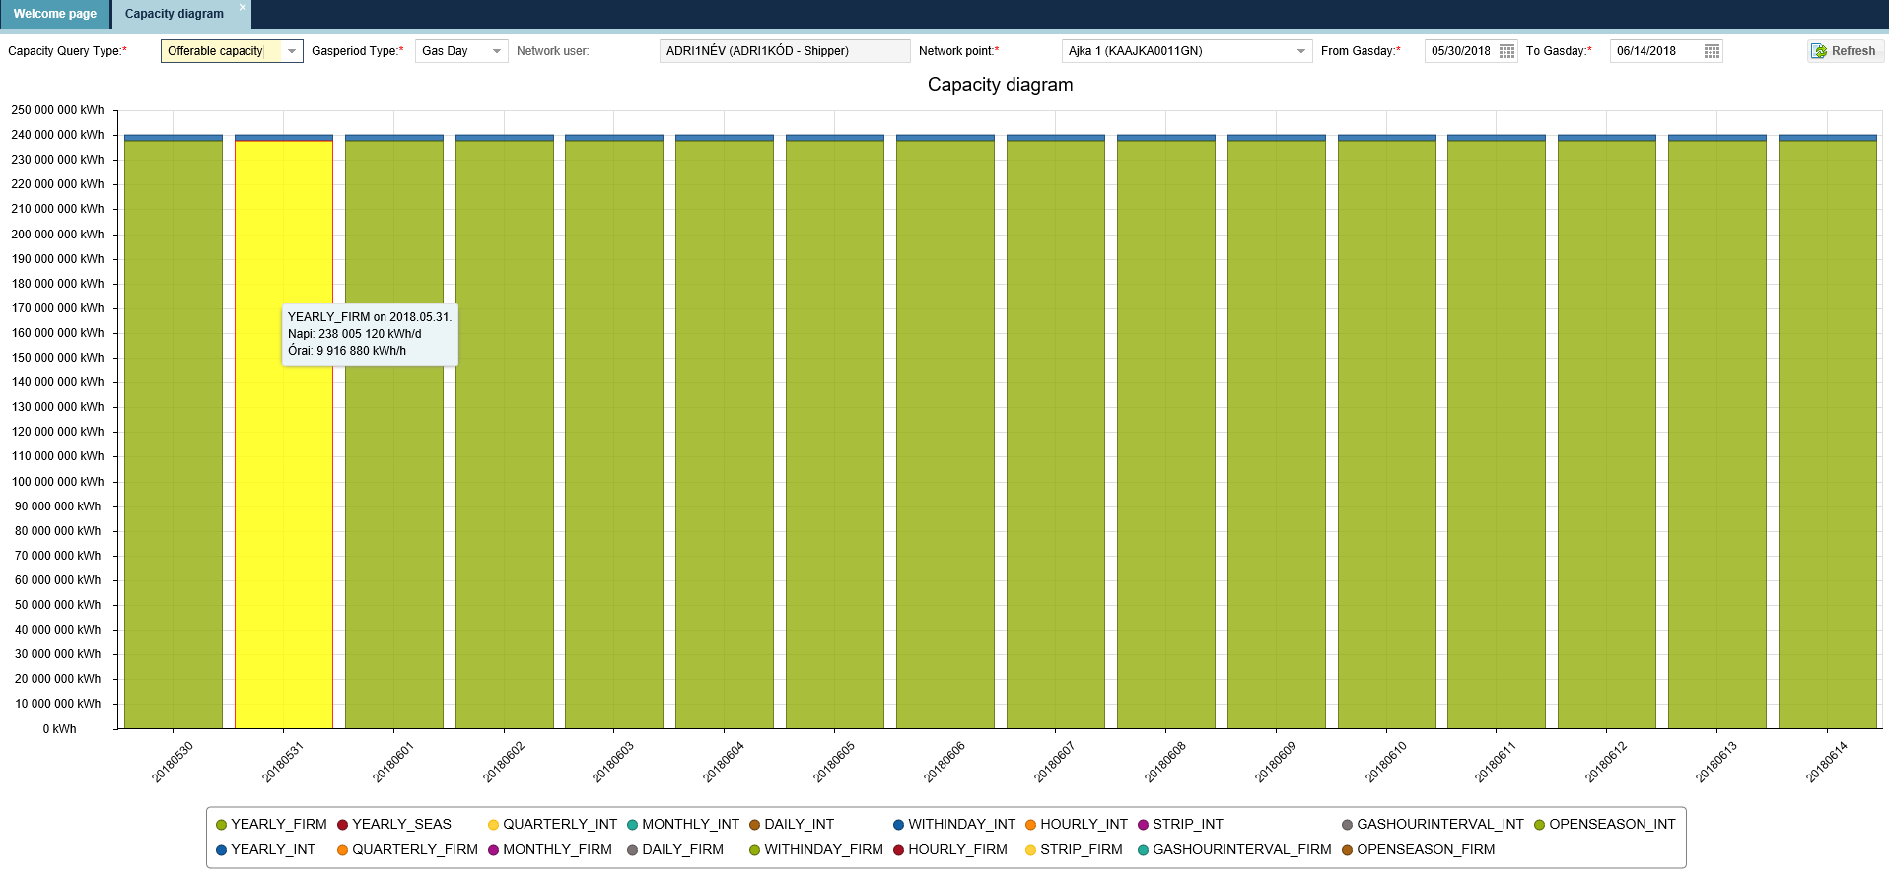
The Offerable capacity diagram shows the given capacity to be offered per Service quality for a selected Network point and period. When you move your mouse over the given column, exact information is visible and you do not need to read them from the diagram.

LTIUIOLI lockable capacity diagram
Open the Capacity menu Capacity diagram view. Select LTIUIOLI lockable Capacity to from the diagram type from the scroll down list. Enter a Network point, Gas period type, Gas period and the requested breakdown.

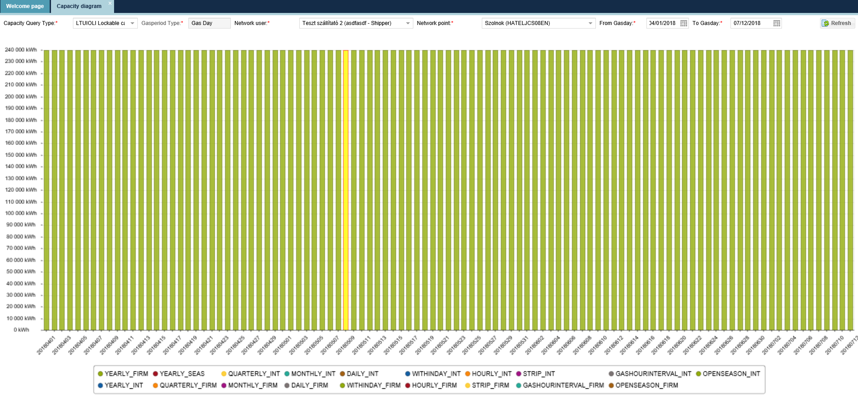
The LTIUIOLI lockable Capacity diagram shows the given LTIUIOLI Capacity for a selected Network point and period, not considering the uninterruptible capacity product. When you move your mouse over the given column, exact information is visible and you do not need to read them from the diagram.

Capacity diagram for Customer Migration Transferable Capacity migration
Open the Capacity menu Capacity diagram view. Select Customer Migration Transferable Capacity from the diagram type from the scroll down list. Enter a Network point, Gas period type, Gas period and the requested breakdown.

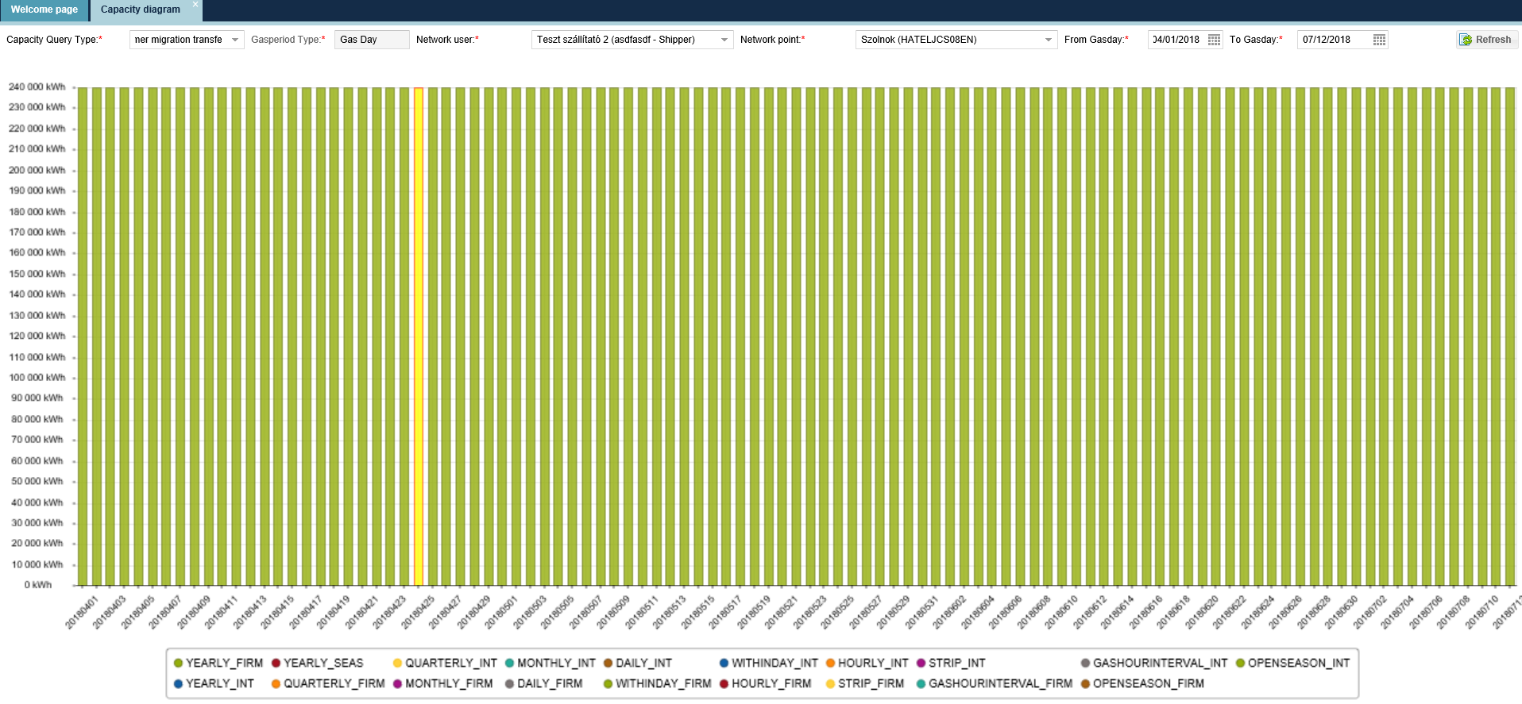
The Customer Migration Transferable Capacity diagram shows the given Customer Migration Transferable Capacity for a selected Network point and period, considering the annual product. This diagram does not consider capacities to be taken over or handed over in the pending Network user Customer Migration plans. When you move your mouse over the given column, exact information is visible and you do not need to read them from the diagram.

Capacity Transfer Transferable Capacity diagram
Open the Capacity menu Capacity diagram view. Select capacity transfer from the diagram type from the scroll down list. Enter a Network point, Gas period type, Gas period and the requested breakdown.

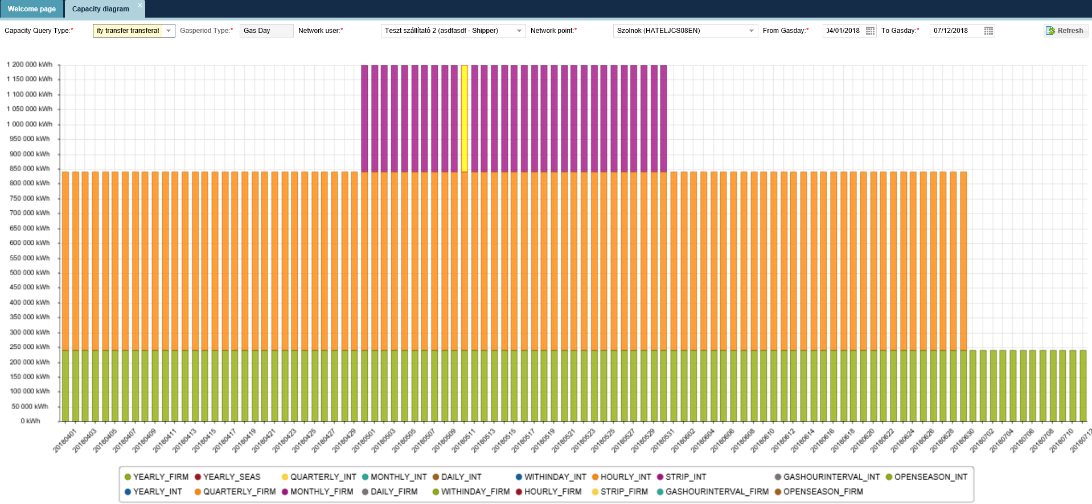
The Capacity Transfer Transferable Capacity diagram shows the given Capacity Transfer Transferable Capacity for a selected Network point and period, considering the annual, quarterly and monthly products. This diagram does not consider capacities to be taken over or handed over in the pending Network user Capacity transfer plans. When you move your mouse over the given column, exact information is visible and you do not need to read them from the diagram.

Capacity surrender capacity diagram
Open the Capacity menu Capacity diagram view. Select Capacity to be surrendered from the diagram type from the scroll down list. Enter a Network point, Gas period type, Gas period and the requested breakdown.
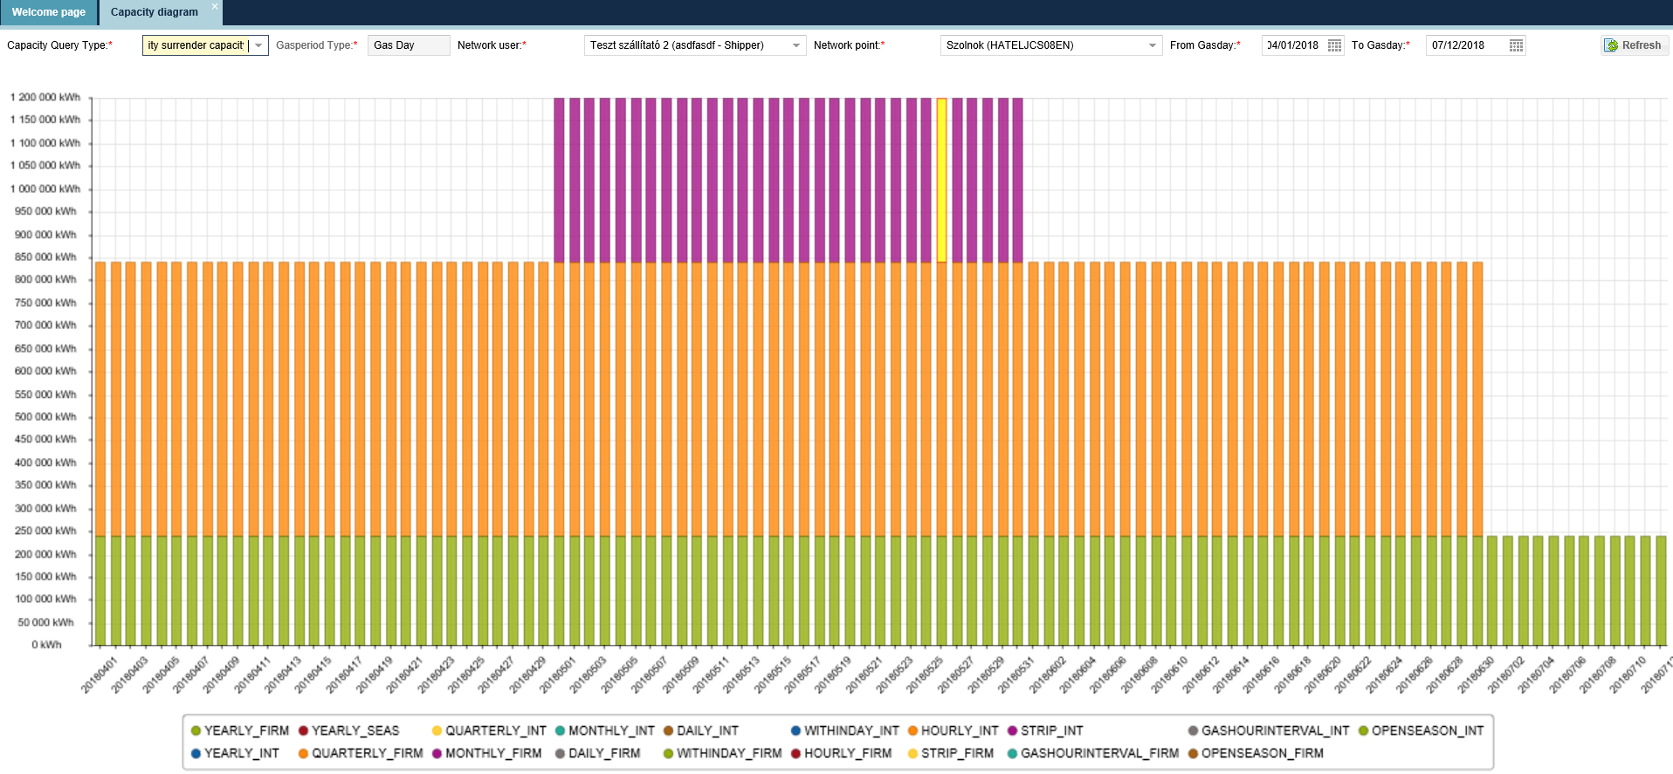
The capacity to surrender diagram shows the given Capacity to surrender for a selected Network point and period, not considering the uninterruptible capacity product. When you move your mouse over the given column, exact information is visible and you do not need to read them from the diagram.

Bilat deal capacity diagram
Open the Capacity menu Capacity diagram view. Select Bilat Deal Capacity from the diagram type from the scroll down list. Enter a Network point, Gas period type, Gas period and the requested breakdown.

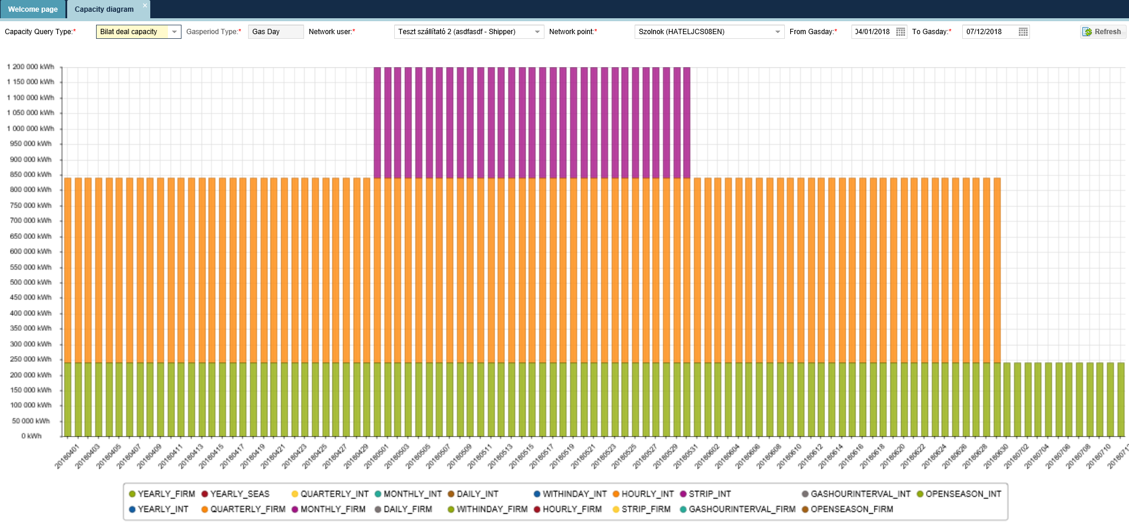
The Bilat Deal Capacity diagram shows Bilat Deal Capacity for a selected Network point and period the given capacity per capacity product. When you move your mouse over the given column, exact information is visible and you do not need to read them from the diagram.

Capacity market deal capacity diagram
Open the Capacity menu Capacity diagram view. Select Capacity market deal capacity from the diagram type from the scroll down list. Enter a Network point, Gas period type, Gas period and the requested breakdown.

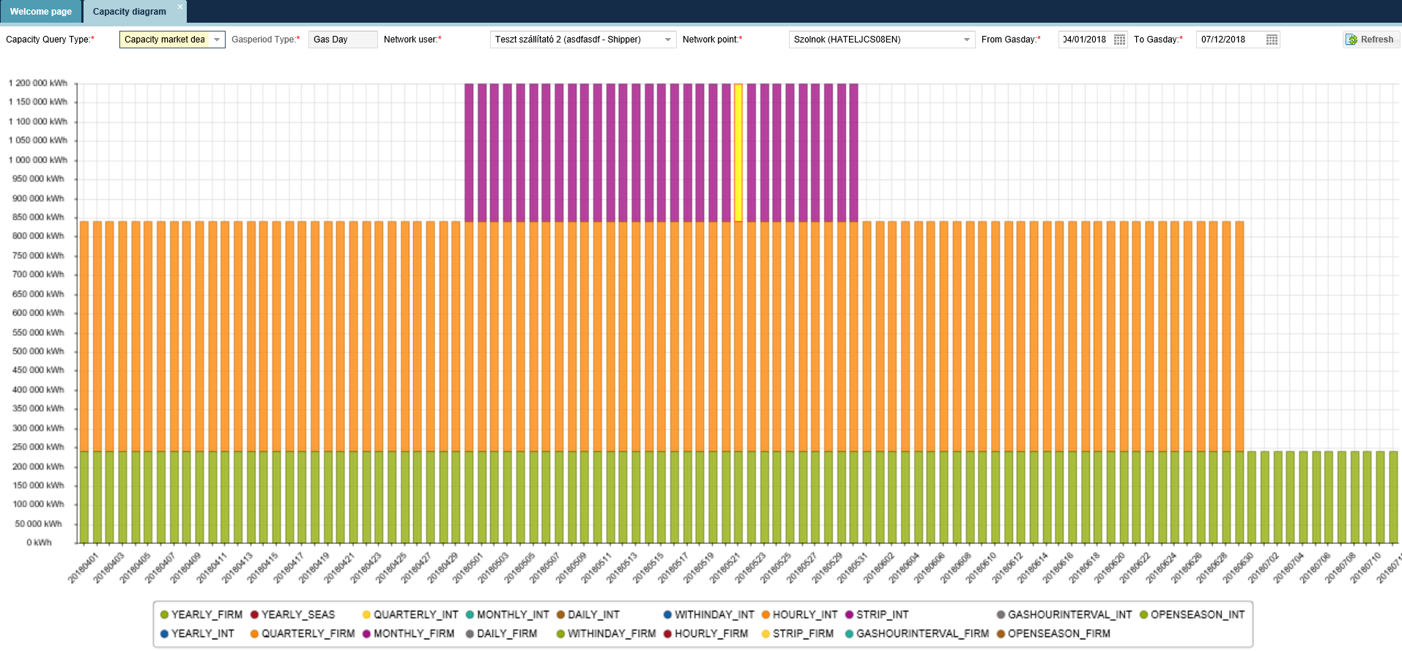
The Capacity market deal capacity diagram shows Capacity market deal (Anonym market deal) capacity for a selected Network point and period the given capacity per capacity product. When you move your mouse over the given column, exact information is visible and you do not need to read them from the diagram.

Capacity demand forecast

Data provisions

Listing data provisions
Open the Capacity menu Data provisions view. The data provision list screen comes up.
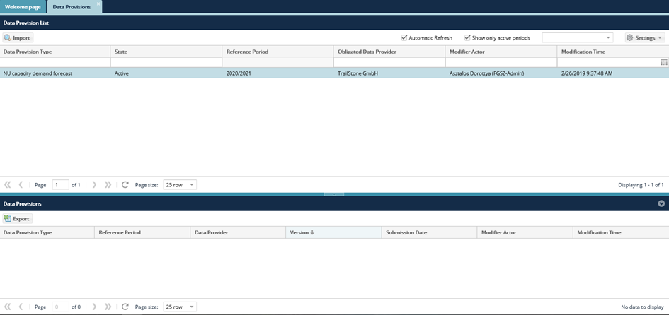
An NU can only see data provisions where the NU is concerned.

NU capacity demand forecast export
Open the Capacity menu Data provisions view.
Click the “Export” button in the bottom view of the screen. The Data provisions will show up

NU capacity demand forecast import
Open the Capacity menu Data provisions view. Click the “Import” button, after selecting the row of items
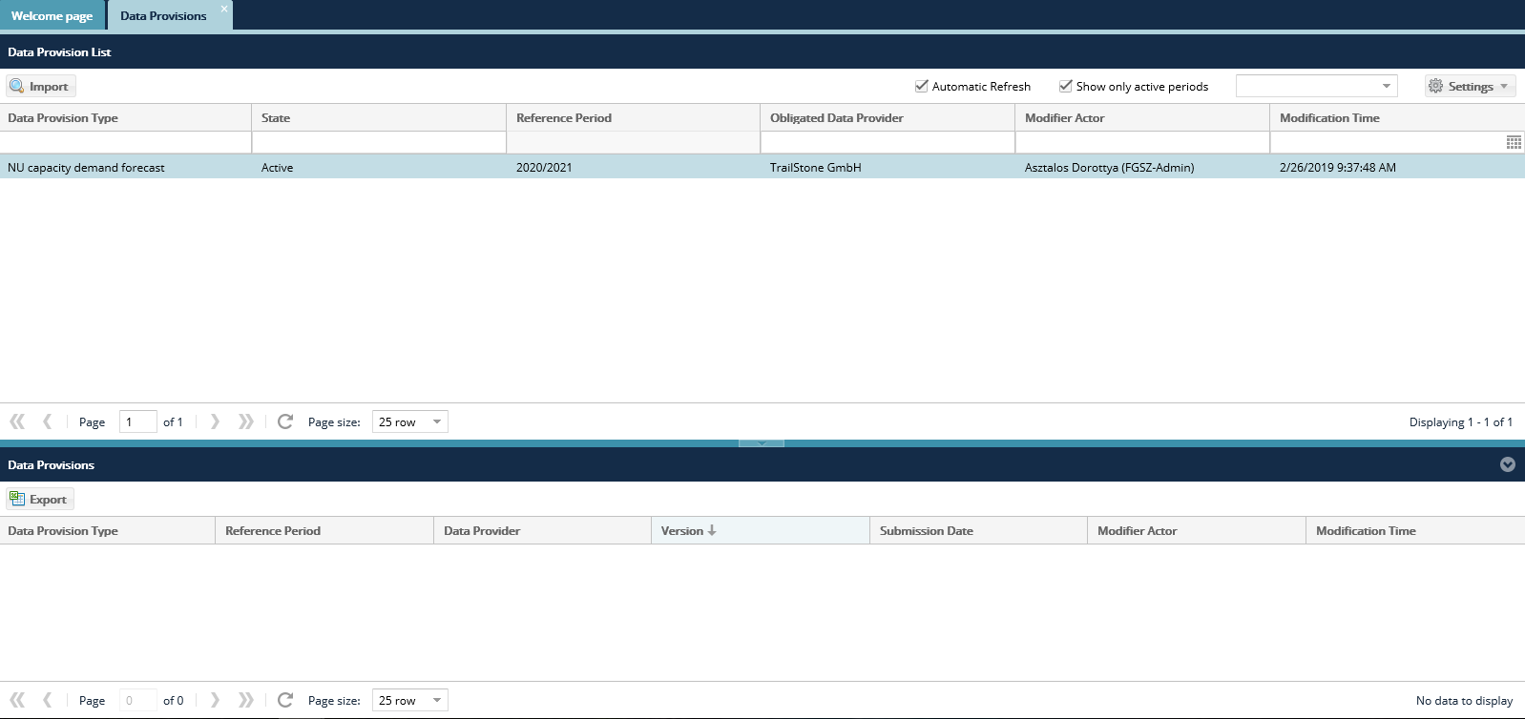
Click “Browse” to select the Excel file to be loaded from the system. The link of the selected file then gets into the field “File to be import”. Then click “Upload”.
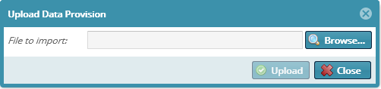
The system shows that uploading is in progress and the “Import results” window will appear. Loaded data will display in the list view as per version. The completed template will be uploaded and the version number will increase by one.

Contract

Capacity contracts
Contract management handles the contract data for documenting contracts that won KLP auction but were taken away/surrendered due to CMP and then sold again, furthermore customer migration, capacity transfer and capacity inheritance related hand overs and take overs or amended capacity contracts.
The system allocates version numbers to capacity contracts. All changes that can be the result of a new similar period KLP Auction won, will be saved to a new contract version each. All versions include all previous capacity contract rows and their charges too.
Capacity contract transfers basically have to types:
- Started from IP:
  - Customer migration
  - Capacity transfer
  - LTUIOLI locking
- Started from KLP:
  - Bilat transaction (7: Bilateral capacity transfer transactions in Regional Booking Platform User Manual)
  - Anonym market deal (8: Capacity market transactions in Regional Booking Platform User Manual)
  - Capacity surrender: (9: Capacity surrender in Regional Booking Platform User Manual)
  - Capacity conversion(10: Capacity conversions in Regional Booking Platform User Manual

List Capacity contracts
Open the Contracts menu Capacity contracts view. Quick filter is available on the left side of the screen. Available functions: Download contract, export.

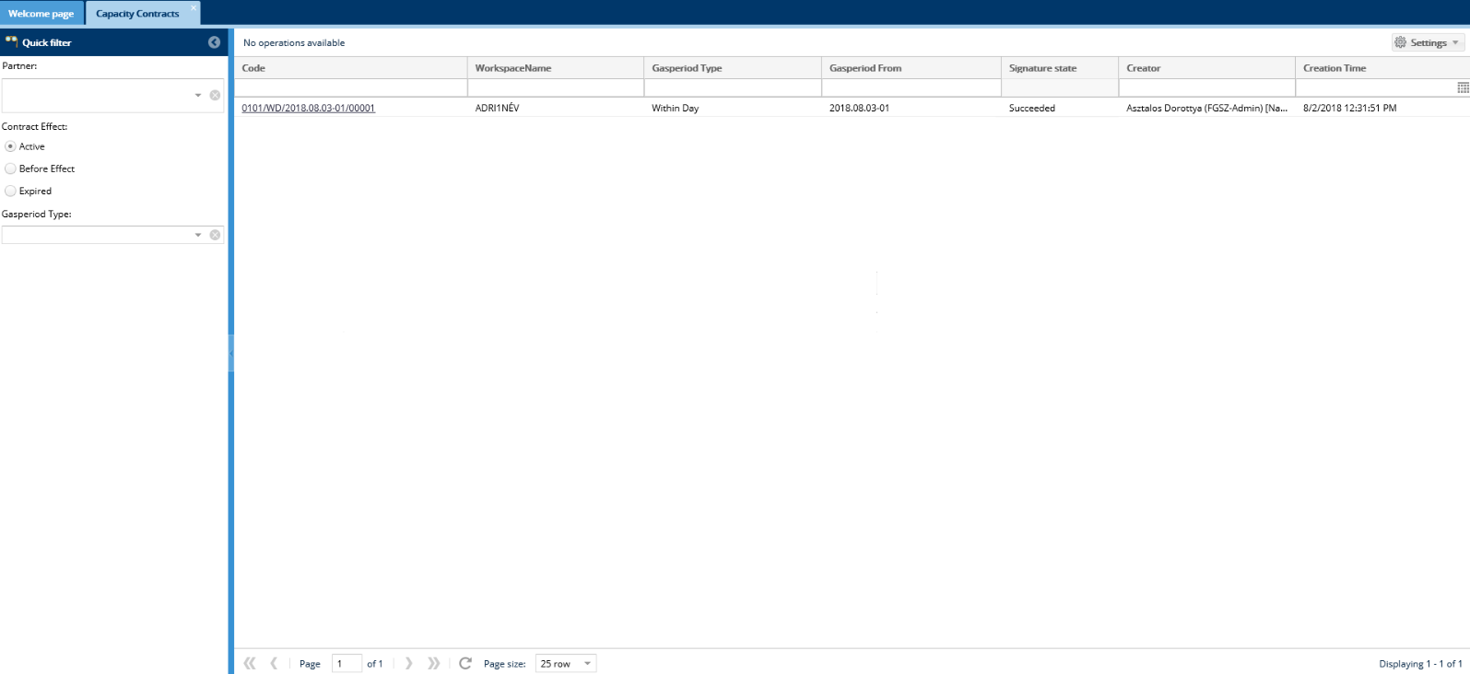
This list will show contracts as per the quick filter validity and gas period type. System Users can only see their own contracts

View capacity contract
Open the Contracts menu Capacity contracts view. Click the link of the selected contract in the Contract number column. Available functions: Download contract, export.
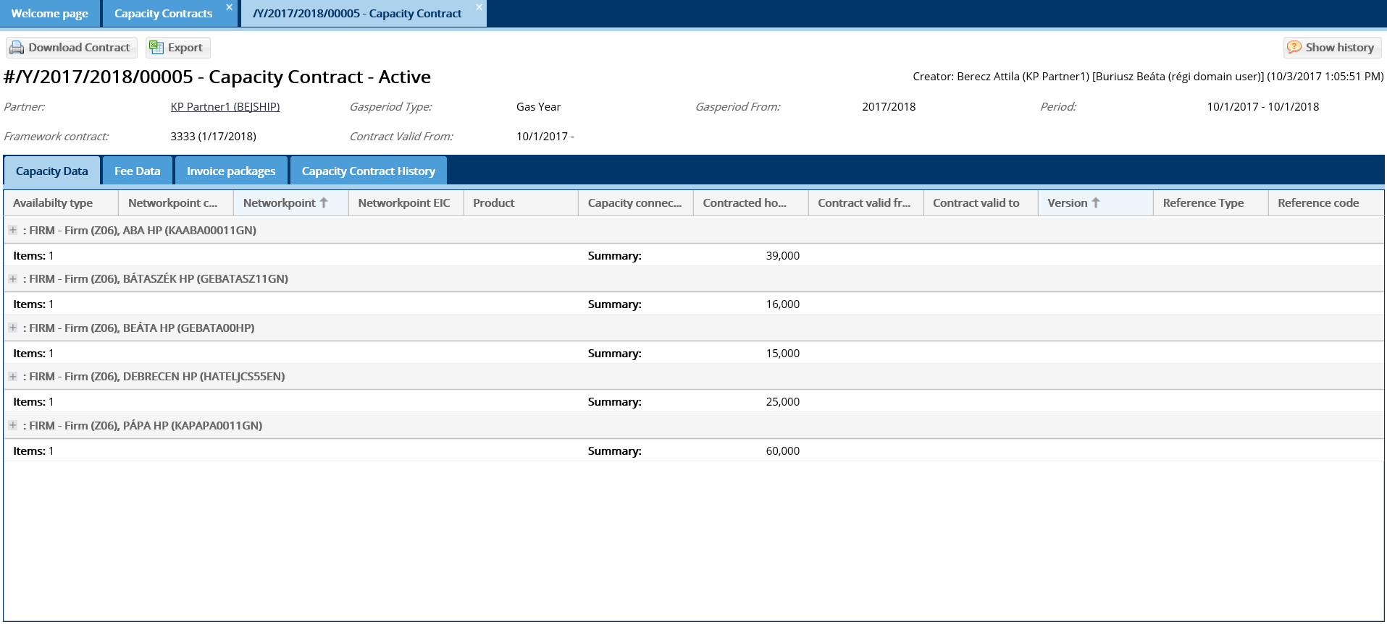
The data sheet of the selected capacity contract will display, and it has four worksheets according to contents: Capacity data, Free Data, Invoice package, Capacity Contract History.

Download contractual documents
Open the Contracts menu Capacity contracts view. Use list view or data sheet view for this function. Select the required contract and after selection, please click Download contract. Signed documents can only be downloaded, if the documents exist attached to the contract, then this function is turned on.
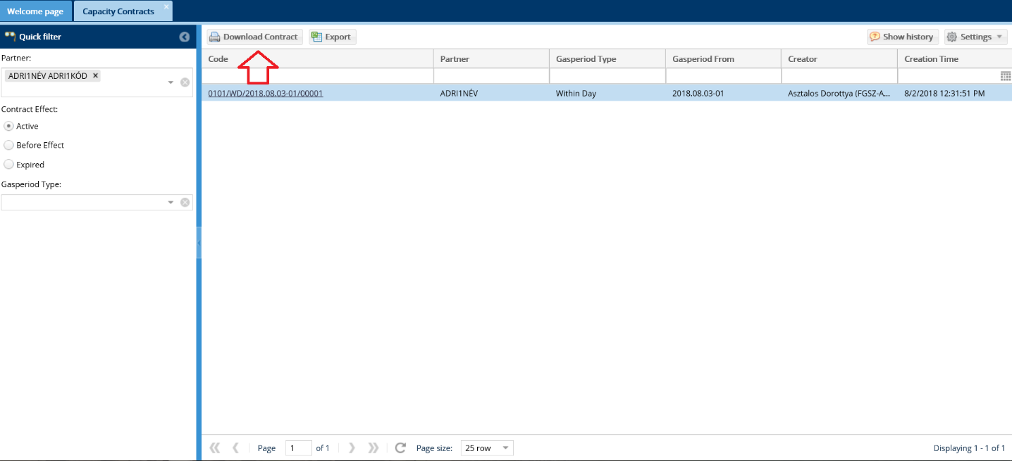
The given contract is downloaded.

Capacity contract Excel export
Open the Contracts menu Capacity contracts view. Use list view or data sheet view for this function. Select the required contract and after selection, please click Export.
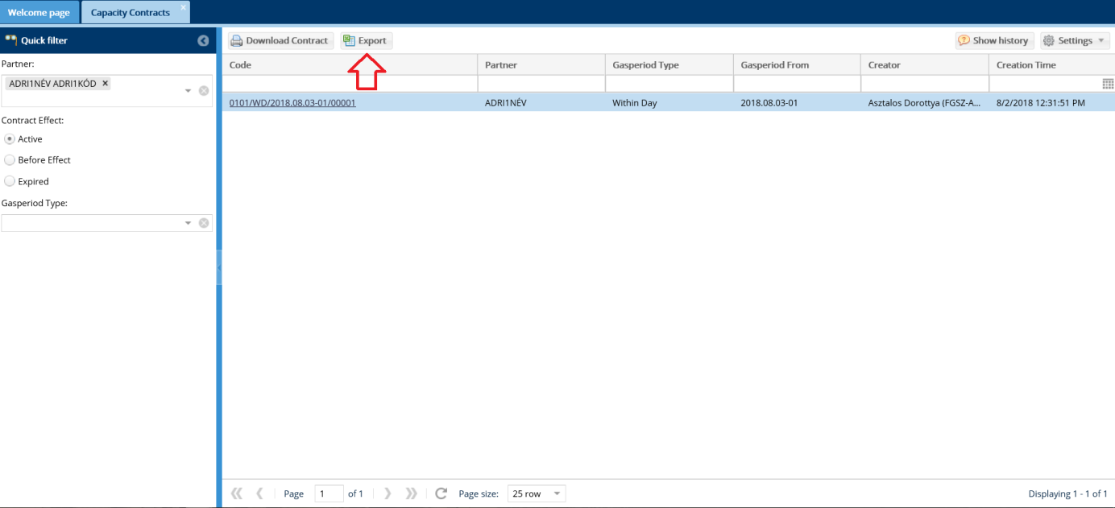
If you say “Yes” to the confirmation message, an Excel file is downloaded from the browser.

Detail export file
The generated Excel file has 3 worksheets:
- With capacity contract data
- With capacity contract “input” points data
- With capacity contract “output” points data

- worksheet: INFO
Capacity contract summarized data, that includes Network user name, Contract type, Contract number, Start of contract validity, and end of Contract validity.
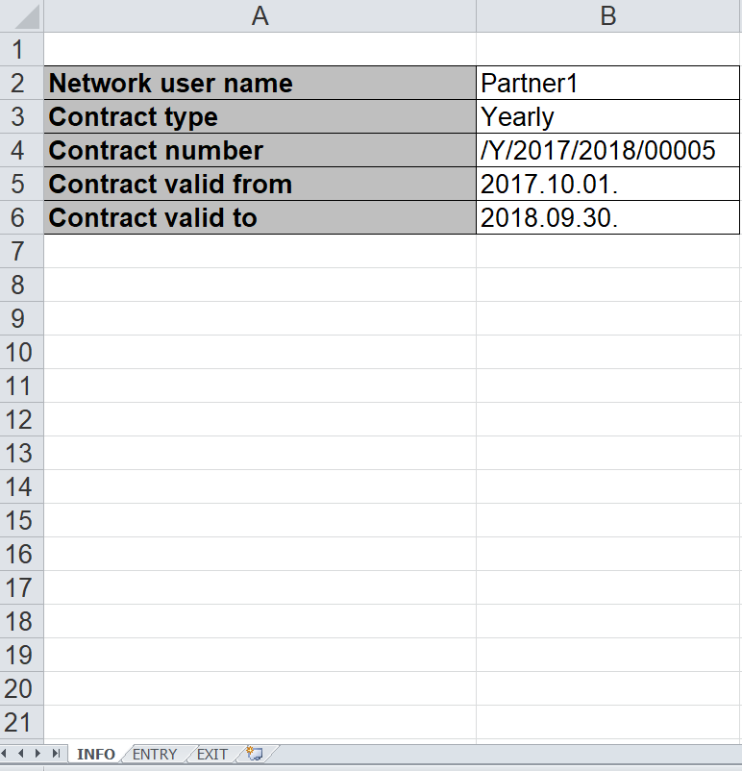

- worksheet: ENTRY
Capacity contract “input” points data.
- Per network point group (grouped and summarized for columns G, H and I
- As per network point code within a Point group
- Summarized for all points as per columns G, H and I
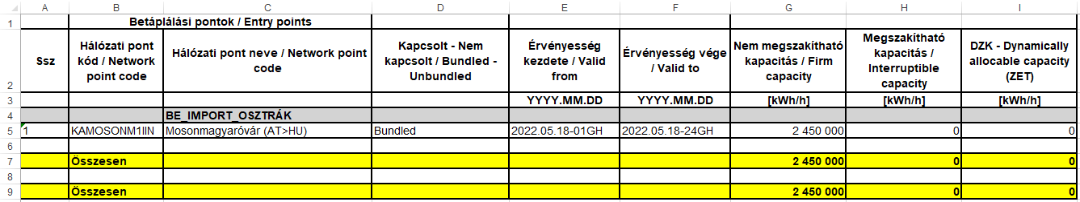

- worksheet: EXIT
Capacity contract “Output” points data.
- Per network point group summarized for columns G, H, I and J
- As per network point code within a Point group
- Summarized for all points as per columns G, H, I and J
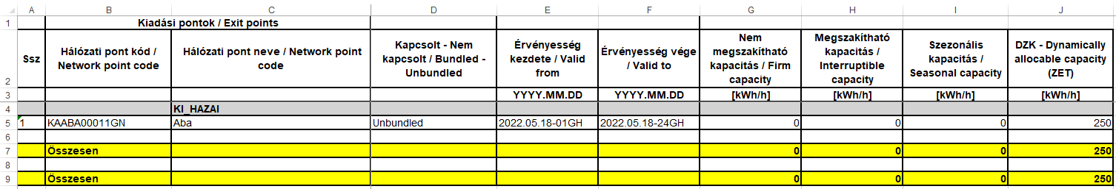

Customer migration
Customer migration function supports annual capacity transfer among Shippers.

List Customer Migration
Open the Contracts menu Secondary deals -> Customer Migration view. Quick filter is available on the left side of the screen, and the filter criteria are: Partner (all Partners can see their own information only), the Gas period (a specific gas year can be selected) and the Customer Migration status (multiple items can be selected, even all)

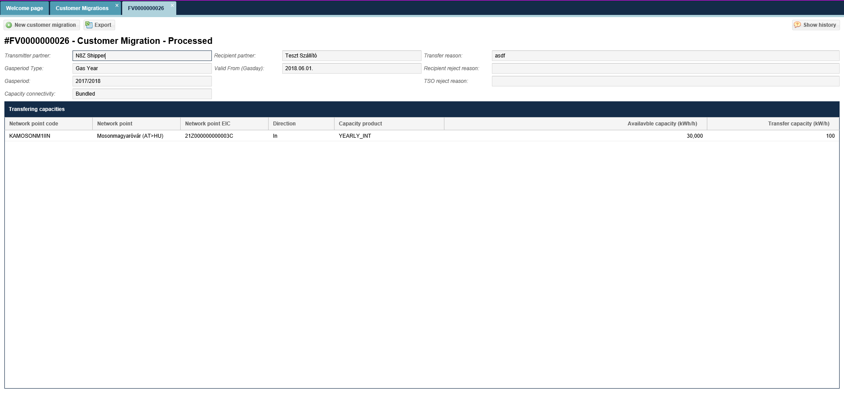
Customer Migration plan screen comes up.

View Customer Migration
Open the Contracts menu Secondary deals -> Customer Migration view. Click Customer Migration row then click the link in the Code column.
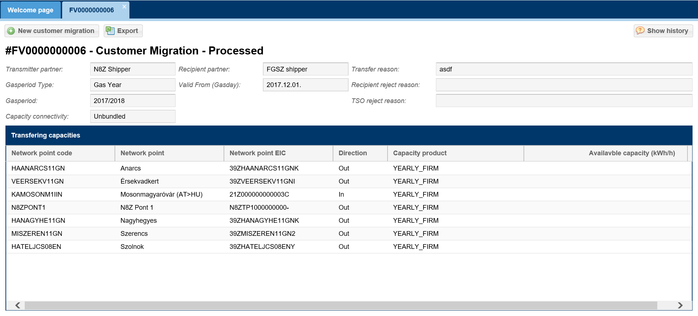
The Customer Migration data sheet displays. The Partner taking over can only see rows, where the Transfer capacity (kWh/h) amount exceeds zero and the volume in the Available capacity column is not visible.

Recording new Customer Migration
Open Contract menu Secondary deals -> Customer Migration view or start the function from the Customer Migration data sheet. Click New customer migration.
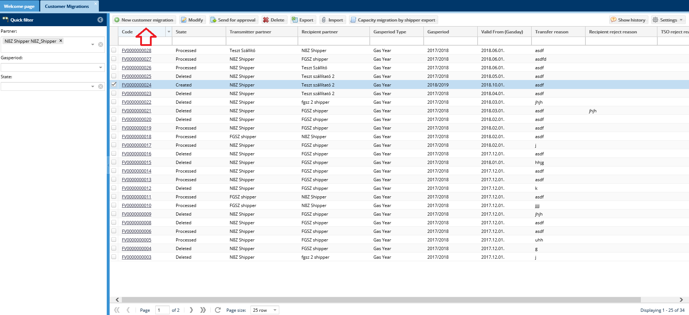
Then enter mandatory data to the screen that displays and click save. The hand over date is the starting date of the capacity transfer, therefore it must be within the selected Gas period. The Transmitter partner and the Recipient partner cannot be the same user.

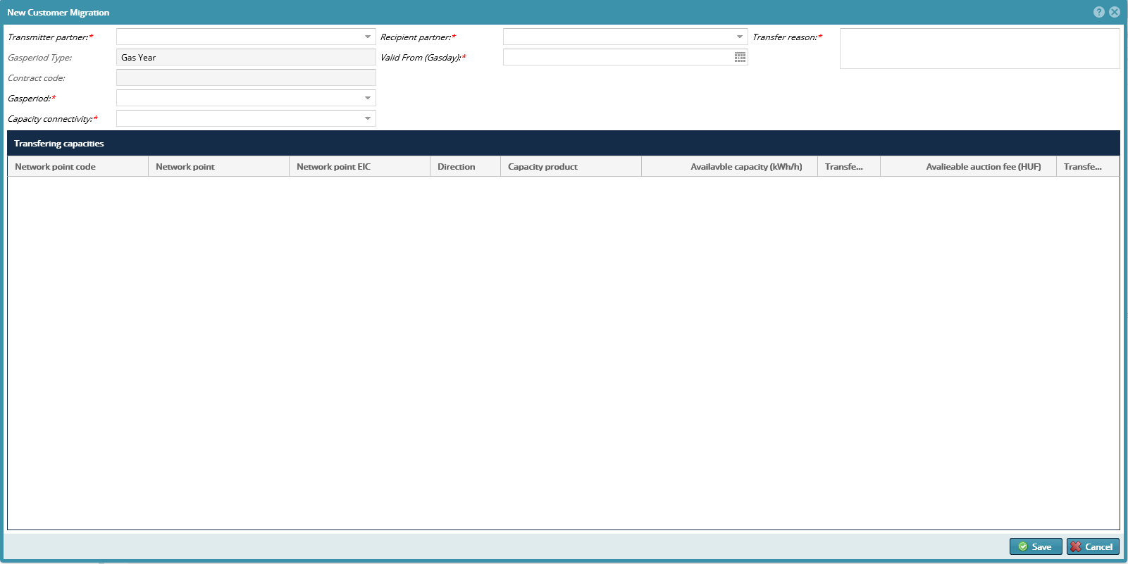
The given data are saved in the databased and the status is Created.

Edit Customer Migration
Open Contract menu Secondary deals -> Customer Migration view or start the function from the Customer Migration data sheet. Make sure that the Quick filter status selection is selected from the Created status. Click the selected Created status Customer Migration row and click Modify button.
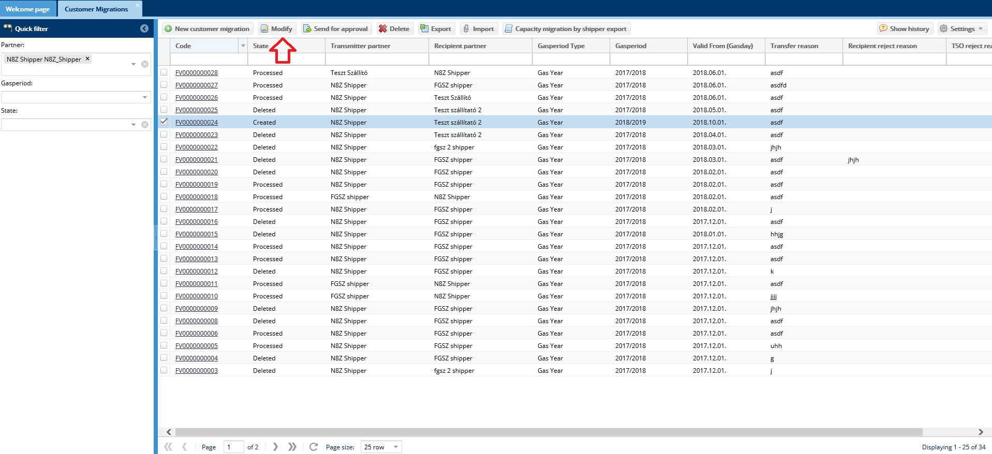
Change the required Transfer capacity (kWh/h) data on the editing screen and save it.

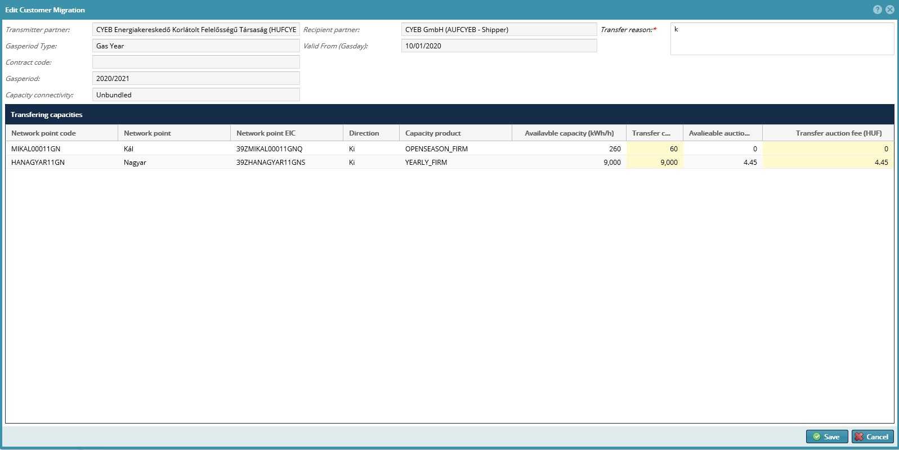
Click save button and the data will be saved in the system.

Send Customer Migration for approval
Open Contract menu Secondary deals -> Customer Migration view or start the function from the Customer Migration data sheet. Click the selected Created status Customer Migration to be handed over row and click Send for approval.
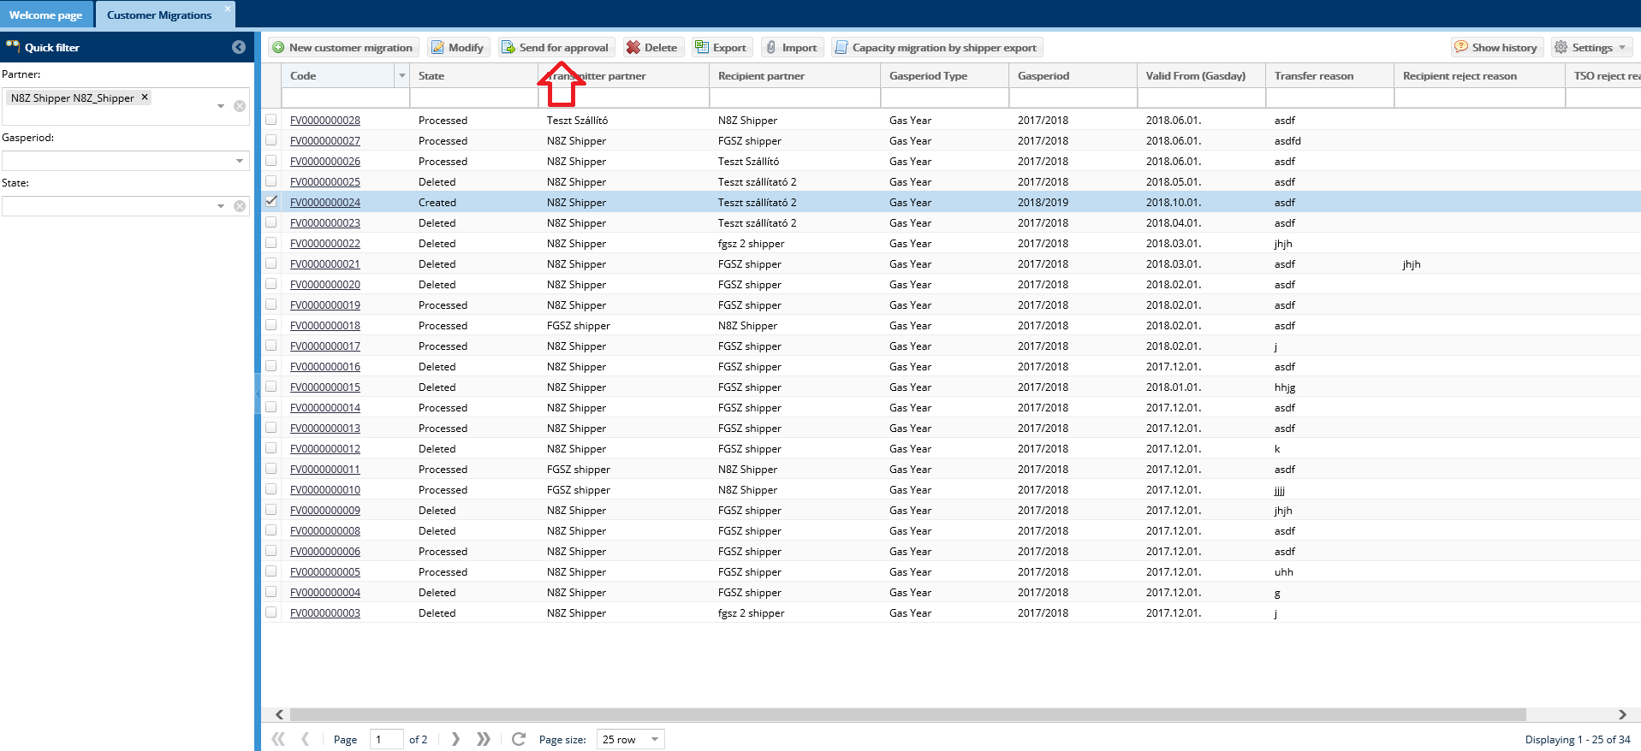
If you say “Yes” to the confirmation message the status of the selected row changes to Waiting for Recipient, and is listed in the Transferring Partner Customer Migration list. Make sure to select Waiting for Recipient from Quick filter status selection.

Recipient partner accepts Customer Migration
Open the Contracts menu Secondary deals -> Customer Migration view. Make sure to select Waiting for take over from Quick filter status selection. After clicking Waiting for Recipient status line it is possible to change its contents. In case the data in the selected Waiting for Recipient status in transferable Customer Migration row is right, click Recipient approve. The System will ask a confirmation question, and after its approval the selected Customer Migration plan will change to Waiting for TSO status.

Recipient partner rejects Customer Migration
Open the Contracts menu Secondary deals -> Customer Migration view. Make sure to select Waiting for Recipient from Quick filter status selection. Click the selected Waiting for Recipient transferable Customer Migration row and click Recipient reject button. You will need to justify your decision, and select Save after. The System will ask a confirmation question, and after its approval the selected Customer Migration plan will change to Created status.

Delete Customer Migration
Open Contract menu Secondary deals -> Customer Migration view or start the function from the Customer Migration data sheet. Make sure that the Quick filter status selection is selected from the Created status. Click the selected Created status Customer Migration row and click Delete button.
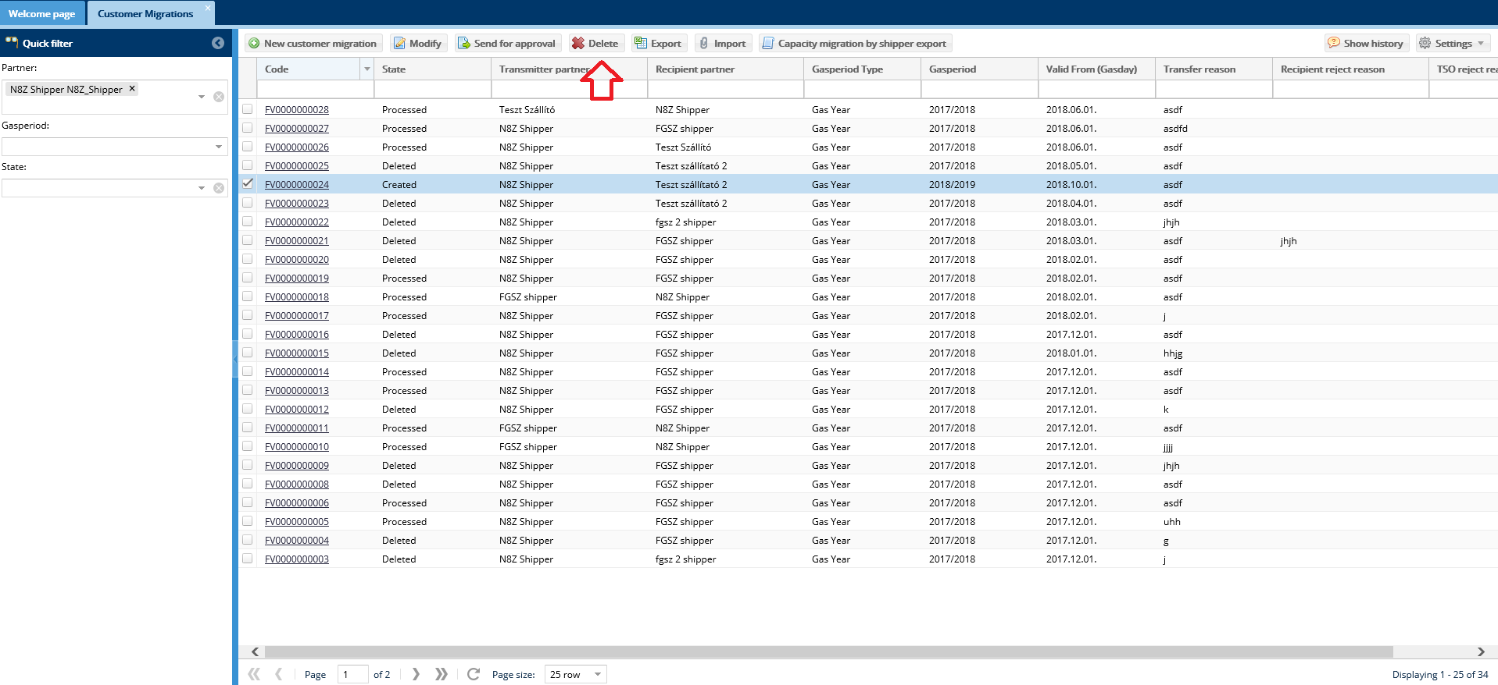
After the confirmation question the notification status changes to “Deleted”.

Export Customer Migration
Open Contract menu Secondary deals -> Customer Migration view or start the function from the Customer Migration data sheet. The selected customer migration row can be: Created, Waiting for Recipient, waiting for TSO, TSO approved, TSO rejected. After selecting click Export.
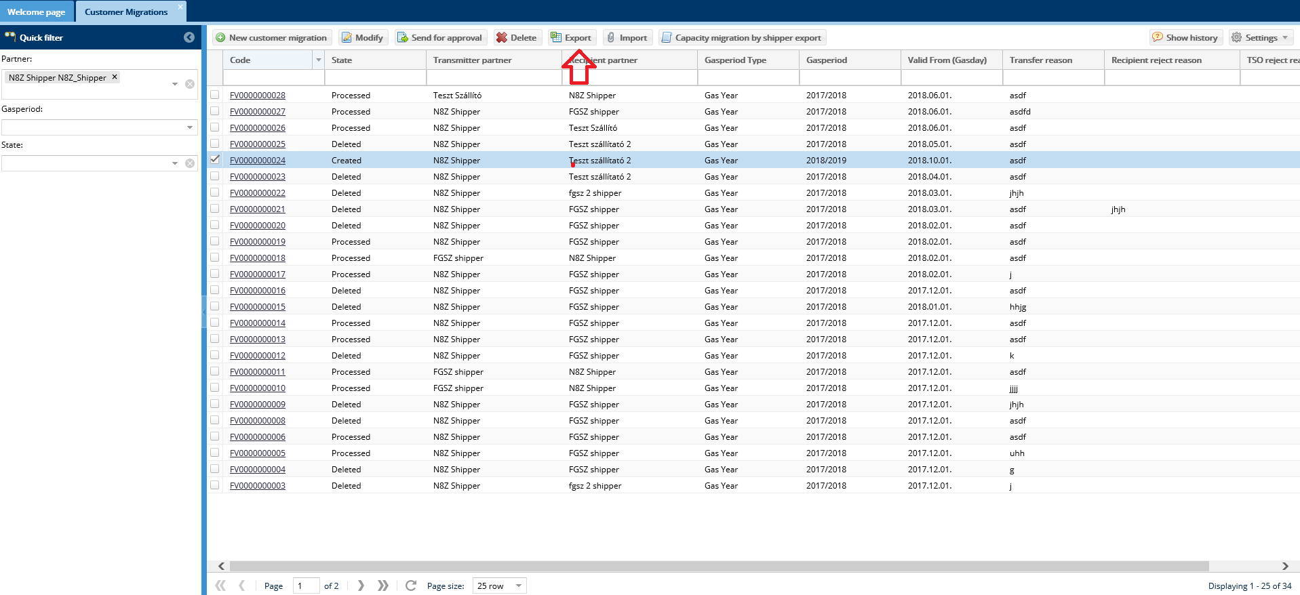
An Excel file will be downloaded from the browser.

Import Customer Migration
Open Contract menu Secondary deals -> Customer Migration view or start the function from the Customer Migration data sheet. Click the selected Created status Customer Migration row and click Import button.
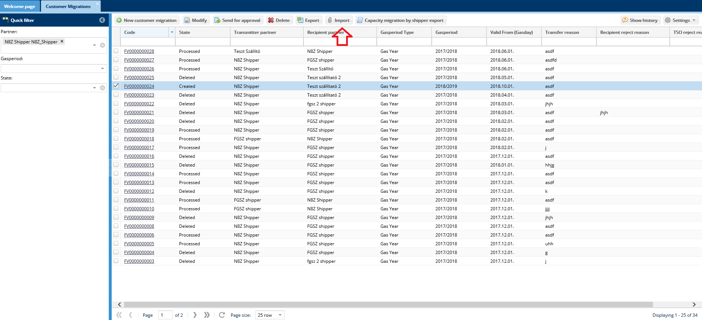
Then the window displays where you may upload the file to be imported via the Browse function. Then upon clicking the Upload button the system will make the necessary checks. You may upload an Excel file to the Customer Migration record, where the export was made from.
After running controls the Excel file data will overwrite the selected Customer Migration plan data.

Customer migration hand over - take over export
Open the Contracts menu Secondary deals -> Customer Migration view. Click Customer Migration row then click the Capacity migration by shipper export.
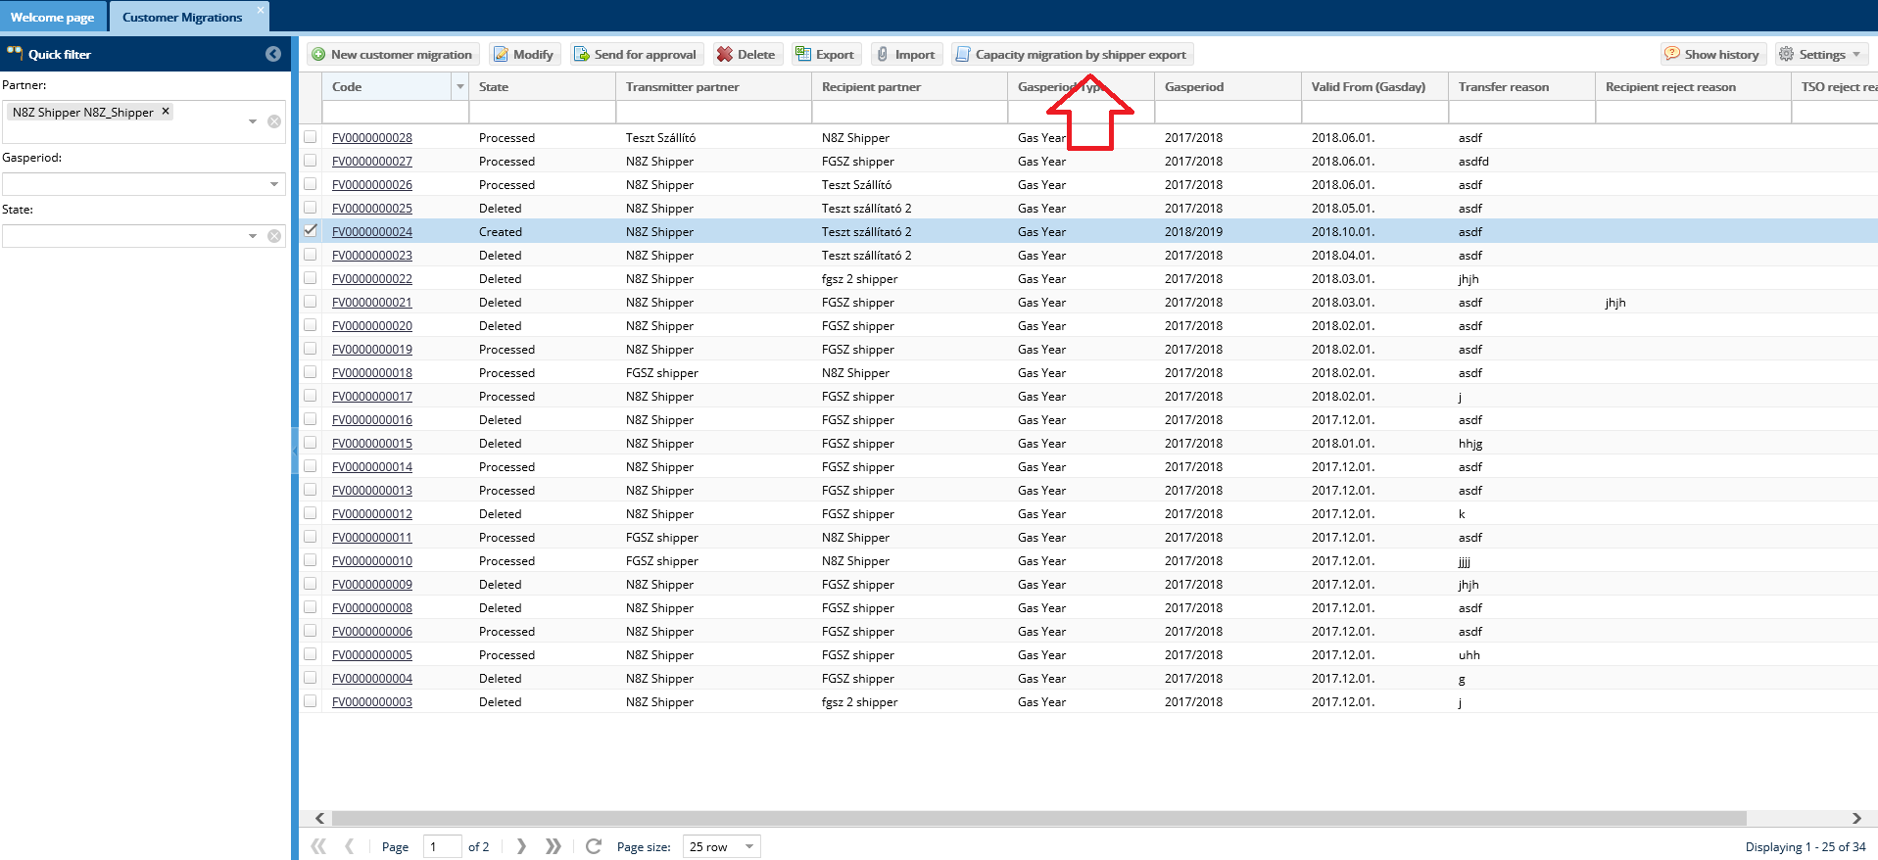
In the pop up window enter gas period and click Export.
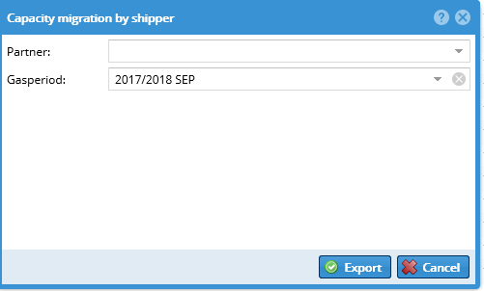

An Excel file will be downloaded from the browser.

Detail export file
The generated Excel file has 4 worksheets:
- worksheet: INFO
With the total data of the customer migration that includes the file name, the transfer date, the shipper code, the shipper name and the time of exporting into Excel.
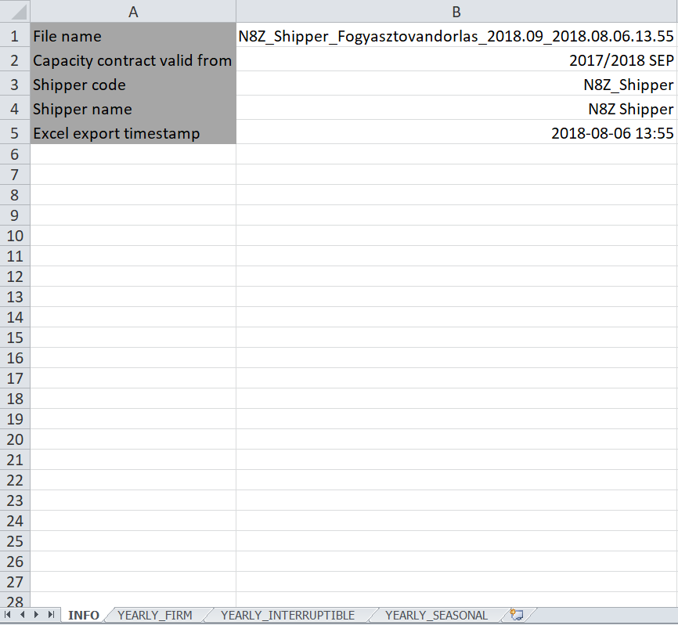
- worksheet: YEARLY_FIRM
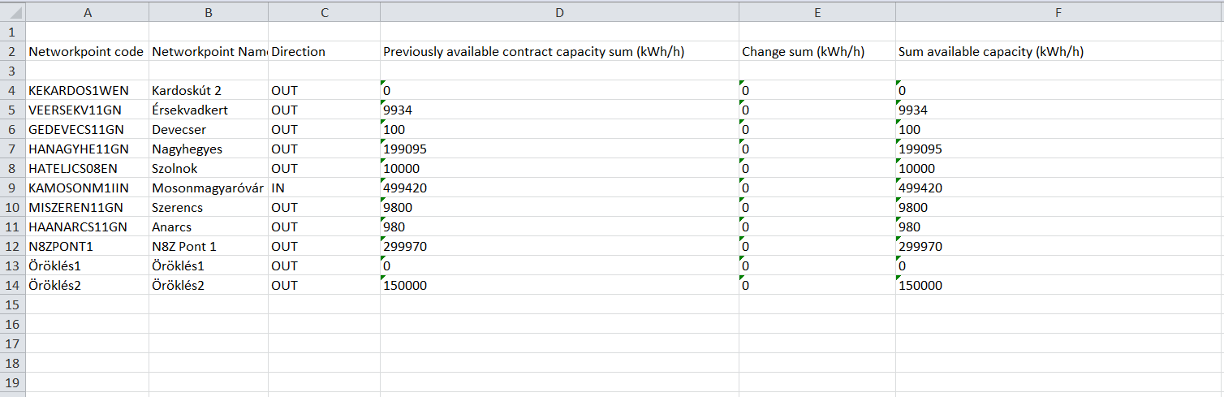

Column | Column name (2nd row) | Value (from 3rd row)
A | Network point code  Network point name  Network point direction
B
C
D | Booked capacity prior to Customer Migration (kWh/h) | Booked capacity value prior to Customer Migration in kWh/h
Summary
… | Total changes (kWh/h) | The amount of hand over and take over transactions
… | Booked capacity after Customer Migration (kWh/h) | Booked capacity after Customer Migration in kWh/h + (The total of hand over and take over)

- worksheet: YEARLY_INTERRUPTIBLE
The same as worksheet 2 but for interruptible capacities.

- worksheet: YEARLY_SEASONAL
The same as worksheet 2 but for seasonal capacities.

Capacity Transfers
Capacity contract transfer from a Shipper who pulls out of the market or is terminated and it supports the distribution to multiple Shippers.

List capacity transfers
Open the Contracts menu Secondary deals -> Capacity transfers view. Capacity transfers recorded in the RBP are listed here (their code is prefixed with BD) and also recorded as BCP in the IP (their code is prefixed with KA).
Quick filter is available on the left side of the screen according to the following parameters: Partner (all Partners can see their own information only), the Gas period (a specific gas year can be selected), Gas period type (Gas month, Gas Quarter, Gas Year), and Capacity transfer status multiple items can be selected, even all)
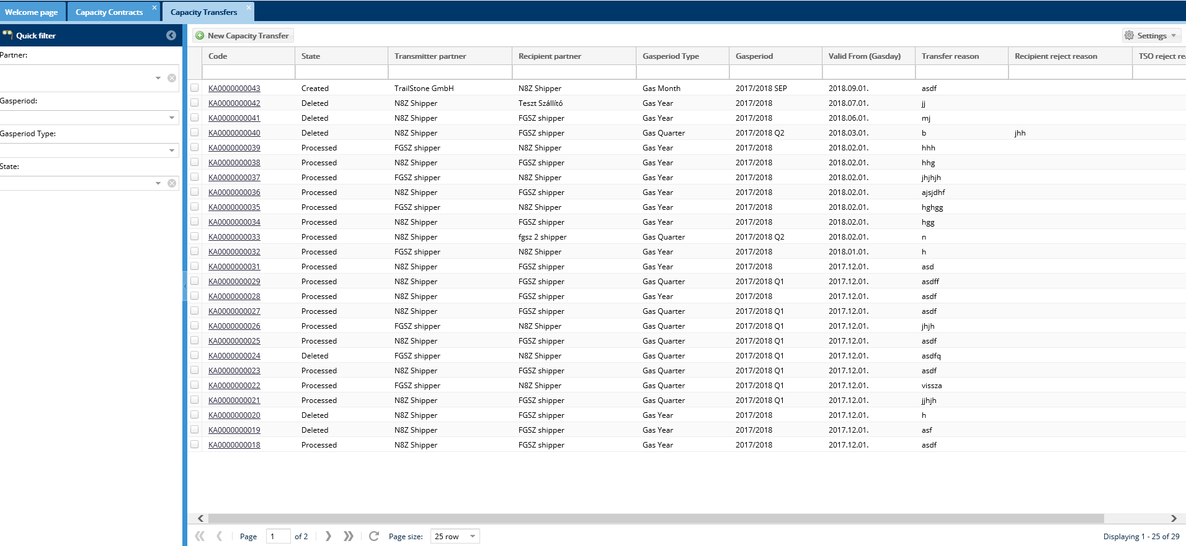
Capacity transfer plan screen comes up.

View capacity transfers
Open the Contracts menu Secondary deals -> Capacity transfers view. Click Capacity transfer row then click the link in the Code column.

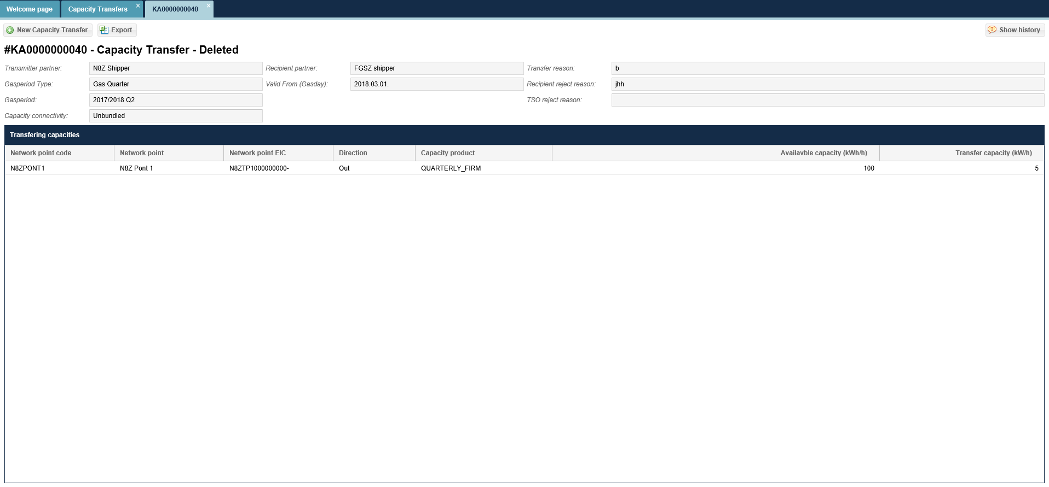
The Capacity transfer data sheet displays. At the Recipient partner the Available column is not shown

Record new capacity transfer manually (BCP procedure)
Open Contract menu Secondary deals -> Capacity transfer view or start the function from the Capacity transfer data sheet. Click new capacity transfer button. Then enter mandatory data to the screen that displays and click save. Please consider that the Transmitter partner and the Recipient partner cannot be the same User, and the transfer capacity (kWh/h) cannot exceed available capacity.

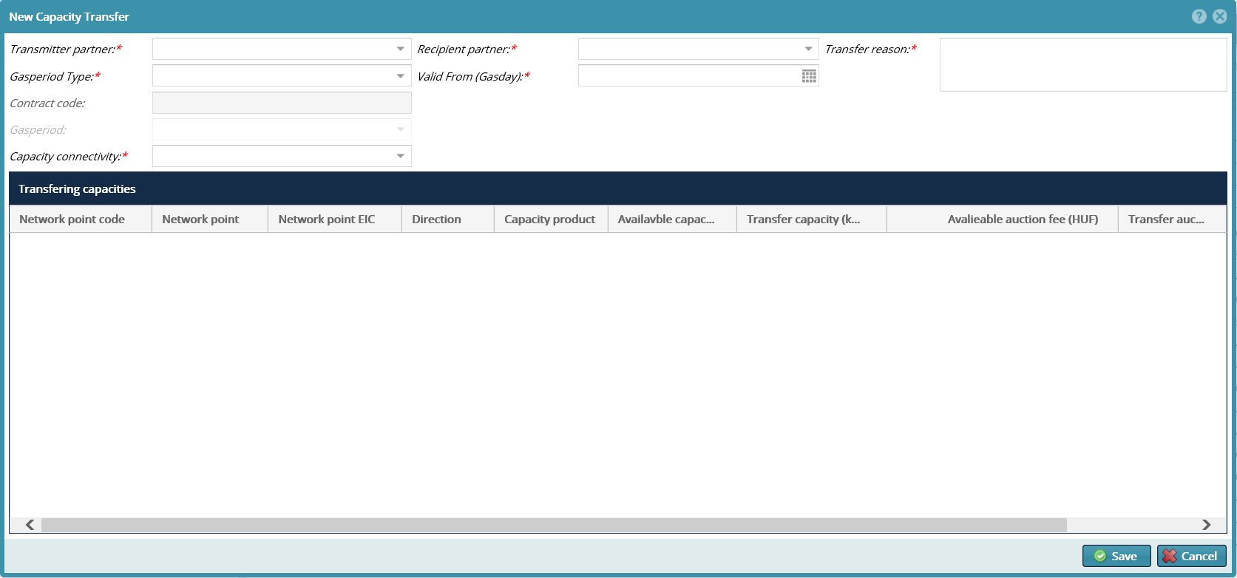
The given data are saved in the databased and the status is Created.

Edit a manually recorded Capacity transfer
Open Contract menu Secondary deals -> Capacity transfer view or start the function from the Capacity transfer data sheet. Click the selected Created status Capacity transfer row and click Modify button.

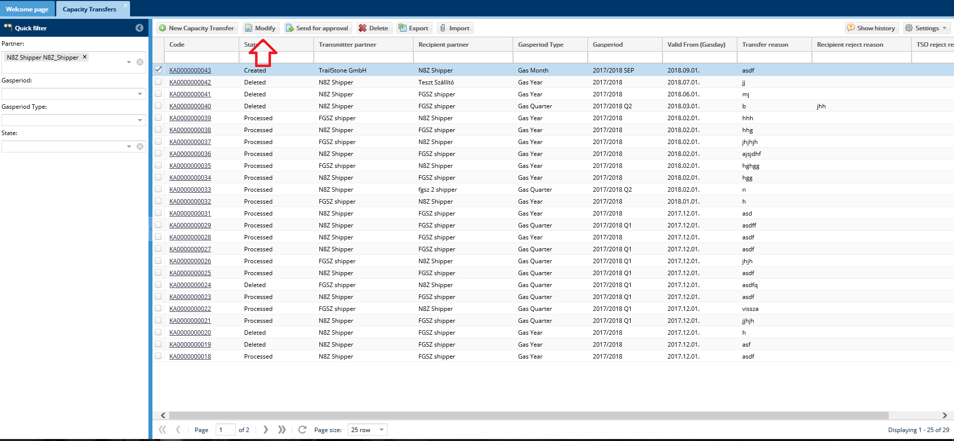
Change the required data on the editing screen and save it.

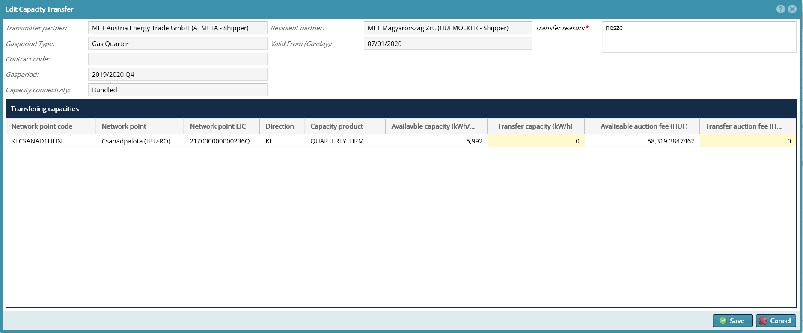
The data will be saved in the system.

Send a manually recorded Capacity transfer for approval
Open Contract menu Secondary deals -> Capacity transfer view or start the function from the Capacity transfer data sheet. Make sure to select Created status from the Quick filter status selection. Click the selected Created status Capacity transfer row and click Send for approval button.
The selected status changes to Waiting Recipient, and this item will display in the Capacity transfer list of the Transmitter partner.
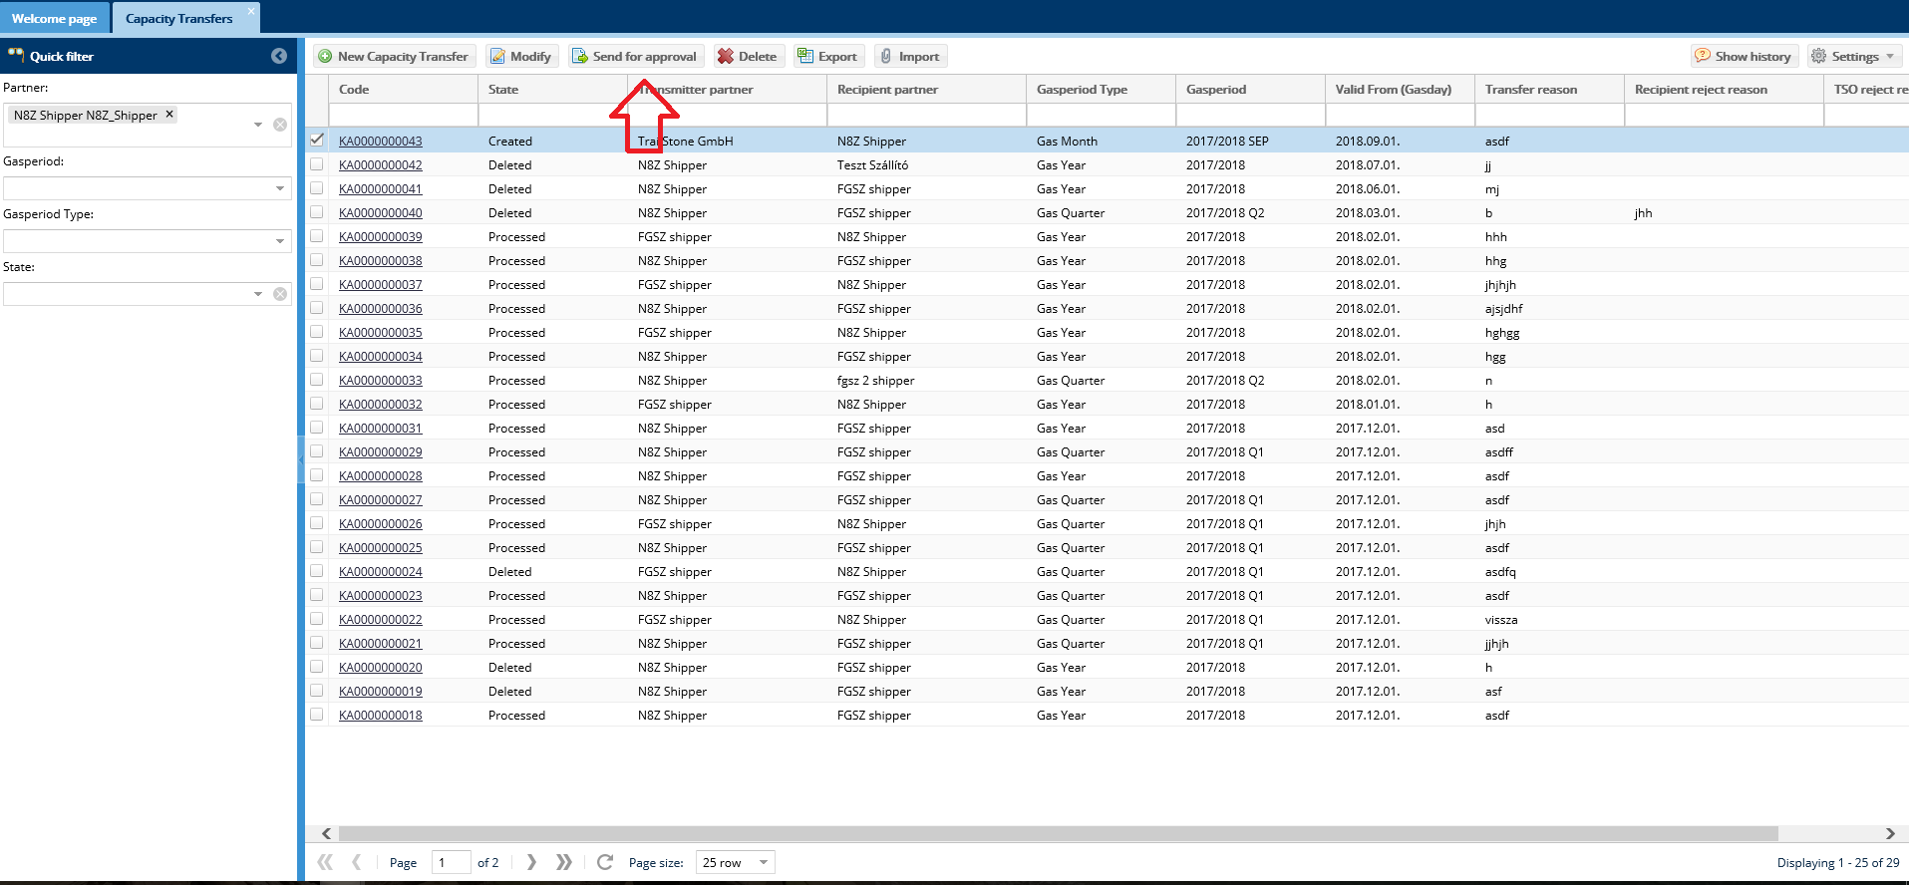

Recipient partner accepts a manually recorded Capacity transfer
Open the Contracts menu Secondary deals -> Capacity transfer view. Make sure to select Waiting Recipient from Quick filter status selection. Click the selected Waiting Recipient capacity transfer row and click Recipient approve button. The System will ask a confirmation question, and after its approval the selected Capacity transfer plan will change to Waiting for TSO status.

Recipient Partner rejects a manually recorded Capacity transfer
Open the Contracts menu Secondary deals -> Capacity transfer view. Make sure to select Waiting for Recipient from Quick filter status selection. Click the selected Waiting for Recipient capacity transfer row and click Recipient reject button. You will need to justify your decision, and select Save after. The System will ask a confirmation question, and after its approval the selected Capacity transfer plan will no longer be part of the Recipient partner capacity transfer list. For the Transferring Partner the plan status changes to Created with a red background.

Export Capacity transfer
Open Contract menu Secondary deals -> Capacity transfer view or start the function from the Capacity transfers data sheet. The selected capacity transfer row status can be: Created, Waiting for Recipient, waiting for TSO, TSO rejected, processed, deleted. After selecting click Export.
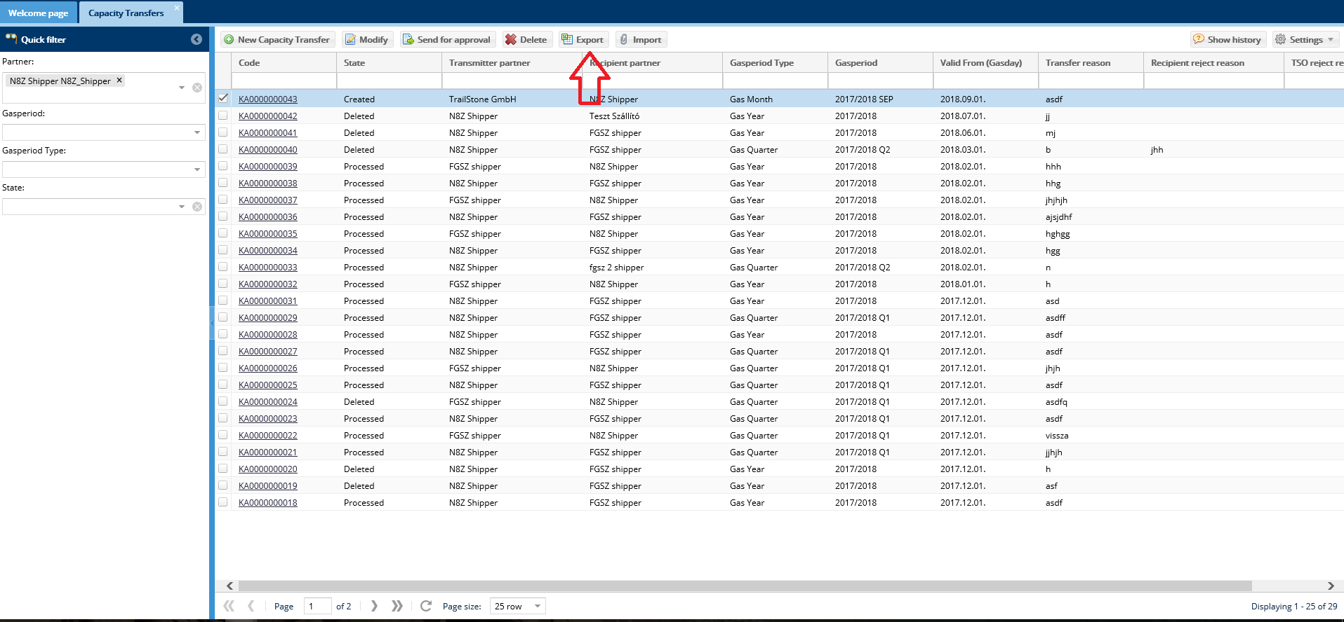
An Excel file will be downloaded from the browser.

Import Capacity transfer
Open Contract menu Secondary deals -> Capacity transfer view or start the function from the Capacity transfer data sheet. Click the selected Created status Capacity transfer row and click Import button.
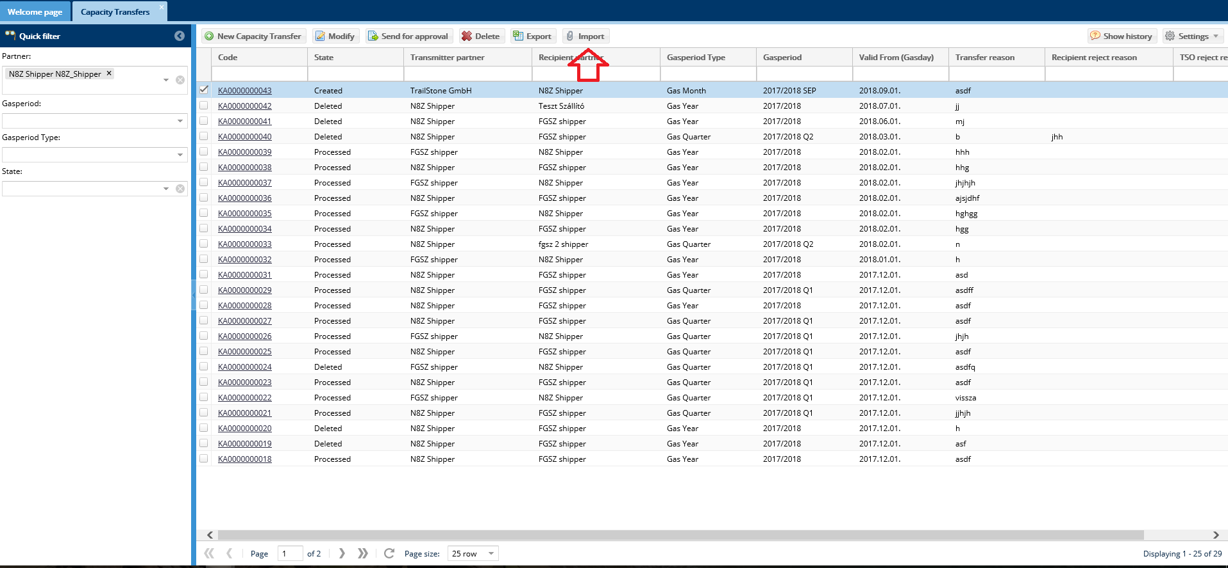
Then the window displays where you may upload the file to be imported via the Browse function. Important notice: You may upload an Excel file to the Customer Migration record, where the export was made from. The details of the Excel file capacity transfer plan worksheet data are to be cross checked with the data of the selected row. Then upon clicking the Upload button the system will make the necessary checks.
After running controls the Excel file data will overwrite the selected Capacity transfer plan data.

Bilat and Anonym market deals
Open the Contracts menu Secondary transactions -> Bilat and Anonym market deals view.
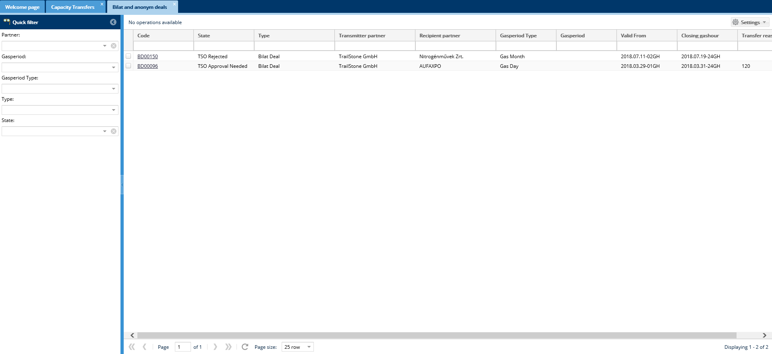
The IP system has a scheduled task to periodically query the KLP system to receive secondary market transactions. They are listed on the screen. Network users can only see secondary market deals if they are Users concerned in the transaction.

CMP locking

List CMP locking
Open the Contracts menu CMP deals -> CMP locking view.

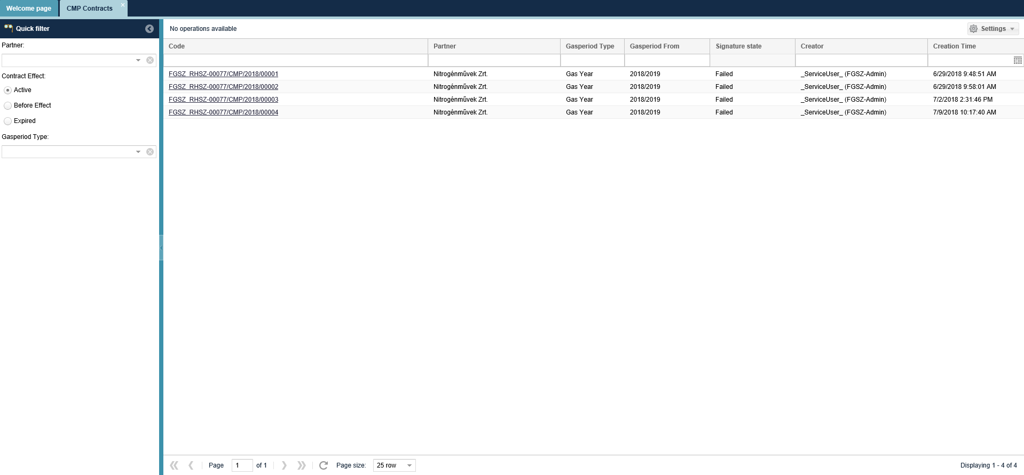
Our own list of LTUIOLI locking is displayed.

View CMP locking
Open the Contracts menu CMP deals -> CMP locking view. Click the link of the Code column.
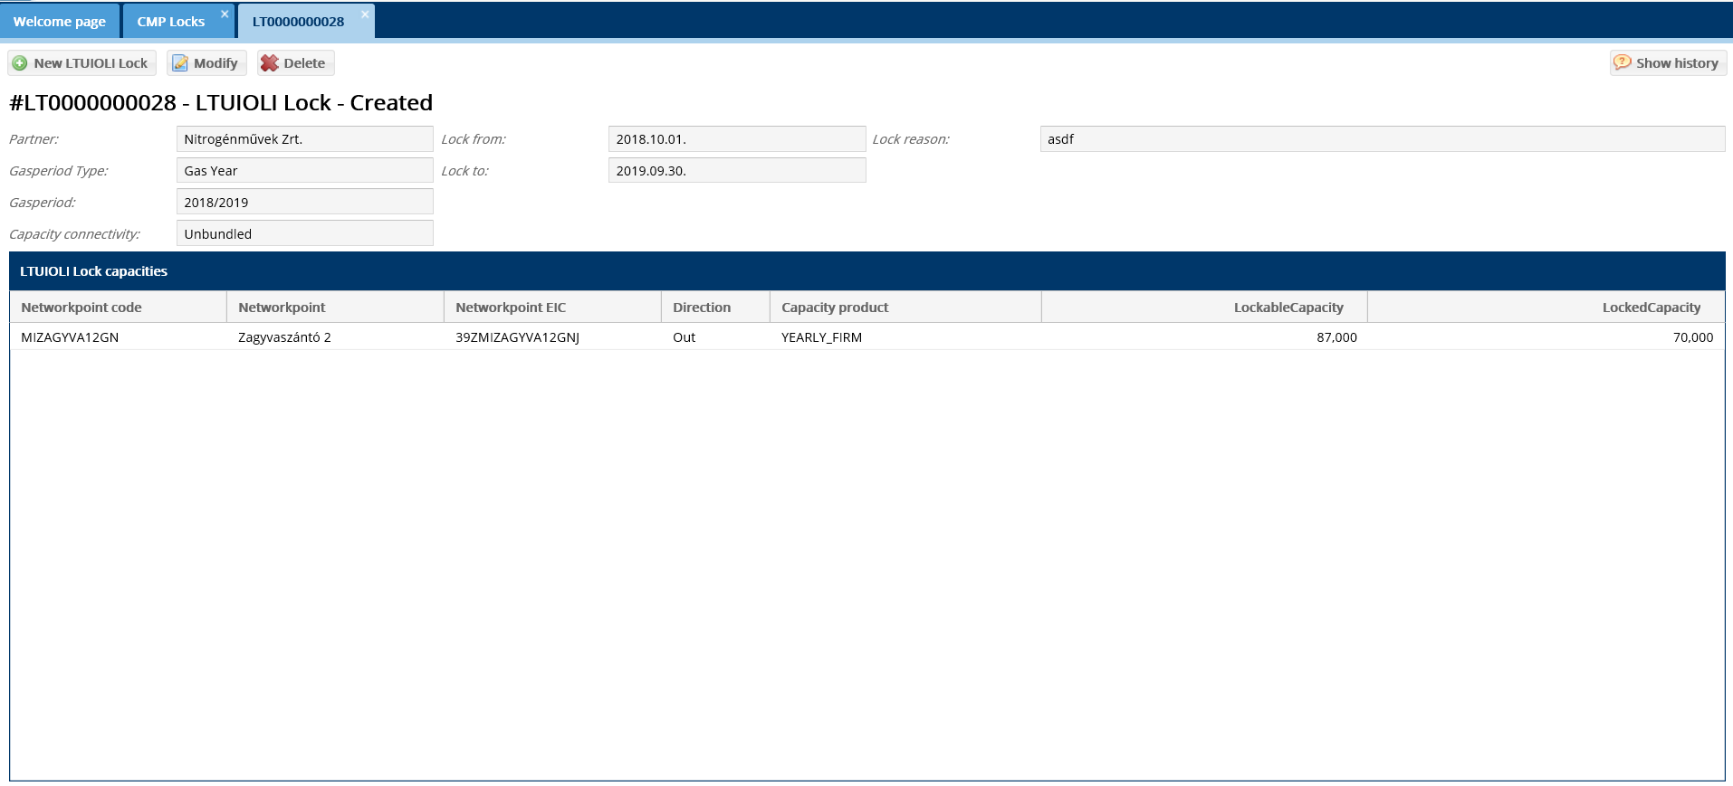The LTUIOLI type CMP locking data sheet displays.

CMP contracts

List of CMP contracts
Open the Contracts menu CMP transactions -> CMP contracts view.

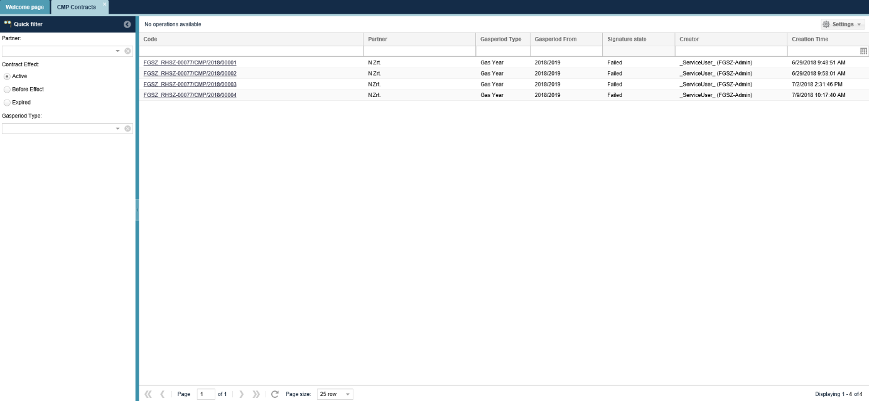
Our own list of contracts is displayed.

View CMP contracts
Open the Contracts menu CMP deals -> CMP contracts view. Click the link in the Contract number column.

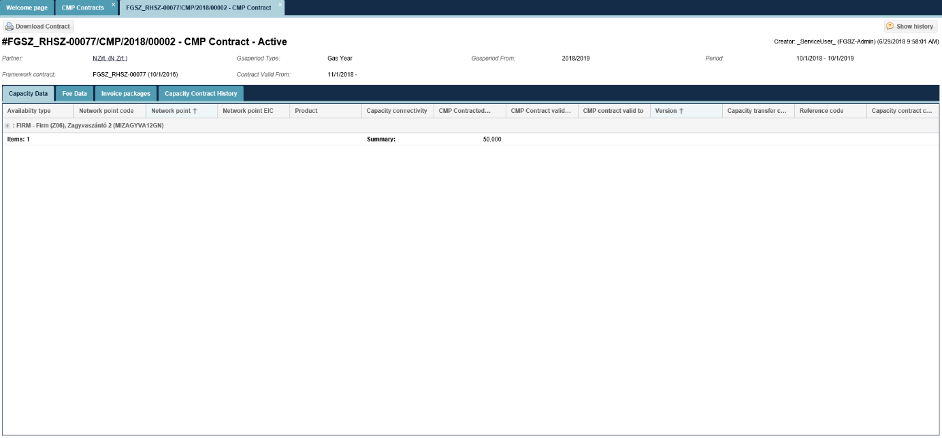
The data sheet of the selected CMP contract displays and also the related capacities and charge data on different worksheets. If there is any contractual document generated or signed for the contract, a button for Download signed contract will be active.

Download CMP contracts
Open the Contracts menu CMP transactions -> CMP contracts view. Select the contract to download and after selection, please click Download contract button.
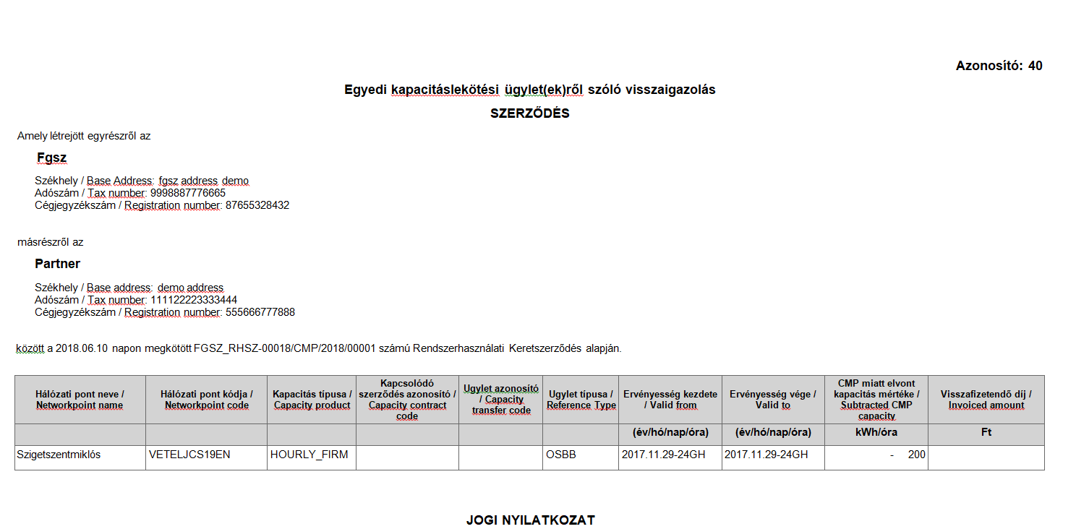
Upon the approval of the confirmation question the system will download the contract from the browser in a pdf file.

Capacity Conversions
Capacity conversion means the conversion of a unbundled capacity a Shipper previously purchased and converting it to bundled capacity. Capacity conversion demands arrive from KLP and the IP automatically evaluates the demand. When evaluation is successfully completed, the Capacity contracts are amended (via this creating Capacity library, Coverage and Account plan rows), and on informing KLP on the acceptance of the demand. When evaluation is unsuccessful only KLP is notified of the reasons and the fact of rejection, and KLP sends a notice to the Shipper in relation to this.

List capacity conversions
Open the Contracts menu Capacity conversions view.
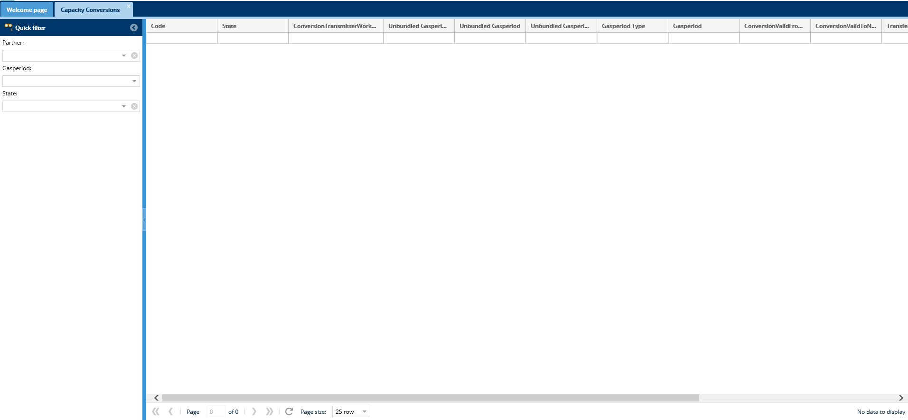
Our own list of capacity conversions is displayed.

View capacity conversions
Open the Contracts menu Capacity conversions view. Click the link in the Code column.

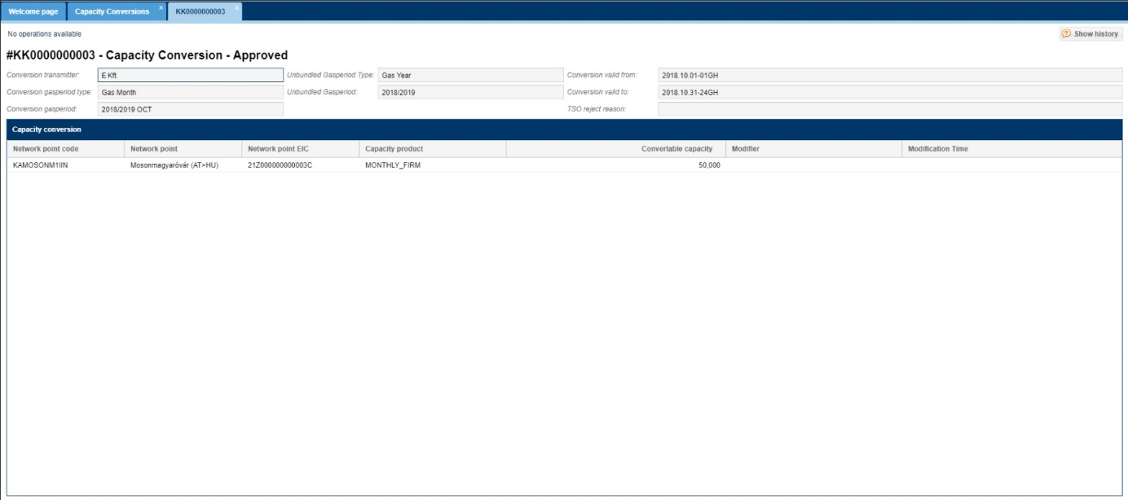
Capacity conversion data sheet is displayed.

Allocation

List allocation items (also with OBA accounting)
Open the Allocation menu Allocation Details view.

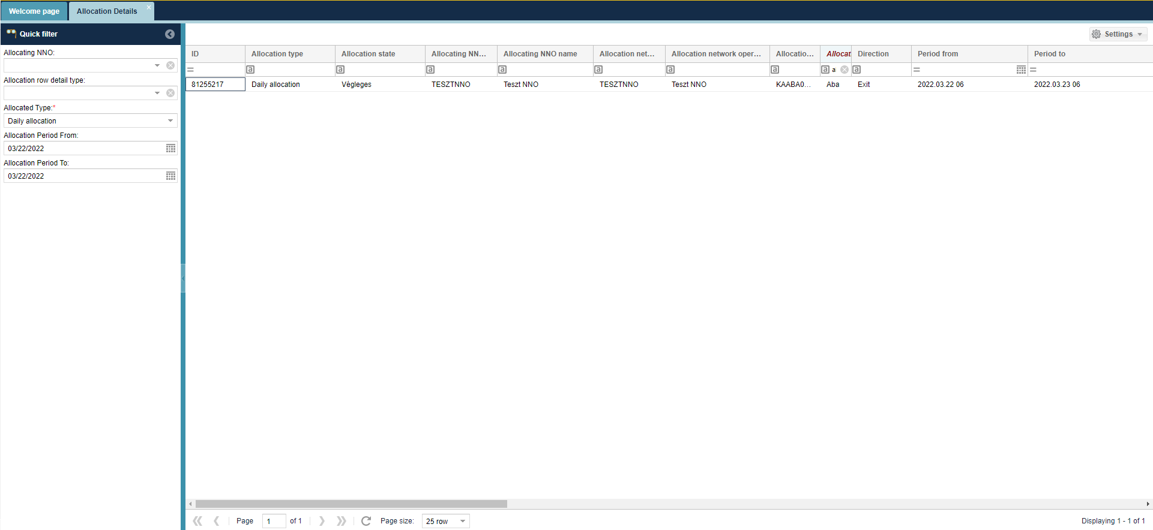
Allocation Details are shown in a list form: per network point, for gas days, and in a breakdown related to system operators Network user– RH partner. From each list of items the last version is displayed.
The interface allows quick filtering for the following fields:
• Allocating NNO: When logged in with an NNO user, the field takes the name of the logged in NNO by default and cannot be changed; Allocation NNO is the partner specified by the IP network point that performs the allocation tasks. If the NNO and Allocating NNO are different partners at the IP network point, only the Allocating NNO will see the allocation queues for the corresponding points.
• Allocation row detail type: You can search by allocation row detail type.
• Allocated type: You can search by allocated type.
• Network point: You can search for a network point name and code, you can enter more than one value at a time.
• Start of period: current day by default
• End of period: current day by default

Accounting / Invoicing

Document library

List document library
Open Settlement menu Generated Reports view. Download function will be available by clicking a row.
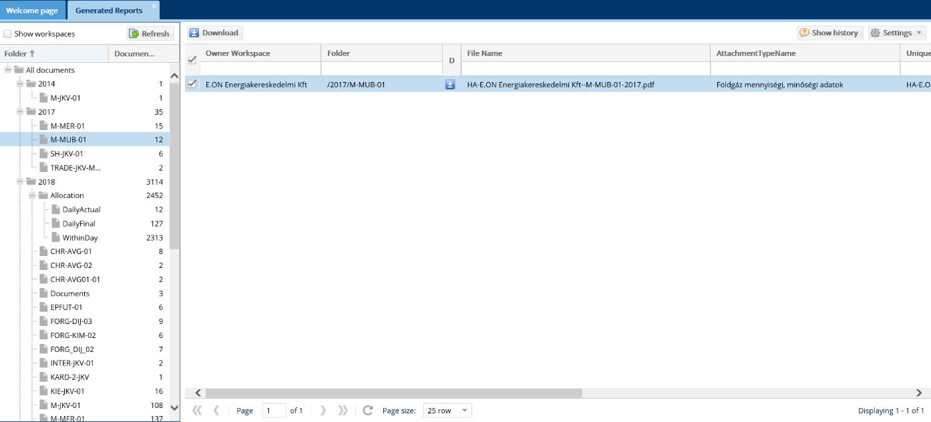
The document filter list option displays. Document hierarchy can be viewed in the left folder view. Network users can only see their own documents.

Downloading documents
Open Settlement menu Generated Reports view. Select folder and click Download button or the icon in the Download column.
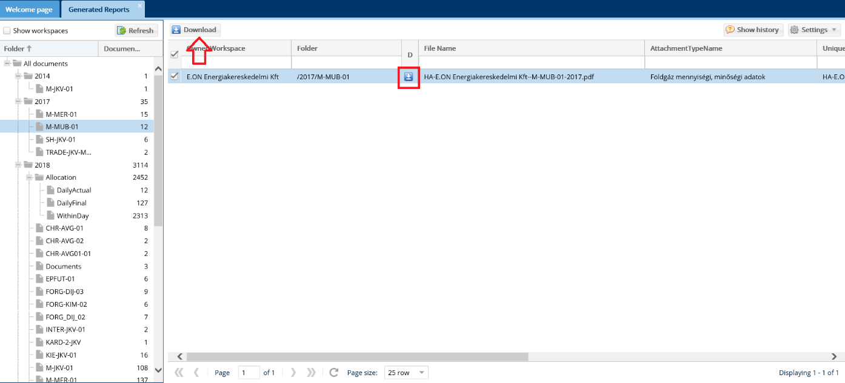
The file is downloaded and the system offers to save or open the document. In the document type column you can find in what format the file is downloaded. Network users can only download their own documents.

List Daily Close Shipper Balance
The shipper balance items, which are created as part of the gas day closing, can be viewed on a separate menu in the system, it is a list, with the option of filtering and exporting.
Open Settlement menu Daily close shipper balance view.

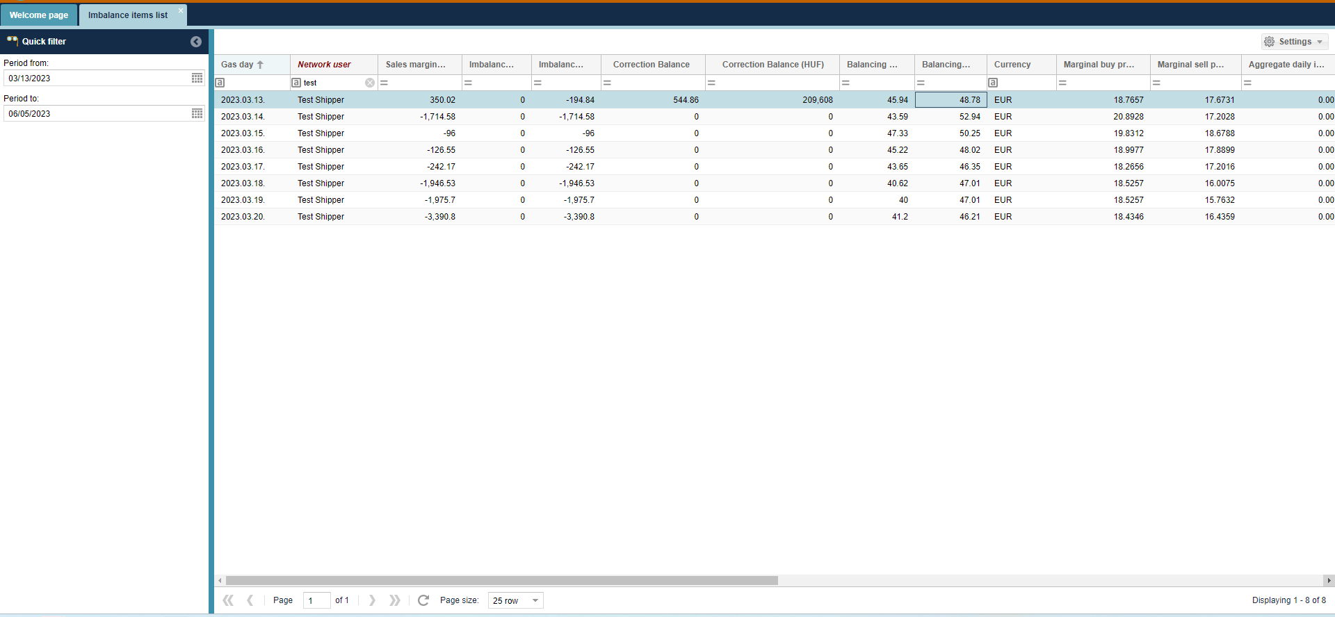
Daily Close Shipper Balance items are displayed in a chart form. The “Final daily input (kWh)”, “Final daily off-take (kWh)” and the “Aggregate daily imbalance (kWh)” for the given day are also modified by the value of the LPFS quantity.
In the list you can also view the correction balance values calculated during the distribution of results applied in the Monthly Close with Correction (the "Correction balance (HUF)", and the "Correction balance" - this is the EUR value here), on the gas day when the correction was calculed.
Network users can only see their relevant items.

Collateral
Network users have to offer collateral to guarantee for their obligations related to contracts, capacity purchase and use to the system manager. Collateral function group has the task to register, follow and manage these coverages, and to ensure that the Network user does not exceed the guarantee made available during system use.

Collateral accounts

List collateral accounts
Open Settlement menu Collateral -> Collateral accounts submenu. On the left of the screen enter the relevant date for the filter.
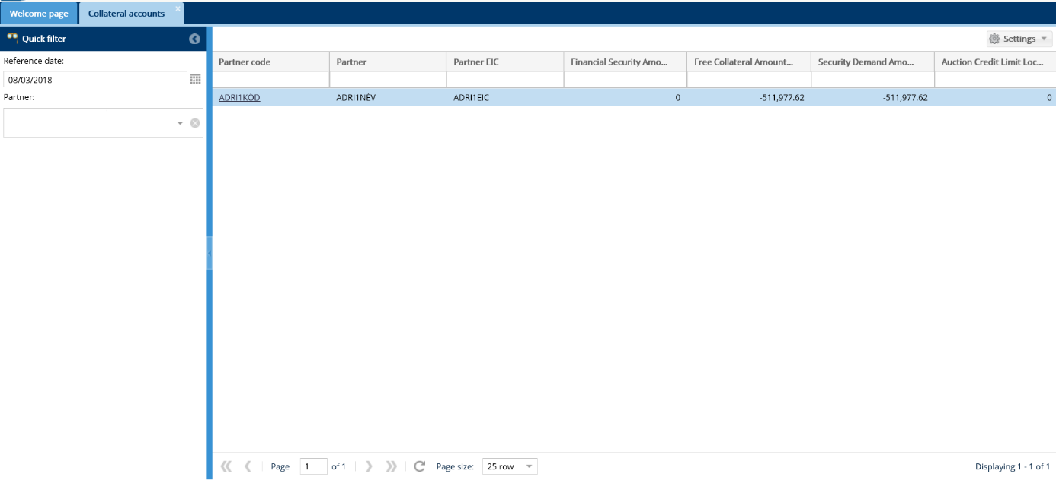
Only the free collateral of the Network user on a given own date will appear on the listing screen.
Reference date filter is valid for a gas day. We can display rows based on the reference date until the end of the gas day.
In the Released Row ID field link you may find rows with Release document where the relevant released row ID is displayed. Upon clicking the link the data sheet of the released row displays.

View collateral accounts
Open Settlement menu Collateral-> Collateral accounts submenu. Click the link of the selected account in the Partner code column.
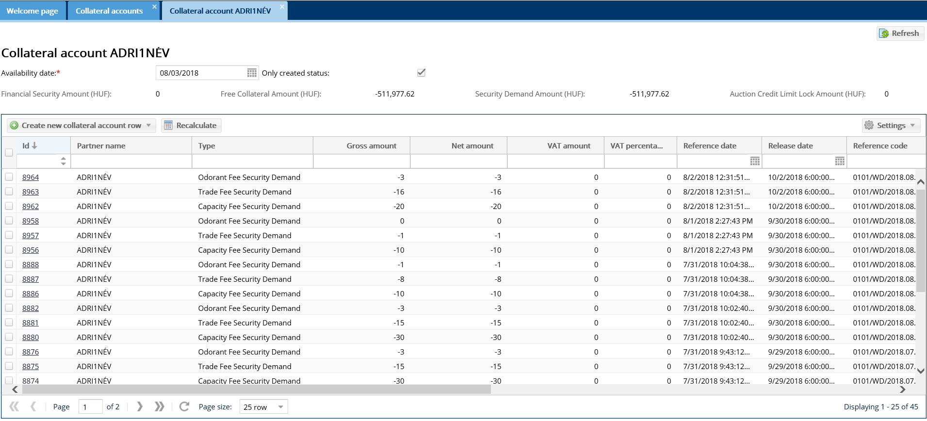
The selected collateral account data sheet and the collateral account rows displays.

Declaration of participation in an auction
The network user has the opportunity to declare his intention to participate in the annual and quarterly capacity auction - up to the 15th day before the start of the auction.
Submission of the declaration is not a condition for participation in the auction. If the declaration has not been made for a certain period of time (typically 15 days before the start of the auction), the system will automatically classify the partner in the worst (C – highest) category.
Open Settlement menu Collateral-> Collateral accounts submenu. Click the link of the selected account in the Partner code column. The selected collateral account data sheet displays. Select the "Statement" tab sheet.
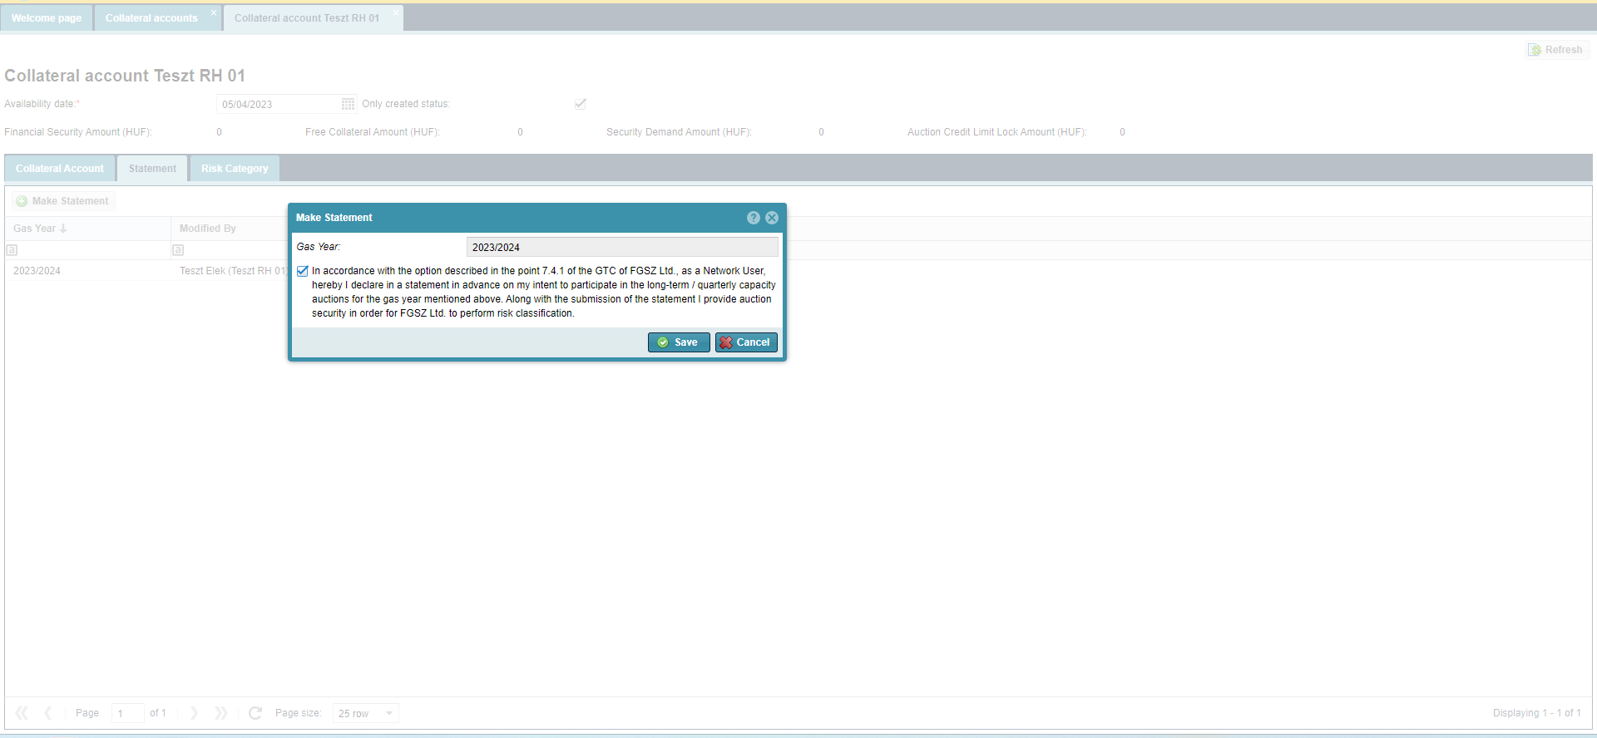
The process:
1. Click on the "Make Statement" button, which will cause the "Make Statement" pop-up window to appear, where the "Gas Year" field to which the declaration applies is automatically filled in (cannot be modified)
2. Clicking on the check box in front of the declaration text, the declaration is made
3. Then select the "Save" button
A new line of items will be added to the list regarding the declaration for the given gas year. An entry is also created on the "Risk Category" tab sheet, the status of which is "Categorisation in Progress", in which case the "Risk Category" column is empty, yet.

If the user clicks the "Save" button without checking the check box before the text of the statement, the system displays the following message: "Legal Content is Mandatory!";
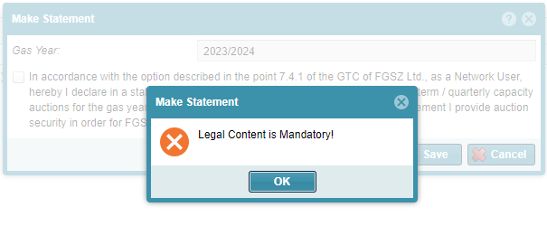
If the declaration has already been made for the given gas year, and it is not possible to declare for another gas year, but the user still initiates the declaration, the system displays the following message: "[WS0027] The partner already made statement about the <code of the gas year> gas year!"
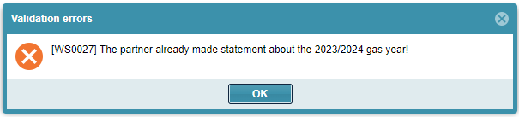
If it is not yet possible to make a statement for the given gas year, but the user still initiates the declaration, the system displays the following message: "[WS0030] The statement can be made from <start date of declaration> for <name of gas year> gas year!"
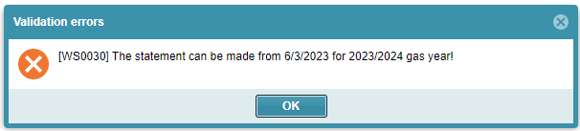
You can only make a statement once per gas year, and this declaration cannot be modified or canceled in the future.

View risk categories
Open Settlement menu Collateral-> Collateral accounts submenu. Click the link of the selected account in the Partner code column. The selected collateral account data sheet displays. Select the "Risk categories" tab sheet.
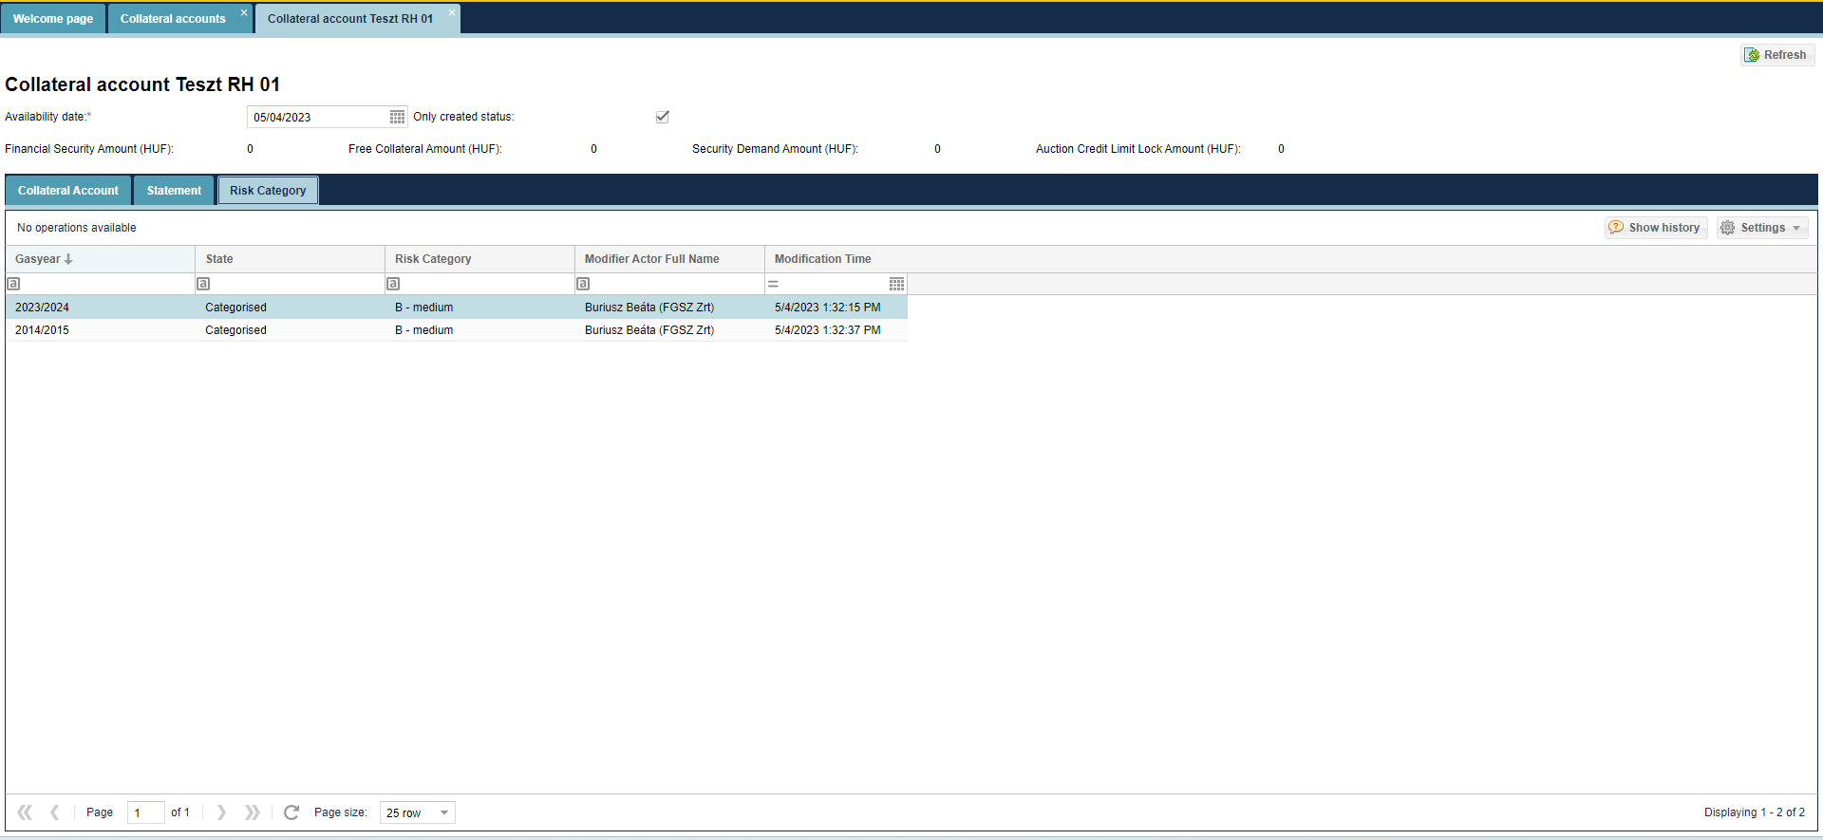
After the classification is done, the status of the item in the list will be "Classified". If the classification was done automatically, because the system user did not declare for the given gas year, the status of the item will be "Automatically classified".
In addition, an e-mail notification with template CA0005 is sent to the system user whose classification has been made or changed.

Collateral account rows

List collateral account rows
Open Settlement menu Collateral -> Collateral accounts submenu or click the link of the collateral account list in the ID column. Filter options can be activated on the left of the screen.
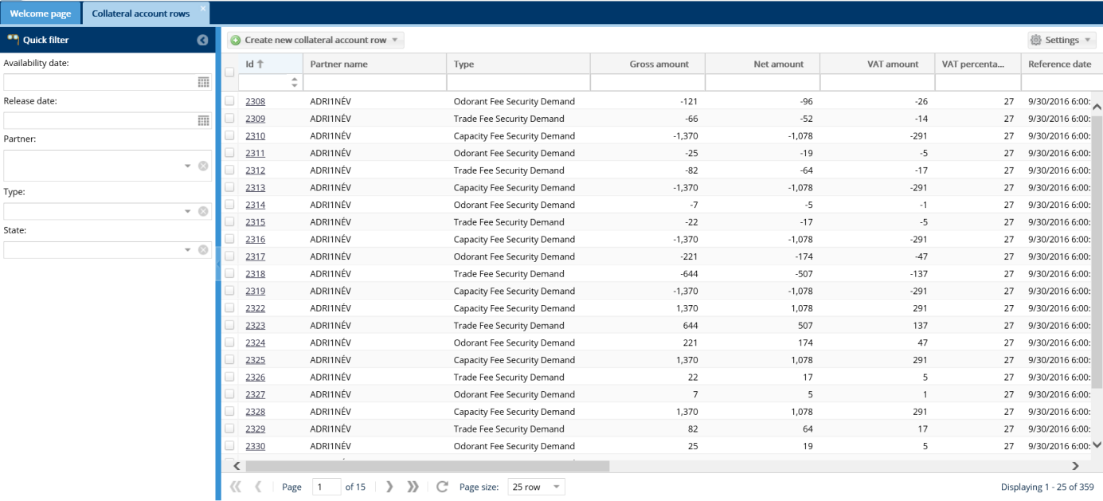
A screen will display to list collateral account rows according to possible filter criteria.

View collateral account row
Open Settlement menu Collateral -> Collateral accounts rows submenu. Click the link of the selected account in the ID code column.
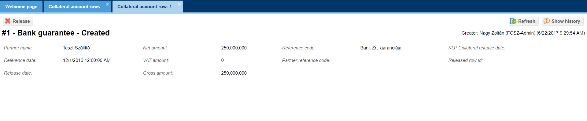
The data sheet of the selected collateral account will display.

List Marginal prices
Open Settlement menu Marginal prices view.
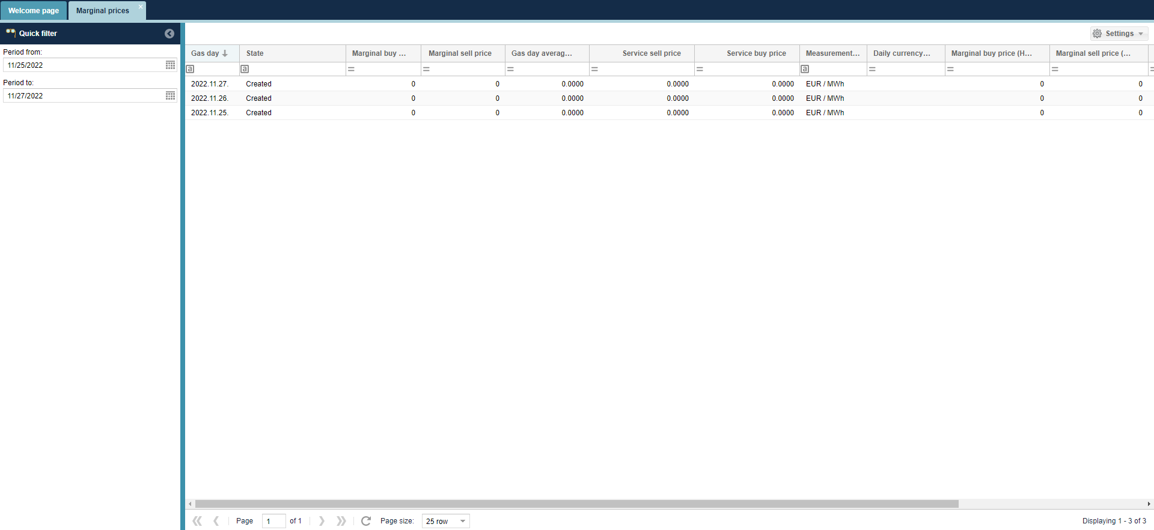
Marginal prices and LPFS prices are displayed in a chart form.

List crisis prices
Open Settlement menu Crises prices view.
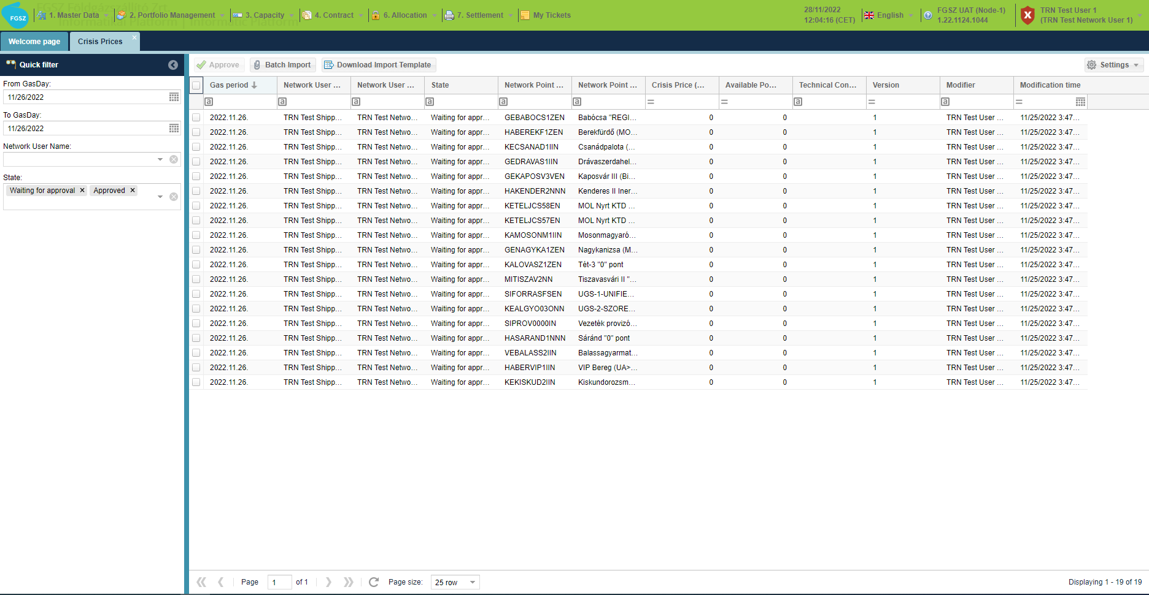
The crisis settlement prices uploaded by the system users and the available source indicated by them are displayed.

Download import template for crisis prices
Open Settlement menu crisis prices view and click Download import template button.
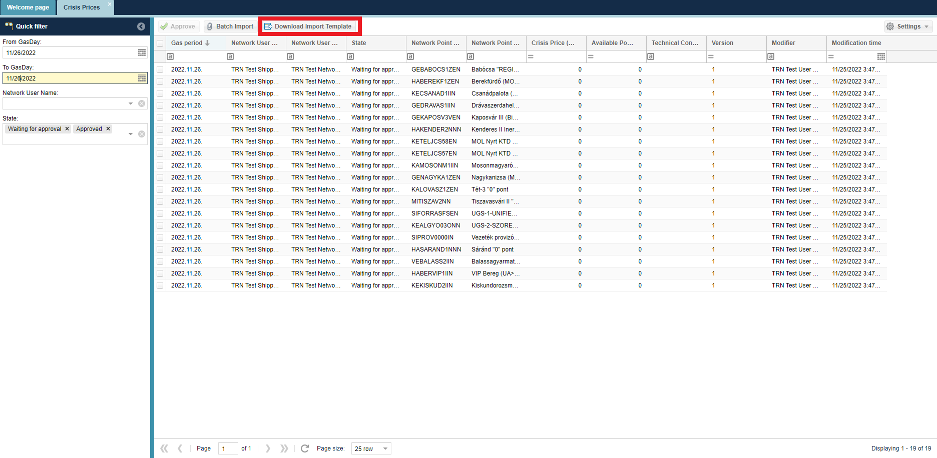

Crisis prices batch import

Open the Crisis settlement prices view of the Settlement / Invoicing menu item and click on the Bulk import button.
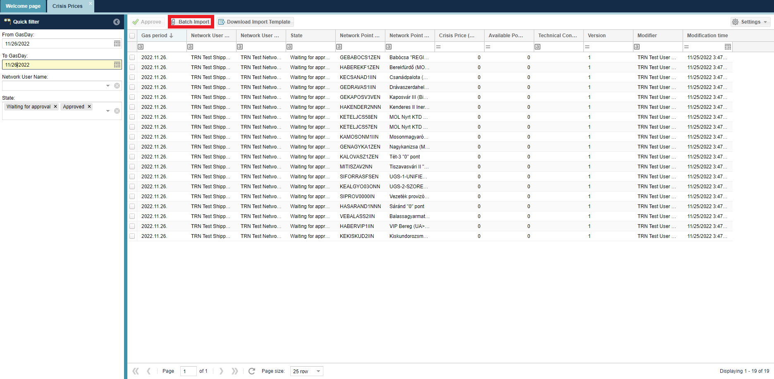
The Crisis Import settlement prices interface appears, where we can upload the file, we want to import using the Browse button. Then, by clicking save, the system performs the necessary checks.
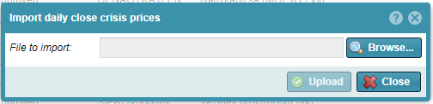
After uploading, the system displays the following message:
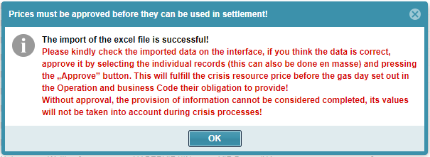

Approve crisis prices
Open Settlement menu crisis prices view and select the Waiting for approval status rows and click Approval button.
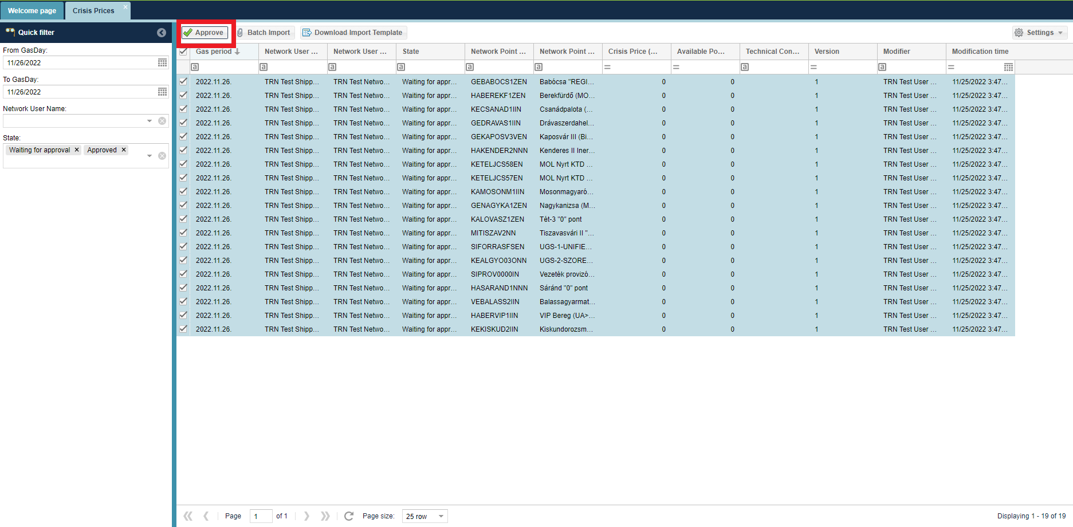

Functions only for Shipper Admin

Partners

Listing partners
Open the Master Data menu Partners view.

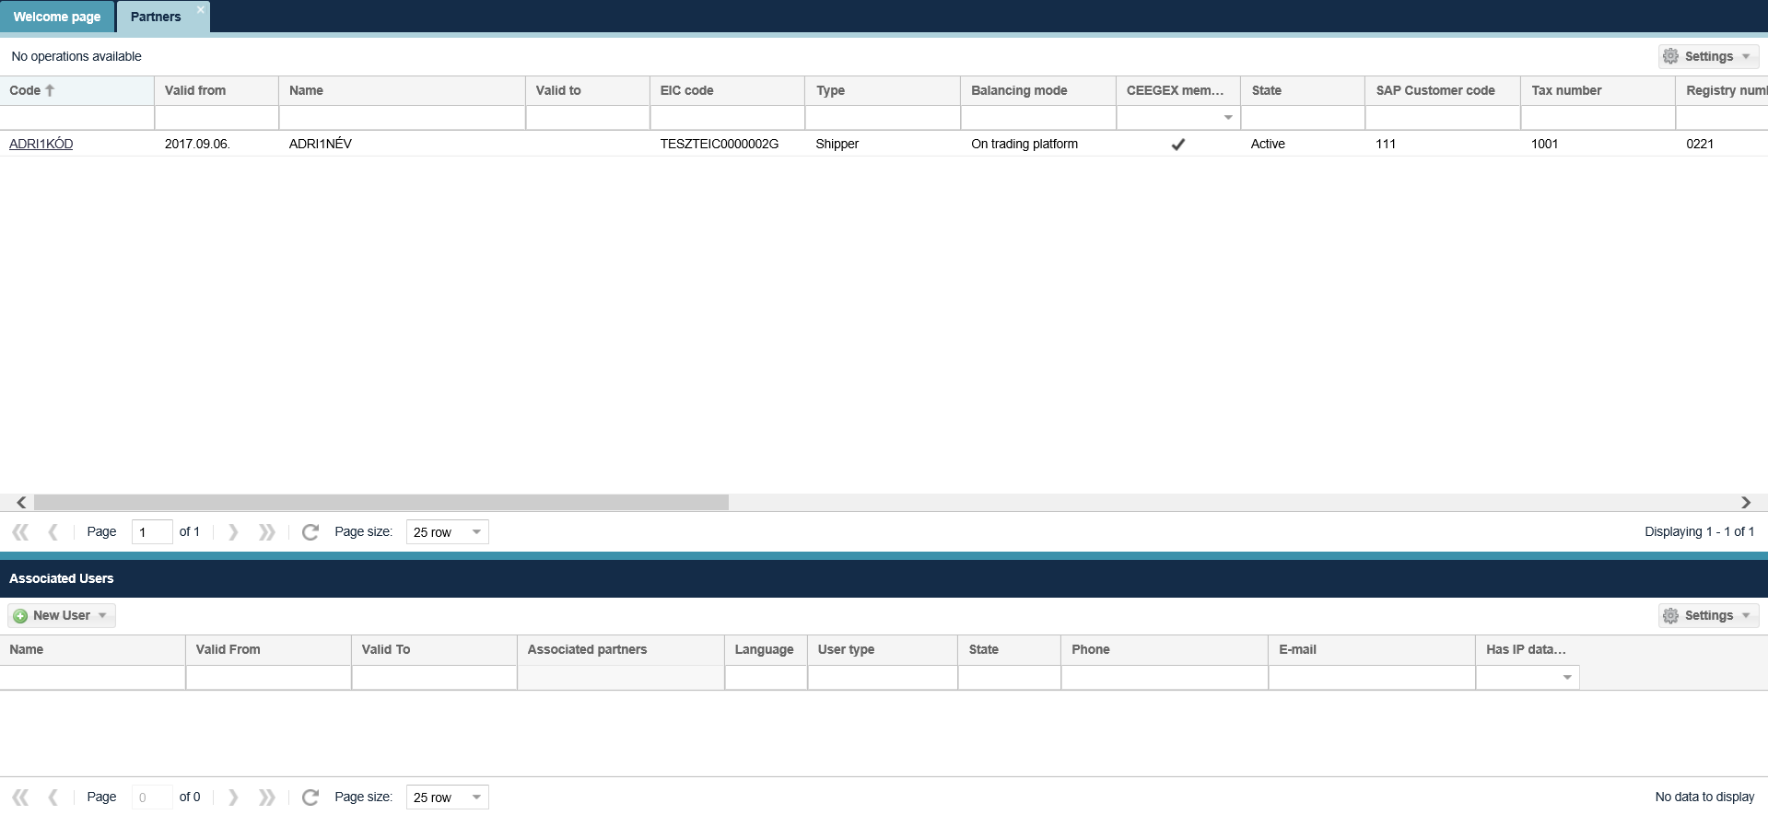
The Partners list screen is displayed. You can see the partners current attributes as well as their code here. The following data are also available in the view: network user subtype, NUMA 1st modification, FGSZ contact person data. Documents related to the partner are available on the Generated reports tab of the partner view.
By clicking Request data modification function, we can create a data modification request.

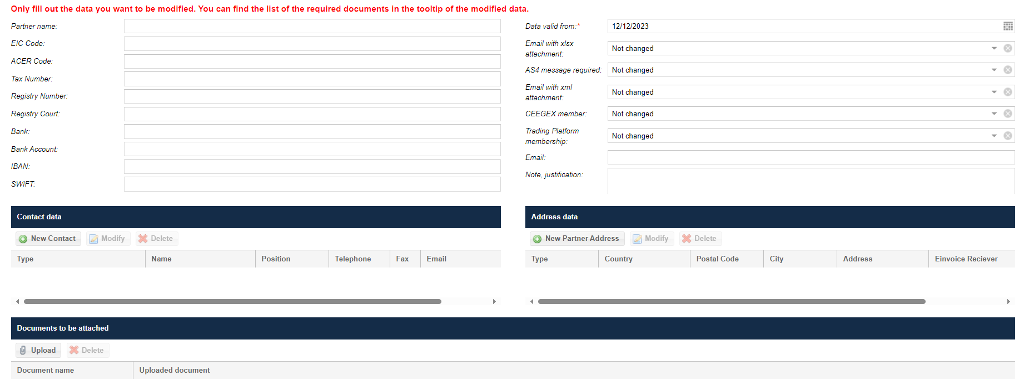

The network user can declare about the acceptance of an e-invoice by giving the e-mail address under the Invoice Address data.

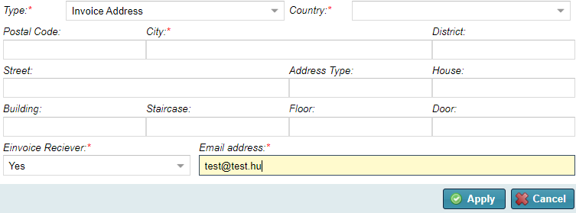

Open Partner management menu, Partner datamodification requests view. The network user can list the requests created its self.

Users

Add New User (for Organization)
Open the Master Data menu Users view.
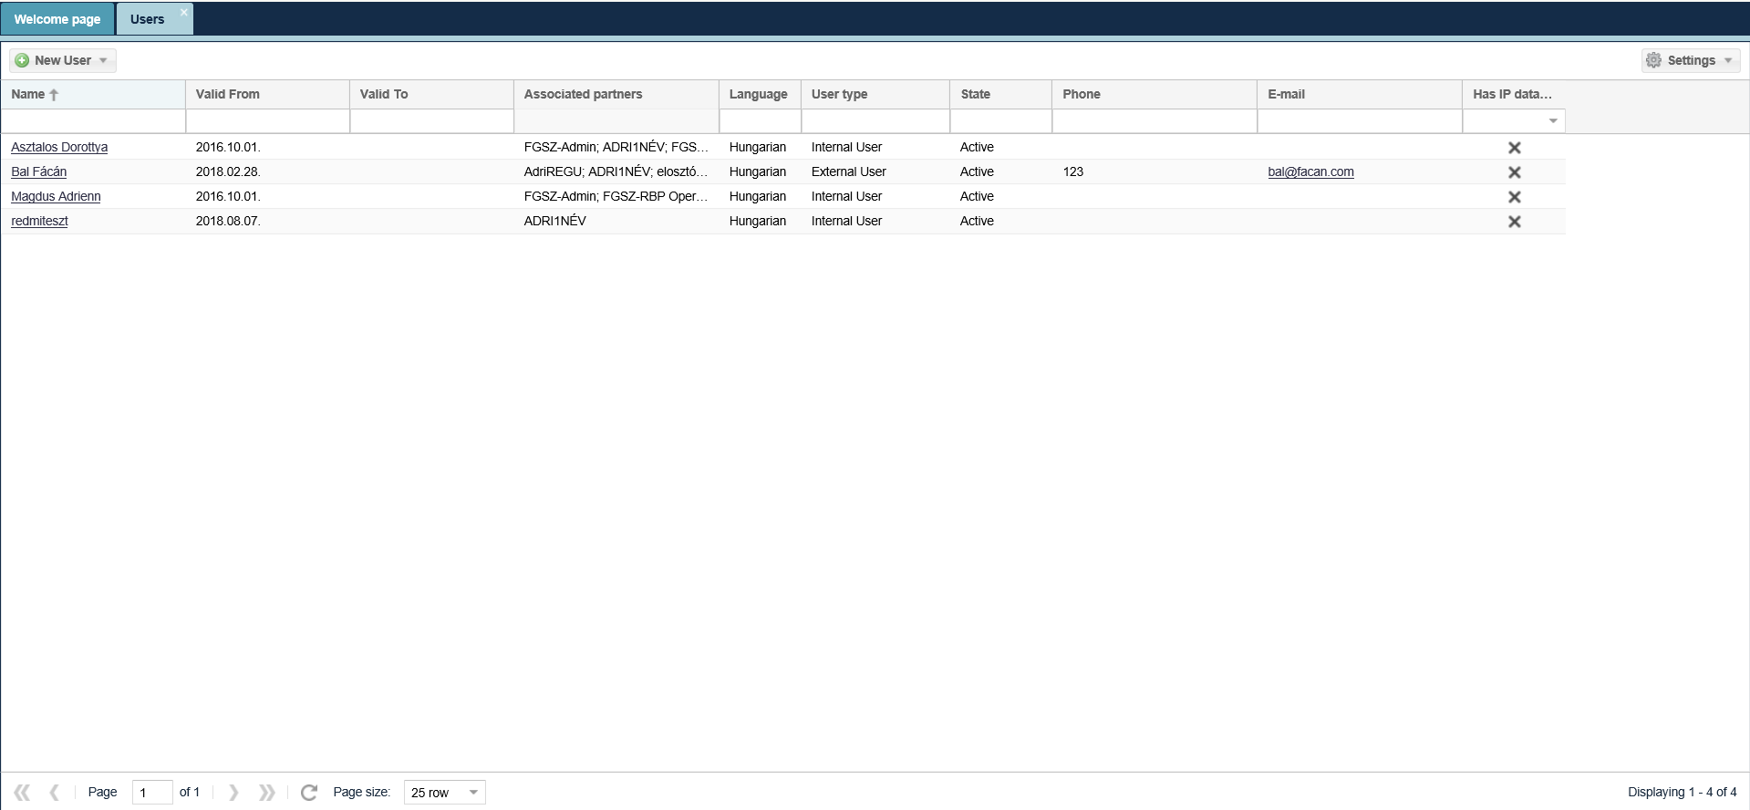
Click on the “New User” button and select the “New User (for Organisation). Then enter mandatory data to the screen that displays and click save. Multifactor authentication is also possible, in which case the power of attorney must be uploaded.
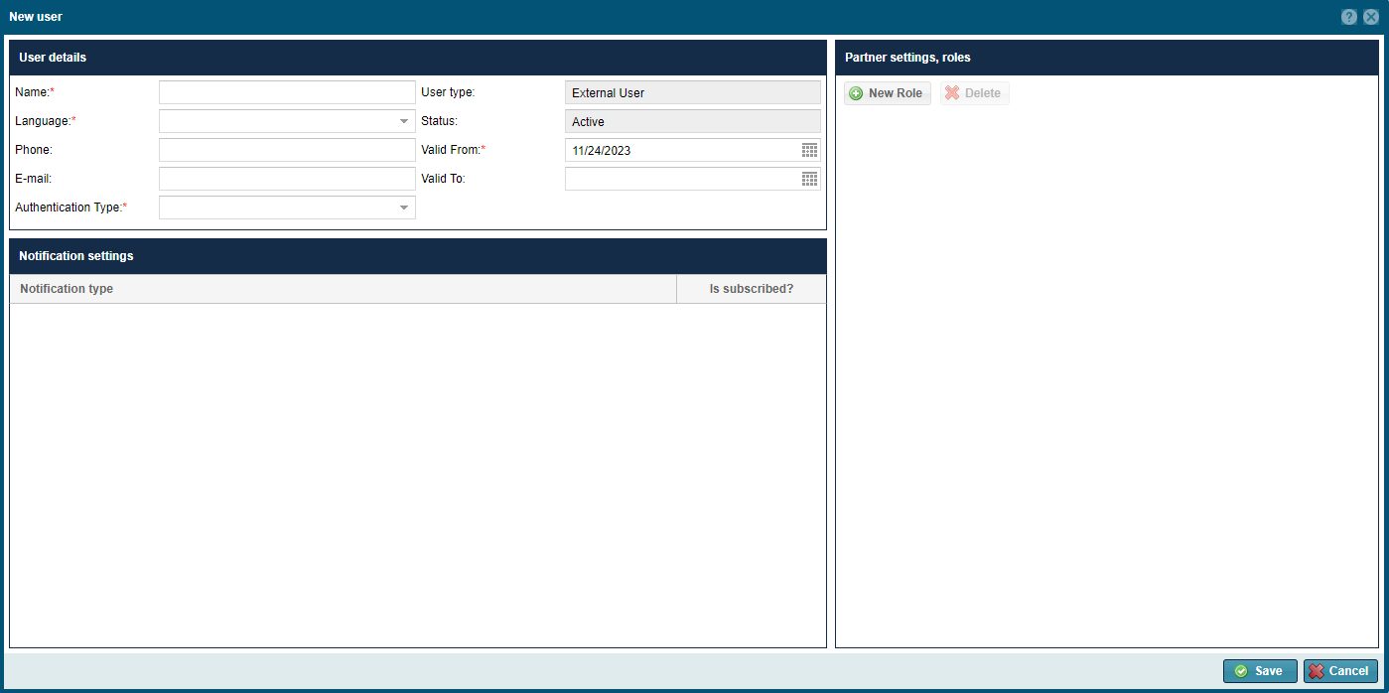
You can also add new partners with a button on the bottom of the Partners view Associated Users section on the sheet.
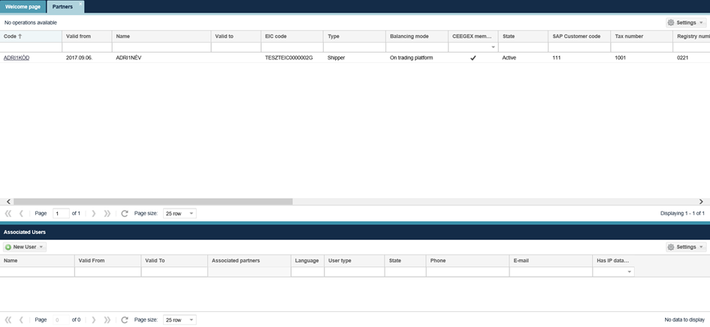

Data transfers
Open the Master Data Data transfers view. This function can be used to view data transfers and related messages. You can download the request and response actions here.

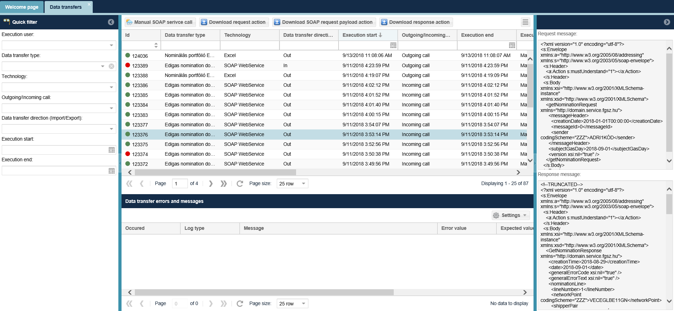

Shipper pair registration

Listing shipper pair registrations
Open the Master Data menu Shipper pair registration view.
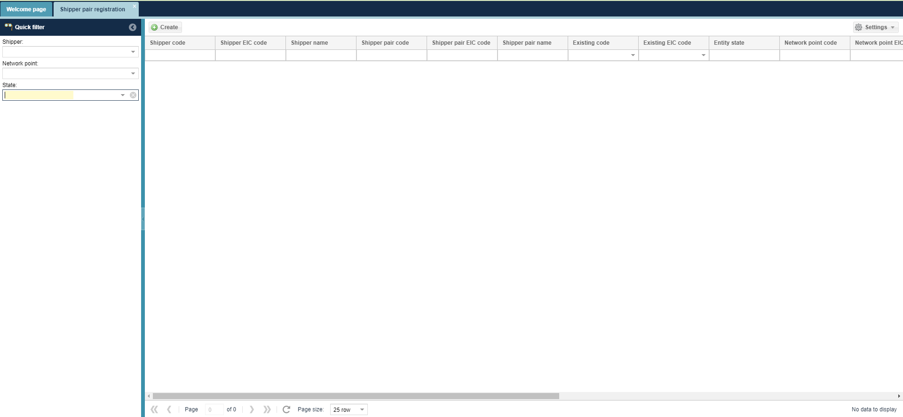

The Shipper pair registration list screen is displayed.

Add new shipper pair registration.
Open the Master Data menu Shipper pair registration view.
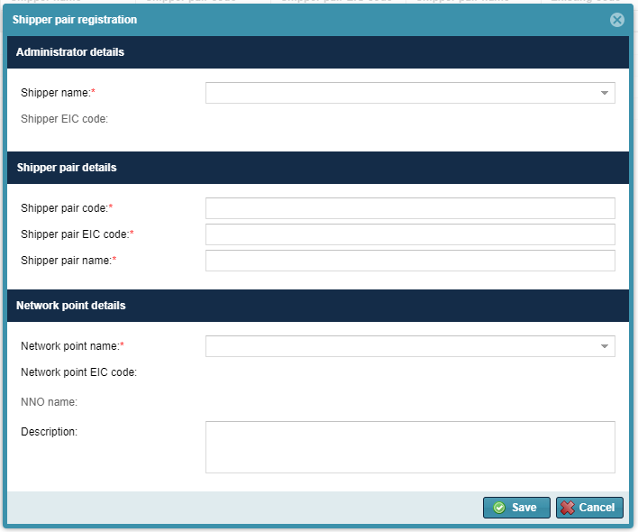

Click on the “Create” button. Then enter mandatory data to the screen that displays and click save.

Edit shipper pair registration
Open the Master Data menu Shipper pair registration view.
Click the selected Created status row and click Modify button.
Change the required data on the editing screen and save it. The data will be saved in the system.

NU counterparty list
Open the Master Data menu NU counterparty list view. You can browse the Network Users and the NU counterparties public data and the related NNO if there is one.
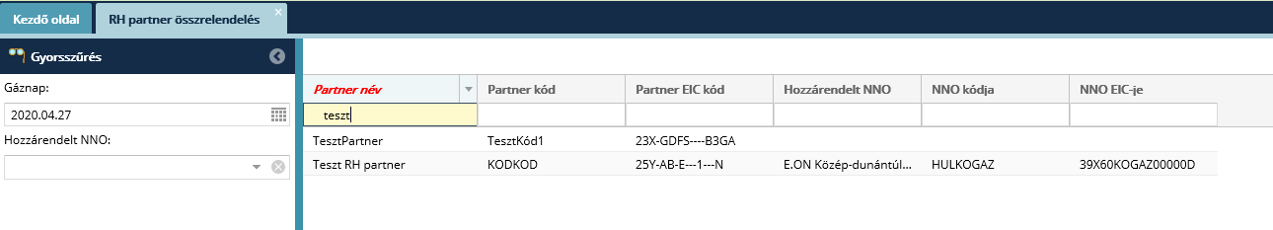

My Tickets
Use the My Tickets button in the menu to open our ticketing tool to report an issue or file a request.

Restriction Data Service

POD master data list

Open the menu item Maintenance/Restriction data service/POD master data. The POD master data loaded into the system will be displayed.

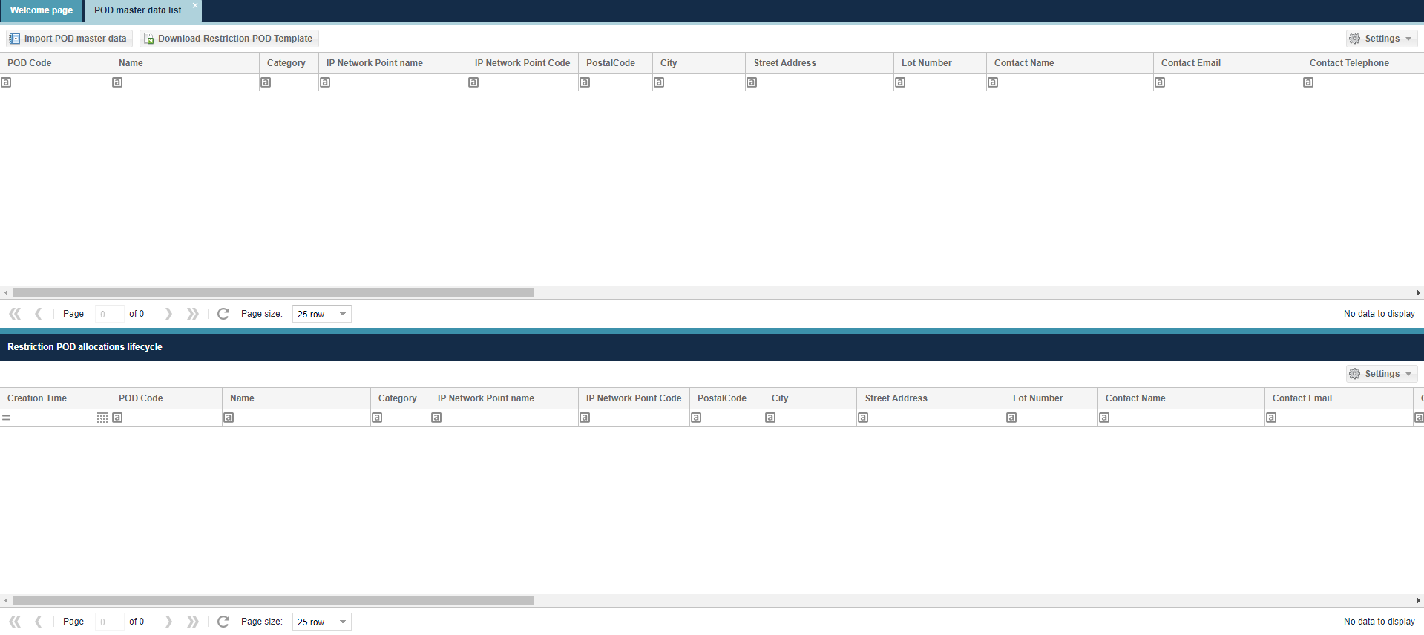

In the list you can view the data sent in the KORTORZS file(s). The system always displays the data corresponding to the last data transfer.

In the 'POD master data lifecycle' list at the bottom of the screen, the previous version of each POD master data is displayed based on the previous data transfers.

Import POD master data

Open the menu item Maintenance/Restriction data service/POD master data. Click on the "Import POD master data" button in the header.

This will display the "Import POD master data" window. Click on the "Browse" button to select the Excel file to upload. The user then clicks on the "Upload import file" button.

The system will inform the user in the "Import Result" window that the file upload was successful and the system has started the verification.
If processing is successful, the uploaded data will be displayed in the list.

The system will inform the user in the "Import Result" window that the file upload was successful, the system has started the verification.

The system sends an e-mail notification of the import result to the operational contact of the submitting partner ((LI0001) Restriction classification SFTP import).

The result of the import can be viewed in the 'Master data' menu under 'Data Transfers. In the Korlátozási beosorlás folder, select the data transfer type "Restriction KORTORZS CSV file import".

Error codes:
Error code | Error message
LI0001 | The number of columns {0} is not proper! Line=[{1}]
LI0002 | Wrong data type: line =[{0}], column=[{1}]
LI0003 | The field is mandatory: line=[{0}], column=[{1}]
LI0004 | Name of the file {0} is not proper!
LI0005 | The content of the file does not correspond to a CSV file with UTF-8 encoding.
LI0006 | The size of file can not be greater than 100 MB.
LI0007 | The file contains illegal characters.
LI0105 | The value of the „Vegrehajtasra rend.Idotart. (ora)” field must be between 4 and 72!
LI0107 | The {0} Network Point limitation POD owner is not the FGSZ!
LI0108 | The value of the"POD azonosito" field ({0}) is not the same as the POD code ({1}) given at the Network Point!
LI0109 | The value of the "Halozati pont" field ({0}) is not matching with the Code field of any valid Network Point!
LI0110 | The value of the "Halozati pont EIC-kodja" field ({0})is not the same as the POD code ({1}) given at the Network Point!
LI0116 | Invalid Limitation category {0}. Valid values are: 1, 2 , 3!
LI0122 | The 'Valid to' field {0} cannot be earlier than the current day!
LI0125 | The value in the '{0}' field ({1}) does not match the value stored for the current restriction action ({2}). During the restriction , the '{0}' field cannot be modified!
LI0126 | If the value of the '{0}' field is NEM, then the '{1}' field cannot be filled!

