User manual IP – System Operator / NNO - v2.8
0 Version control
Date | Author | Version | Change
2020.02.18. | Lajtos András | 1.1 | Master copy created
2020.06.10. | Szernai Judit | 2.0 | 2020 developments shipment 1
2020.12.10. | Szernai Judit | 2.1 | HLD 2020 3. package - Allocation
2021.08.11. | Bandi Zsuzsa | 2.2 | Filter bars
2021.11.16. | Magdus Adrienn | 2.3 | Login informations
2022.03.10. | Bandi Zsuzsa | 2.4 | My Tickets
2022.03.28. | Szernai Judit | 2.5 | Allocating NNO
2023.10.25 | Bandi Zsuzsa | 2.6 | Data modification request
2023.11.24 | Bandi Zsuzsa | 2.7 | MFA
2023.12.15. | Szernai Judit | 2.8 | Restriction data service

Table of Contents
1. General framework functions 4
1.1 Settings 4
1.2 Filter fields 4
1.3 Hide or show columns 8
1.4 Quick filters 8
1.5 Exporting 10
1.6 History 10
1.7 Shortcut keys 11
1.8 Refresh 11
1.9 Forward 12
1.10 Field check 12
1.11 Layout 13
2. Login informations 14
2.1 Certificate expiration 14
2.2 Setting the language of the system 15
2.3 View Own privileges 15
2.4 View current workspace 16
3. Menu structure 17
4. Closing nomination 17
4.1 List cycle documents 17
4.1.1 Type of cycle documents 18
4.2 View cycle documents 19
4.3 View matching results 20
4.4 View closing results 22
4.5 Cycle document Excel export 22
4.6 Cycle document Excel import 23
4.7 Cycle document XML Export 24
5. Capacity 24
5.1 Capacity demand forecast 24
5.1.1 Data provisions 24
6. Allocation 27
6.1 List hourly allocations 27
6.1.1 View hourly allocation data sheet 28
6.2 List allocations within day 29
6.2.1 Allocation within day data sheet 30
6.3 Edit allocation within day data 32
6.4 MASS export of allocation within day data 33
6.5 MASS import of allocation within day data 34
6.6 List daily allocations 34
6.6.1 View daily allocation data sheet 35
6.7 Edit daily allocation data (balanced allocation) 37
6.8 MASS export of daily allocation data 38
6.9 MASS import of daily allocation data 39
6.10 List monthly allocations 40
6.10.1 View monthly allocation data sheet 40
6.11 Edit Monthly (correction) allocated data (balanced reallocation) 42
6.12 MASS export of monthly allocation data 43
6.13 MASS import of monthly allocation data 44
6.14 List allocation details (also with OBA accounting) 45
6.15 List peak hour allocations 46
6.15.1 View peak hour allocation data sheet 47
6.16 Edit peak hour allocation 49
6.17 MASS export of peak hour allocation data 50
6.18 MASS import of peak hour data 51
6.19 List Peakhour by nomination row 51
6.19.1 View Peakhour by nomination row data sheet 52
6.20 Edit Peakhour by nomination row 54
6.21 MASS export of Peakhour by nomination row data 54
6.22 MASS import of Peakhour by nomination row data 56
7. Settlement 56
7.1 Browse Reports 56
7.1.1 List generated reports 56
7.1.2 Downloading documents 57
7.1.3 Upload documents 57
8. Maintenance 58
8.1 List maintenance works 59
8.2 List NNO maintenance works 59
8.3 NNO Edit maintenance works 60
8.4 Excel import by NNO 61
9. Functions only for NNO Admin 62
9.1 Partners 62
9.1.1 Listing partners 62
9.2 Users 63
9.2.1 Add New User (for Organization) 63
9.3 Data transfers 64
9.4 Measurement 65
9.4.1 Listing Daily Measurement data – to elementary point 65
9.4.2 Listing Daily Measurement data – to Network point 66
9.4.3 Listing Hourly Measurement data – to elementary point 67
9.4.4 Listing Hourly Measurement data – to Network point 67
10. My Tickets 68
11. Restriction data service 69
11.1 POD Allocation list 69
11.2 Import POD allocations 69

- General framework functions

Settings
Click settings in the top right corner of list view to access the following functions:
- Display/hide filter fields
- Delete filters
- Save current filter
- Load saved filter
- Restore original column order
- Export
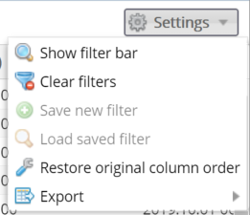

Filter fields
Each view has relevant filters. To view filters they need to be activated on the screen. If filters are not activated, select the Show filter bar button from the top right corner menu.
Or alternatively click the arrow on the top of the column headers and select “Show filter bar”.
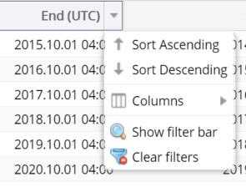
Filter bars will appear on the top of the column headers under the title; and their type depends on whether they contain numerical or alphabetic values. For textual values the following filter criteria can be selected:
- Contains – the text contains the filter expression, in any location
- Starts with – the filter expression is at the beginning of the text
- Ends with – the filter expression is at the end of the text
- Like – filter values matching the given search pattern (the * wildcard character matches any number of any characters)
- Not like – filter values not matching the given search pattern (the * wildcard character matches any number of any characters)
- In – values matching any of the specified elements (separated by semicolons)
- Not in – values not matching the specified elements (separated by semicolons)
- Similar to – text is similar to the filter expression entered
- Empty – search for empty values
- Not empty – search for non-empty fields with any value
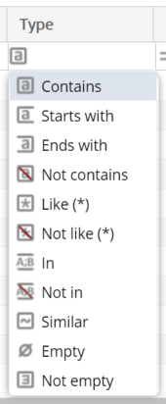
For numerical values and date columns the following filter criteria can be entered:
- Is equal to – the value equals the given number/date
- Greater than or equal – the value equals or is greater than the given number/date
- Less than or equal – the value equals or is less than the given number/date
- Is not equal to – the value does not equal to the given number/date
- Between – the number/date is within the given range (the two values must be separated by a semicolon)
- Not between – the number/date is outside of the given range (the two values must be separated by a semicolon)
- Empty – search for empty fields
- Not empty – search for non-empty fields with any value
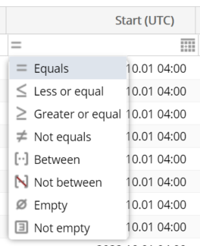
When typing in the filter bar filtering automatically starts shortly after and the searched rows will come up. When a row is filtered the header row turns red and italics. Filter criteria in the field can be deleted by clicking “X”. All filters can be deleted in Settings/Clear filters function.
The column order of the views can be changed as desired by dragging the columns. Use the Restore original column order button under the Settings menu to restore the original column order of the view.
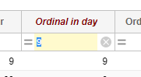
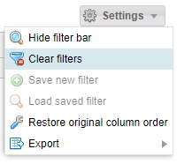
You may set up custom filters to make your work easier, so that you do not have to set up the same complex filters each time.
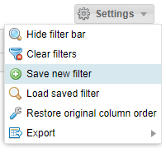
It is sufficient to perform it once, then click “Save new filter” from the “Settings” menu on the right above the list.
Please enter the filter parameters composed previously in the pop up window “Saved filters” and give them a name (one that is easy to identify). Click “OK” to save them.
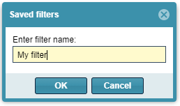
Select “Load saved filters” from “Settings” menu to see the “saved filters” pop up window.
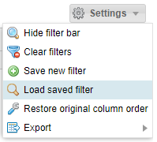
Select the filter you wish to run from the saved filters, then click “Apply filter”.
It is possible to delete the selected filter parameter select “Delete filter”.
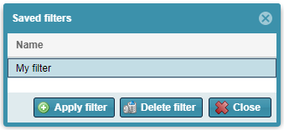

Hide or show columns
In the drop down menu on the top right corner of the column move the mouse over “columns” and tick or uncheck the columns upon your preferences.
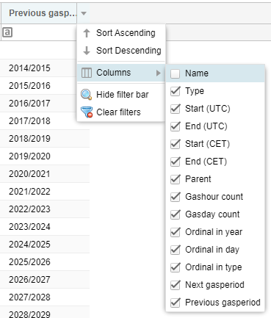

  - Quick filters
This function is available on the left side of the screen for certain views.
When typing in the filter field filtering automatically starts shortly after and the searched rows will come forward.
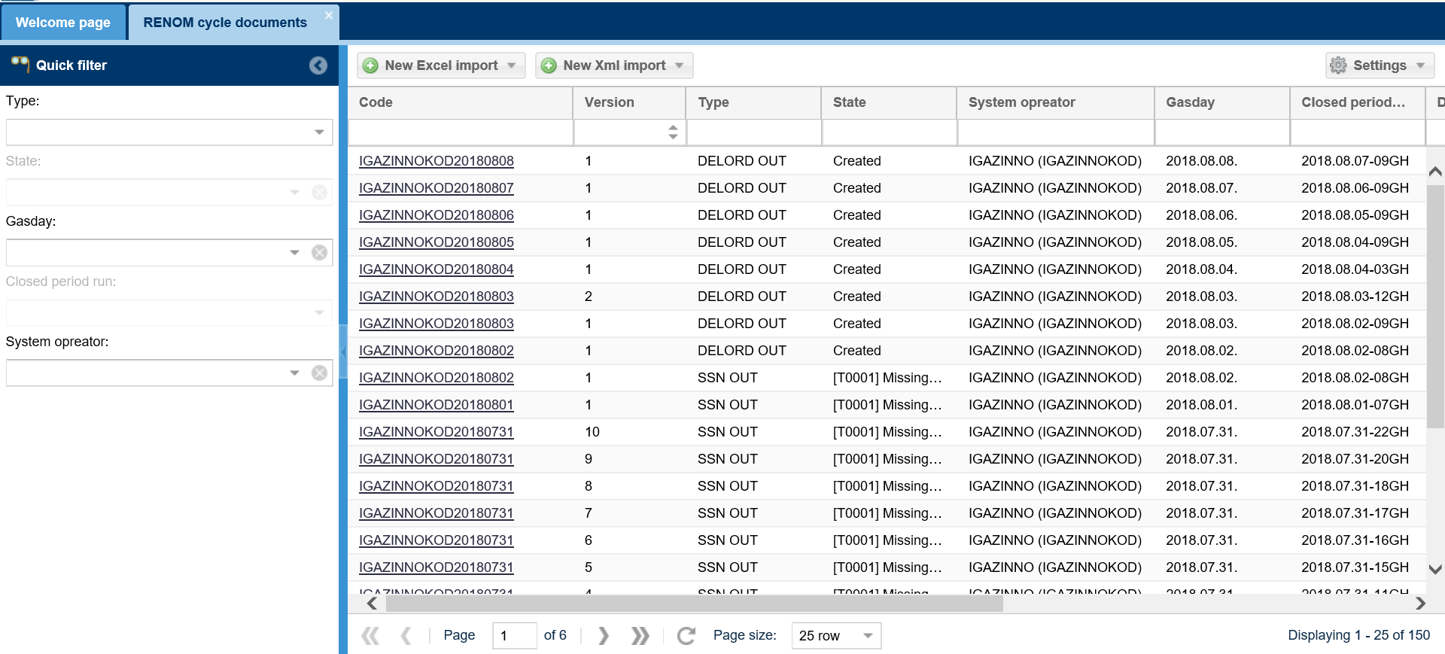
Filter criteria in the field can be deleted with clicking “X”. The screen resets to the original version without filters.
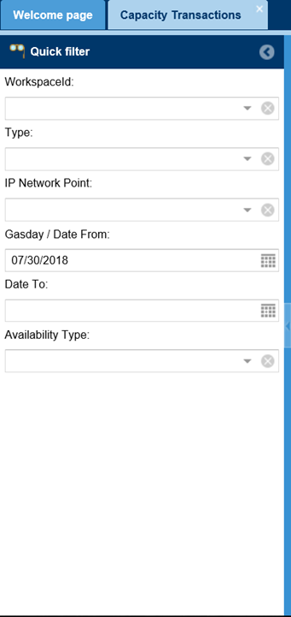
If you do not wish to use quick filters, click the arrow in the title row to “close” it.
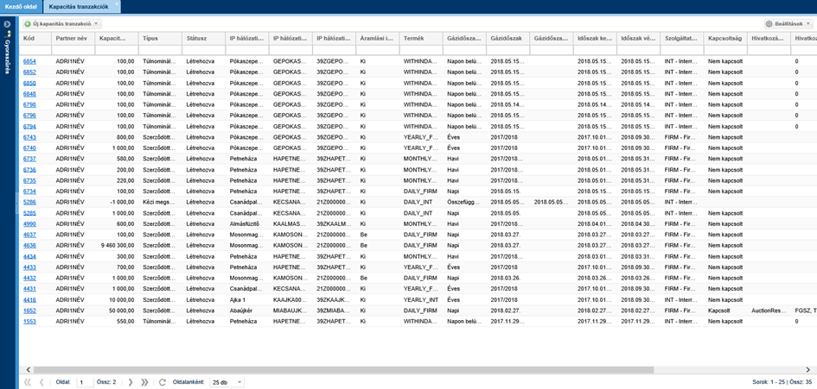

Exporting
Under different menus in this system listed data can be exported in XLSX (Excel 2007/2010), CSV (Comma Separated), XML, HTML, JSON format. Please use Settings/Export function in the top right corner.
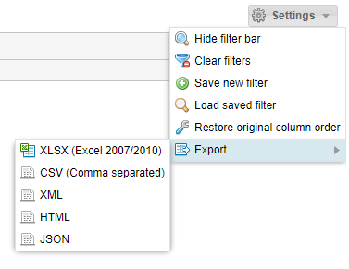
Export is valid for the total (filtered or not filtered list (regardless of the number of pages). The maximum number of rows to be exported can be activated at system parameters with an admin role.
Files can be saved or opened with an .xlsx extension file by MS Excel application and .csv files can also be opened by MS Excel. After opening you may use the options for a linked application (e.g. Formatting, editing, printing, etc.).

History
Core functions’ history can be viewed. Functions are visible in the top right corner of a chart overview if a record is highlighted.
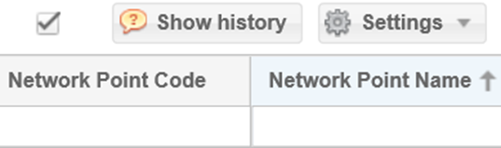
In the pop up window you may see when and what functions were performed by certain users on the same record.
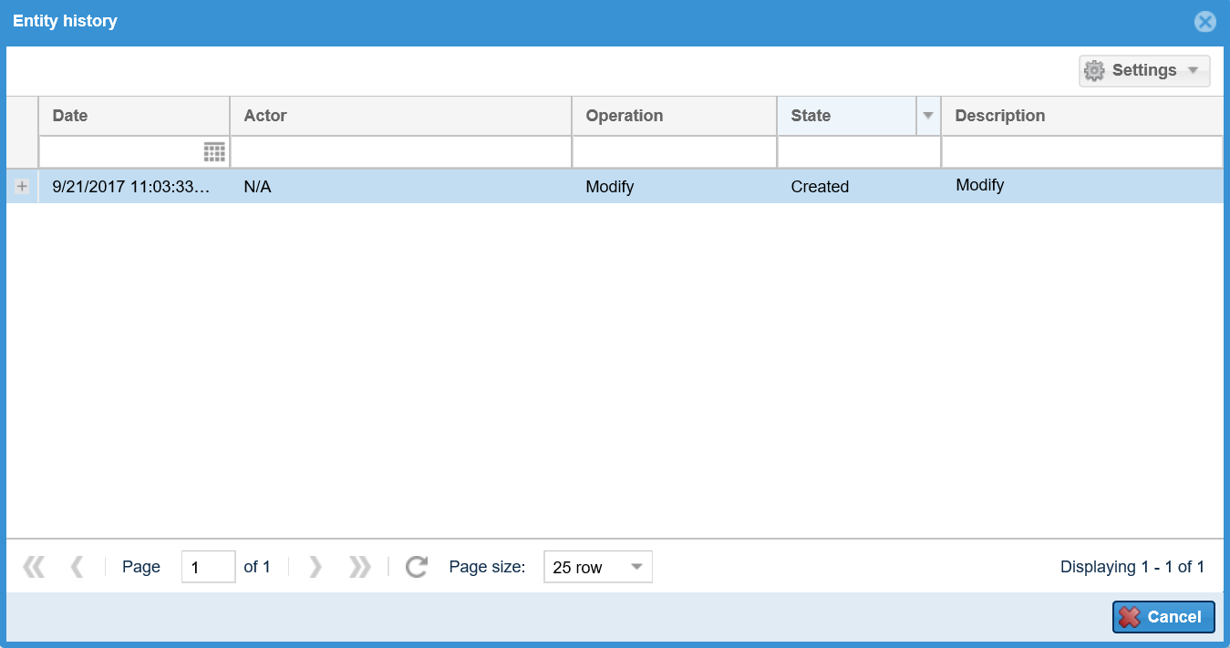

Shortcut keys
Use “Tab” to navigate, “Enter” to save and “Esc” to exit the edit window. This system does not support any other shortcut keys.

Refresh
Click “Refresh” to make the system download the given page again with the current data contents.
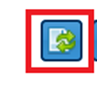
or
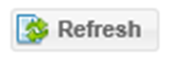

Forward
If you have several pages of information in the given list view you can see Forward at the bottom of the page.
Use left arrows to go back. Single arrow jumps pages and double arrows navigate you to the first page of the list view.
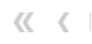
Use right arrows to move Forward. Single arrow jumps pages and double arrows navigate you to the last page of the list view.
If you know the page number, you may directly jump to the information page you are looking for.
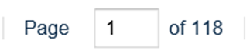
You can use the scroll down bar to select the number of hits on a page.
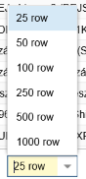
Click this button to refresh the contents of a page.
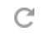

Field check
The system checks immediately if the fields are filled out as soon as we leave the fields. Any incorrect fields with no data will be highlighted with red borders and if you keep the mouse over the text box the reason for the fault will appear in a tooltip.
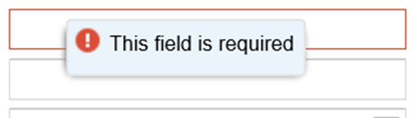
Generally a red asterisk is put in front of each required field in system edit screens.
The system also checks the field length. Edit windows cannot be saved until the user corrects the value.
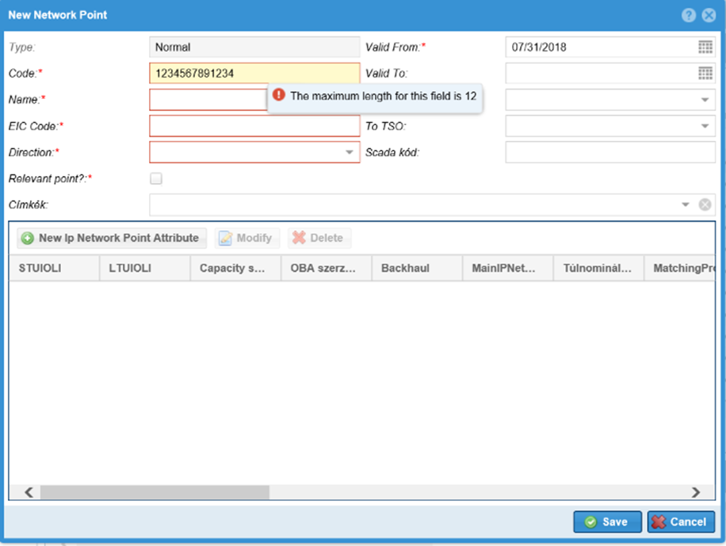

Layout
In any view you may arrange columns according to different criteria. Click the highlighted column, and hold down the left mouse button to move columns. Pull the mouse to the required location and a green arrow appears to indicate where the column will move. Use left mouse button to adjust column width and size to make their contents well visible.
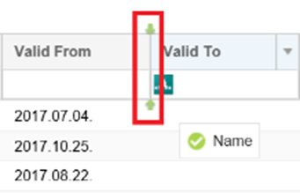
Click the arrow on the right of the header to open the drop down menu. The contents of the columns can be activated as per sorting order either “ascending” or “descending”. Use checkers in Columns menu before the columns to include them in a view or not. You may change settings any time. All fields will be displayed on lists in a default case.
You may change the order of columns with moving their header rows and click their sides to change width.

Login informations

Certificate expiration

The logged in user can look at the right corner and see the green shield icon before her/his name, which indicates the current certificate of the user is valid. Move the cursor over the icon. A tooltip informs the user about the expiration date of its password.
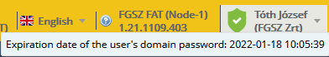

If the expiration date of the certificate or password is soon, a yellow shield icon with an exclamation point appears before the name of the logged in user:

If the expiration date of the certificate or password is going to be very soon, a red shield icon with an exclamation point appears, warning the user, that the password needs to be changed very soon:

In case of invalid certificate or password a red shield icon with an „X” appears before the name of the logged in user:
When logging into the application, the system shows a warning message, that the password is invalid:
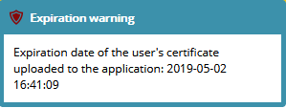

Setting the language of the system
Clik on the flag icon in the right corner of the window and set your language from the drop down list. The system will reload to the choosen language.
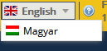

View Own privileges
Click on the logged in user’s name in the right corner of the window. Choose My privileges from the drop down list.
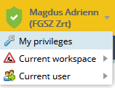
The data sheet of the current user opens, where basic data, notification settings, roles and privileges can be seen.
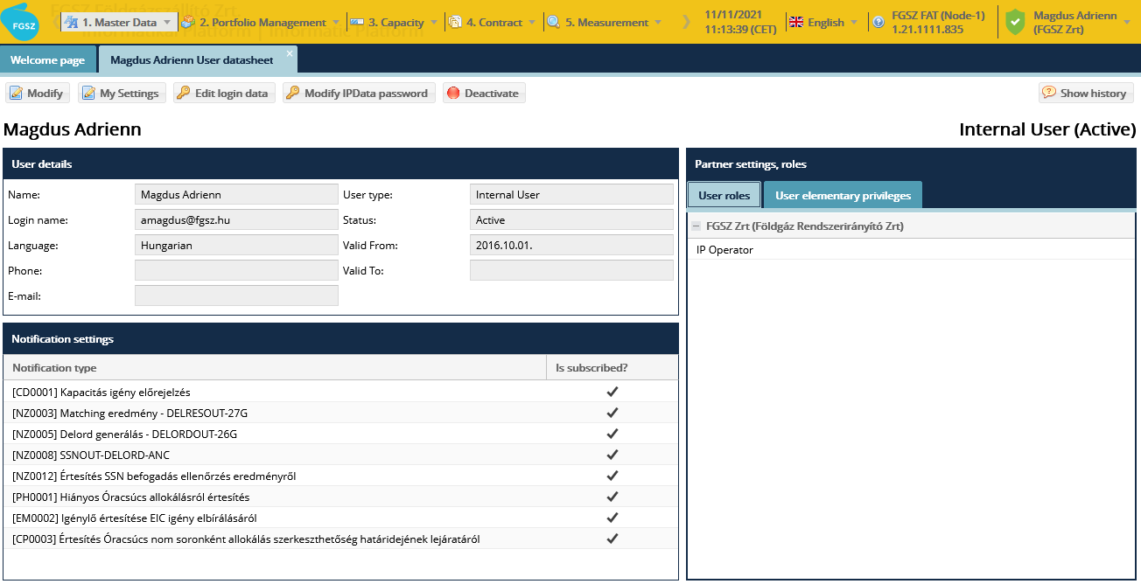

View current workspace
Click on the logged in user’s name in the right corner of the window. Choose Current workspace from the drop down list. There appears a list of the partners of which the current user is assigned. A user usually has one workspace to work.
In case of impersonating the current workspace is the impersonated user’s workspace.
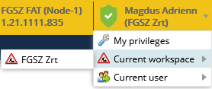
If there are more than one partners assigned to the current user, then those partners will be listed here. A user can be assigned only to different types of partners, for example one network user and one
The user can change workspaces using this function

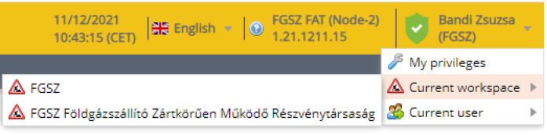

Changing workspace also means that changing roles and privileges the user has at that particular network user.

Menu structure
View application menu.
The following menu sections are available from here:
2. Portfolio managementBalancing portfolios, RENOM cycle documents, RENOM cycle closing results, matching results
6. AllocationHourly allocation, Within the day allocation, Daily allocation, Monthly allocation, Allocation detail, Peakhour allocation
7. SettlementBrowse reports
8. MaintenanceMaintenance works, NNO maintenance works

Closing nomination

List cycle documents
Cycle documents: Nomination is generated during closing process steps, or if their source is not the IP system, the closing step will enter their data contents to the system. Cycle document structure follows the logical structure of the nomination document and the nomination rows, as it includes nomination rows or is a forecast of nomination rows. Shall the Network users not change nomination, the corresponding portfolio will include it for the full gas day at the end of the gas day, and the cycle documents generated when the fist gas hour of the gas day saved at the last hourly saving.
Open the Manage portfolio menu Cycle documents view. System Operator users can see documents that belong to the given System Operator. Four functions will be available when you click an optional cycle document: New Excel import, New XML import, Excel Export, XML Export.
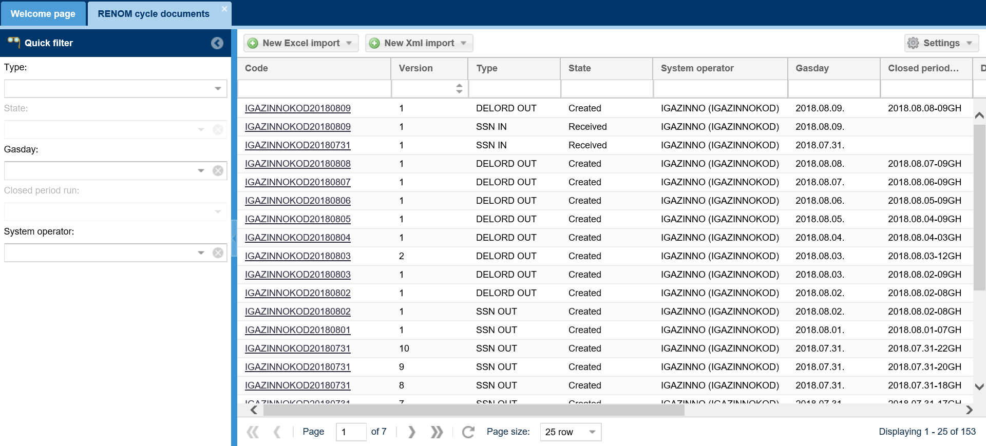
A listing screen displays.

Type of cycle documents
The system uses 4 cycle document categories: DELORD, DELRES, SSN and NOMRES. With the exception of NOMRES there are outgoing and incoming documents in terms of the IP system.
- DELORDIN: It arrives when the FGSZ is a TSO (MSO) performing matching procedure and includes the nominations that were not nominated in the IP system
- DELORDOUT: If the initiating TSO (ISO) party is FGSZ, it sends the nomination rows sent by the Network users for negotiation to the operator of the other system in the cycle document.
- DELRESIN: If the initiating TSO (ISO) party is FGSZ it receives the negotiated values generated by matching procedure in the cycle document
- DELRESOUT: If the TSO (MSO) performing the matching is FGSZ, it sends the nomination matched values in this cycle document to the operator of the other system.
- NOMRES will be an attachment of the notification sent out to the shippers, including the given daily nomination/nomination forecast/final nomination.
  - NOMRES07G: This is the nomination confirming document, after NOMINT01G import, and the same data contents.
  - NOMRESAND: interrupt notice on the possible interruptions, the interrupted values get into this and the shipper has to send a notice to attach the document, and it is to be completed within 45 minutes from the start of processing.
  - NOMRES08G: When processing is completed, the snaphot records are to be filtered for shippers, and the document is to be sent back to the shippers in a notice as attachment.
- SSN: includes single sided nominations. Can be imported or exported to the system during closing depending if the FGSZ SSN role is active or passive. Accordingly there are two document types: incoming and outgoing.
  - The IP system generates the outgoing SSN document (edigas: NOMINT ANC) for each system operator. The system examines per partner at which points FGSZ has an active role for single side nominations, and if at these points the shipper is active for SSN submissions (that means someone who can nominate on behalf of a shipper that is passive for SSN submission) submitted a single side nomination in the IP system, that is collected to an SSNOUT document.
  - The IP system as system operator is able to receive the incoming SSN document. The system examines per partner at which points FGSZ has a passive role for single side nominations and if at these points the shipper is active for SSN submissions (that means someone who can nominate on behalf of a shipper that is passive for SSN submission) submitted a single side nomination, that is collected to an SSNIN document.

View cycle documents
Open the Manage portfolio menu RENOM Cycle documents view. The users of working areas marked as System Operator can see documents that belong to the given System Operator. Click the required ID for the document and the document data sheet opens on a separate tab. Also four functions are available: New Excel import, New XML import, Excel Export, XML Export.
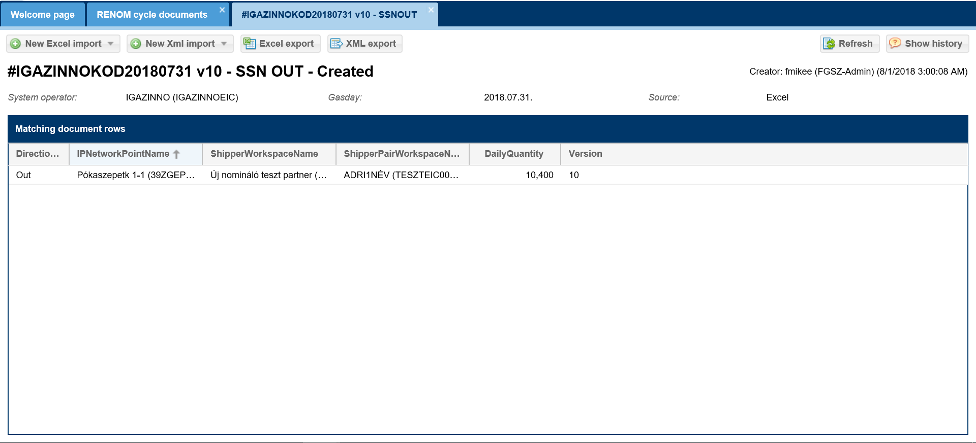
Document data can be viewed.

View matching results
A matched list of matching results created by the closing/loaded for DELORD and DELRES documents.
Open the Manage portfolio menu Matching results view. System Operators can only access their relevant matching/ matched results. Select the document match and in the bottom view of the screen you can see the hourly breakdown of the document contents.
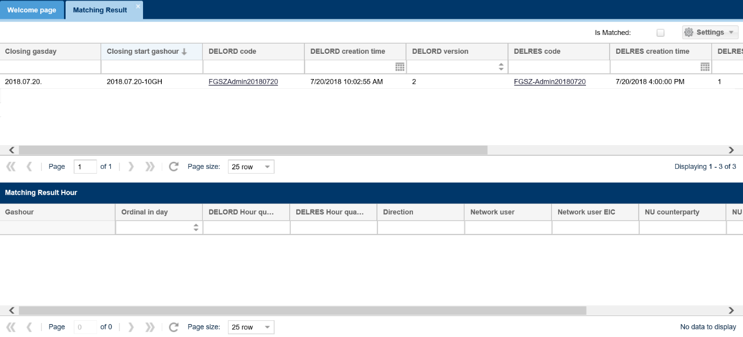
The data sheet of the given document opens upon clicking the links of the document ID columns.
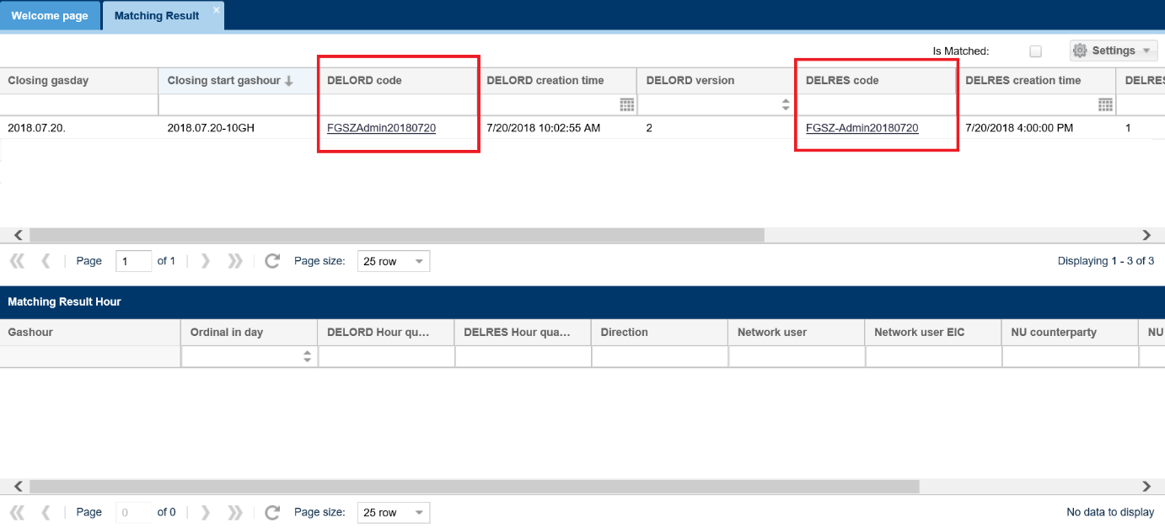
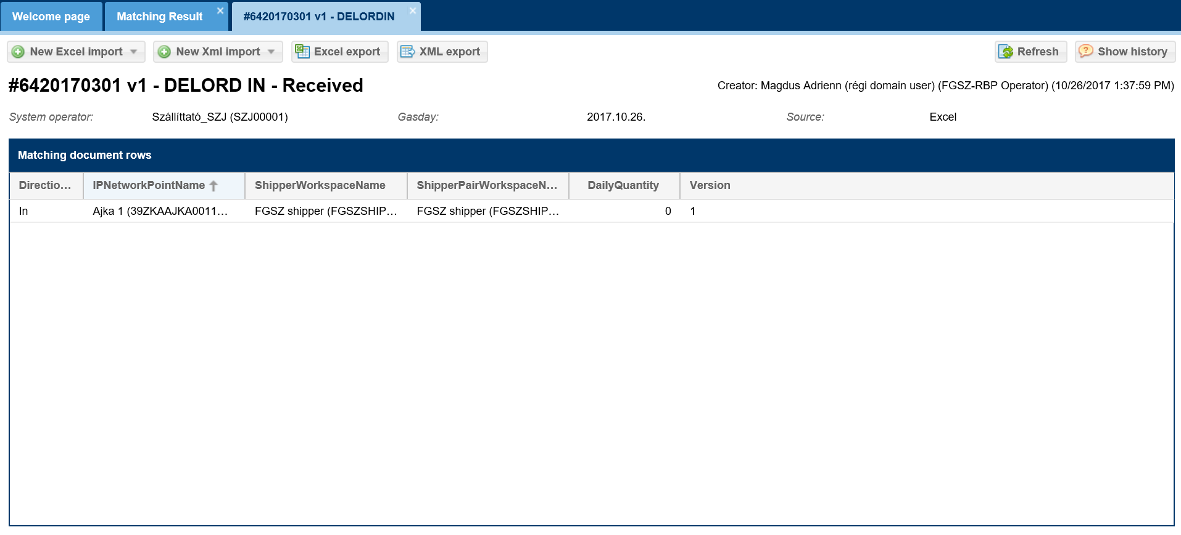
Thy system lists matches with is matched check box in the top of the screen with a volume mismatch, and if the system found different values during the matching process as compared to DELORDIN. If there is a difference, these rows are red. This type of filtering also refers to the chart on the bottom of the screen.
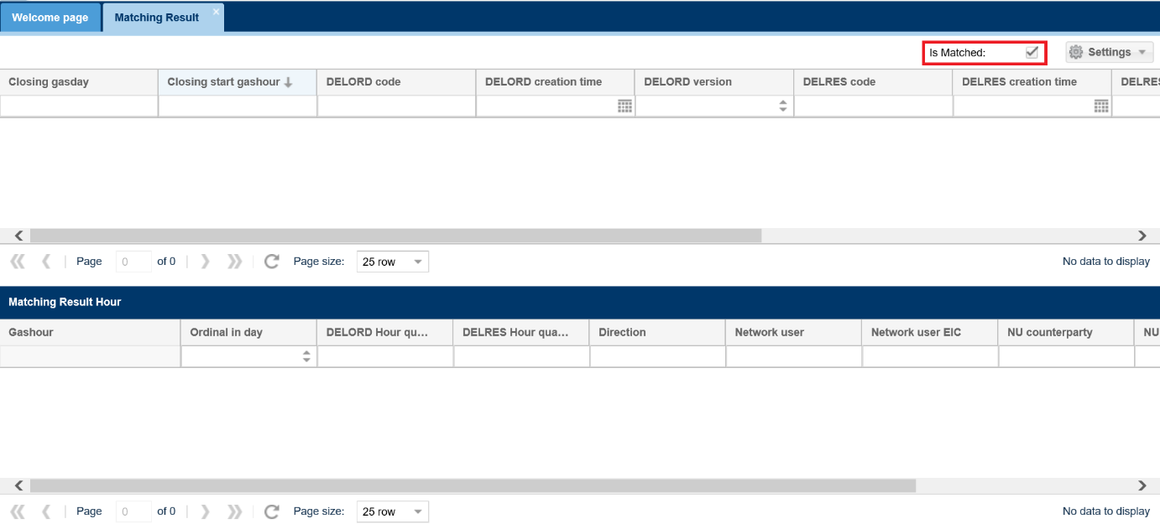

View closing results
The system shows the status and reason for hourly changes of records generated by the closing steps on the close cycle results platform.
Open the Manage portfolio menu Closing Result view. System Operators can only access their relevant closing results.
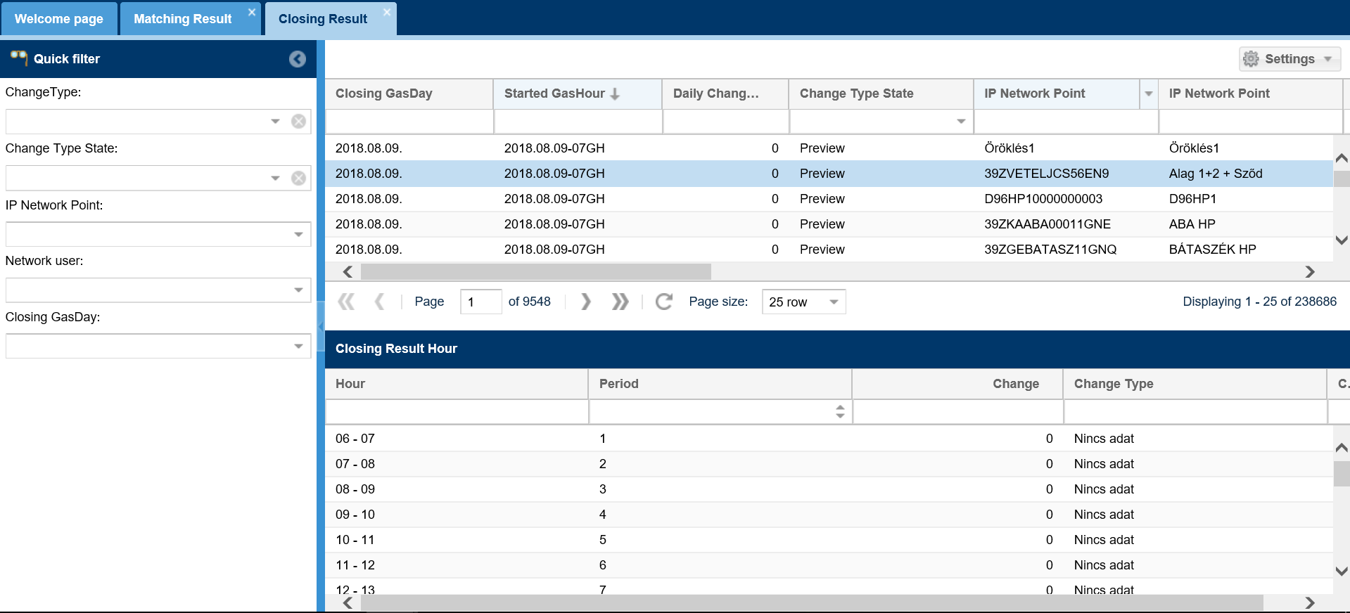
Click the required results and the hourly breakdown can be viewed in the bottom view of the screen.

Cycle document Excel export
Open the Manage portfolio menu RENOM Cycle documents view. Select a document and click Excel export function. The system opens or saves the Excel file after the confirmation of the question.
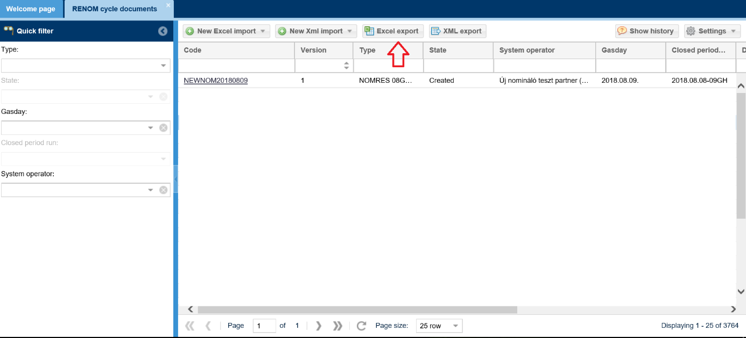
The rows of the given cycle are generated. The document type will determine the name of the excel worksheet. File names are in compliance with the naming convention.

Cycle document Excel import
Open the Manage portfolio menu RENOM Cycle documents view. Click new Excel import function and select what type of file you wish to export from the scroll down menu.
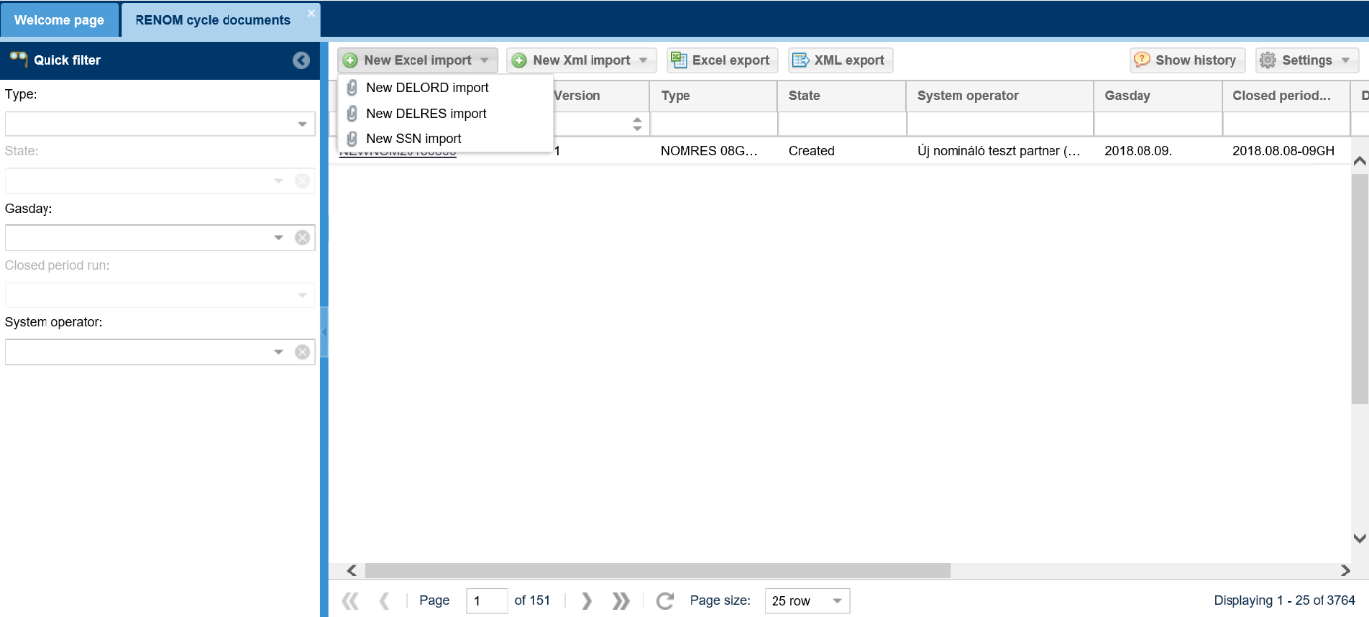
After selecting from the pop up loading window, click Browse to upload the selected file, then the Excel is imported into the system with Upload and will be displayed on the screen listing cycle documents.
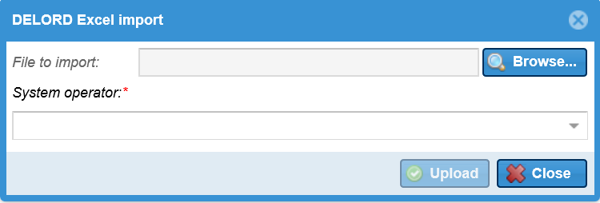

Cycle document XML Export
Open the Manage portfolio menu RENOM Cycle documents view. Select a document and click XML export function. The system opens or saves the file after the confirmation of the question.
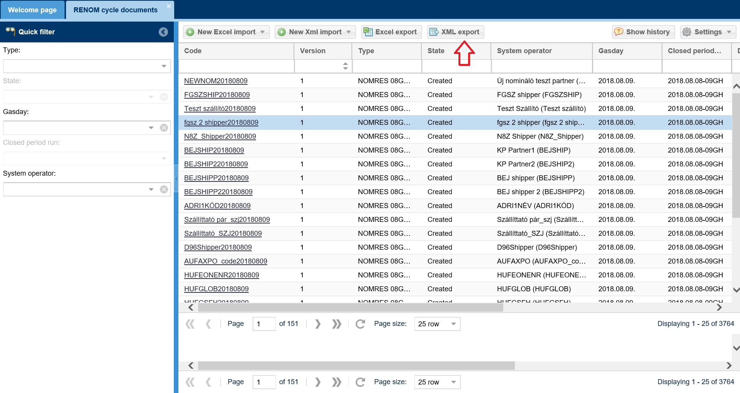
The rows of the given cycle are generated. The file name is the following:
DATA_[Dgasday:yyyymmdd]_[NNOcode+Dgasday]_[version]_[cycle documenttype]

Capacity

Capacity demand forecast

Data provisions

Listing data provisions
Open the Capacity menu Data provisions view. The data provision list screen comes up.
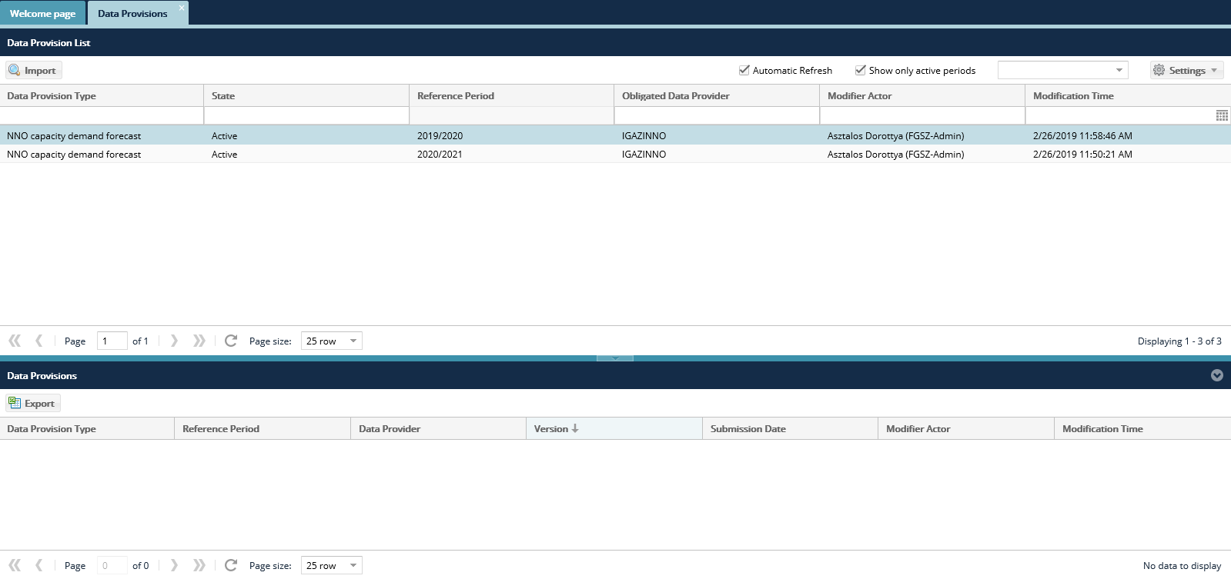
Select a data provision row, if it has already been submitted, the submitted versions are displayed. An NNO can only see data provisions where the NNO is concerned.

NNO capacity demand forecast export
Open the Capacity menu Data provisions view.
Click the “Export” button in the bottom view of the screen. The data provisions will show up.
If no data provision has been provided yet, an empty template will be generated upon export. If you have already submitted a data provison, selecting that particular data version to export the data provision template you entered in that version.

NNO capacity demand forecast import
Open the Capacity menu Data provisions view. Click the “Import” button, after selecting the row of items.

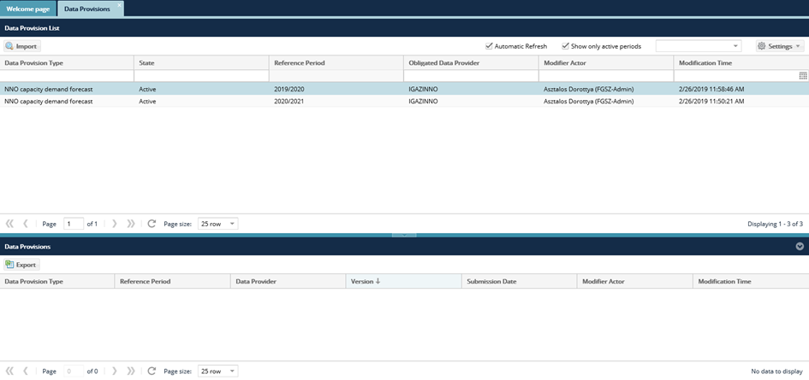
Click “Browse” to select the Excel file to be loaded from the system. The link of the selected file then gets into the field “File to be import”. Then click “Upload”.
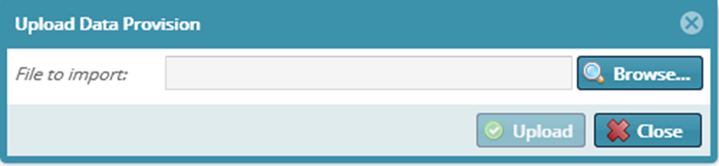
The system shows that uploading is in progress and the “Import results” window will appear. Loaded data will display in the list view as per version.

Allocation

List hourly allocations
Open the Allocation menu Hourly allocations view.
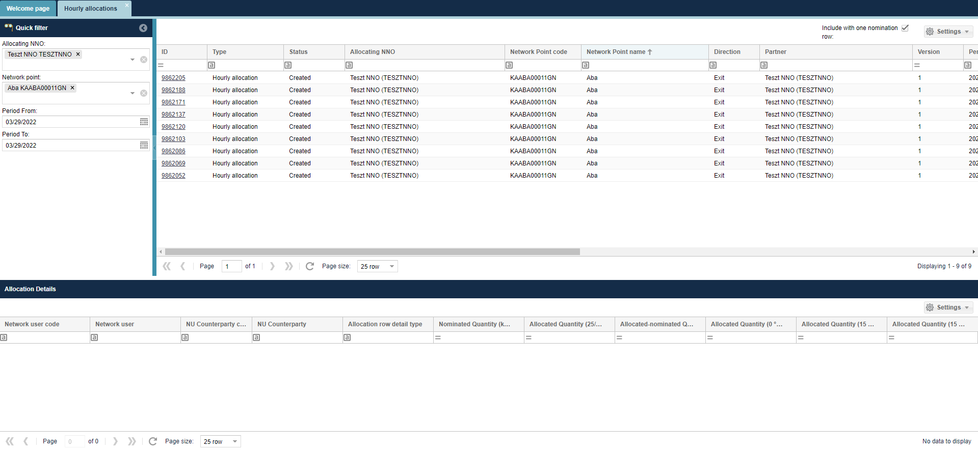
The hourly allocation list screen comes up. The system always displays the last version. In the list on the bottom of the screen allocation items are broken down Network user – Network user Partner in accordance with previous nominations.
The purpose of hourly allocation is to generate data for the past hour to the Network users, to monitor their actual gas use and to be able to adjust nominations to this. This process starts without user intervention. It is timed and time points that can be parametered. The NNO is not notified of the completion of allocated data, but can view its results on this screen.
The interface allows quick filtering for the following fields:
• Allocating NNO: When logged in with an NNO user, the field takes the name of the logged in NNO by default and cannot be changed; Allocation NNO is the partner specified by the IP network point that performs the allocation tasks. If the NNO and Allocating NNO are different partners at the IP network point, only the Allocating NNO will see the allocation queues for the corresponding points.
• Network point: You can search for a network point name and code, you can enter more than one value at a time.
• Start of period: current day by default
• End of period: current day by default

View hourly allocation data sheet
Open the Allocation menu Hourly allocations view. Select “Allocations”.
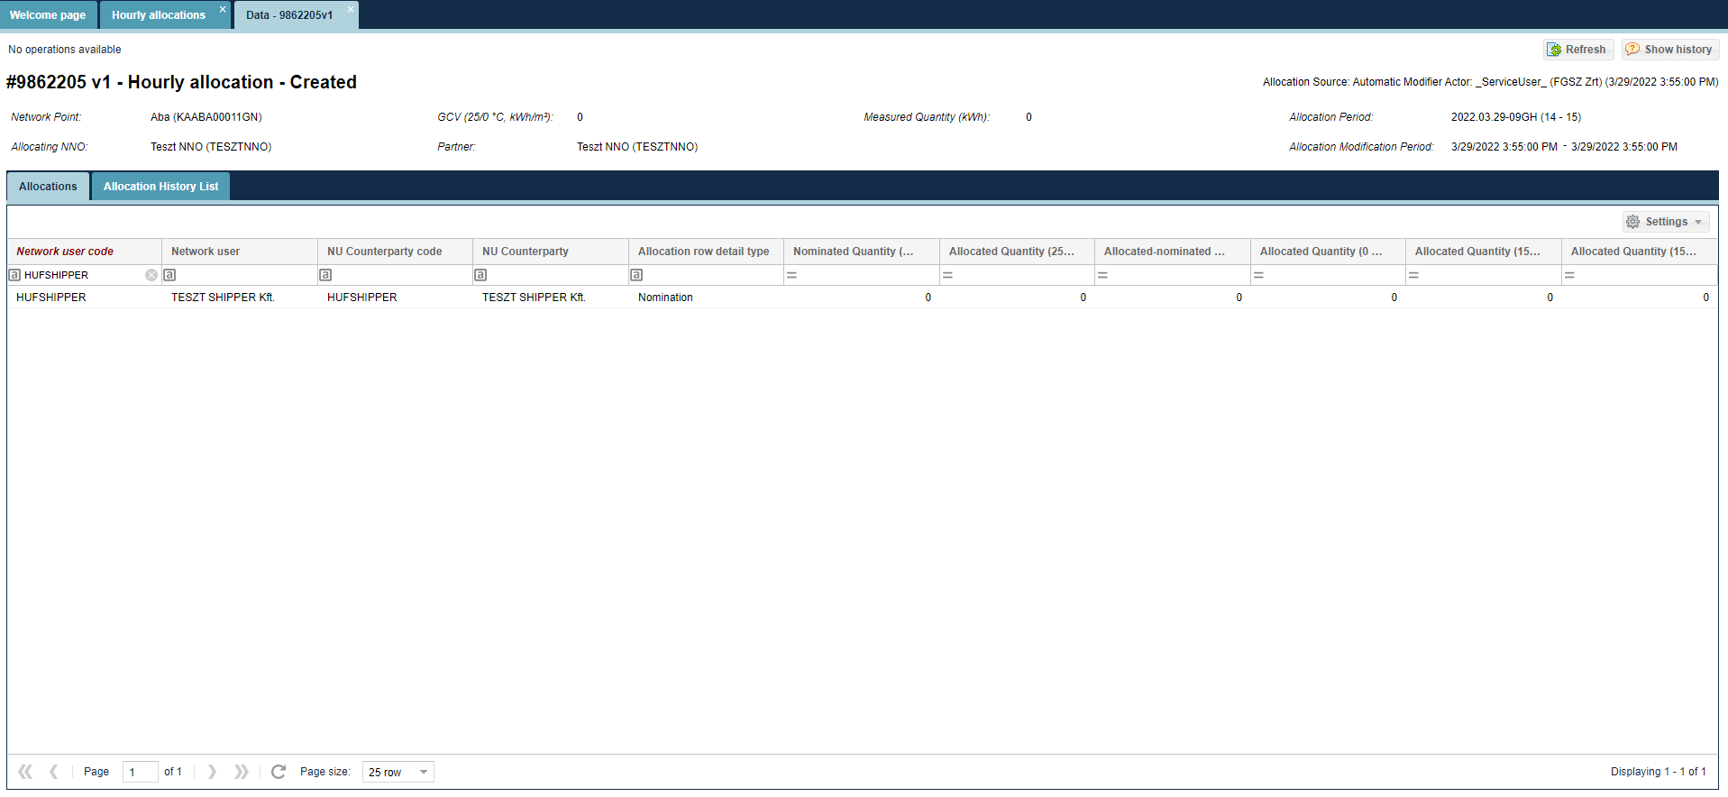
The data sheet of the selected hourly allocation is displayed to show the nominations (shipping tasks) and the relevant allocation items broken down to Network user – Network user partner. The data sheet is view only, no editing function is available.

View hourly allocation versions
Open the Allocation menu Hourly allocations view. Select “Allocation versions”.
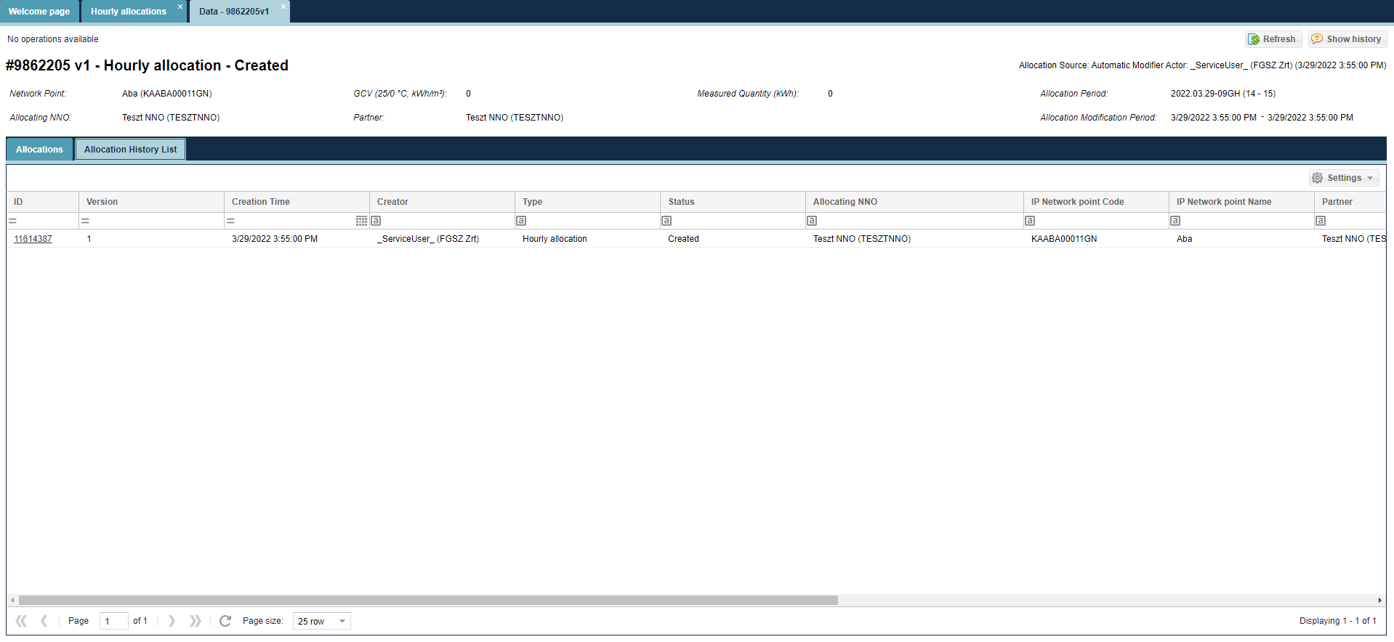
The versions of the selected item display

View hourly allocation version data sheet
Open the Allocation menu Hourly allocations view. Select “Allocation versions”.
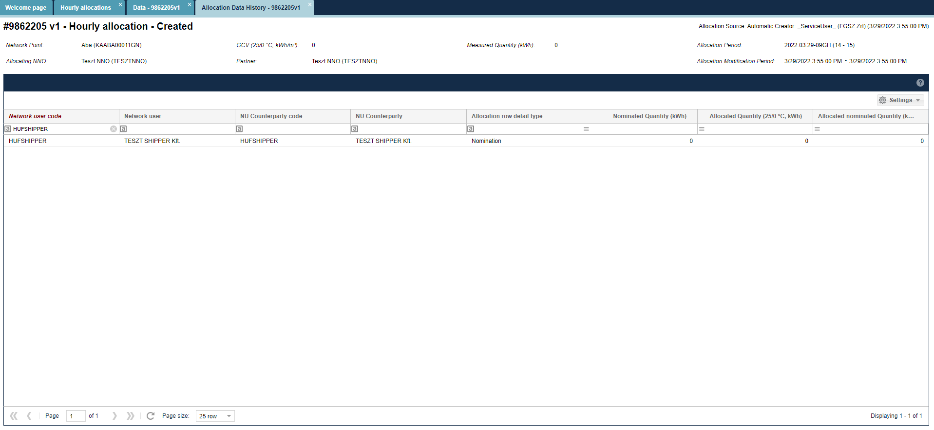
The data sheet of the selected item will display.

List allocations within day
Open the Allocation menu Allocation within day view. Available functions by clicking a row of items: Edit, Allocate mass export, Allocate mass import.

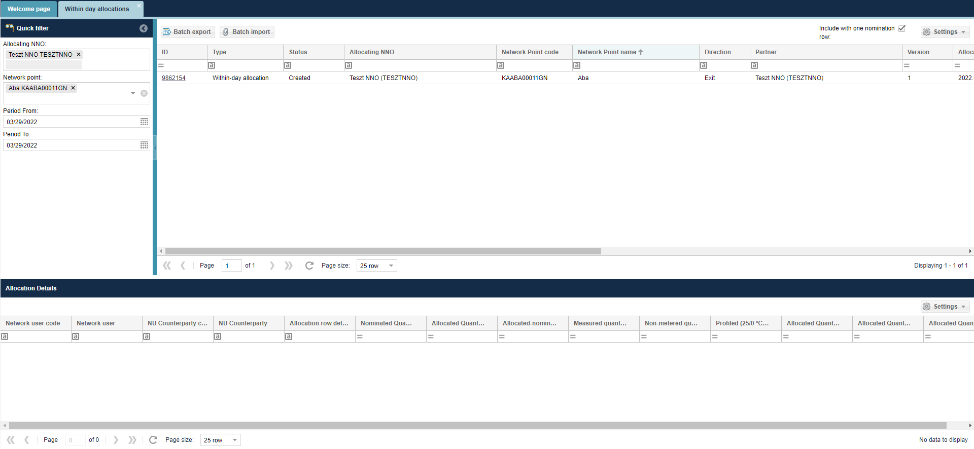
Allocation within day rows appear. The system always displays the last version. In the list on the bottom of the screen allocation items are broken down Network user – Network user Partner in accordance with previous nominations.
The purpose for Allocation within day is to generate summary auto-allocated data from the start of the current gas day until the current gas hour period. The system always uses the latest measuring and nomination data for calculations.
The interface allows quick filtering for the following fields:
• Allocating NNO: When logged in with an NNO user, the field takes the name of the logged in NNO by default and cannot be changed; Allocation NNO is the partner specified by the IP network point that performs the allocation tasks. If the NNO and Allocating NNO are different partners at the IP network point, only the Allocating NNO will see the allocation queues for the corresponding points.
• Network point: You can search for a network point name and code, you can enter more than one value at a time.
• Start of period: gas day before the current day by default
• End of period: gas day before the current day by default

Allocation within day data sheet
Open the Allocation menu Allocation within day view. Click the link in the Identify column. Select “Allocations”.
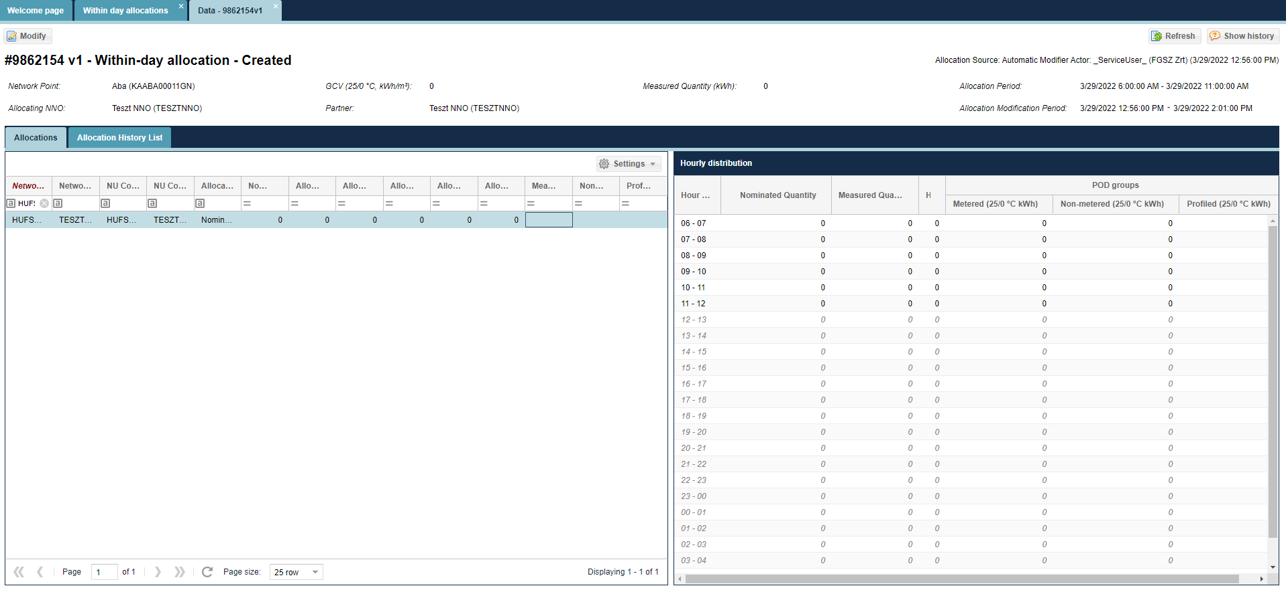
The data sheet of the selected Allocation within day is displayed to show the tasks and the relevant allocation items broken down to Network user – Network user partner. Allocated volume is displayed in a breakdown and linked to the given gas day.

View allocation within day history list
Open the Allocation menu Allocation within day view. Select “Allocation versions”.
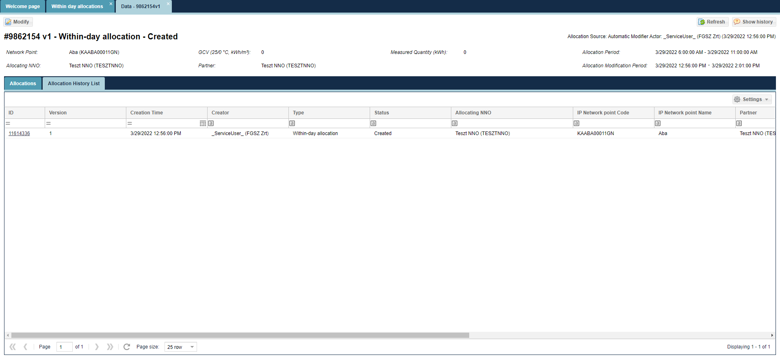
The versions of the selected item display

View Allocation within day version data sheet
Open the Allocation menu Allocation within day view. Select “Allocation versions”.

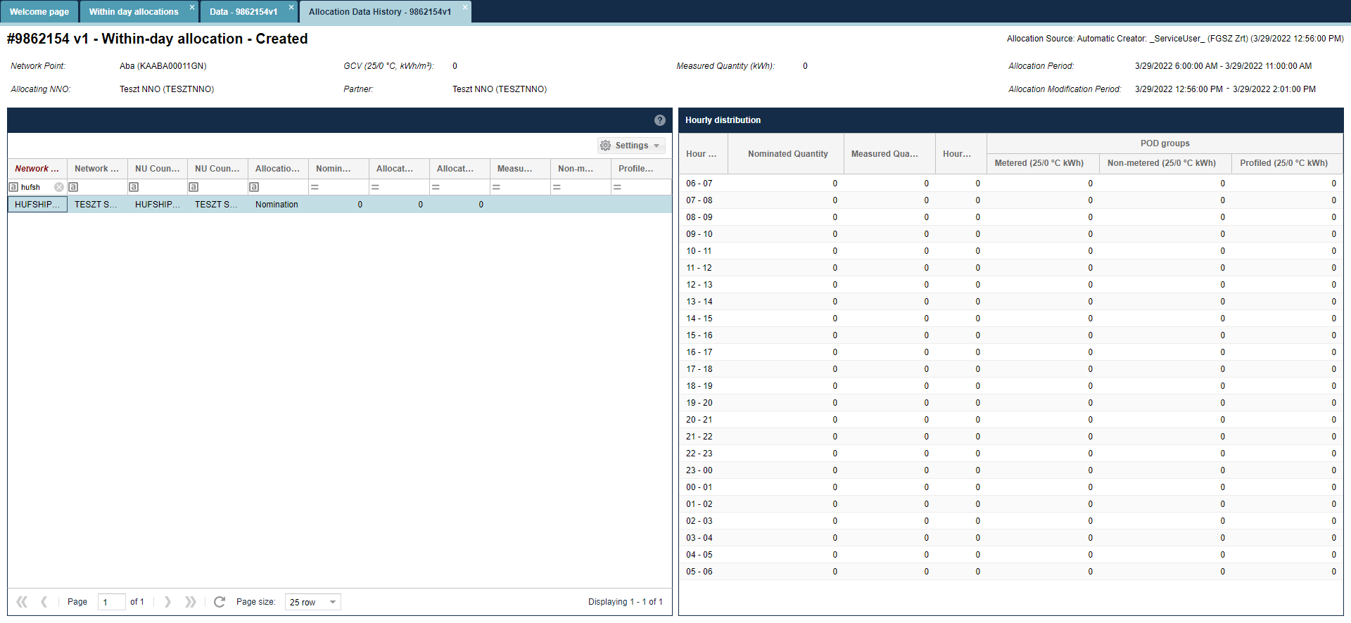
The data sheet of the selected item version will display.

Edit allocation within day data
Open the Allocation menu Allocation within day view. Click Edit after selecting the row of items.
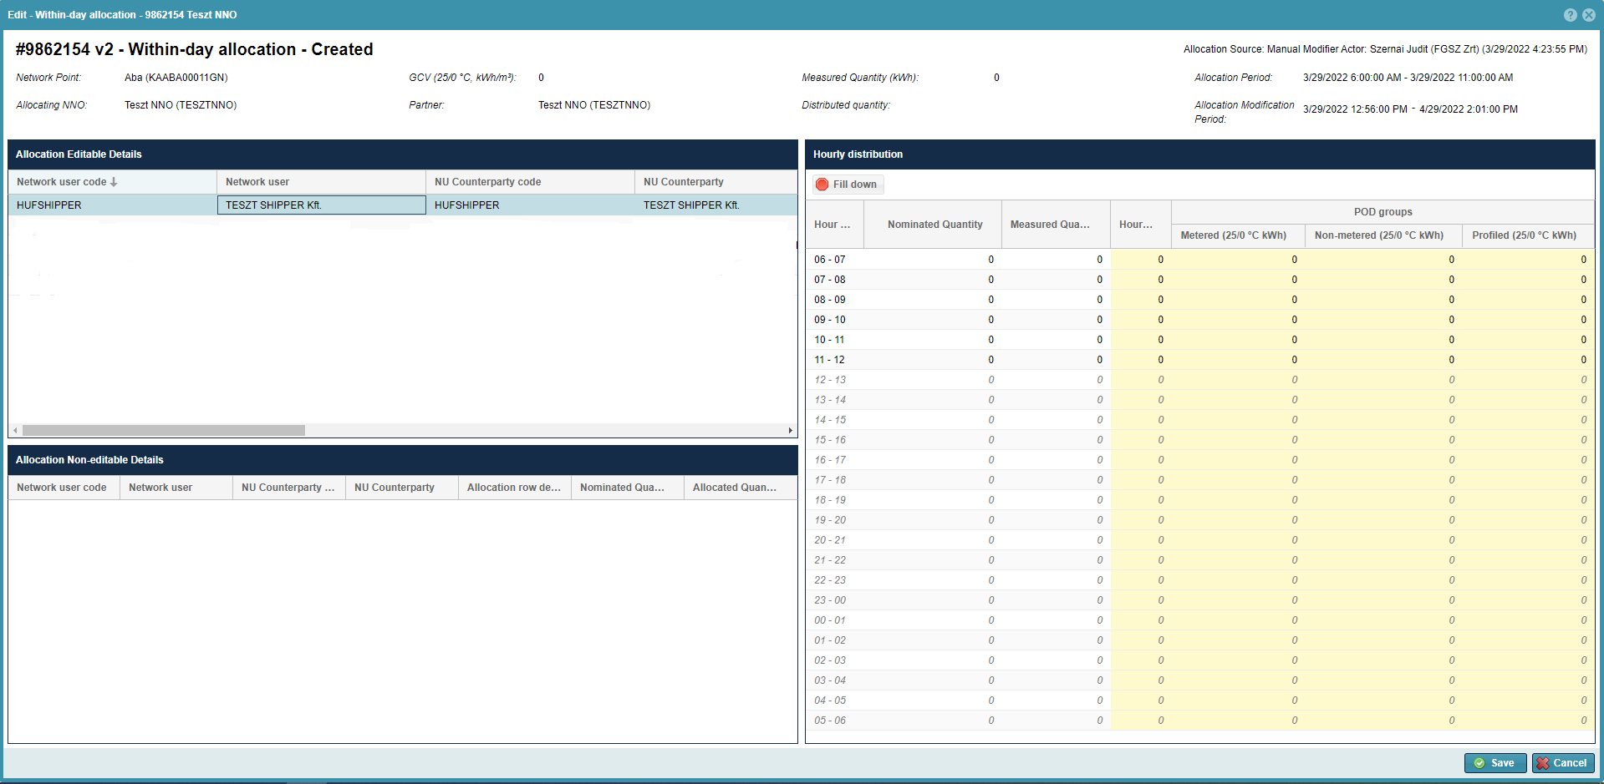
A window will open to display another list related to the selected row of items to display nominations in Network user – Network user Partner breakdown, and the relevant system auto- allocated – nomination proportionate allocation values, in the “Allocated volume (25/0 °C, kWh)” column.
You can see a non-editable informative chart under the list, and for OBA contractual network points it also shows OBA balance items.
On the right of the two charts a list will display that shows the hourly breakdown of nominated values and the relevant auto-allocated volumes. Users can modify the values in this part in column “Allocated volume (25/0 °C, kWh)”. The system shows a summary of hourly allocated values, and then overwrites the selected row of items “Allocated volume (25/0 °C, kWh)” column value in the “Allocation editable items” list. The items of each row can be changed one by one.
During editing the system shows in the field “Volume to be distributed” the balance of the “Measured value (kWh)” and “Allocated value (kWh)” fields.
After changes select “Save”.

MASS export of allocation within day data
Open the Allocation menu Allocation within day view. Click Allocate mass export after selecting the row of items.
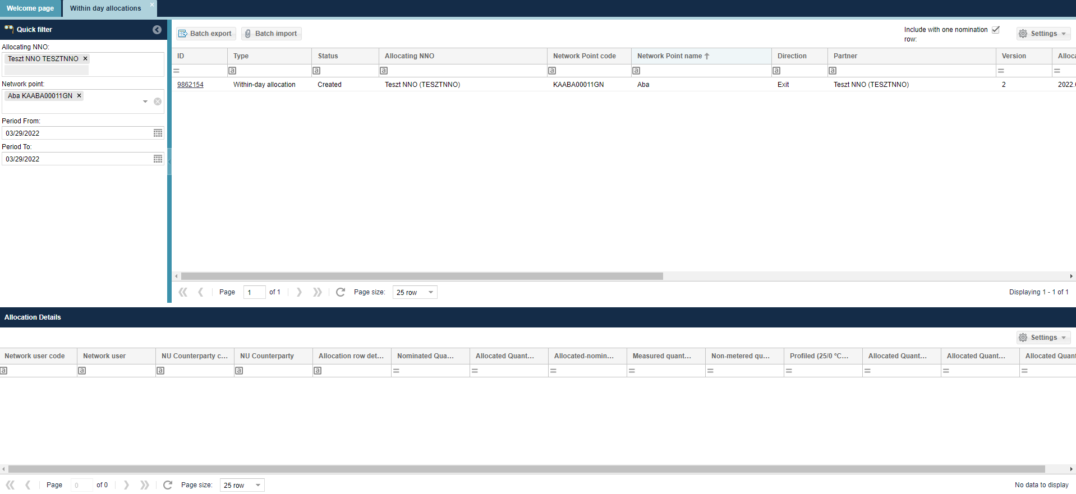
You will see Allocation row mass export pop up window
The user shall enter the start and end date of the period, the user wishes to export the allocation within day data for.
“Allocation Network Operator” and „Network point” fields are not mandatory.
Selecting the "Include with one nomination row" check box also includes one nomination row points in the exported file.
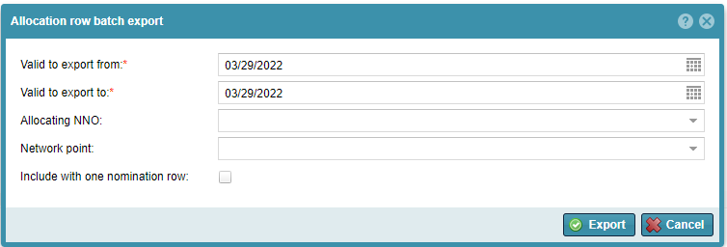
The system exports files to a predefined formatted Excel file according to filter. If multiple allocations within day arrive, only the last version will get into the Excel file. Users can edit green fields in the Excel file.

MASS import of allocation within day data
Open the Allocation menu Allocation within day view. Click Allocate mass import after selecting the row of items.
Click “Browse” to select the Excel file to be loaded from the system. The link of the selected file then gets into the field “File to be imported”. Then click “Import”.
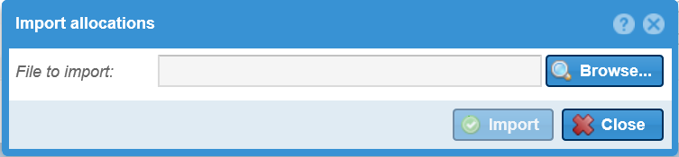
The system shows that uploading is in progress and the “Import results” window will appear. You may view possible faults generated when the system run checks. Loaded data will display in the list view as per version.

List daily allocations
Open the Allocation menu daily allocations view. Available functions by clicking a row of items: Edit, Allocate export, Allocate import, Allocate mass export, Allocate mass import.

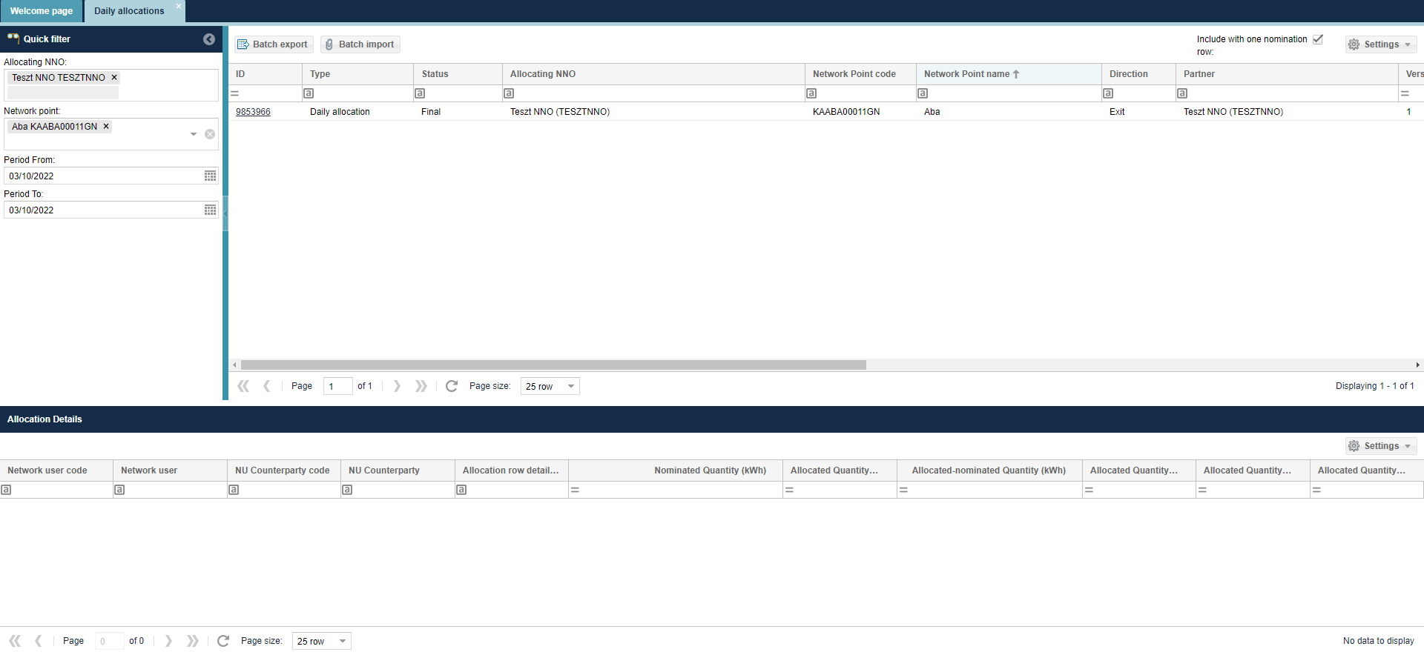
Allocation within day rows appear. The system always displays the last version. In the list on the bottom of the screen allocation items are broken down Network user – Network user Partner in accordance with previous nominations.
The interface allows quick filtering for the following fields:
• Allocating NNO: When logged in with an NNO user, the field takes the name of the logged in NNO by default and cannot be changed; Allocation NNO is the partner specified by the IP network point that performs the allocation tasks. If the NNO and Allocating NNO are different partners at the IP network point, only the Allocating NNO will see the allocation queues for the corresponding points.
• Network point: You can search for a network point name and code, you can enter more than one value at a time.
• Start of period: gas day before the current day by default
• End of period: gas day before the current day by default

View daily allocation data sheet
Open the Allocation menu daily allocations view. Click the link in the Identify column. Select “Allocations”.

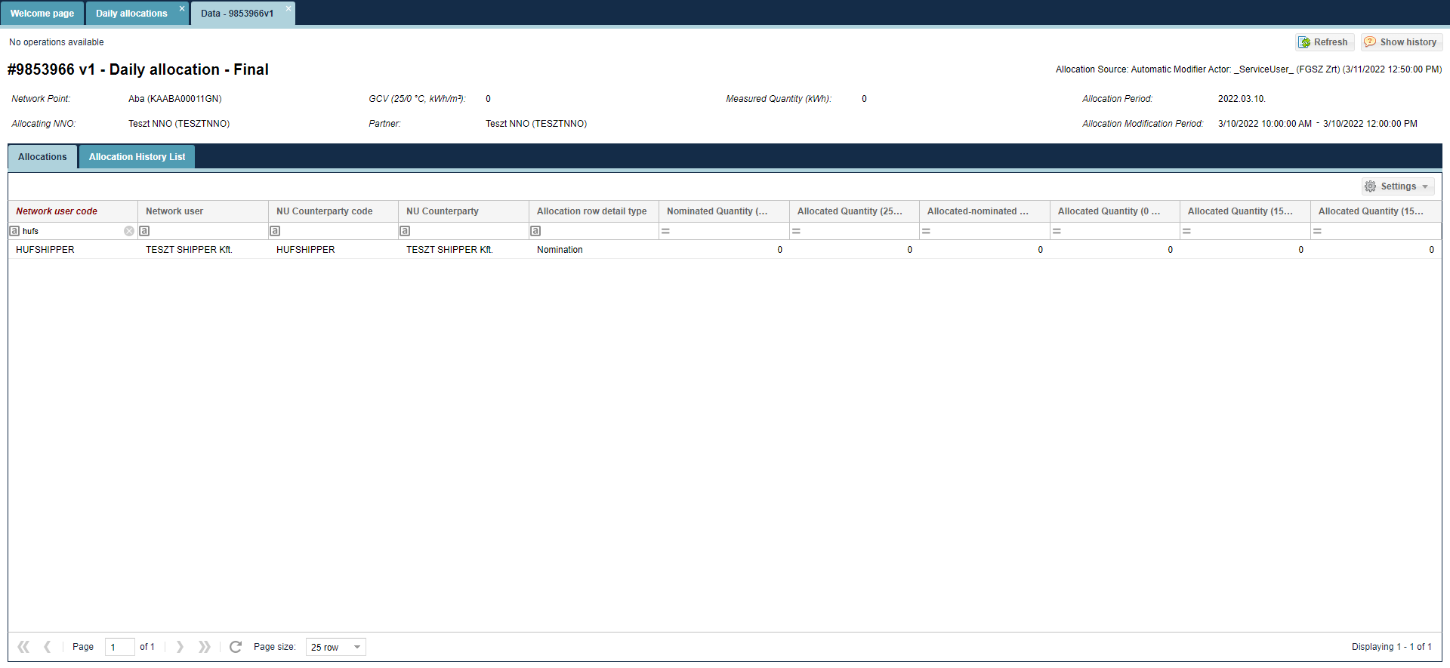
The data sheet of the selected daily allocation is displayed to show the nominations (shipper tasks) and the relevant allocation items broken down to Network user – Network user partner. Allocated volume is displayed in a breakdown and linked to the given gas day.

View daily allocation versions
Open the Allocation menu daily allocations view.
Click the link in the Identify column. Select “Allocation versions”.
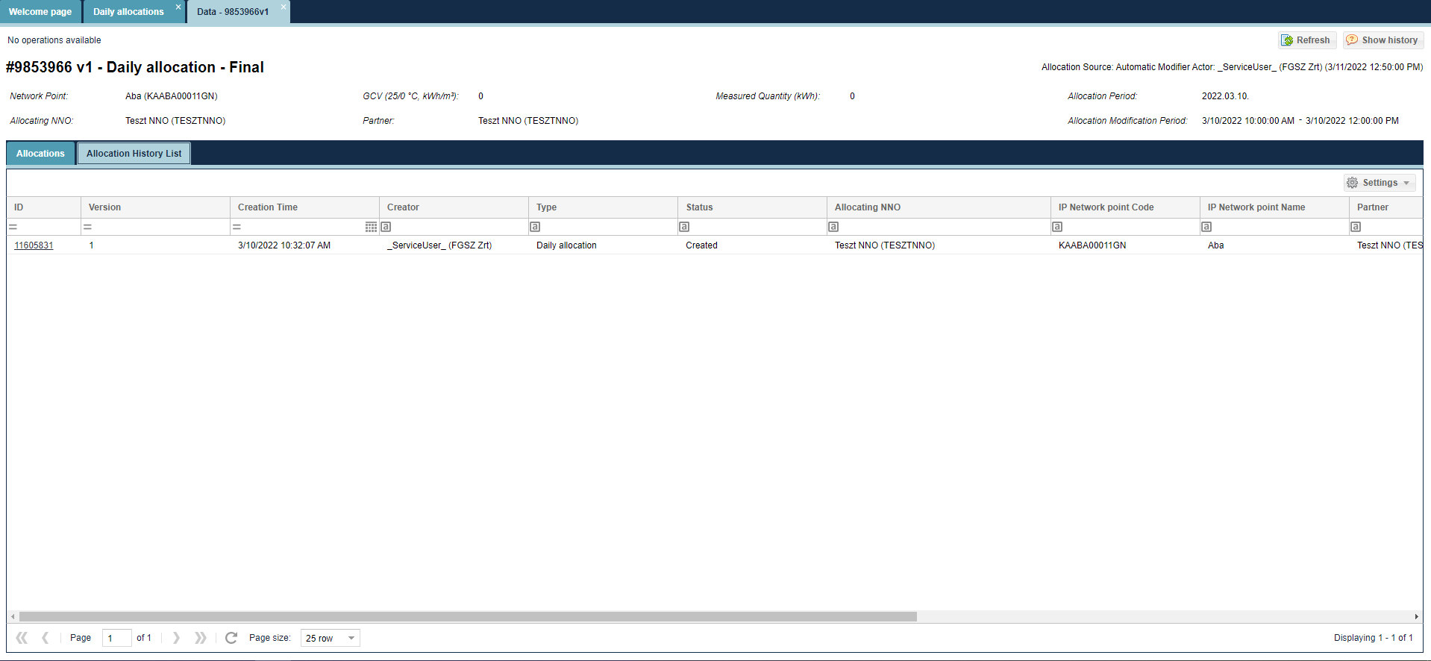
The data sheet of the selected item version will display.

View daily allocation versions data sheet
Open the Allocation menu daily allocations view. Select “Allocation versions”. Click the link in the Identify column.
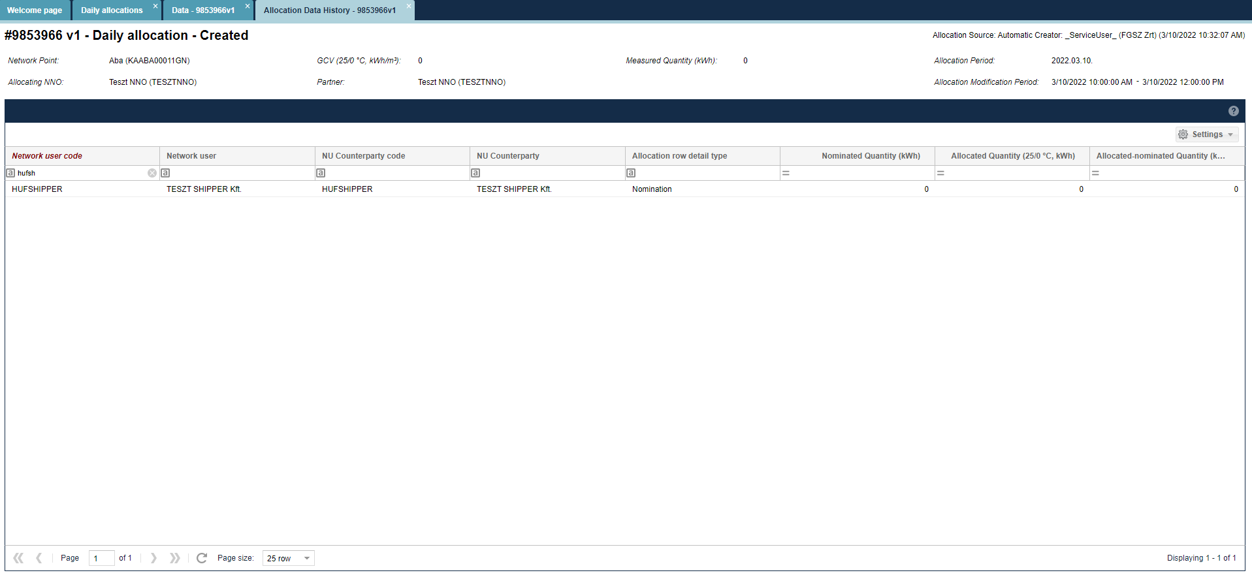
The data sheet of the selected item version will display.

Edit daily allocation data (balanced allocation)
Open the Allocation menu daily allocations view. Click Edit after selecting the row of items.
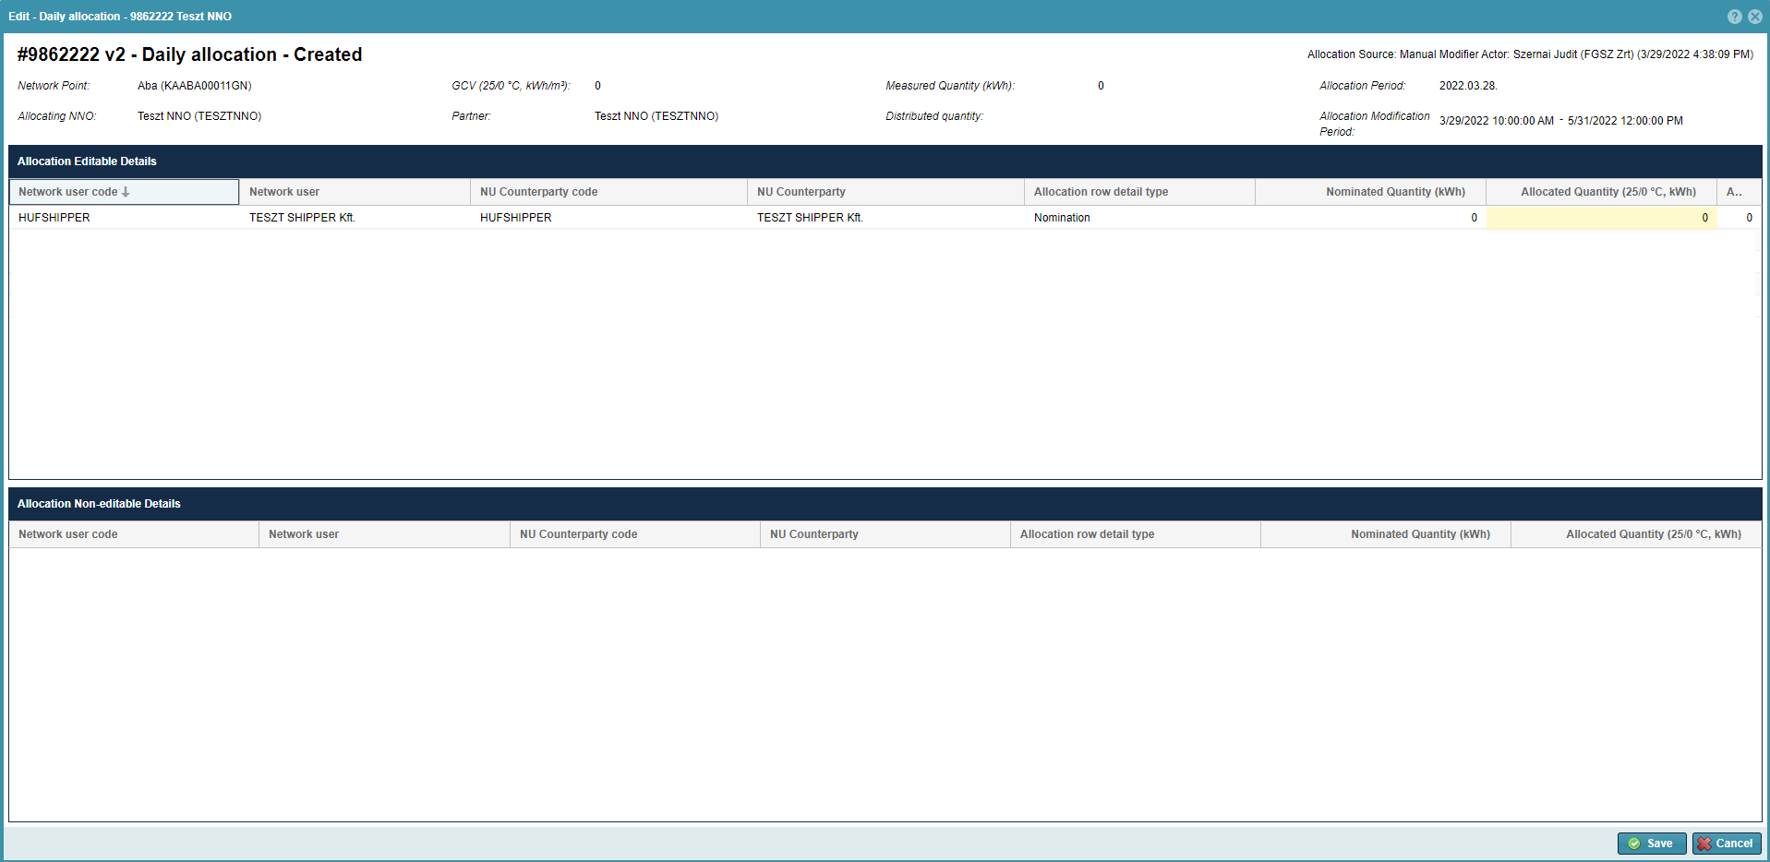
A window will open to display another list related to the selected row of items to display nominations in Network user – Network user Partner breakdown, and the relevant system auto- allocated – nomination proportionate allocation values, in the “Allocated volume (25/0 °C, kWh)” column.
You can see a non-editable informative chart under the list, that details the change of title transactions, and for OBA contractual network points it also shows OBA balance items.
Users can modify the values in this part in column “Allocated volume (25/0 °C, kWh)”, and this has to be according to the rule that the sum of the “Allocated volume (25/0 °C, kWh)” has to match the header data field values of “Measured value (25/0 °C, kWh)”.
Click save after changes.
In case the header data “Measured value (kWh)” field is the same as “Allocated volume (25/0 °C, kWh)” column values, a new version is created among allocations.
The system displays the last modified row items in green on the “Allocations” screen. The NNO is not obliged to make changes, and can see data also outside the change time window, however cannot modify them.

MASS export of daily allocation data
Open the Allocation menu within day allocations view. Click Allocate mass export after selecting the row of items.
You will see Allocation row mass export pop up window
The user shall enter the start and end date of the period for which the user wishes to export the allocation within day data.
“Allocation Network Operator” and „Network point” fields are not mandatory.
Selecting the "Include with one nomination row" check box also includes one nomination row points in the exported file.
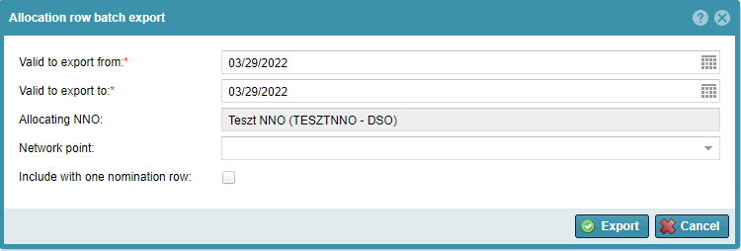
The system exports files to a predefined formatted Excel file according to filter. If multiple allocations within day arrive, only the last version will get into the Excel file. Users can edit green fields in the exported Excel file. Allocation items with no allocation data for the given period are not generated in Excel.

MASS import of daily allocation data
Open the Allocation menu within day allocations view. Click Allocate mass import after selecting the row of items.
Click “Browse” to select the Excel file to be loaded from the system. The link of the selected file then moves into the field “File to be imported”. Then click “import”.
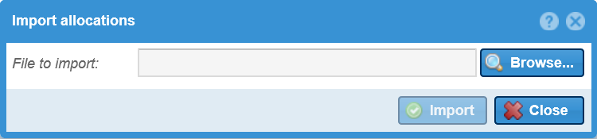
The system shows that uploading is in progress and the “Import results” window will appear. You may view possible faults generated when the system run checks. Loaded data will display in the list view with version control.

List monthly allocations
Open the Allocation menu monthly allocation items view.
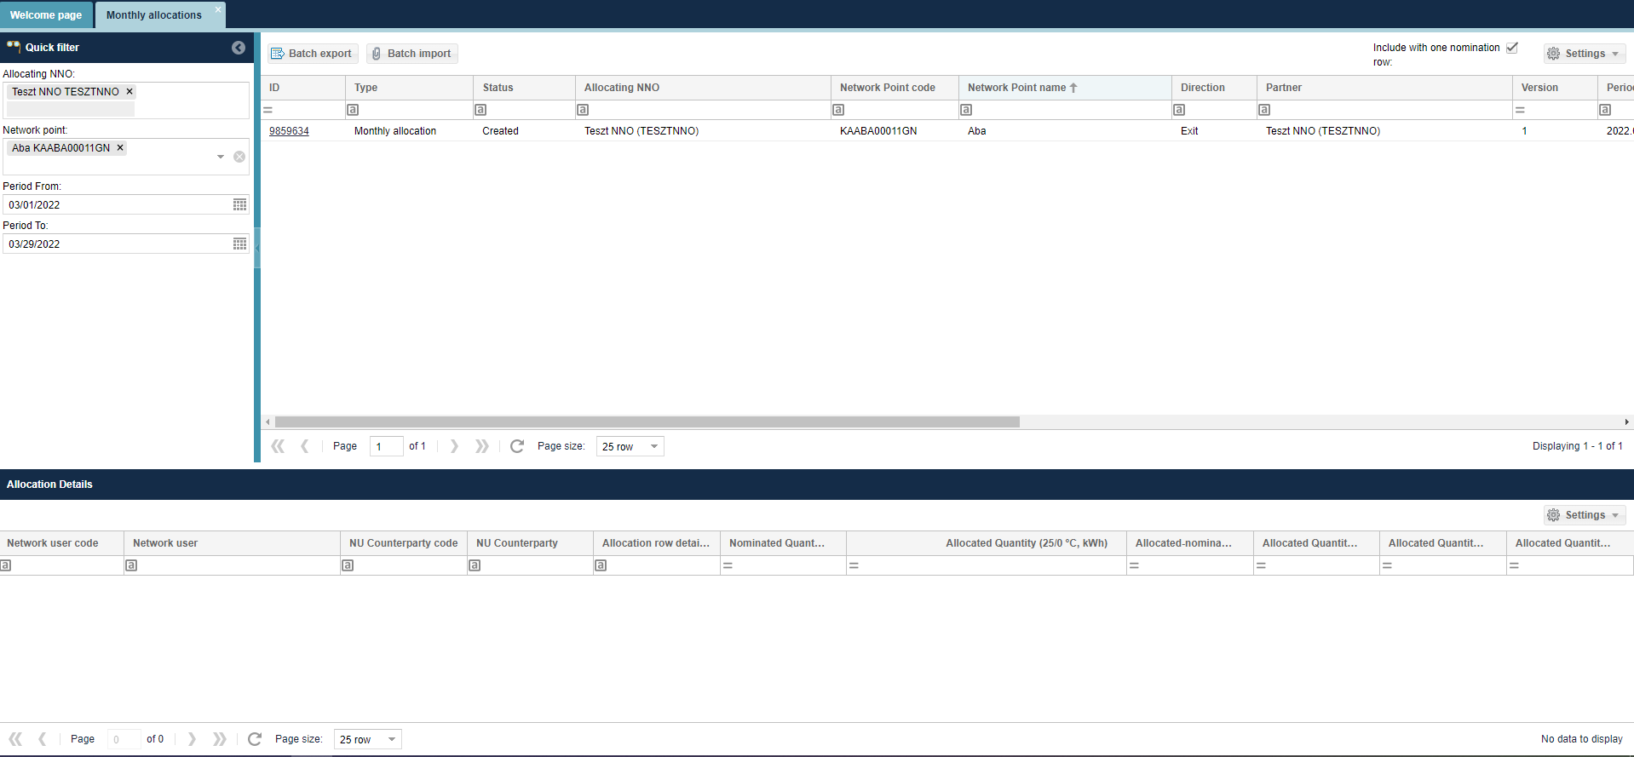
Monthly allocation rows appear. The system always displays the last version. In the list on the bottom of the screen allocation items are broken down to Network user – Network user Partner in accordance with previous nominations.
The interface allows quick filtering for the following fields:
• Allocating NNO: When logged in with an NNO user, the field takes the name of the logged in NNO by default and cannot be changed; Allocation NNO is the partner specified by the IP network point that performs the allocation tasks. If the NNO and Allocating NNO are different partners at the IP network point, only the Allocating NNO will see the allocation queues for the corresponding points.
• Network point: You can search for a network point name and code, you can enter more than one value at a time.
• Start of period: first gas day of the current month by default
• End of period: current day by default

View monthly allocation data sheet
Open the Allocation menu monthly allocation items view. Select “Allocations”.
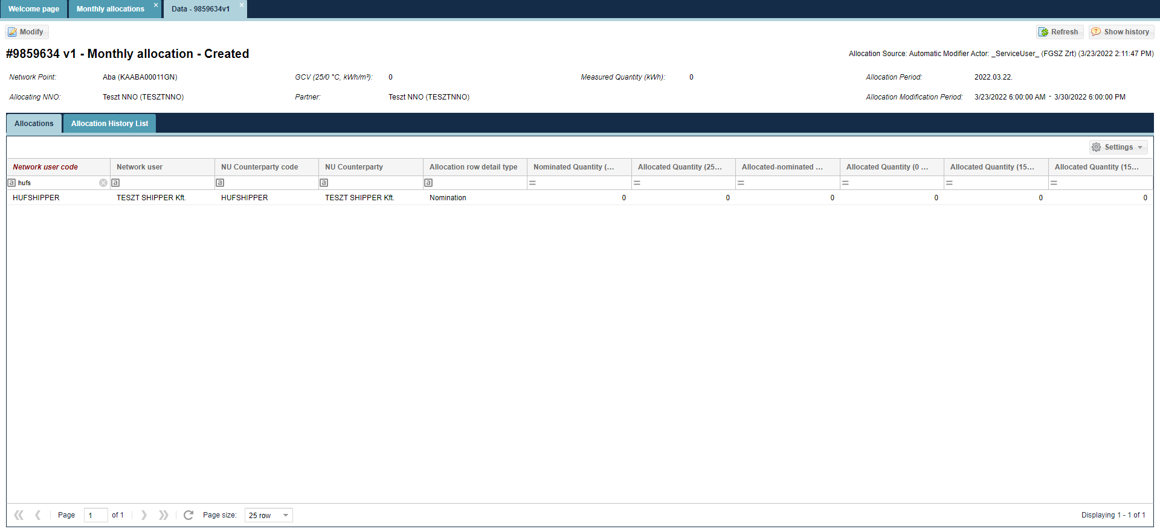
The data sheet of the selected monthly allocation is displayed to show the tasks and the relevant allocation items broken down to Network user – Network user partner. Allocated volume is displayed in a breakdown and linked to the given gas day.

View monthly allocation versions
Open the Allocation menu monthly allocation items view.
Click the link in the Identify column. Select “Allocation versions”.
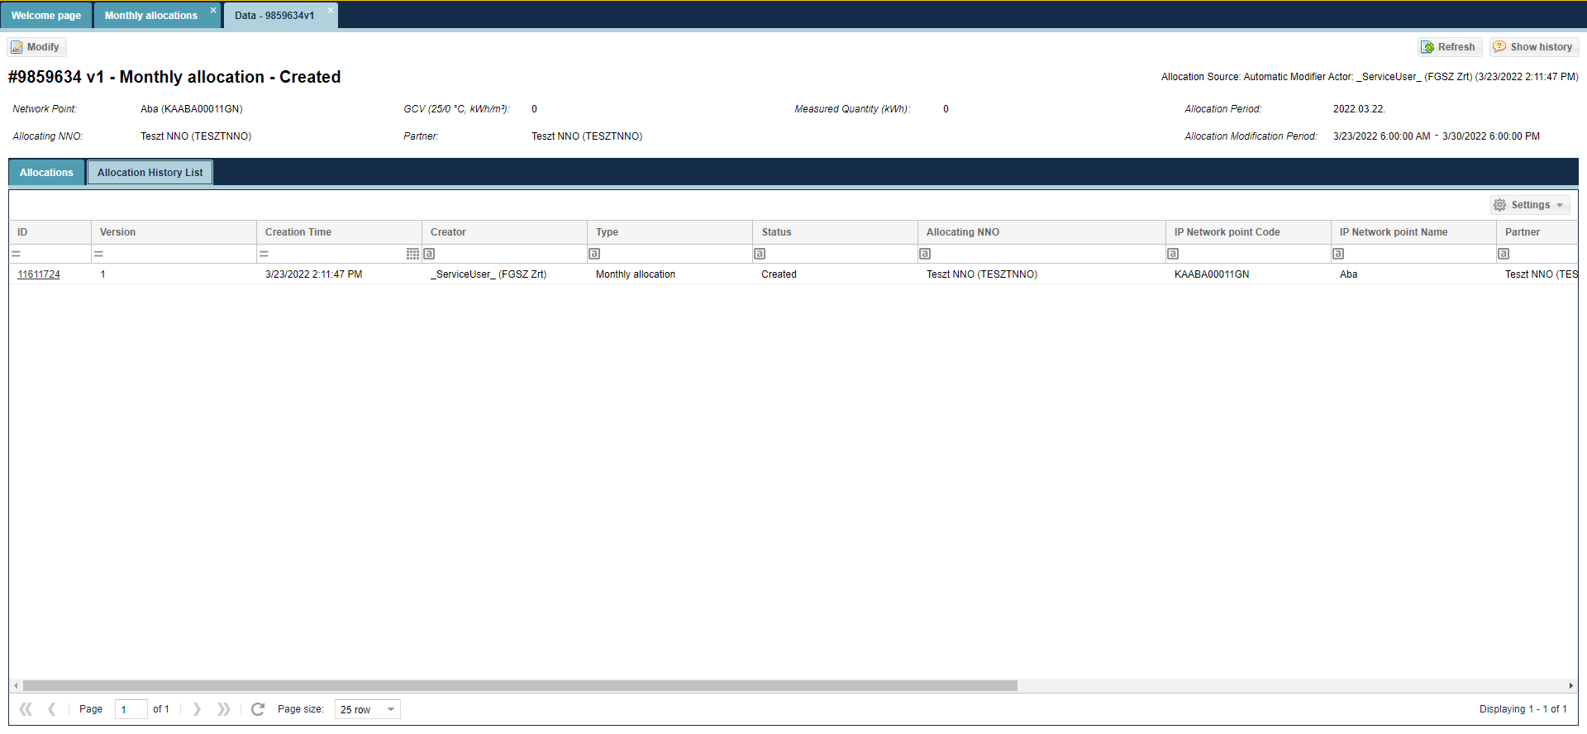
The data sheet of the selected item version will display.

View monthly allocation versions data sheet
Open the Allocation menu monthly allocation items view.
Select “Allocation versions”. Click the link in the Identify column.
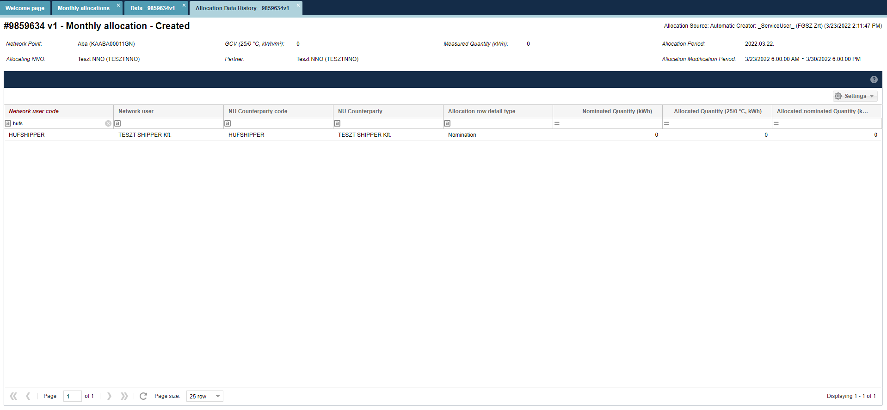
The data sheet of the selected item version will display.

Edit Monthly (correction) allocated data (balanced reallocation)
Open the Allocation menu monthly allocation items view. Select the row of items and click Edit.
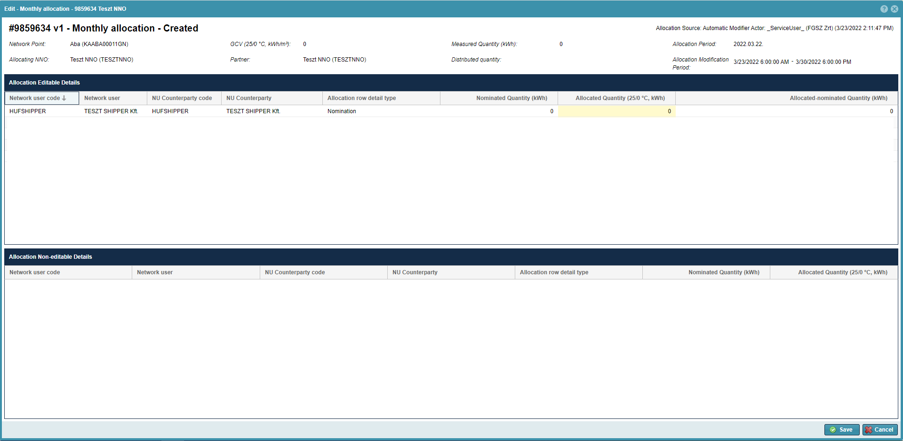
A window will open to display another list related to the selected row of items to display nominations in Network user – Network user Partner breakdown, and the relevant system auto- allocated – nomination proportionate allocation values, in the “Allocated volume (25/0 °C, kWh)” column.
You can see a non-editable informative chart under the list, that details the change of title transactions, and for OBA contractual network points it also shows OBA balance items.
Users can modify the values in this part in column “Allocated volume (25/0 °C, kWh)”, and this has to be according to the rule that the sum of the “Allocated volume (25/0 °C, kWh)” has to match the header data field values of “Measured value (25/0 °C, kWh)”.
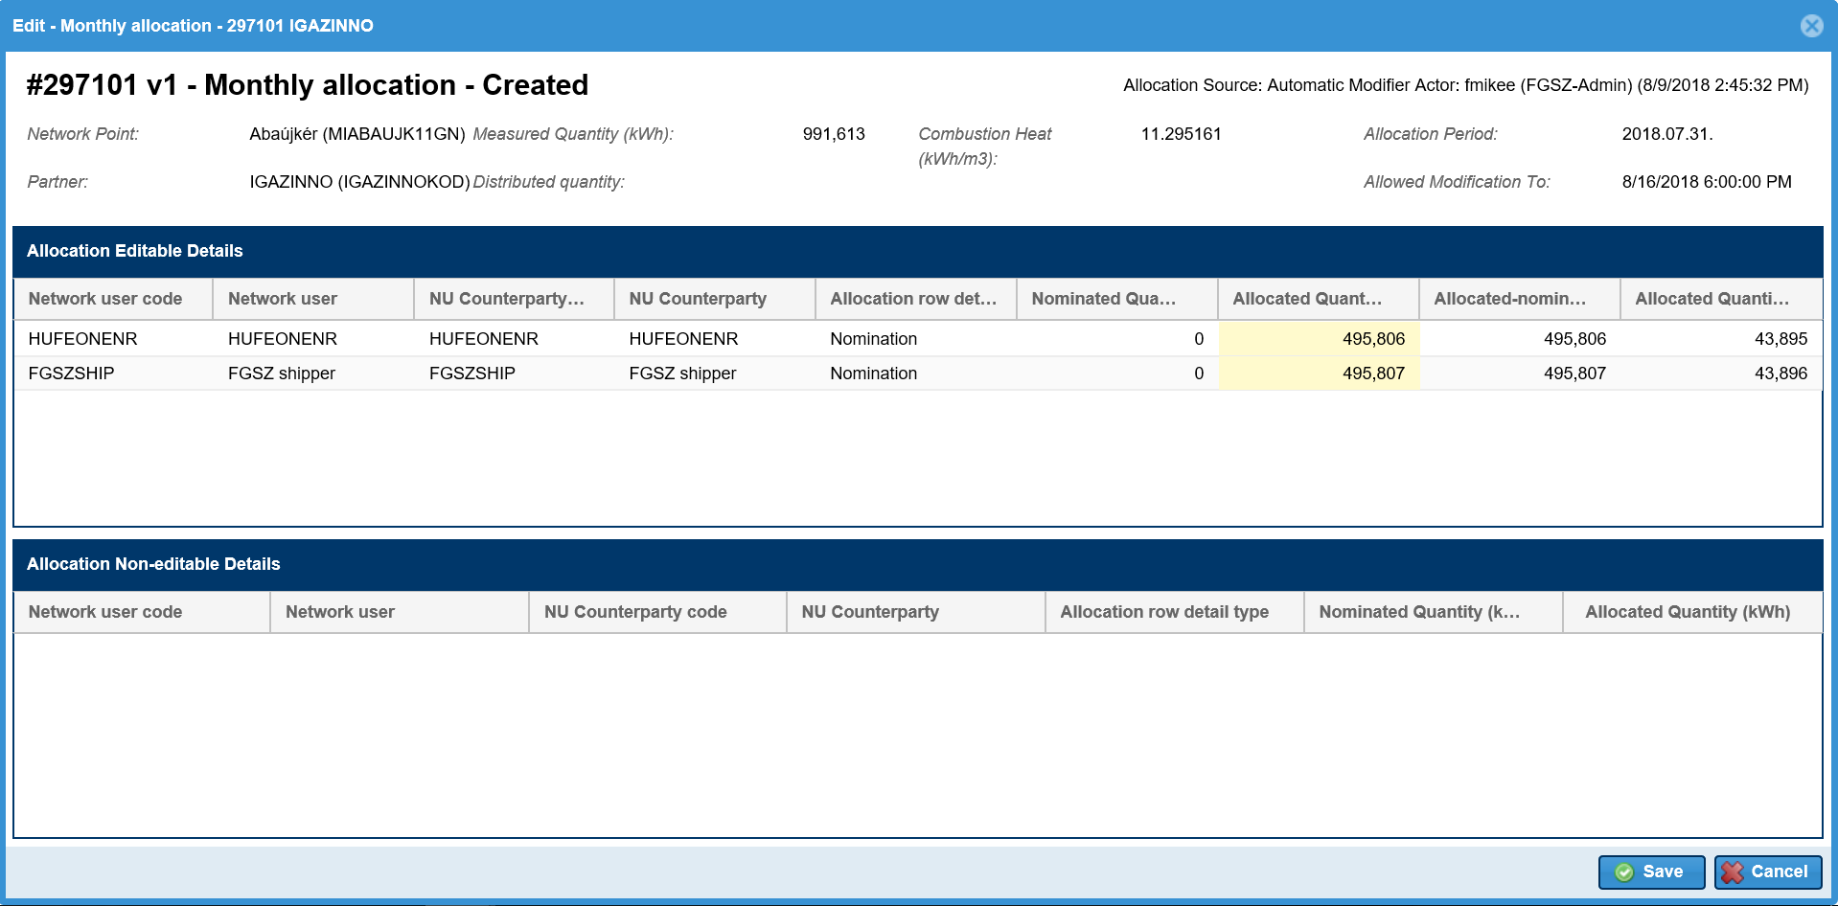

Click save after changes.
In case the header data “Measured value (kWh)” field is the same as “Allocated volume (25/0 °C, kWh)” column values, a new version is created among allocations.
The system displays the last modified row items in green on the “Allocations” screen. NNO does not have to make changes, and can also see data outside the change time window, however cannot change them

MASS export of monthly allocation data
Open the Allocation menu monthly allocation items view. Click Allocate mass export after selecting the row of items.

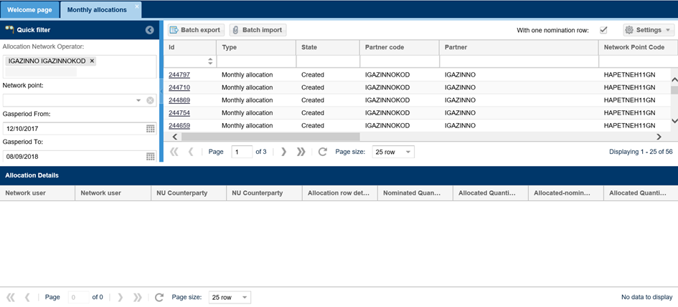
You will see Allocation row mass export pop up window.
The user shall enter the start and end date of the period for which the user wishes to export the allocation within day data.
“Allocation Network Operator” and „Network point” fields are not mandatory.
Selecting the "Include with one nomination row" check box also includes one nomination row points in the exported file.
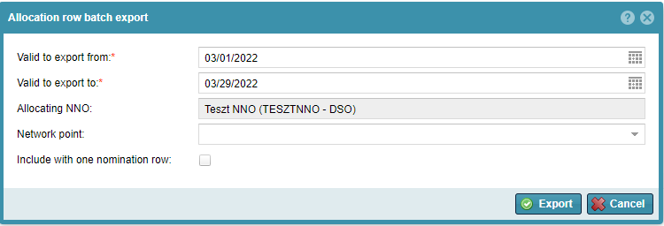

The system exports files according to filter to a predefined formatted Excel file. If multiple allocations within day arrive, only the last version will get into the Excel file. Users can edit green fields in the exported Excel file. Allocation items with no allocation data for the given period are not generated in Excel.

MASS import of monthly allocation data
Open the Allocation menu monthly allocation items view. Click Allocate mass import after selecting the row of items.
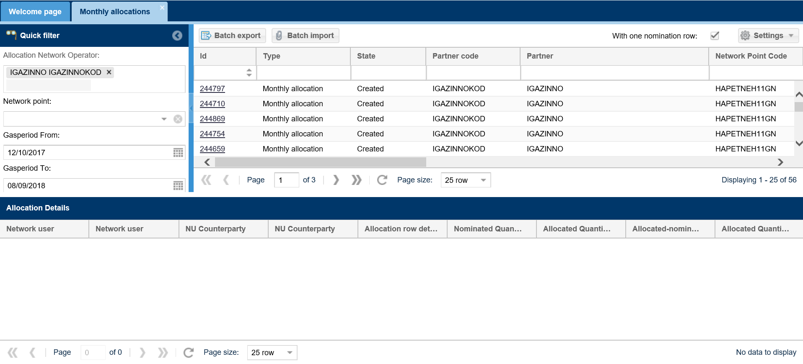
Click “Browse” to select the Excel file to be loaded from the system. The link of the selected file then moves into the field “File to be imported”. Then click “import”.
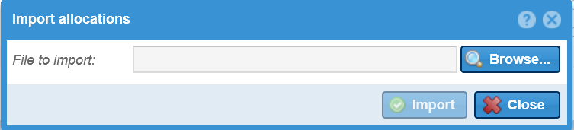
The system shows that uploading is in progress and the “Import results” window will appear. You may view possible faults generated when the system run checks. Loaded data will display in the list view with version control.

List allocation details (also with OBA accounting)
Open the Allocation menu Allocation details view.

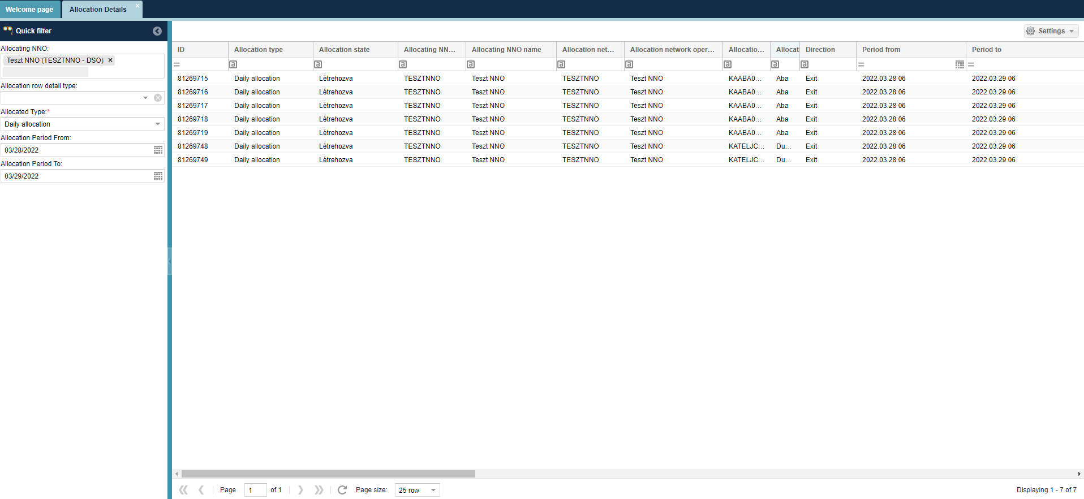
Allocation details are shown in a chart form: per network point, for gas days, and in a breakdown related to system operators Network user – Network user partner. From each list of items the last version is displayed.
The interface allows quick filtering for the following fields:
• Allocating NNO: When logged in with an NNO user, the field takes the name of the logged in NNO by default and cannot be changed; Allocation NNO is the partner specified by the IP network point that performs the allocation tasks. If the NNO and Allocating NNO are different partners at the IP network point, only the Allocating NNO will see the allocation queues for the corresponding points.
• Allocation row detail type: You can search by allocation row detail type.
• Allocated type: You can search by allocated type.
• Network point: You can search for a network point name and code, you can enter more than one value at a time.
• Start of period: current day by default
• End of period: current day by default

List peak hour allocations
Open the Allocation menu Peak hour allocation items view.
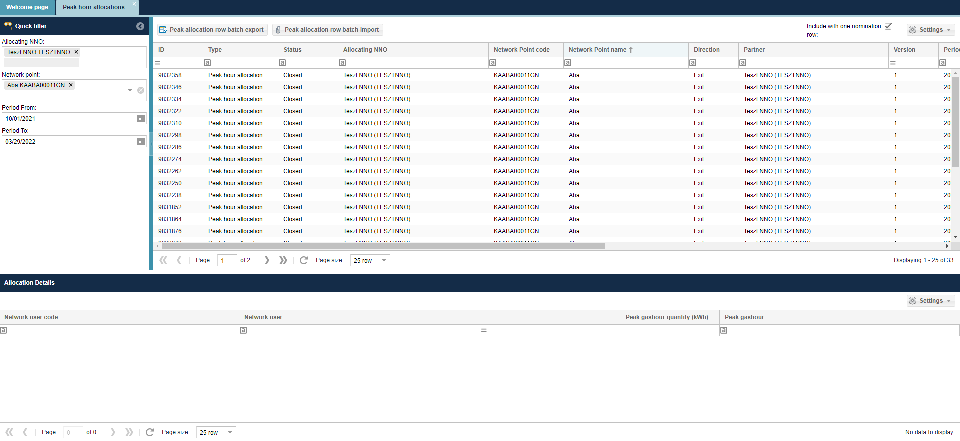
Allocation rows appear. The system always displays the last version. In the list on the bottom of the screen allocation items are broken down Network user – Network user partner in accordance with previous nominations.
The interface allows quick filtering for the following fields:
• Allocating NNO: When logged in with an NNO user, the field takes the name of the logged in NNO by default and cannot be changed; Allocation NNO is the partner specified by the IP network point that performs the allocation tasks. If the NNO and Allocating NNO are different partners at the IP network point, only the Allocating NNO will see the allocation queues for the corresponding points.
• Network point: You can search for a network point name and code, you can enter more than one value at a time.
• Start of period: first gas day of the current month by default
• End of period: current day by default

View peak hour allocation data sheet
Open the Allocation menu Peak hour allocation items view. Select “Allocations”.

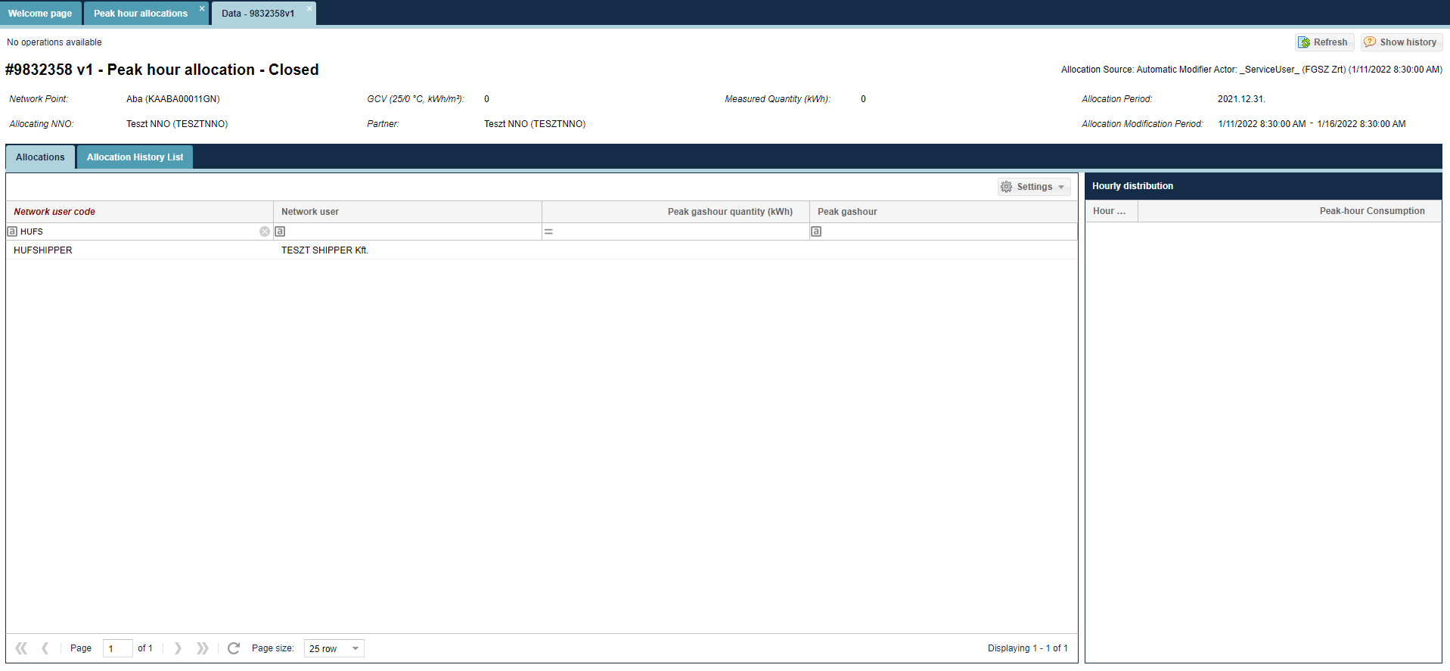
The data sheet of the selected allocation is displayed to show the tasks and the relevant allocation items broken down to Network user – Network user partner. Allocated volume is displayed in a breakdown and linked to the given gas day.

View peak hour allocation versions
Open the Allocation menu Peak hour allocation items view.
Click the link in the Identify column. Select “Allocation versions”.

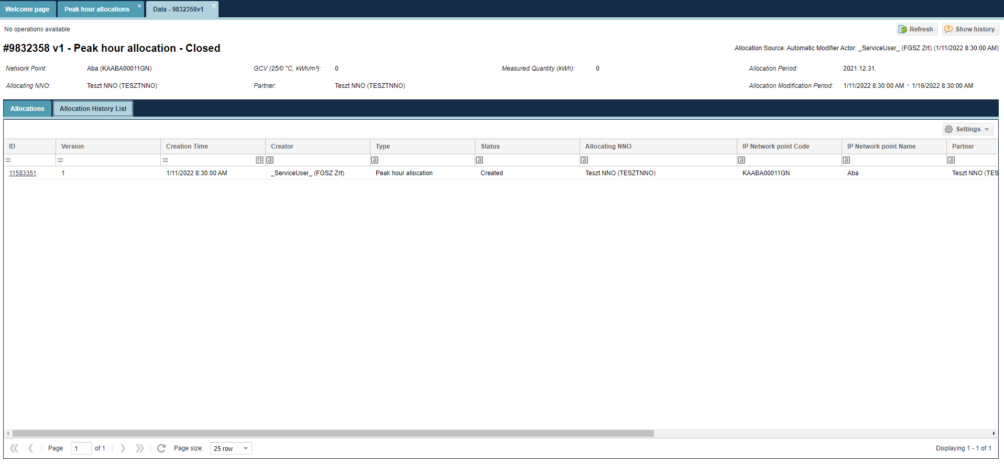
The data sheet of the selected item version will display.

View peak hour allocation versions data sheet
Open the Allocation menu Peak hour allocation items view.
Select “Allocation versions”. Click the link in the Identify column.
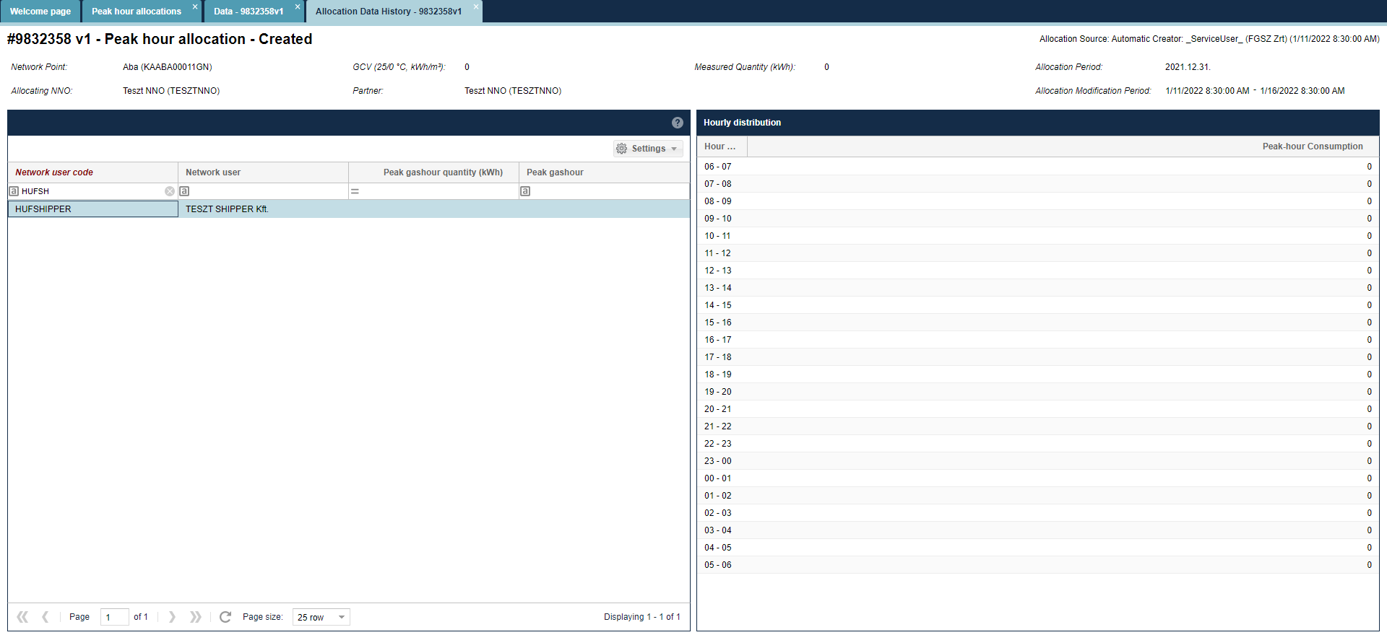
The data sheet of the selected item version will display.

Edit peak hour allocation
Open the Allocation menu Peak hour allocation items view. Select the row of items and click Edit.
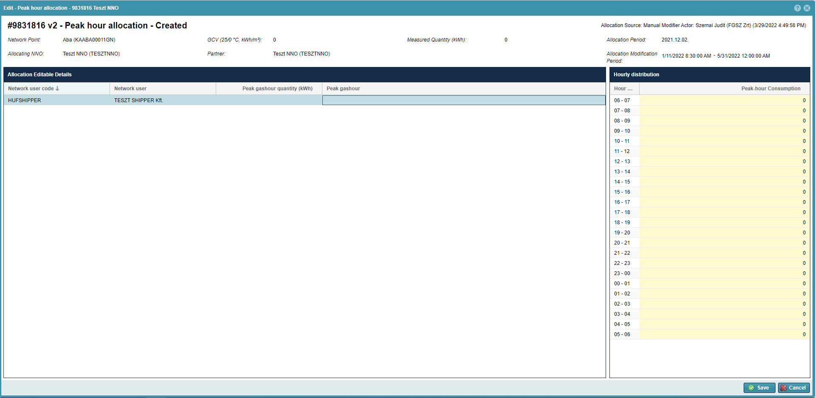
A window opens to display a relevant list to the selected row of items, where hourly peak allocation items are generated by Network user. On the right of the two charts a list will display that shows the hourly breakdown of the given gas day. After selecting an allocation row in relation to the given gas hour it fills out the “Hourly peak usage (kWh)” column. Following this the system auto-allocates fields in the “Allocations” list “Hourly peak usage (kWh)” and “Gas hour”.
Click save after changes. A new version is created among allocations.
The system displays the last modified row items in green on the “Allocations” screen.

MASS export of peak hour allocation data
Open the Allocation menu Peak hour allocation items view. Click Allocate mass export after selecting the row of items.
You will see Allocation row mass export pop up window
Enter the start and end date of the period for which the user wishes to export the allocation within day data.
“Allocation Network Operator” and „Network point” fields are not mandatory.
Selecting the "Include with one nomination row" check box also includes one nomination row points in the exported file.
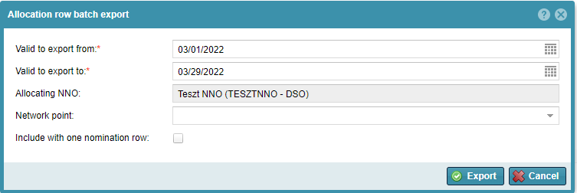
The system exports files according to filter to a predefined formatted Excel file. If multiple allocations within day arrive, only the last version will get into the Excel file. Users can edit green fields in the exported Excel file. Allocation items with no allocation data for the given period are not generated in Excel.

MASS import of peak hour data
Open the Allocation menu Peak hour allocation items view. Click Allocate mass import after selecting the row of items.
Click “Browse” to select the Excel file to be loaded from the system. The link of the selected file then moves into the field “File to be imported”. Then click “import”.
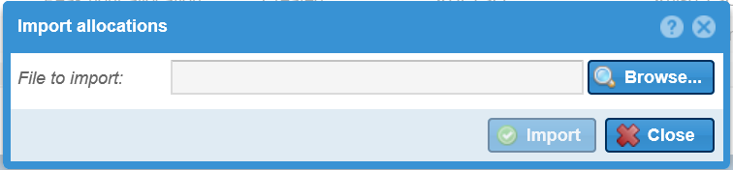
The system shows that uploading is in progress and the “Import results” window will appear. You may view possible faults generated when the system runs checks. Loaded data will display in the list view with version control.

List Peakhour by nomination row
Open the Allocation menu Peakhour by nomination row items view.
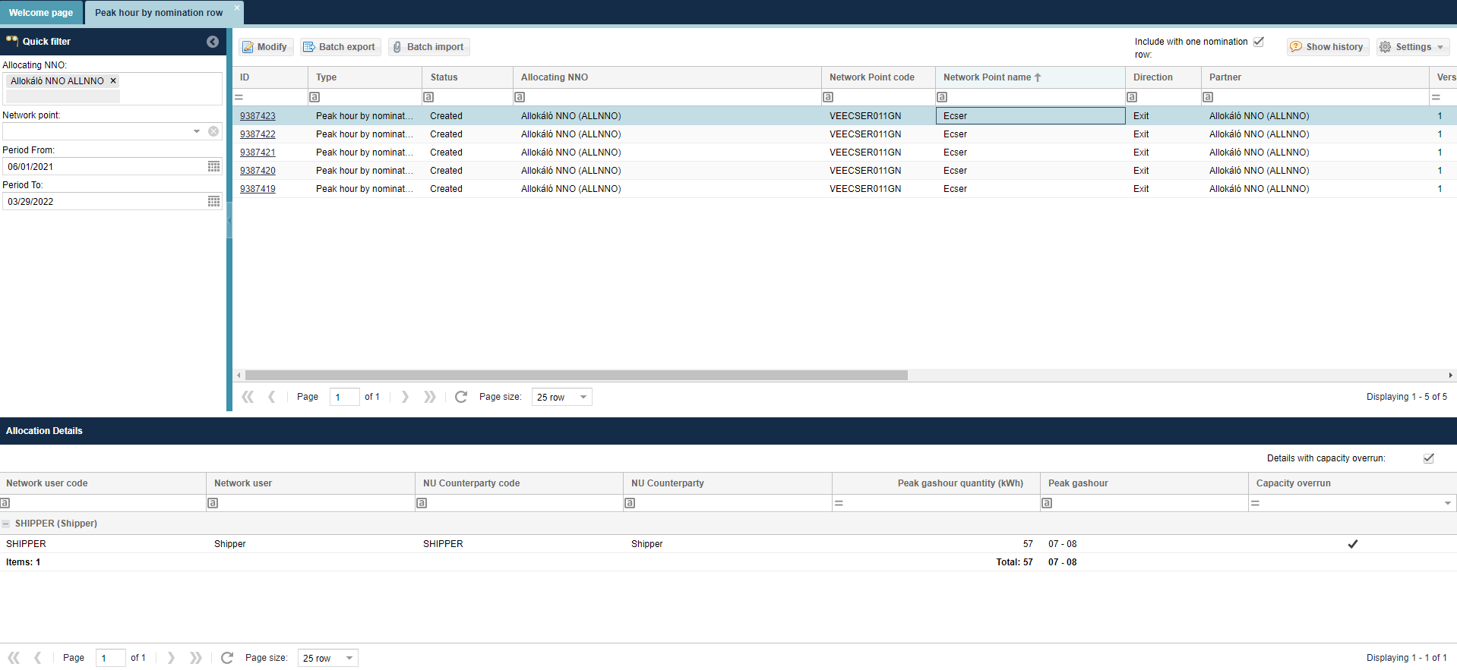Allocation rows appear. The system always displays the last version. In the list on the bottom of the screen allocation items are broken down Network user – Network user partner in accordance with previous nominations.
The interface allows quick filtering for the following fields:
• Allocating NNO: When logged in with an NNO user, the field takes the name of the logged in NNO by default and cannot be changed; Allocation NNO is the partner specified by the IP network point that performs the allocation tasks. If the NNO and Allocating NNO are different partners at the IP network point, only the Allocating NNO will see the allocation queues for the corresponding points.
• Network point: You can search for a network point name and code, you can enter more than one value at a time.
• Start of period: first gas day of the current month by default
• End of period: current day by default

View Peakhour by nomination row data sheet
Open the Allocation menu Peakhour by nomination row items view. Select “Allocations” Tab.
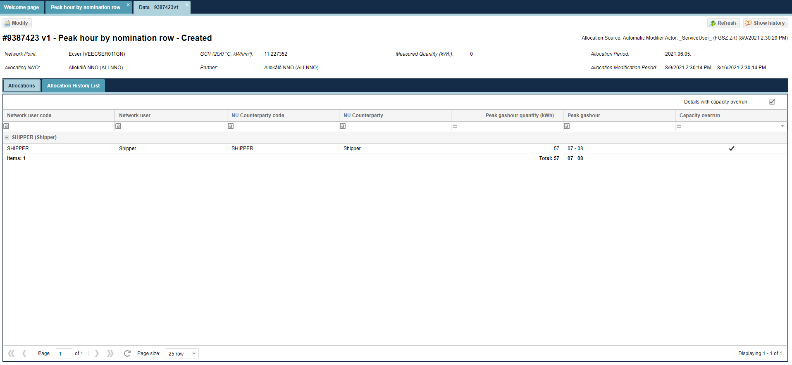The data sheet of the selected allocation is displayed to show the tasks and the relevant allocation items broken down to Network user – Network user partner. Allocated volume is displayed in a breakdown and linked to the given gas day.

View Peakhour by nomination versions
Open the Allocation menu Peakhour by nomination row items view.
Click the link in the Identify column. Select “Allocation History List” Tab.
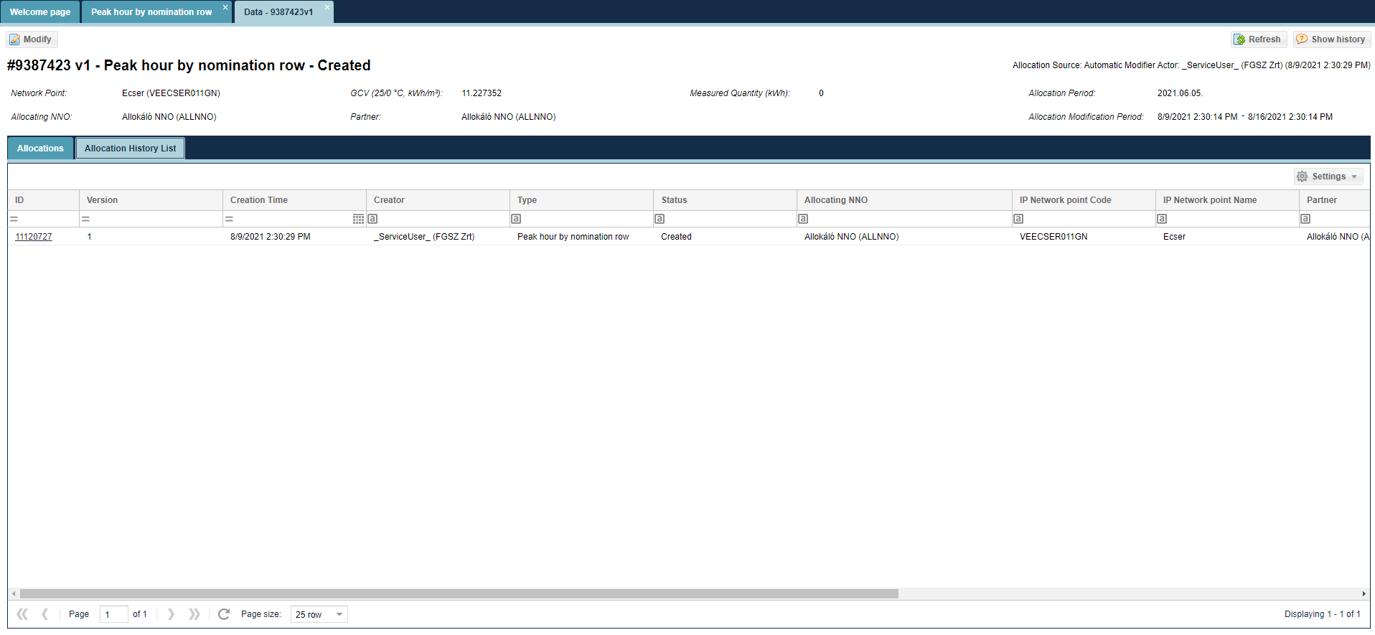The data sheet of the selected item version will display.

View Peakhour by nomination row versions data sheet
Open the Allocation menu Peakhour by nomination row items view.
Select “Allocation History List”. Click the link in the Identify column.
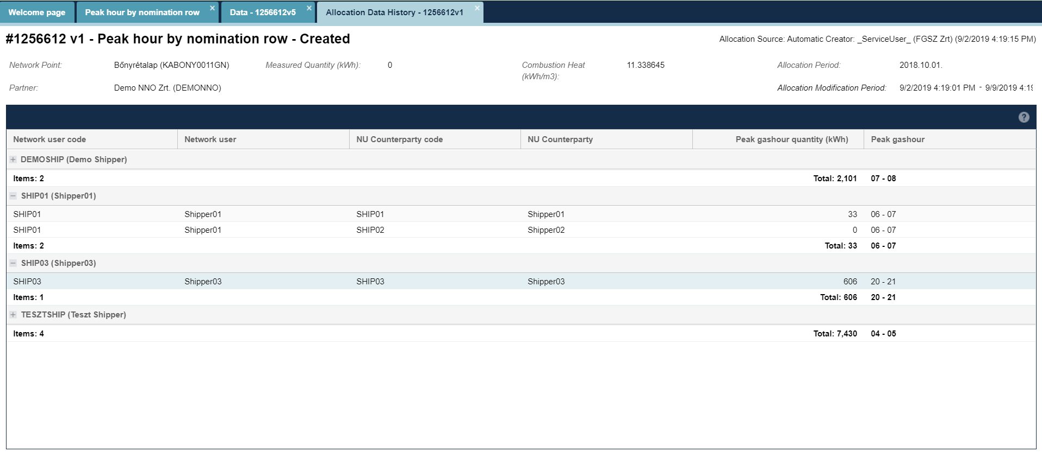The data sheet of the selected item version will display.

Edit Peakhour by nomination row
Open the Peakhour by nomination row items view. Select the row of items and click Edit.
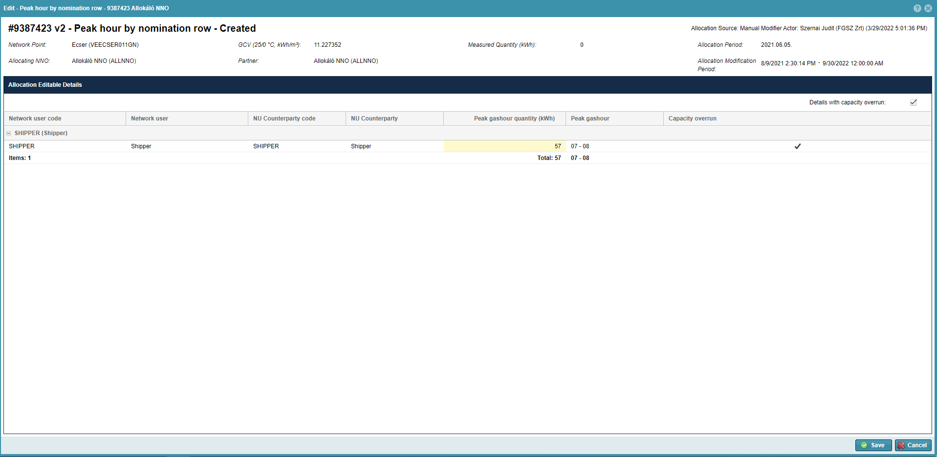A window will open to display another list related to the selected row of items to display system auto-allocated nomination proportionate peakhour by nomination row allocation values in Network user – Network user Partner breakdown. The user may change the Network user Partner peakhour quantity. It is not possible to change the “Peak gashour”.
Click save after changes. A new version is created among allocations.

MASS export of Peakhour by nomination row data
Open the Allocation menu Peakhour by nomination row items view. Click “Batch export” of items.
You will see Allocation row mass export pop up window
Enter the start and end date of the period for which the user wishes to export the allocation within day data.
“Allocation Network Operator” and „Network point” fields are not mandatory.
Selecting the "Include with one nomination row" check box also includes one nomination row points in the exported file.
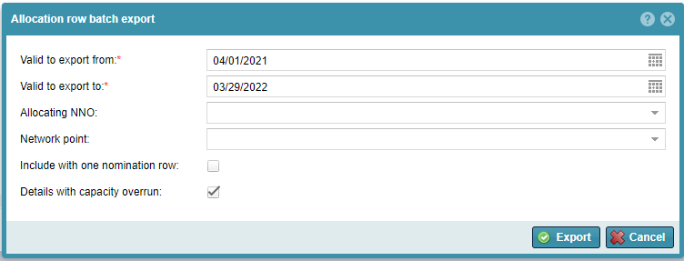
The system exports files according to filter to a predefined formatted Excel file. If multiple allocations within day arrive, only the last version will get into the Excel file. Users can edit green fields in the exported Excel file. Allocation items with no allocation data for the given period are not generated in Excel.
  - MASS import of Peakhour by nomination row data
Open the Allocation menu Peakhour by nomination row items view. Click “Batch import” after selecting the row of items.
Click “Browse” to select the Excel file to be loaded from the system. The link of the selected file then moves into the field “File to be imported”. Then click “import”.
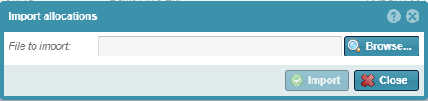
The system shows that uploading is in progress and the “Import results” window will appear. You may view possible faults generated when the system runs checks. Loaded data will display in the list view with version control.

Settlement

Browse Reports

List generated reports
Open Settlement menu Generated reports view.
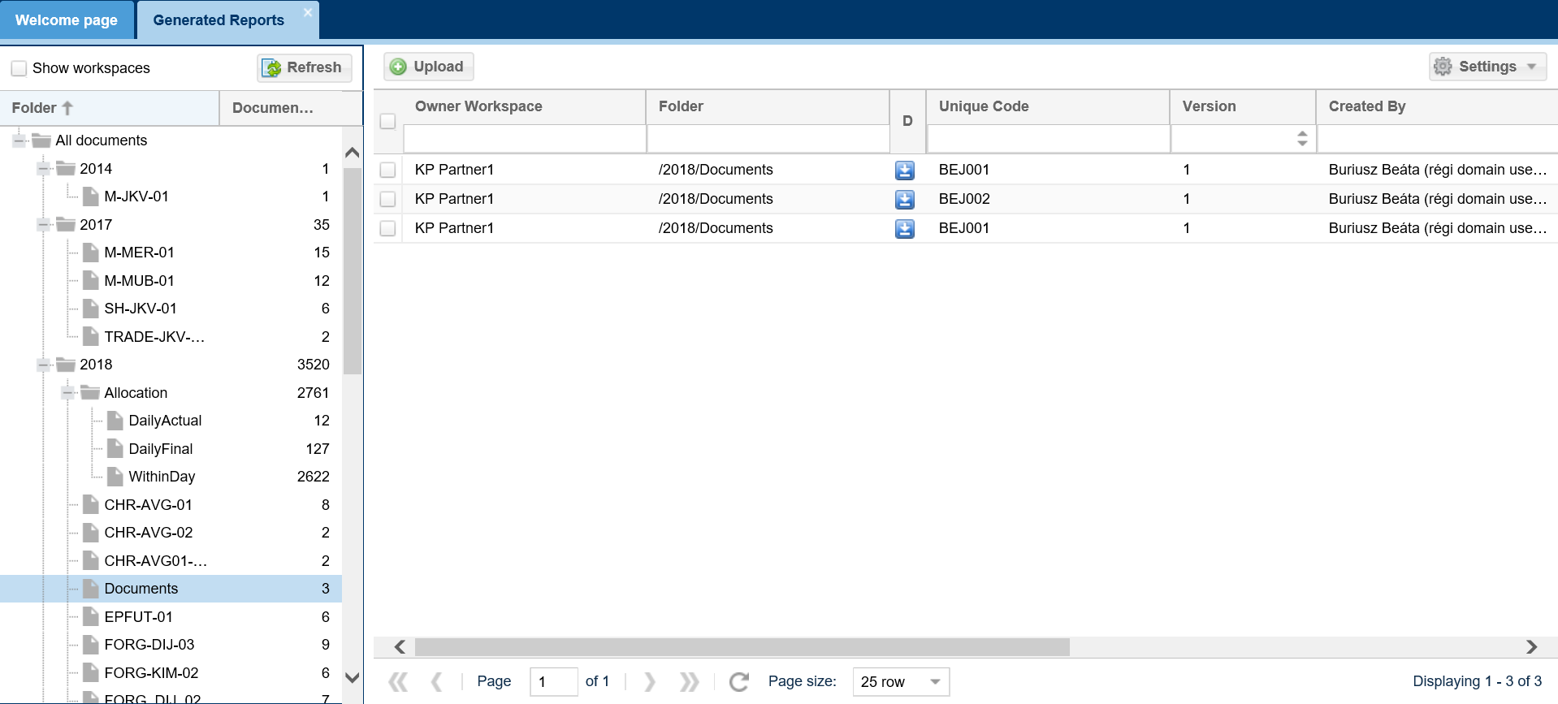
The document filter list option displays. Document hierarchy can be viewed in the left folder view. NNO can only see their own documents.

Downloading documents
Open Settlement menu Generated reports view. Select folder and click Download button or the icon in the Download column.
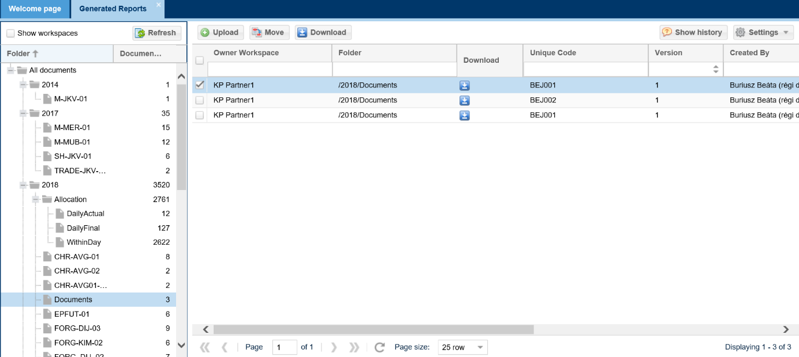
The file is downloaded and the system offers to save or open the document. In the document type column you can find the format the file is downloaded in. NNO can only download their own documents.

Upload documents
Open Settlement menu Generated reports view. Select the folder then click Upload button.
Manual Document upload window will open, click “Browse” to select the file to be uploaded from the file system, and enter mandatory data.
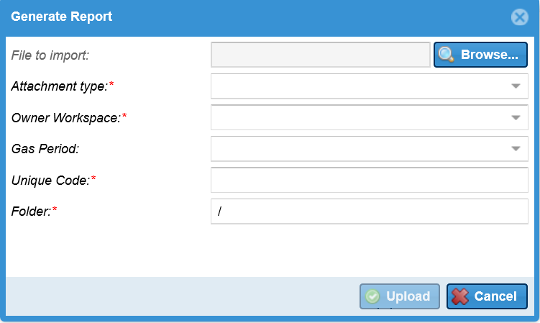
After filling out required fields with an asterisk, the Upload button becomes active. Click this to upload data to the system. You can view uploaded documents in the selected folder.

Maintenance
Work has three types: yearly maintenance, maintenance cleaning, weekly maintenance
Yearky maintenance works may influence the technical capacity of pipes or basic points, can decrease it to the extent of capacity to be met. Pipeline cleaning concerns storages and interconnect (border crossing) points, and does not concern users. Weekly works do not concern capacity, but the weekly schedule also concerns the weekly part of annual works.
Maintenance works can be organized into weekly executive and yearly schedule. Schedules are stored in with version numbers. If there is any change in maintenance works for a given year, the schedule is to be regenerated.

List maintenance works
Open the Operation menu Maintenance works view.
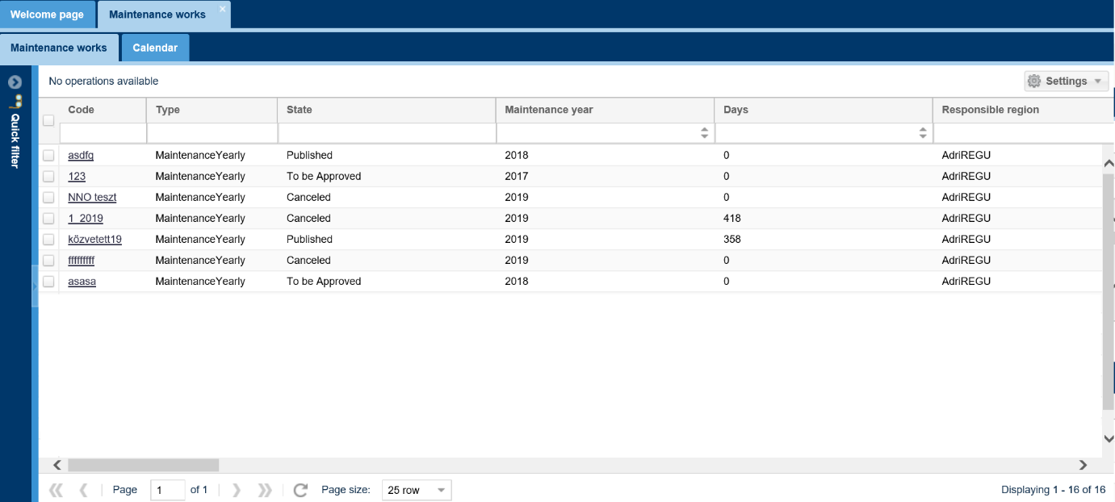
The screen listing Maintenance works opens, and it can be filtered and searched.

List NNO maintenance works
Open Operation menu NNO Maintenance view.
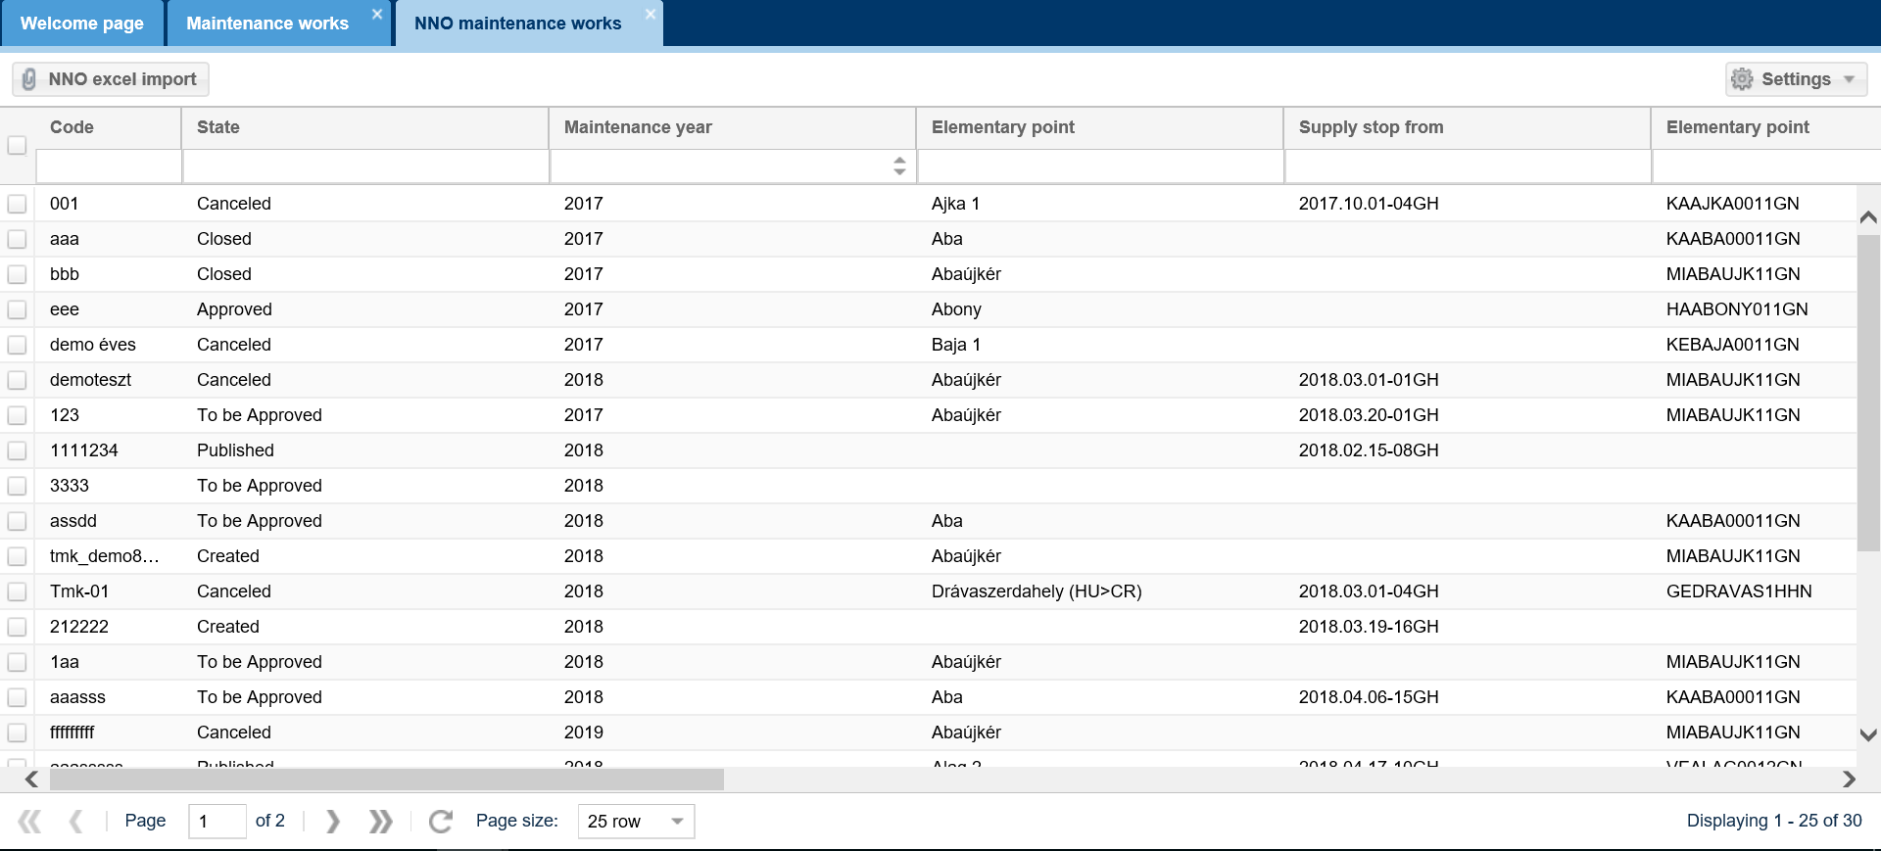
An NNO can only see maintenance works where the NNO is concerned. The screen lists these maintenance works.

NNO Edit maintenance works
Open Operation menu NNO Maintenance view. Select a non-deleted and non-closed status maintenance work. By selecting work “NNO Edit” function button becomes active.
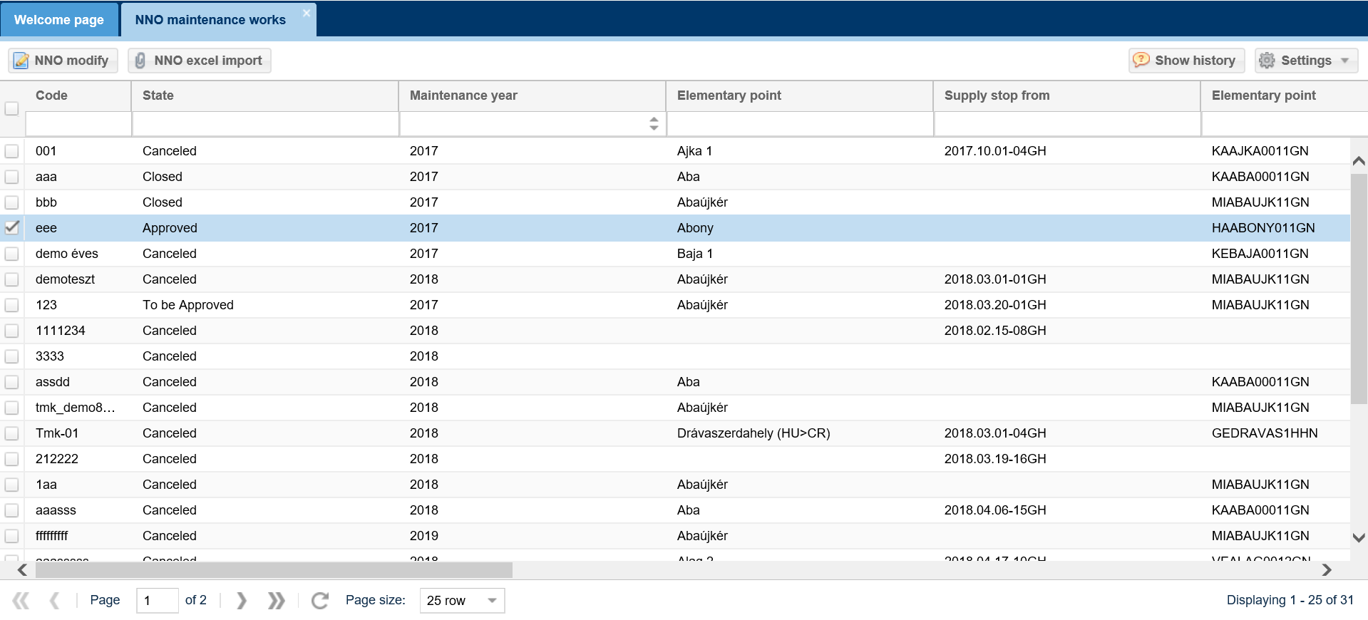
Upon a click an Edit window will open. Change the required fields, then save.
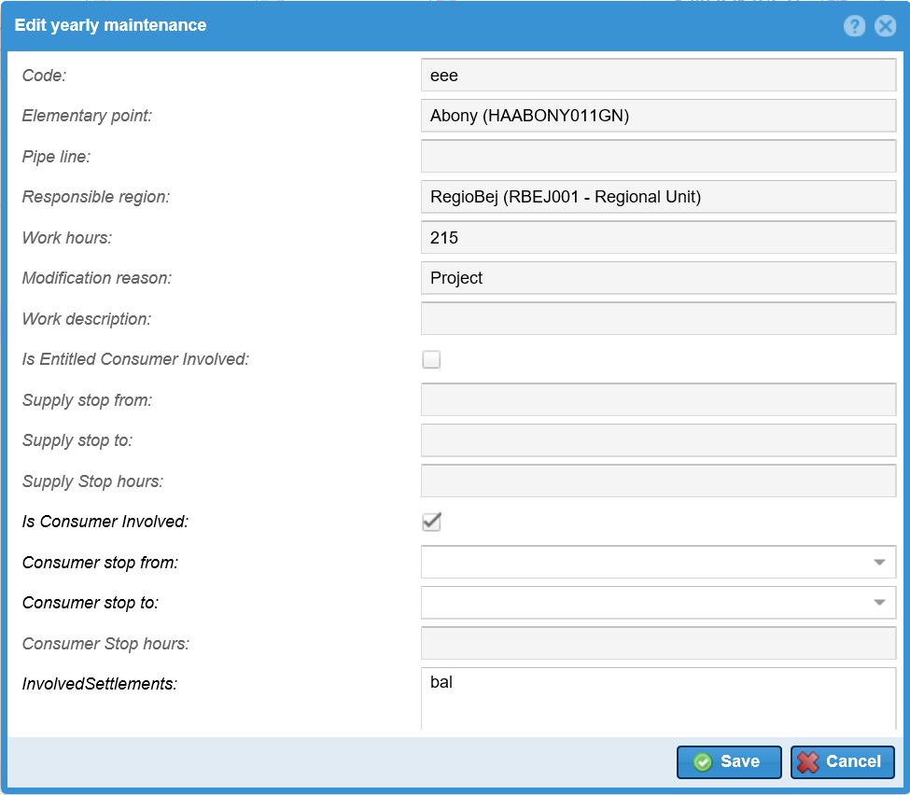
Maintenance work will change to “Waiting for approval status”

Excel import by NNO
Open Operation menu NNO Maintenance view. Click “NNO Excel import” after selecting the row of items.
Click “Browse” to select the Excel file to be loaded from the system. The link of the selected file then moves into the field “File to be imported”. Then click “import”.
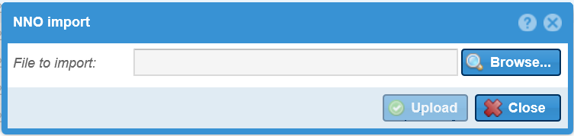
The system shows that uploading is in progress and the “Import results” window will appear. You may view possible faults generated when the system runs checks. If the system has not found any errors, the changes will be saved.

Functions only for NNO Admin

Partners

Listing partners
Open the Master Data menu Partners view.
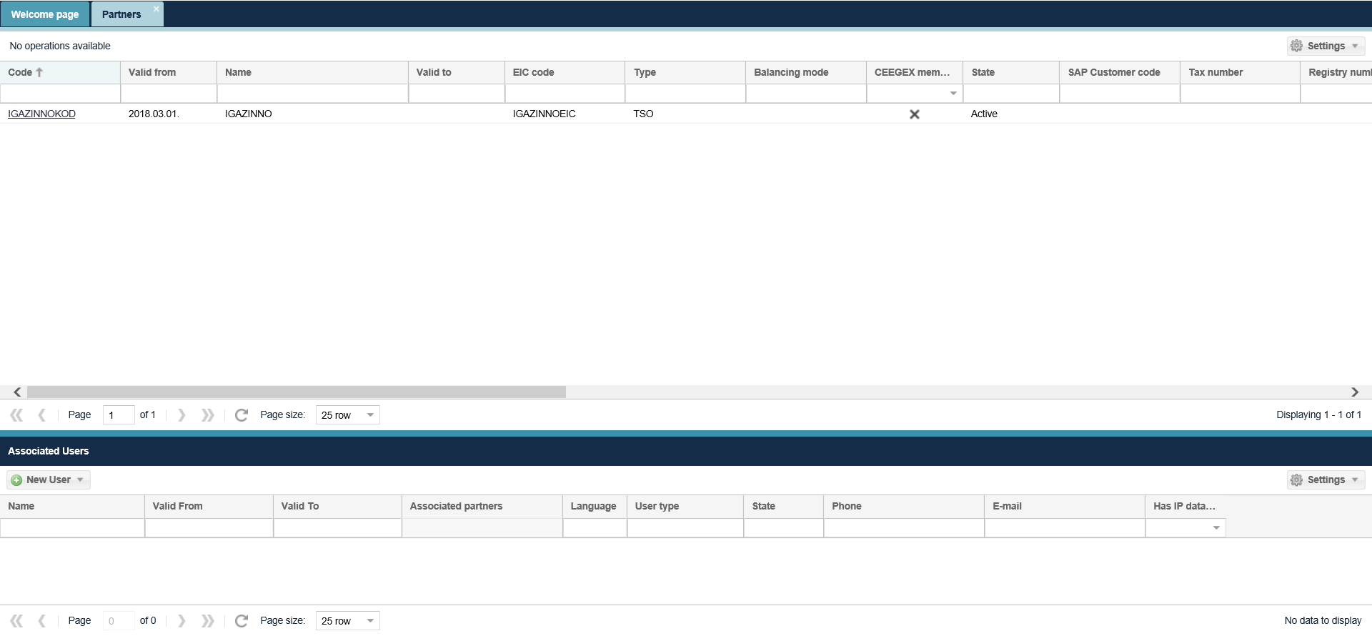
The Partners list screen is displayed. You can see the partners current attributes as well as their code here.
By clicking Request data modification function, we can create a data modification request.
Open Partner management menu, Partner datamodification requests view. The network user can list the requests created its self.

Users

Add New User (for Organization)
Open the Master Data menu Users view.
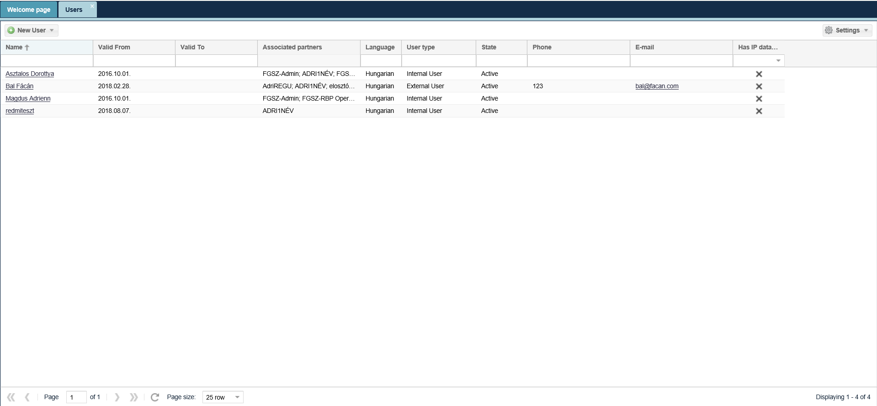
Click on the “New User” button and select the “New User (for Organisation). Then enter mandatory data to the screen that displays and click save. Multifactor authentication is also possible, in which case the power of attorney must be uploaded.
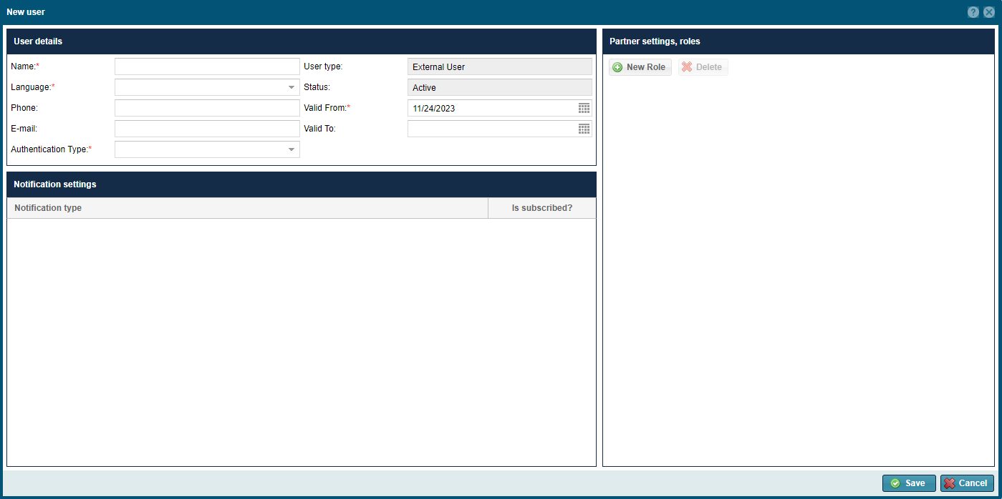
You can also add new partners with a button on the bottom of the Partners view Associated Users section on the sheet.
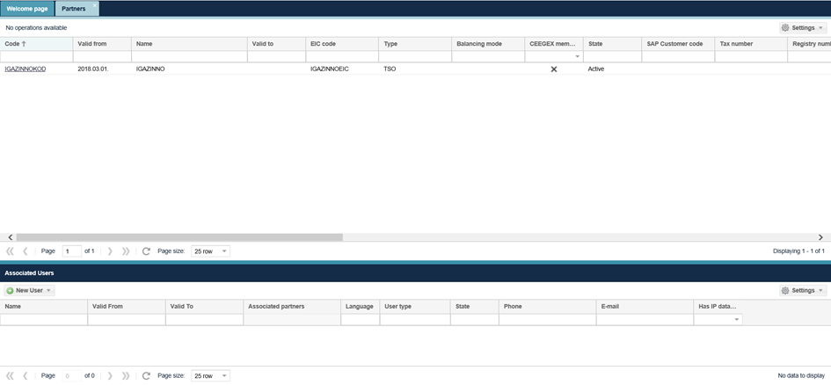

Data transfers
Open the Master Data Data transfers view. This function can be used to view data transfers and related messages. You can download the request and response actions here.

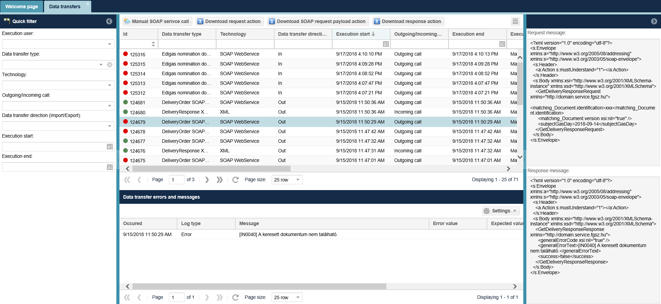
  - Measurement
    - Listing Daily Measurement data – to elementary point
Open the Measurement menu Daily measurement data to elementary point view.
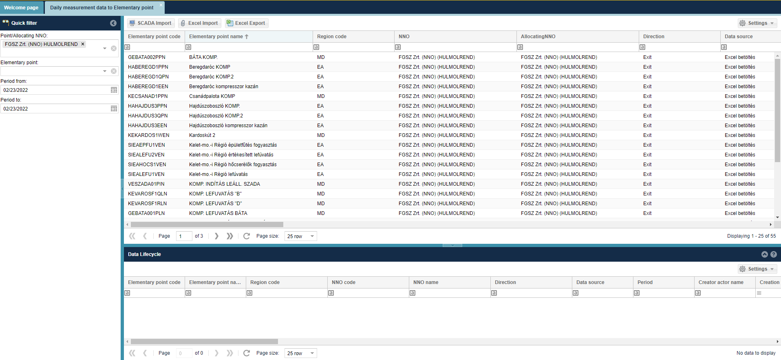
The current daily measurement data is displayed for elementary points and gas days with the latest data for each measurement parameter.

The interface allows quick filtering for the following fields:
• Point/Allocating NNO: When logged in with an NNO user, the field takes the name of the logged in NNO by default and cannot be changed; Allocation NNO is the partner specified by the IP network point that performs the allocation tasks. If the NNO and Allocating NNO are different partners at the IP network point, only the Allocating NNO will see the measurement datas for the corresponding points.
• Elementary point: You can search for an elementary point name and code, you can enter more than one value at a time.
• Start of period: gas day before the current day
• End of period: gas day before the current day

    - Listing Daily Measurement data – to Network point
Open the Measurement menu Daily measurement data to Network point view.
The current daily measurement data is displayed for Network points and gas days with the latest data for each measurement parameter.
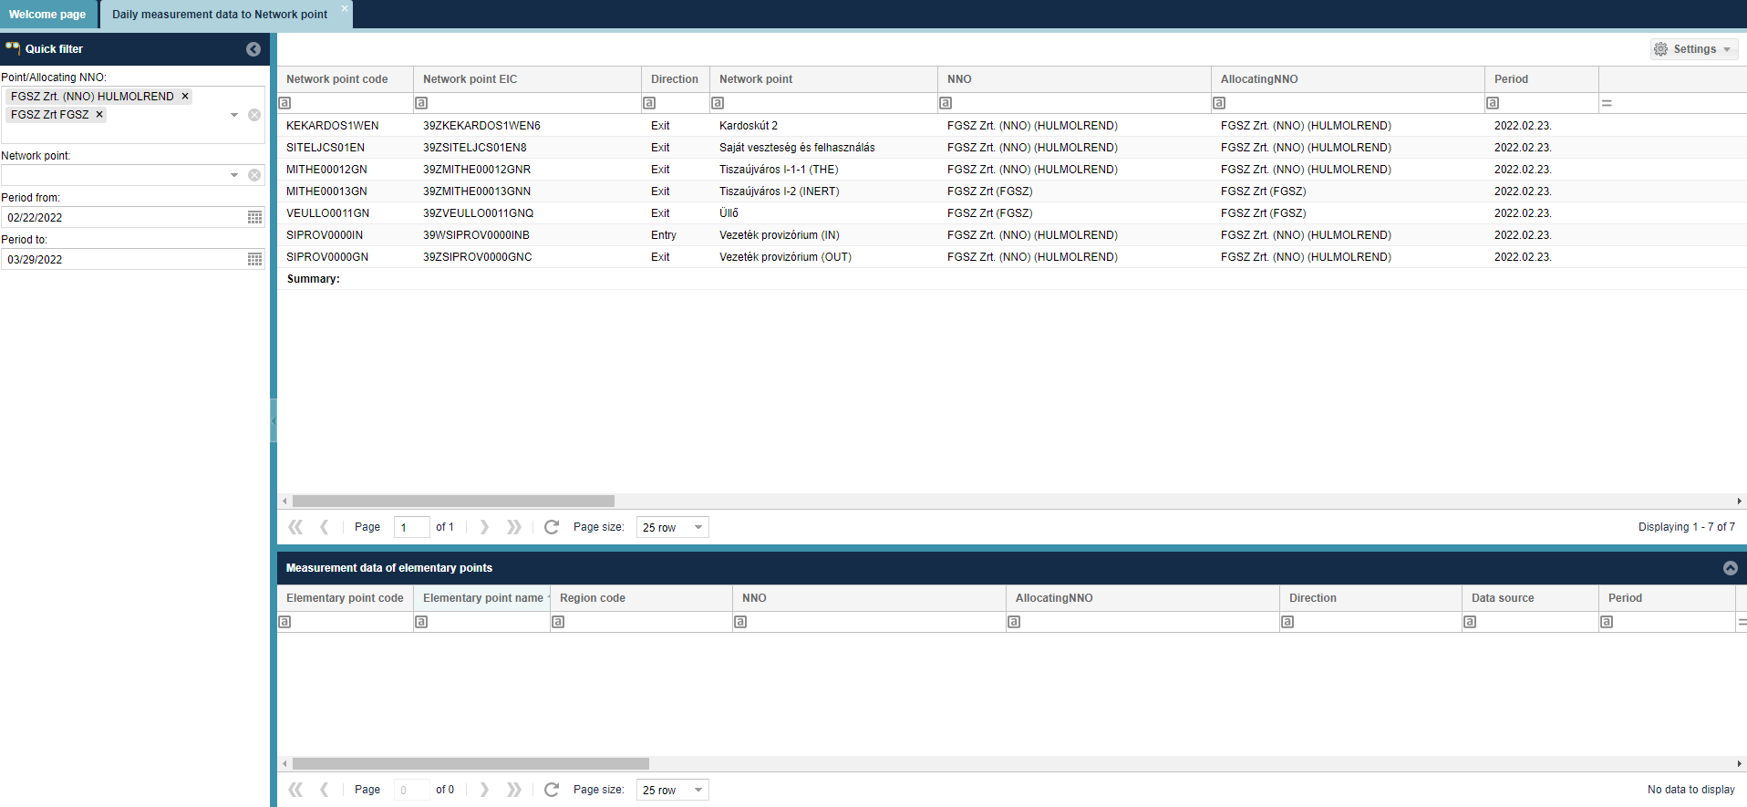
Elementary points for a given Network point are displayed on the bottom of the screen in the „Measurement data of elementary points” section, after you select a row in the upper list.
The interface allows quick filtering for the following fields:
• Point/Allocating NNO: When logged in with an NNO user, the field takes the name of the logged in NNO by default and cannot be changed; Allocation NNO is the partner specified by the IP network point that performs the allocation tasks. If the NNO and Allocating NNO are different partners at the IP network point, only the Allocating NNO will see the measurement datas for the corresponding points.
• Network point: You can search for a network point name and code, you can enter more than one value at a time.
• Start of period: gas day before the current day
• End of period: gas day before the current day

    - Listing Hourly Measurement data – to elementary point
Open the Measurement menu Hourly measurement data to elementary point view.
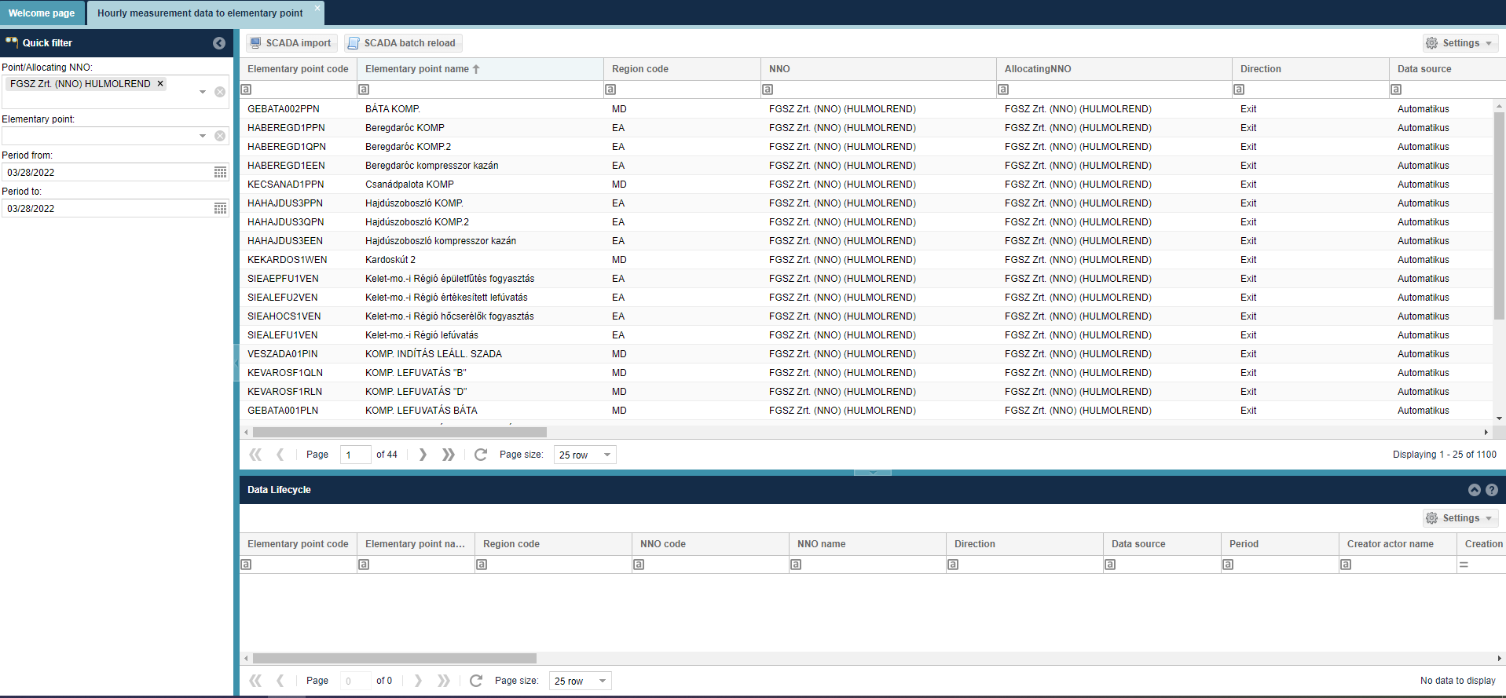
The current hourly measurement data is displayed for elementary points and gas-hours of the gas days with the latest data for each measurement parameter.
The interface allows quick filtering for the following fields:
• Point/Allocating NNO: When logged in with an NNO user, the field takes the name of the logged in NNO by default and cannot be changed; Allocation NNO is the partner specified by the IP network point that performs the allocation tasks. If the NNO and Allocating NNO are different partners at the IP network point, only the Allocating NNO will see the measurement datas for the corresponding points.
• Elementary point: You can search for an elementary point name and code, you can enter more than one value at a time.
• Start of period: current day
• End of period: current day

    - Listing Hourly Measurement data – to Network point
Open the Measurement menu Hourly measurement data to Network point view.
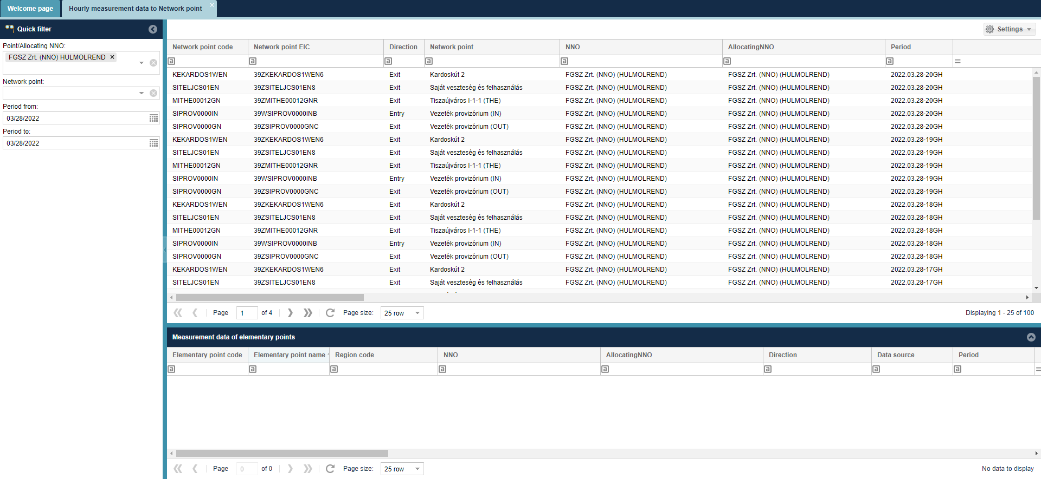
The current hourly measurement data is displayed for Network points and gas-hours of the gas days with the latest data for each measurement parameter.
The interface allows quick filtering for the following fields:
• Point/Allocating NNO: When logged in with an NNO user, the field takes the name of the logged in NNO by default and cannot be changed; Allocation NNO is the partner specified by the IP network point that performs the allocation tasks. If the NNO and Allocating NNO are different partners at the IP network point, only the Allocating NNO will see the measurement datas for the corresponding points.
• Network point: You can search for a network point name and code, you can enter more than one value at a time.
• Start of period current day
• End of period: current day

My Tickets
Use the My Tickets button in the menu to open our ticketing tool to report an issue or file a request.

Restriction data service

POD Allocation list
Open the menu item Maintenance/Restriction data service/POD Allocations. The POD allocations loaded into the system will be displayed.

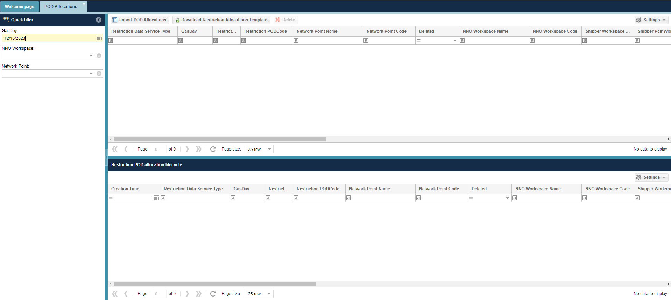

In the list you can view the data sent in the KORALL file(s). The system always displays the data corresponding to the last data transfer.

In the 'POD allocations lifecycle' list at the bottom of the screen, the previous versions of each POD allocation are displayed based on the previous data transfers.

Import POD allocations

Open the menu item Maintenance/Restriction data service/POD Allocations. Click on the "Import POD allocation" button in the header.

This will bring up the "Import POD allocations" window. Click on the "Browse" button to select the Excel file to upload. The user then clicks on the "Upload Import file" button.

The system will inform the user in the "Import Result" window that the file upload was successful and the system has started the verification.
If processing is successful, the uploaded data will be displayed in the list.

The system will send an e-mail notification of the import result to the operational contact of the submitting partner ((LI0001) Restriction classification SFTP import).

The result of the import can be viewed in the 'Data transfers section of the 'Master Data' menu. In the Korlátozási besorolás folder, select the data transfer type "Restriction KORALL CSV file import".

POD allocation can only be sent for a restriction data service with an active status and only during the period specified in the restriction data service call for data.
Reporting counterparties will be notified of a change in the status of a data service (both in case of activation and in case of deactivation) by e-mail (Notification of change in status of POD (LI0002)) and by SMS (SMS of change in status of POD (LI0003)). The messages also include the type of data service, the period and the reference date(s).

Hibakód | Hibaüzenet
LI0001 | The number of columns {0} is not proper! Line=[{1}]
LI0002 | Wrong data type: line =[{0}], column=[{1}]
LI0003 | The field is mandatory: line=[{0}], column=[{1}]
LI0004 | Name of the file {0} is not proper!
LI0005 | The content of the file does not correspond to a CSV file with UTF-8 encoding.
LI0006 | The size of file can not be greater than 100 MB.
LI0007 | The file contains illegal characters.
LI0101 | The data was received for an inactive provision day ({day}).
LI0102 | The data provision period closed.
LI0103 | Cannot send data to the ({network point code}) network point.
LI0104 | In the case of early forecast, alarm and emergency level data provision, the last hour's measurement data is mandatory.
LI0105 | The „Hours Executing Limitation (hour)” field minimum value is 4, maximum value is 72.
LI0106 | In the case of a residential collector POD, the "Is Fifth Exception (YES/NO)" field can only be filled in with YES.
LI0101 | Data received for an inactive data service day ({day}).
LI0102 | The data service period has ended. End of data service: {0}!
LI0103 | You cannot send data to the ({0}) network point.
LI0104 | In the case of early forecast, alarm and emergency level data service, the last hour's measurement data is mandatory.
LI0105 | The value of the „Vegrehajtasra rend.Idotart. (ora)” field must be between 4 and 72!
LI0106 | In the case of a residential collection POD, the field "Is Fifth Exception" can only be filled with YES.
LI0109 | The value of the "Halozati pont" field ({0}) is not matching with the Code field of any valid Network Point!
LI0111 | The data service time window is not open. Start of data service: {0}!
LI0112 | The value of the 'Gaznap' field {0} can not be found in the Gas Calendar!
LI0113 | The value of the 'Eloszto' field ({0}) is not matching with the Code field of any Active Partner!
LI0114 | The value of the 'Szallittato' field ({0}) is not matching with the Code field of any Active Partner!
LI0115 | The value of the 'Szallittatopar' field ({0}) is not matching with the Code field of any Active Partner!
LI0116 | Invalid Limitation category {0}. Valid values are: 1, 2 , 3!
LI0117 | There is no Limitation data service with Active state!
LI0118 | Gas hour {0} not found in Gas period calendar!
LI0121 | Invalid Category. In case of a residential collection POD, the value of the "Category" field can only be 3.
LI0124 | No data can be sent to network point {0}. The point is not marked with the Affected by restriction flag.
LI0125 | The value in the '{0}' field ({1}) does not match the value stored for the current restriction action ({2}). During the restriction , the '{0}' field cannot be modified!
LI0126 | If the value of the '{0}' field is NEM, then the '{1}' field cannot be filled!
LI0128 | The file contains repetitions! A POD code for a given network point can only be entered once per gas day. Repetitive data series: {0} {1} {2}!
LI0129 | The file contains POD code repetitions. Repeating data: {0}!

